Use case #2 - dependent timing and standalone flow-nodes

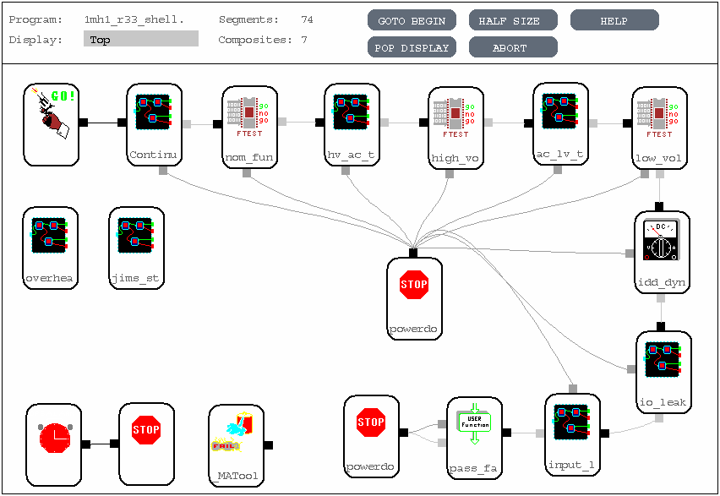
Top-level flow-group
DPS Alarm flow

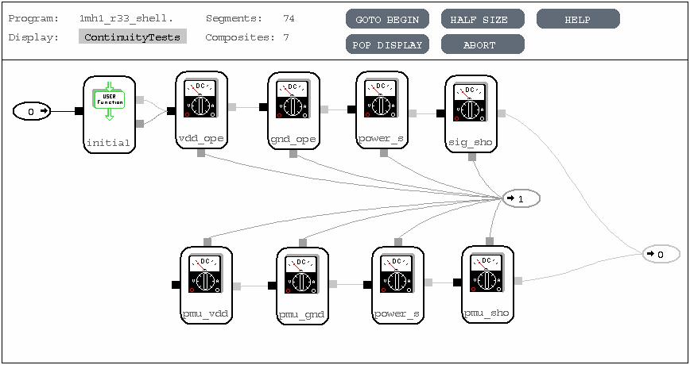
Continuity flow-group

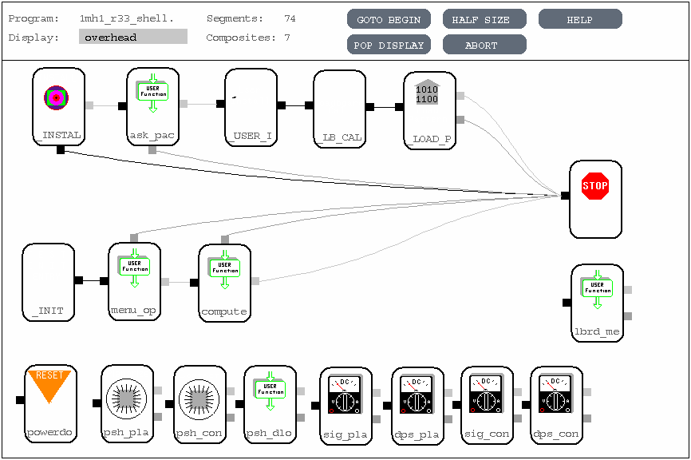
Overhead flow-group

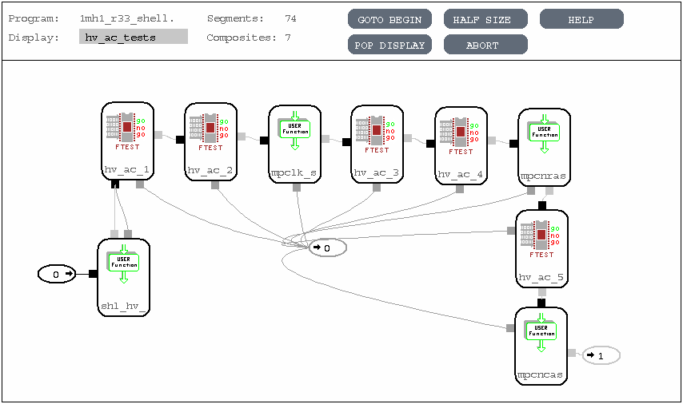
High-voltage speed test flow-group
User code - performs search and updates timing with search result

