Multi-chamber testbeds for Wi-Fi/NR-U coexistence testing
Leigh Chinitz¹
1 CTO at octoScope, Inc. leigh.chinitz@octoscope.com

Summary
As the wireless industry prepares for the potential of 1.2 GHz of unlicensed spectrum to become available in the 6 GHz band, organizations such as IEEE and 3GPP are anticipating how some of the latest wireless technologies will be able to coexist in that band. The technologies of most interest are Wi-Fi 6, based on the IEEE 802.11ax standard, and NR-U, the unlicensed spectrum version of 3GPP’s 5G New Radio standard. In this paper we discuss the important attributes the testbeds used to test the coexistence of, in particular, these two technologies will need to have, and we propose an architecture to meet those requirements.

Introduction

What is meant by coexistence?
When considering whether or not devices can coexist, it is first necessary to define what we mean by coexistence. For the purposes of this discussion, we define wireless coexistence to be “the situation in which two or more wireless communication devices, operating intentionally in the same frequency band, are all able to perform as expected.”
This definition of coexistence excludes several scenarios of interest to wireless system designers, which are, nonetheless, not included under the coexistence umbrella. These include:
- The interaction of wireless communications devices with non-communications devices which may, nevertheless, interfere with their operations.
- The interaction of wireless communications devices in one frequency band with other wireless communications devices operating in different frequency bands (adjacent channel interference scenarios.)
While these scenarios are of significant interest in terms of understanding wireless performance, we categorize them under the heading of “electromagnetic compatibility” (EMC) rather than coexistence.
The definition of coexistence used here is informed by the work of the ANSI C63.27 Draft Standard for Evaluation of Wireless Coexistence.

Testing methodology

How can we decide if two (or more) wireless systems can coexist?
Referring to the work of the ANSI C63.27 group again¹, the probability of coexistence can be determined by determining the probability that the wireless networks will be able to operate as intended in the presence of the other wireless networks. This definition obviously leaves much more to be defined. For example, what does it mean to operate “as intended?” What are the criteria for this? In the context of the ANSI draft standard, this is referred to as “functional wireless performance (FWP)”, and determining this requires a knowledge of the system, the applications, and what is acceptable performance and what is not.

Any test plan defined to answer this question will need to be defined in the context of a specific testbed
At the end of the day, testing must be done in a specific environment. Test plans may define various options for those environments, but at some level they will have to specified. Looking once again at the draft work of C63.27, we can see a number of test configurations:
- RF conducted testing
- Multiple chamber testing
- Radiated anechoic chamber testing
- Radiated open environment testing
Since this project is looking specifically at coexistence between Wi-Fi 6 (based on IEEE 802.11ax) and 3GPP NR-U, operating the 6 GHz unlicensed band, it is reasonable to think about testbed configurations in the context of previous, similar testing.
The goal of this investigation is very similar to the goal of a previous coexistence study undertaken by the Wi-Fi Alliance to look at Wi-Fi and cellular technology coexistence in the 5 GHz band. That test plan, announced on September 21, 2016 was made publicly available by the Wi-Fi Alliance. The stated goal of that testing is “to measure the impact of an LTE-U device on a Wi-Fi network. For the purposes of this test plan, LTE-U devices are LTE devices that operate in unlicensed spectrum, do not fully conform to the LTE-LAA specification as defined by 3GPP and do not undergo RAN4 conformance testing for LTE-LAA.”
One thing that is important to recognize from that statement of goals, and from the test plan itself, is that this previous coexistence work looked only at the effect of LTE-U on Wi-Fi, not vice versa. A more general coexistence study does not distinguish between the coexisting networks – the ability to maintain functional wireless performance needs to be examined for all participating networks.
In the previous work undertaken by the Wi-Fi Alliance, a specific testbed configuration was defined, as shown in Figure 1.
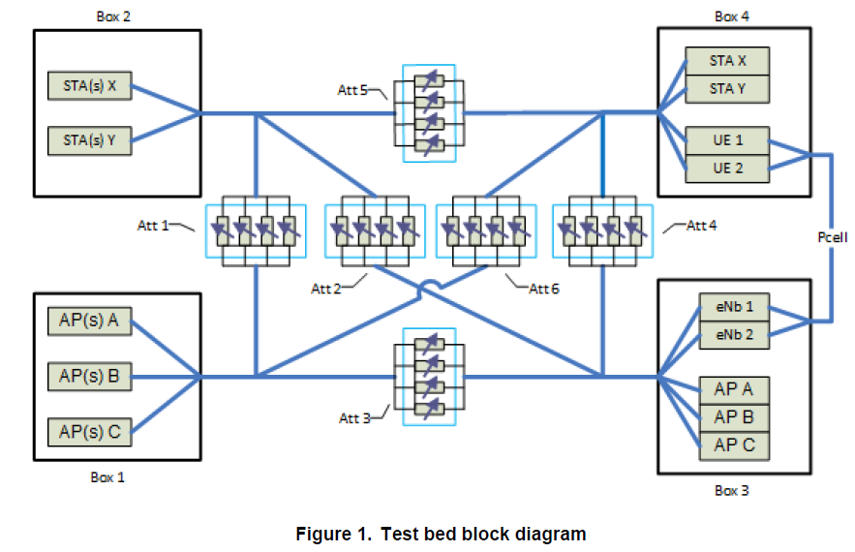
Figure 1: Wi-Fi Alliance testbed configuration for coexistence testing of LTE-U and Wi-Fi
The physical implementation of this environment, in a testbed provided by octoScope, is shown in Figure 2.
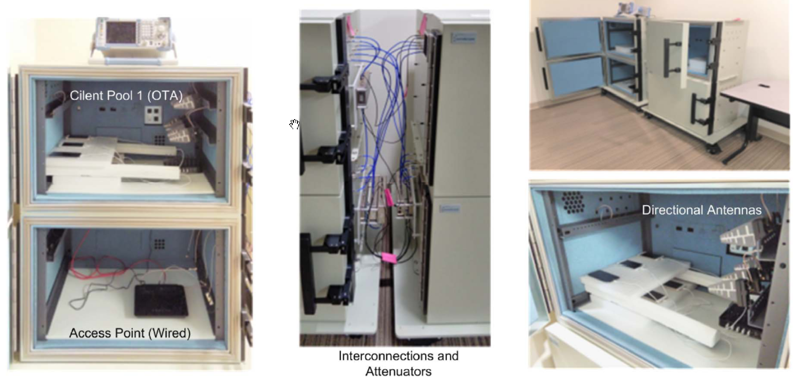
Figure 2: octoScope testbed for Wi-Fi Alliance coexistence testing

Multi-chamber RF testbeds are suited for coexistence testing

Configuration
Multiple chamber configurations, like those shown above, and again somewhat more simply in Figure 3, are very well suited for coexistence testing. Figure 3 shows a fully meshed testbed that allows for testing of two separate networks. As shown, the NR-U network contains a UE and a gNB connected via programmable attenuator 1 (PA_1). This allows the UE and gNB to be any desired RF “distance” from each other. The same is true for the Wi-Fi network made up of the AP and STA, connected through PA_2.
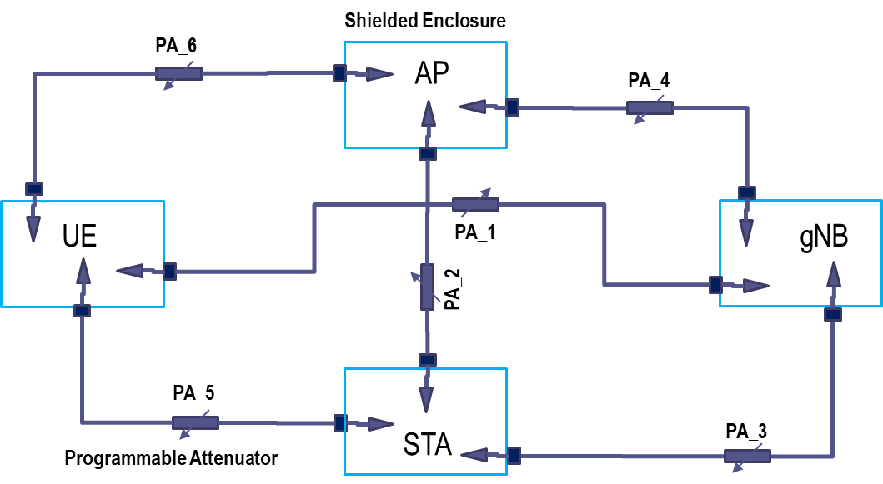
Figure 3: Simple schematic of a fully-meshed, two-system, coexistence testbed
The true power of the fully-meshed, multi-chamber testbed, however, is that all of these devices can be moved “further from” or “closer to” each other simply by modifying the attenuators PA_3 through PA_6. That is, the topology of the coexistence scenario is completely configurable via software changes to the programmable attenuators. No manual re-cabling of the system is required in order to test different topologies.
Other elements can easily be added to these RF links (for example, multi-path emulation) if desired or required by the coexistence test plan.

Repeatability
Of critical importance to coexistence (or any) testing is that the results be repeatable. Well-designed multi-chamber testbeds provide excellent isolation for external interference, leading to an extremely stable RF environment. This results in very repeatable, and reproducible, test results, as demonstrated in Figure 4. As seen in this plot which overlays 10 separate runs of data rate as a function of attenuation (that is, RF “distance), the average coefficient of variation of the data, across a wide range of attenuations and throughputs, is less an 0.5%. This includes test runs in which the devices have been moved and returned to their original position (that is, “reproducibility” as well as “repeatability”).
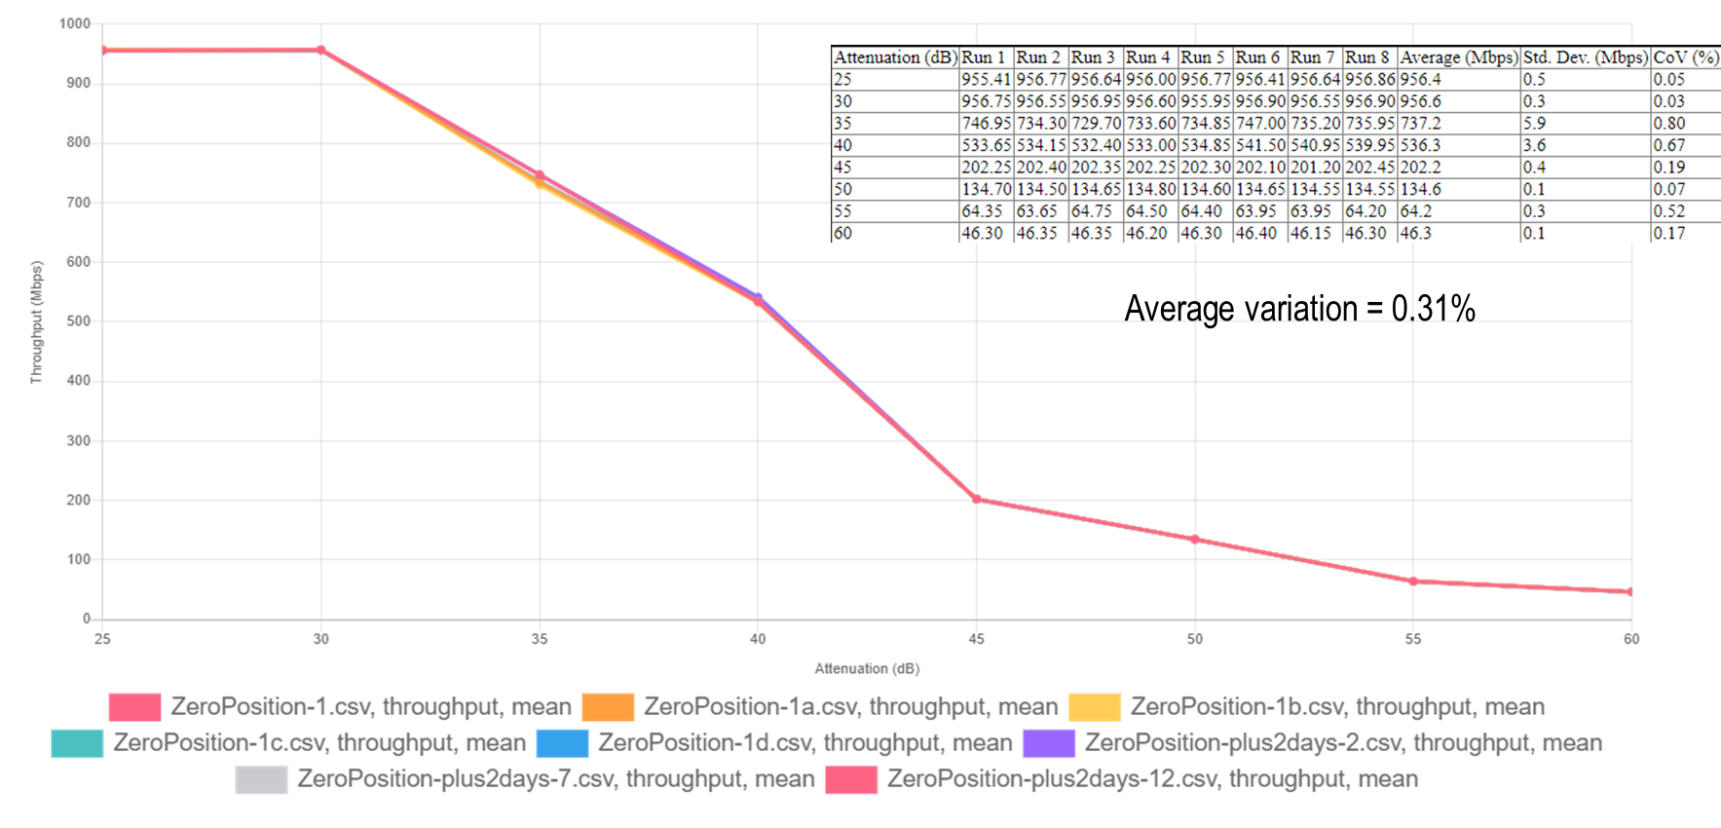
Figure 4: Repeatable and reproducible test results from a multi-chamber testbed

The coexistence testbed must be flexible and expandable

Wi-Fi 6 performance testing is new, complex territory
A key aspect of this effort will be to look into the effects that Wi-Fi 6 and NR-U have on each other from a coexistence perspective. Key to this is first defining the desired wireless performance (for each technology), and then determining the effect on the desired wireless performance of the coexisting network. As a new technology, Wi-Fi 6 has barely reached the interoperability stage, much less the performance testing stage. However, indications are that in order to truly understand how well a Wi-Fi 6 network is performing it will be necessary to evaluate it in a multi-dimensional space whose axes include (at least) throughput (per device), the number of devices in the OFDMA link, and the packet sizes (per stream).

NR-U testing will likely include mobility as a key test parameter
As a cellular technology, and possible element of an operator’s wireless network, the definition of acceptable performance for NR-U networks may include the ability of devices to smoothly transition from NR-U networks to wide-area cellular networks, and back. The testbeds used for coexistence testing, therefore, must be able to support these mobility scenarios.

Testbed must be expandable to new topologies, interference scenarios
Wi-Fi networks have evolved beyond the simple single-AP model to include, much of the time, complex topologies with full or partial meshes, and wireless extenders. Whatever testbed is used for the coexistence testing must be capable of implementing more than basic topologies for one, or both networks of interest. In addition, it may be necessary, or desired, to look at the coexistence probabilities not only in a clean environment made up of only Wi-Fi 6 and NR-U devices, but in the presence of other interference sources as well. The testbed used should at least be capable of supporting those types of tests as well.

Multiple chamber testbeds are a good fit to these requirements
The multi-chamber testbed configuration used for Wi-Fi/LTE-U coexistence testing by the Wi-Fi Alliance, shown in Figure 3, above, is a fully-meshed, four chamber system that allows for complete flexibility in designating the RF “distance” between a Wi-Fi AP and STA, and an NR-U gNB and UE. However, the testbed configuration is not limited to this simple scenario. It is straightforward to expand a testbed like this to include:
- Multiple devices in the networks, to model Wi-Fi mesh/extender networks, and whatever more complex topologies may be contemplated for NR-U;
- Other interfering devices, to model Wi-Fi/NR-U coexistence in the face of other interference;
- Real-world modeling, such as for multipath.

Automation will be necessary to do these tests efficiently
As described above, the number of dimensions along which coexisting testing will need to be done is very large (throughput, number of devices, packet size, QoS, network topology, etc.) In order to be able to do this testing quickly and efficiently, a highly automated testbed will be a requirement.

Conclusion
Coexistence testing between Wi-Fi 6 and NR-U will be a complicated endeavor. Both technologies are very new, and between them they include technologies such as multi-user operation via OFDMA and MU-MIMO, mesh configurations, and mobility requirements. The testbed used for coexistence testing will need to be very flexible, expandable, and highly automated in order to be able to provide complete testing coverage in a reasonable amount of time. A multi-chamber testbed, with programmable attenuation and other possibly required elements provides an ideal environment in which this testing can be achieved.

“Traditional EMC testing is designed to exclude frequency bands where the device under test communicates wirelessly. Coexistence testing focuses on devices and systems that intentionally use wireless and it extends beyond traditional EMC to examine the device’s performance in frequency bands where it uses wireless communication.” C63.27/D1 Draft American National Standard for Evaluation of Wireless Coexistence, Revision 1—D4, September 2018
https://www.wi-fi.org/news-events/newsroom/wi-fi-alliance-delivers-lte-u-coexistence-test-plan
https://www.wi-fi.org/downloads-registered-guest/Coexistence_Test_Plan_Package_v2.0.zip/30083

