***Justification for Removing TEST_MODE***

*TEST_MODE is out of scope of this power standard and is best left for proprietary implementation*.

* Forcing power to non-compliant PDs is out of scope of this standard
* Leaving it in encourages continuing complication of this standard
* TEST_MODE implies a hole in interoperability, given its lack of specification and may create interoperability problems in the field

***30.9.1.1.4 aPSEPowerDetectionStatus***

*Page 36 Line 10*

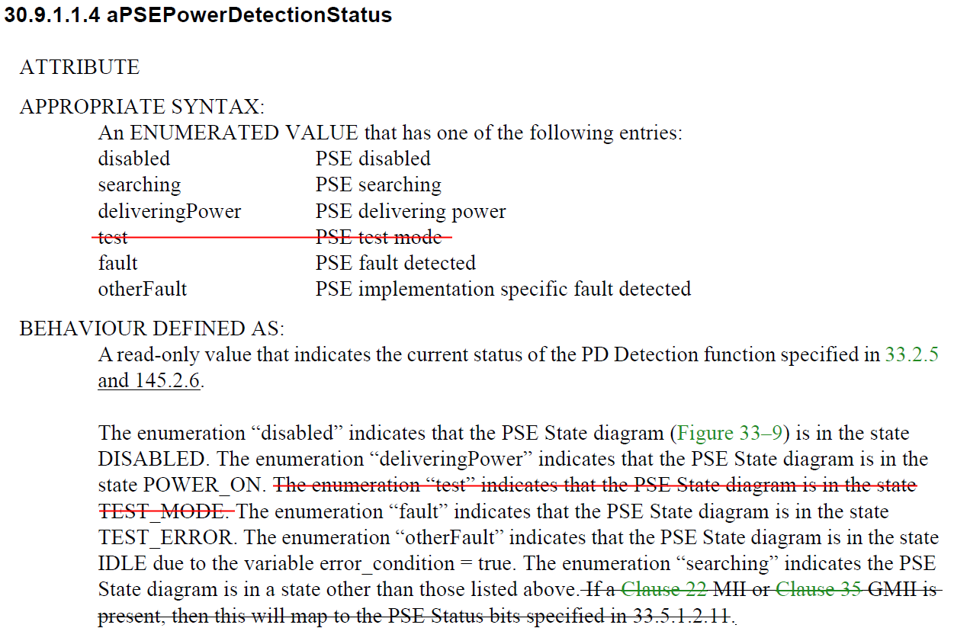

**Propose also change:**

The enumeration “fault” indicates ~~that the PSE State diagram is in the state TEST_ERROR. The enumeration “otherFault” indicates~~ that the PSE State diagram is in the state IDLE due to the variable error_condition = true.

**145.2.5.1**

Page 108 Line 36

In the state diagram, each Alternative serves a distinct role during 4-pair operation. In any implementation, the roles of the Alternatives shall be established in IDLE ~~or TEST_MODE~~ and be maintained in every other state. In the state diagram, the roles of the Alternatives are named Primary Alternative and Secondary Alternative.

**145.2.5.4**

Page 110 Line 33

alt_pwrd_pri

A variable that controls the circuitry that the PSE uses to power the PD over the Alternative that has been assigned as Primary.

Values:

FALSE: The PSE is not to apply power to the Primary Alternative.

TRUE: The PSE has detected, classified, and will power a PD on the Primary Alternative~~; or power is being forced on the Primary Alternative in TEST_MODE~~.

Page 110 Line 40

alt_pwrd_sec

A variable that controls the circuitry that the PSE uses to power the PD over the Alternative that has been assigned as Secondary.

Values:

FALSE: The PSE is not to apply power to the Secondary Alternative.

TRUE: The PSE has detected, classified, and will power a PD on the Secondary Alternative~~; or power is being forced on the Primary Alternative in TEST_MODE~~.

Page 111 Line 52

Remove force_pwr_pri and force_pwr_sec

~~force_pwr_pri~~

~~This variable indicates if the Primary Alternative is to apply power to the pairset while in TEST_MODE (see Table 145–3).~~

~~Values:~~

~~FALSE: The Primary Alternative is not powered.~~

~~TRUE: The Primary Alternative is powered.~~

~~force_pwr_sec~~

~~This variable indicates if the Secondary Alternative is to apply power to the pairset while in TEST_MODE (see Table 145–3).~~

~~Values:~~

~~FALSE: The Secondary Alternative is not powered.~~

~~TRUE: The Secondary Alternative is powered.~~

Page 116 Line 42

pse_enable

A control variable that selects PSE operation and test functions.

Values:

disable: All PSE functions disabled (behavior is as if there was no PSE functionality).

enable: Normal PSE operation.

f~~orce_power: Test mode selected that causes the PSE to apply power to the PI when there are no detected error conditions.~~

**145.2.5.7**

Remove entire TEST_MODE page

