Annex 113A
(informative)

Description of cable clamp and test setup
113A.1 Overview
This annex describes an example of a cable clamp and a representative methodology that should be used in common-mode noise rejection, rejection of external EM fields, or similar MultiGBASE-T receiver tests using EM clamp injection techniques, which are used to determine the sensitivity of the PMA receiver to external EM fields introduced by the cabling and interconnect system. Variations of this methodology may also be useful for other testing as applicable for design and development purposes. Refer to the receiver specifications of the PHY under test for specific impairments, impairment source power levels, and relevant frequency ranges.
113A.2 Description of cable clamp
(Note – The larger inner diameter clamp is described here; see Annex 40B for the description of an alternate clamp for use with smaller diameter cable types)
As shown in Figure 113A-1 and 113A-2, the clamp is 300 mm long, 75 mm wide, 78 mm high with a center opening of 9.525 mm (0.375 in). The clamp consists of two halves that permit the insertion of a cable into the clamp.
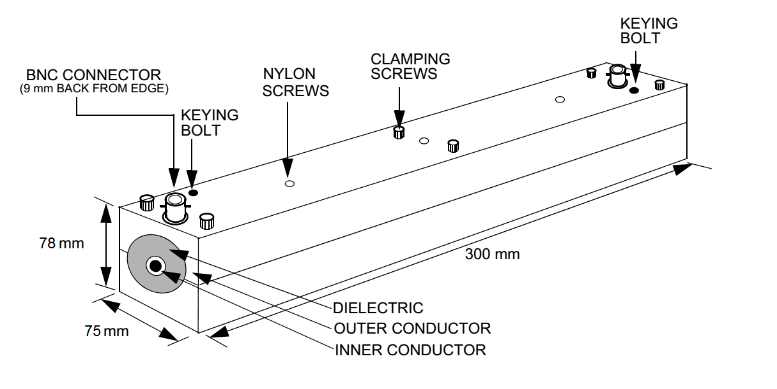
Figure 113A-1 - Cable clamp
The clamp has a copper center conductor and an aluminum outer conductor with a high density polyethylene dielectric. The following is a review of the construction and materials of the clamp:
a) Inner conductor - Copper tubing with an inner diameter of 9.53 mm (0.375 in) and an outer diameter of 12.7 mm (0.50 in).
b) Outer conductor - Aluminum bar that is 300 mm long and approximately 78 mm by 75 mm. The bar is milled to accept the outer diameter of the dielectric material.
c) Dielectric - High Density Polyethylene (Residual, TypeF) with dielectric constant of 2.32. The hollow cylinder has an outside diameter of 45 mm and an inner diameter that accepts the outside diameter of the copper inner conductor.
d) Connectors - BNC connectors are located 9 mm (0.39 in) from each end of the clamp and are recessed into the outer conductor. The center conductor of the connector is connected to the inner conductor as shown in Figure 113A-2.
e) Clamping screws - Six screws are used to connect the two halves of the clamp together after the cable has been inserted. Although clamping screws are shown in Figure 113A-1, any clamping method may be used that ensures the two halves are connected electrically and permits quick assembly and disassembly.
f) Nylon screws - Used to align and secure the inner conductor and dielectric to the outer conductor. The use and location of the screws is left to the manufacturer.
g) Keying bolts - Two studs used to align the two halves of the clamp.
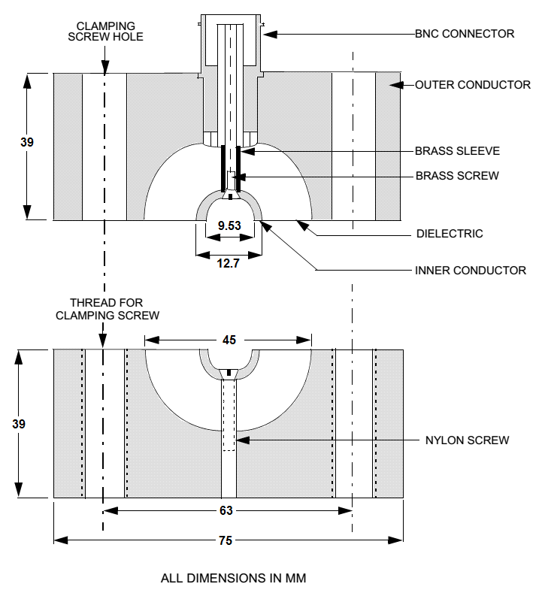
Figure 113A-2 - Cross-section of cable clamp
As shown in Figure 113A-2 the inner conductor on the bottom half of the clamp extends slightly (~ 0.1mm) above the dielectric to ensure there is good electrical connection with the inner conductor of the top half of the clamp along the full length of the conductor when the two halves are clamped together.
The electrical parameters of the clamp between 1 MHz and 2000 MHz are defined in Table 113A-1.
Table 113A-1 – Cable clamp electrical parameters (1 MHz – 2000 MHz)
Frequency range | Insertion Loss | Return Loss
1 MHz - 250 MHz | < 0.2dB | > 20.0 dB
250 MHz - 500 MHz | < 1.0 dB | > 7.0 dB
500 MHz - 1000 MHz | < 3.5 dB | > 3.5 dB
1000 MHz - 2000 MHz | < 15.0 dB | > 1.0 dB

113A.3 Cable clamp validation
In order to ensure the cable clamp is operating correctly, the following calibration, measurement and validation procedures are provided and should be completed prior to conducting the test described in 113A.4 and illustrated in Figure 113A-4. Note that other measurement methods are allowed provided they can demonstrate equivalent results to the method described in this Annex.
Cable clamp calibration - Prior to making validation measurements or performing the test described in 113A.4, the cable clamp should be tested without the cable inserted to determine the variation of the signal generator voltage with frequency at the output of the clamp. The signal generator output should be adjusted to the specified signal power (for example, 6 dBm for 40GBASE-T) at 20 MHz on the signal sensor. The signal generator output frequency is swept incrementally from 1 MHz to 2000 MHz with a step size that should not exceed 1% of the preceding frequency value. When the frequency is varied from 1 MHz to 2000 MHz, the measured power should not vary more than ±10%. If the power varies more than ±10%, then a correction factor may be applied at each measurement frequency. If used, the signal power correction factor should not result in common-mode and differential-mode voltages that exceed the limits defined in Table 113A-2.
Cable clamp electrical measurement - The clamp should be measured to ensure the insertion loss and return loss are as specified in Table 113A-1. Electrical parameters of the clamp are measured between the source connections and without cabling (that is, no cabling inserted in the clamp inner conductor).
Cable clamp validation – This validation procedure is provided to verify proper operation of the test setup before performing any tests. In contrast to the clamp electrical measurement, the cable clamp validation test procedure uses the clamp with cabling that meets the PHY link segment specifications inserted into the clamp.
The validation test hardware consists of the following:
a) Transmitter/Receiver – A link partner system, configured for the data rate being evaluated, with the transmitter disabled.
b) Breakout Fixture – A passive fixture with an MDI connector jack input and individual outputs for each of the 8 signal wires. Wires of pairs not being measured should be terminated to the ground plane with a 50 Ω resistor.
c) Balun – 3 ports, laboratory quality with a 100 Ω balanced differential input (Port 1), a 50 Ω unbalanced single-ended output for the differential component (Port 2), and a 50 Ω unbalanced single-ended output for the common-mode component (Port 3):
Insertion Loss (Port 1 <-> Port 2): < 4dB (1 MHz-2000 MHz)
Return Loss (Port 1): > 8dB (1 MHz- 3 MHz), > 15dB (3 MHz-2000 MHz)
Common-Mode Rejection (Port 1 <-> Port 2): > 50dB (1 MHz-1000 MHz), > 40dB up to 2000 MHz
Common-Mode Return Loss (Port 1): > 8 dB (1 MHz-2000 MHz)
Note that other devices for detecting differential and common mode signals may also be used, provided the performance is demonstrated to be equivalent or better.
The use of two separate differential and common-mode signal component measurement configurations is permissible provided the above specifications are met for each measurement device.
The common-mode reference (termination) impedance may be standard specific. The common-mode return loss requirement does not change, but Zref (common-mode) may be 50 Ω for shielded or 75 Ω for unshielded applications.

d) 50 Ω resistors – Used to terminate unmeasured conductors.
e) Test cable – A 30m, 4-pair 100 Ω plug terminated cable that meets the PHY link segment specifications.
f) Chokes (minimum 5) - Wideband Ferrite Material:
Inner diameter: Selected to minimize the gap between the ferrite and the cable used for the test.
Minimum Impedance: 175 Ω @ 100 MHz, 275 Ω @ 250 MHz, 375 Ω @ 500 MHz, 400 Ω @ 1000 MHz
g) Ground plane - Copper sheet or equivalent large enough to span the equipment interface under test and the clamp, including the portion of the cable between the equipment and the chokes (See Figure 113A-3).
h) Signal generator capable of providing a sine wave signal of 1 MHz to 2000 MHz, with adequate test power for adjustments, low harmonic distortion and the ability to control and monitor power and frequency transitions.
i) Signal Sensor & Measurement System - Oscilloscope, power meter or spectrum analyzer with at least 4000 MHz bandwidth

k) Receiver

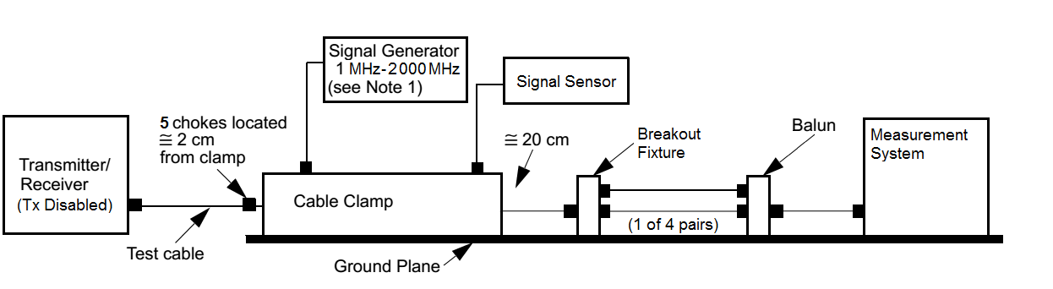
Figure 113A-3 - Cable clamp validation test configuration
With the test cable inserted in the cable clamp, a signal generator with a 50 Ω output impedance is connected to one end of the cable clamp and a signal sensor with a 50 Ω input impedance is connected to the other end.
The signal generator should be capable of providing a sine wave signal of 1 MHz to 2000 MHz. The output of the signal generator is adjusted for the specified signal power at 20 MHz on the signal sensor. The remainder of the test is conducted without changing the signal generator voltage. The cable pairs not connected to the balun (or equivalent measurement network) are terminated in a resistor network. The cable clamp, breakout fixture and balun are in direct contact with the ground plane in a manner consistent with good RF measurement practices. The chokes are placed on the cable, located next to each other and approximately 2.0 cm from the clamp.
The cable between the clamp and the breakout fixture should be positioned straight from the clamp to the breakout port and not contact the ground plane. Any plug shield contacts should mate with the breakout jack shield. The cable between the transmitter and the cable clamp should be installed either in a linear run or wrapped randomly on a cable rack. The cable rack should be at least 3 m from the cable clamp. The cable between the clamp and the balun should be straight and not in contact with the ground plane.
The differential-mode and common-mode voltage outputs of the balun and breakout fixture should meet the limits shown in Table 113A-2 over the frequency range 1 MHz to 2000 MHz for each cable pair.
Table 113A-2 - Common- and differential-mode output voltage
Frequency (f) | Common-mode voltage | Differential-mode voltage
1 MHz - 30 MHz | <0.1+0.97(f/30) Vpp | <2.4 + 19.68 (f/30) mVpp
30 MHz - 80 MHz | <1.07 Vpp | <22mVpp (-29 dBm)
80 MHz - 250 MHz | <1.07 – 0.6 (f-80)/170 Vpp | <22 mVpp (-29 dBm)
250 MHz - 2 000 MHz | <470mVpp (-2.6dBm) | <22mVpp (-29 dBm)

After the setup has been validated, the clamp, cabling, and choke positions should remain unchanged when performing any receiver tests.
NOTE 1 – (Placeholder in case we need a NOTE 1)
113A.4 Test Setup
Cabling up to the maximum specified length that meets the link segment specification for the PHY under test (for example, Clause 113.7 for 40GBASE-T), is connected between two such PHYs and inserted into the cable clamp. The cable should be terminated on each end with an MDI connector plug specified for the PHY under test (for example, Clause 113.8.1 for 40GBASE-T).
The breakout fixture and balun are replaced by the transmitter/receiver under test, with the system port positioned at the original location of the breakout. The clamp should be located a distance of ~20 cm from the receiver port.
As described in the validation setup, the cable clamp and transmitter/receiver under test should be placed on a common ground plane and the system ground of the receiver should be in direct contact with the ground plane. The chassis grounds of all test equipment used should be connected to the ground plane. A signal generator with a 50 Ω impedance is connected to one end of the clamp and measurement equipment with a 50 Ω input is connected to the other end of the clamp. The signal generator should be capable of providing a sine wave signal of 1 MHz to 2 000MHz or other cable-clamp-coupled impairment as specified.
The output of the signal generator (as calibrated in 113A.3) is applied to the clamp input to simulate the specified impairment (for example, an external electromagnetic field of approximately 3 V/m). As with the calibration procedure, the signal generator output frequency is swept incrementally from 1 MHz to 2000 MHz with a step size that should not exceed 1% of the preceding frequency value and with a dwell time at each step of at least 500ms. The signal generator output should be reduced to the minimum output level between steps to minimize any frequency switching transients.

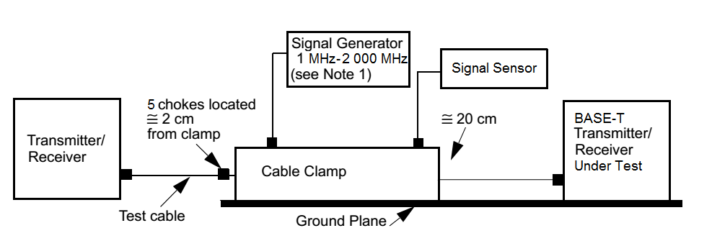Figure 113A-4 - Cable clamp test configuration

