Taxonomy of PON-based Access Network Technologies
There are a number of PON-based access architectures providing layer-2 (L2) connectivity between the location of the Optical Line Terminal (OLT), and the demarcation point (Optical Network Unit, or ONU). Depending on the actual location of the ONU, there are several classes of fiber access networks, namely (adapted from [10]):
- FTTN / FTTLA (fiber-to-the-node, -neighborhood, or -last-amplifier): Fiber is terminated in a street cabinet, with the drop section between the cabinet and customer premises typically implemented using either coaxial or twisted pair cabling. FTTN is often considered to be an interim step toward FTTH.
- FTTC (fiber-to-the-curb, -closet, or -cabinet): An architecture that is very similar to FTTN. The difference between FTTN and FTTC is that the termination point (ONU) is located nearer the customer premises - typically within 1,000 feet (300m).
- FTTB (fiber-to-the-building, -business, or -basement): Fiber is terminated at a selected location within the building, such as the basement in a multi-dwelling unit, with the drop section between the termination point (ONU) and customer premises typically implemented using either coaxial or twisted pair cabling.
- FTTH/FTTU (fiber-to-the-home/fiber-to-the-unit): An architecture in which the fiber is terminated directly on the premises of a residential customer. FTTU refers to this architecture when applied to individual units in a multi-tenant/multi-dwelling unit (MDU/MTU). FTTH refers to this architecture when applied to standalone offices or homes.
- FTTP (fiber-to-the-premises): An architecture that includes both FTTH and FTTB architectures.
- FTTD (fiber-to-the-desktop): An architecture, fiber extends all the way to a fiber media converter near the user's desk.
Optical access architectures can be classified by their logical connectivity options. One distinguishing factor is the number of independent connections (or channels) that exist between the OLT and an ONU. Another factor is the nature of each logical channel: a channel can be dedicated to a single ONU or shared among multiple ONUs.
There exist several physical means of creating the channels. A simple way is to use separate fiber strands for each connection. Another method involves chromatic separation of channels using Wavelength-Division Multiplexing (WDM) techniques. Other methods include carrier frequency separation (Orthogonal Frequency Division Multiplexing channel) and signal coding (Code Division Multiplexing channel).
Figure 1 illustrates the mentioned connectivity options using separate optical fibers (ODNs). The top left quadrant represents a dedicated point-to-point connection from the OLT to each ONU, a so called “home run” architecture. The top right quadrant represents a typical TDM-PON architecture, i.e., EPON or GPON.
The two quadrants at the bottom represent point-to-point and TDM-PON access architectures with dual homing (e.g. for fault protection and/or extra bandwidth).
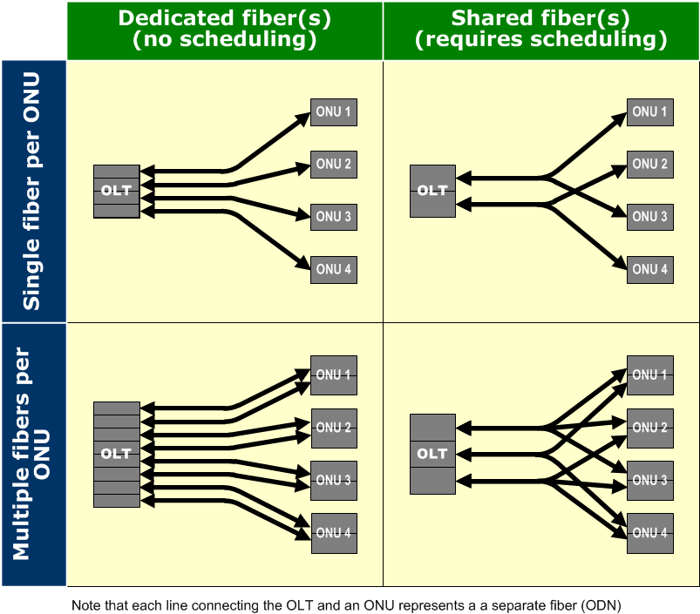

Figure 1: Optical access architectures using multiple ODNs
Figure 2 illustrates the same logical connectivity options, but this time the channel separation is achieved using WDM techniques.

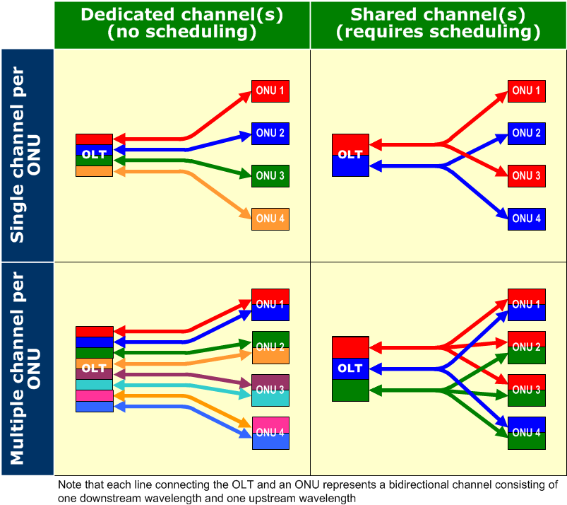

Figure 2: Optical access architectures using WDM
In the scenarios shown in the two quadrants on the left, an ONU has one or more pairs of dedicated wavelength channels (one downstream, one upstream), forming a Wavelength-Division Multiplexing PON (WDM-PON). In the scenarios shown in the two right quadrants, an ONU shares one or more pairs of wavelength channels with other ONUs using a Time-Division Multiplexing (TDM) scheme, resulting in a Hybrid-PON. Depending on the order in which WDM sharing and TDM sharing is applied to these wavelength channels, Hybrid-PON can be further divided into Single-Scheduling Domain WDM-PON (SSD-WDM-PON) and Multiple-Scheduling Domain WDM-PON (MSD-WDM-PON).
This taxonomy of optical access architectures is presented in Table 1.

Table 1: Taxonomy of Optical Access Architectures
PHY Channels per PON per direction {one/many} | PHY Channels per ONU per direction {one/many} | PHY Channel Connectivity Type  {P2P/P2MP/Mix} | Type/Name of Network
One | One | P2P | P2P Link
 |  | P2MP | EPON, 10G-EPON, GPON, XG-PON
Many | One | P2P | WDM-PON
 |  | P2MP | SSD-WDM-PON, MSD-WDM-PON
 | Many | P2P | WDM-PON
 |  | P2MP | SSD-WDM-PON, MSD-WDM-PON
 |  | mix | ?

