How to use ITU-R SG 1 electronic facilities
(June 2014)

1. Introduction
To make full use of the ITU-R electronic facilities you need a TIES user-id and password. If you do not have a TIES ID, please read: http://www.itu.int/TIES/registration/index.html to determine whether you are eligible and then submit your registration form to: ties.registration@itu.int.
The electronic facilities used by ITU-R SG 1 are as follows:
- Mailing lists: Used to send messages to all those that have subscribed to the list.
Large file attachments are discouraged.
- FTP server: For file exchange.

2. Mailing lists
TIES mailing lists are used by the various working parties and their subordinate groups to facilitate work by correspondence between meetings. The following SG 1 mailing lists have now been set up. As there is no automatic subscription to the lists, you will need to request subscription to the lists yourself.

2.1 General Working Party lists
Used for general announcements to members of the WP, e.g. announcement of the creation of a new correspondence group:

Working Party 1A: rwp1a@itu.int

Working Party 1B: rwp1b@itu.int

Working Party 1C: rwp1c@itu.int

2.2 Other SG 1 or Working Party groups
These Groups are set up by SG 1 or by each Working Party.
For the Rapporteur Groups and the Correspondence Groups, clearly Terms of Reference and Rapporteurs or Chairmen have been defined. For the other groups, contact persons have been defined.
Information about the groups currently operating in each Working Party is available by following the link to “Mailing lists - FTP server” on the SG 1 or each Working Party web page.

2.3 How to use
When you send an email to one of the above mailing list addresses, your message is automatically forwarded to all those who have subscribed to that mailing list. You must be subscribed to a mailing list to be able to send messages to it.

To manage your mailing list subscriptions, login to your TIES account:
http://www.itu.int/TIES/
You will then see the following TIES home page.
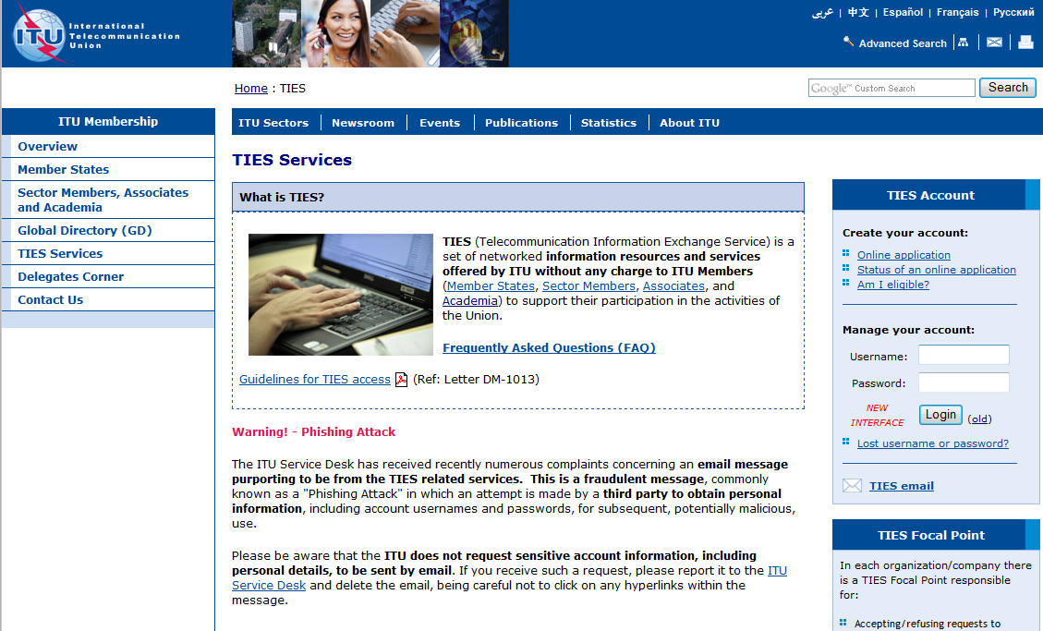
After entering your TIES username and password on the right hand-side, you will see the following web page:
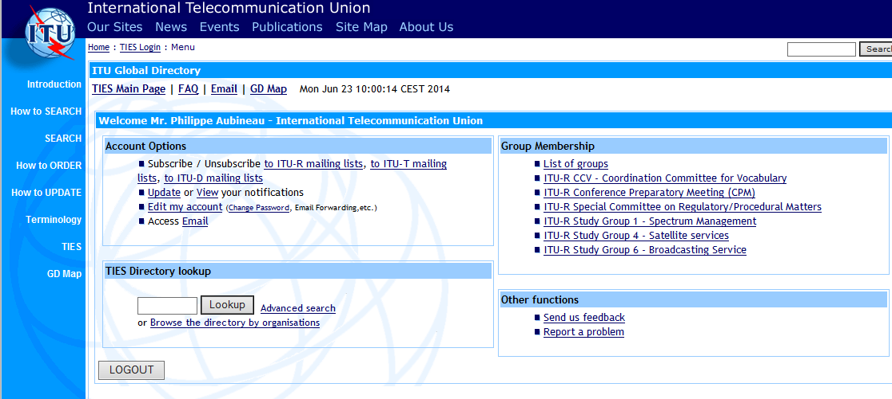
In the first column, under “Account options”, click on “Subscribe / Unsubscribe to ITU-R mailing lists”. You will then see a page showing which mailing lists you are already subscribed to, and below that, which mailing lists you can request subscription to.

To subscribe to a list, scroll down the page to find “Mailing lists for itu-r:sg1”.
Click on the box(es) next to the list(s) that you want to subscribe to.
Scroll back up to “Request Subscription to mailing lists”, where it says “Subscribe <your email address>”. If you want to use a different email address for sending/receiving emails to/from the mailing list, fill in the box next to this. Then click on the “Subscribe” button. Allow a day or two for your request to be processed. You will receive an email advising you once your request is approved.
Once subscribed, in the part of the web page showing which mailing lists you're subscribed to, you will also be able to see who else is subscribed to each list (“Members”) and have access to an archive of emails previously sent to each list (“Archive”). You are also automatically granted access to the associated ftp site.

To unsubscribe from a list, simply click the check-box(es) on the right hand side of the page corresponding to the list(s) that you want to unsubscribe from, then click the “Unsubscribe” button.

3. FTP server
It is preferable that large files (>1-2 Mbytes) be placed on the ITU's FTP server, rather than including them as attachments to messages sent to the mailing lists. Many subscribers' mailboxes apply file size limits, which prevent emails with large attachments being received. A better approach is to include a link to the file on the FTP server in the message that you send to the mailing list.
To be able to access the SG 1 FTP site, you need to have a TIES ID and password and be subscribed to at least one of the mailing lists in SG 1. If, after your subscription to the list has been approved, you are still unable to access a SG 1 FTP site, please send an e-mail to brweb@itu.int and provide your TIES username and the name of the mailing list you have subscribed to.
The SG 1 FTP directory can be accessed either via World Wide Web (WWW) at http://ties.itu.int/u/itu-r/ede/rsg1/ or via File Transfer Protocol (FTP) ITU servers.
For accessing the ITU FTP server, use FTP communication software with the host address as ftp://ties.itu.int/ using your TIES ID and Password. Then change directory to the following:
/u/itu-r/ede/rsg1.

For further information about the ITU-R electronic facilities, please consult:
http://www.itu.int/ITU-R/index.asp?category=information&link=e-facilities&lang=en
______________

