- Recognition and Awards – Chair: Bill Chiu

Committee Membership Certificates
The Transformers Committee welcomes five new full committee members. Each of the following new members was presented with a membership certificate:

New Member | Affiliation
Thomas R. Melle | HighVolt
Poorvi Patel | ABB Inc.
Leslie D. Recksiedler | Manitoba Hydro
Adam M. Sewell | Quality Switch
Charles E. Simmons | Duke Energy
Kenneth R. Skinger | Chicago Bridge & Iron
Troy Tanaka | Burns & McDonnell

General Service Awards Certificate of Appreciation
Certificate of Appreciations were presented to the following list of recipients for their contributions to the Transformers committee:

Name of Award Recipients | Affiliation | Contributions
Jane Ann Verner | PEPCO | Meeting Host – Fall 2014
Potomac Electric Company | PEPCO | Host Company– Fall 2014
Carl G. Niemann |  | Subcommittee Chair  Underground Transformers & Network Protectors (2000 – 2014)
Brian F. Klaponski | Carte International Inc. | “Outstanding Contributor”  to the Transformers Committee

IEEE SA Standards Board Awards
In addition to the Committee Awards above, the IEEE SA SB presents its own Award to the WG Chair upon publication of a new or revised document, and offers the WG Chair the opportunity to nominate significant contributors to the project for an IEEE SA SB Certificate of Appreciation. All Working Group Chairs chose to have their awards sent direct to their residence or place of business. The award recipients were called forward for recognition during our Awards Luncheon on Tuesday.

IEEE SA Award Reccipients:
Revision of C57.134 - Guide for Determination of Hottest-Spot Temperature in Dry-Type Transformers
Paulette Payne Powell - Working Group Chair
Timothy L. Holdway - Significant Contributor
Charles W. Johnson - Significant Contributor
Richard P. Marek - Significant Contributor

Revision to C57.96 - Guide for Loading Dry-Type Distribution and Power Transformers
Richard P. Marek – Working Group Chair
Timothy L Holdway – Significant Contributor
Aleksandr A Levin – Significant Contributor
Dhiru S Patel – Significant Contributor
Sanjib K Som – Significant Contributor

Revision of IEEE 638 - Standard for Qualification of Class 1E Transformers for Nuclear Power Station
Craig Swinderman – Working Group Chair
Roger Wickes – ballot comment resolution
Richard Marek – dry type transformer aspects
Kent Brown – insight from user’s perspective
William Bartley – ballot process, PAR issues, etc.

Revision to C57.116 - Guide for Xfmrs Directly Connected to Generators
Gary Hoffman - WG Chair
Bill Griesacker - WG Vice Chair
Randall Kyle - WG Secretary
Peter Balma - Special Editor
Mark Baldwin, Joe Watson, Randall Kyle Task Force Chair

WG & TF Contributing Members
Wallace Binder | Roderick Sauls**
David Harris | Stephen Schroeder
Jose Izquierdo | Eduardo Tolcachir
John Lackey** | David Wallach**
Jeffrey Ray* | Kipp Yule**
* Technical Contributor
** Ballot Resolution Committee Members

Revision to C57.12.28 & C57.12.29 - Standard for Pad Mounted Equipment - Enclosure Integrity (& Coastal Environments)
Robert C. Olen & Daniel Mulkey - WG Co-Chairs

Revision to C57.12.38
Std. for Pad-Mounted Type, Self-Cooled, Single Phase, Dist Transformer, <250kVA
Ali Ghafourian – Working Group Chair
Michael D. Faulkenberry – WG Vice Chair

International Joint Working Group Chair Award
IEEE SA Award - IEC/IEEE 65700-19-03
Standard Requirements – Terminology and Test Code for Bushings for DC Applications

Leslie D. Recksiedler & John Graham – WG Chair
Pierre Riffon – WG Co-Chair
Reiner Krump – significant contributor
Ulf Radbrandt – significant contributor

IEEE PES Distinguished Service Award

The Transformers Committee recognized two very special individuals in the form of Power & Energy Society Distinguished Service Award at this meeting. This award is reserved for members of PES who has devoted a very significant portion of their career contributing to one of the technical committees within the PES umbrella.

Each Technical Committee is allotted a maximum of one recipient per year for outstanding distinguished individual service. This very special award and personal recognition acknowledges the efforts of those individuals with sustained performance, over many years and/or has contributed to the advancement of the committee technology. This award recognizes contributions in the following categories:
- Enhancing the process through continued service on its major action committees.
- Leadership in developing new aspects of what the technical committee can do to improve its procedural process.
- Interaction on behalf of technical committee to promote national and international growth of standards as a product of IEEE.
- Representing the technical committee at various levels within IEEE Societies/Committees and other standards-developing organizations (ASME, IEC, etc.), which encourages the implementation of the IEEE Standards and also the mission and goals of Power & Energy Society - To be the leading provider of scientific and engineering information on electric power and energy for the betterment of society, and the preferred professional development source for our members.

As in the criteria mentioned earlier, there is only a maximum of one award given each year in this category from each of the 14 technical committee. Because we did not take advantage of this category for the past couple of years, we negotiated with the PES Awards approval committee for us to use some of the past allotment. They were kind enough to have made a special dispensation to grant us two award recipient this year. So I do want to acknowledge my appreciation to the PES Awards Chair, Dr. Mariesa Crow for providing this generous variance. This recognition consists of an engraved brass plate mounted on a wooden plaque, although there is no honorarium attached to this award.

Our first recipient, Gregory W. Anderson, started attending our committee meetings in the mid-1990’s and has been a very active contributor event since. This individual really didn’t take much time to get himself indoctrinated with the committee. He jumped right in and hosted a meeting in the Spring of 1995 when we had our meeting in Kansas City. Over the years, he has continued to play a pivotal role for the success of the committee over the past couple of decades in carrying out his vision on what it takes to facilitate our meetings. He has led many of the innovations that we now take for granted. Many of you remembered what it was like to plan and host a meeting. The host had to physically mail out invitation letters and collect the registration fees from individual members, not to mention tracking individual attendees’ correspondence, on top of making all the local arrangements, from hotel lodging accommodations to food and beverages and everything else in between. During the past couple of decades, this individual has provided countless leadership in breaking the boundary of our traditional thinking on meeting arrangements. As an example of the many notable accomplishments, this individual spearheaded the transition to the Association Management System - AMS-123, which has profoundly changed the way we run our meetings, and greatly simplified some of the tedious task of managing the contact information of our attendees, tracking the meeting attendance, membership rosters, and streamlining the communications for each of the activities that are key to our successes.

Our next recipient, Donald J. Fallon, has been a long term contributor since the mid-1980’s. Don has tirelessly contributed to many of our documents despite some recent travel restriction and continued to participate through correspondences. An example of this is during the previous revision to one of our core document of C57.12.80 several years ago, Don tirelessly went through the more than 500 definitions and made sure we didn’t overlook or had conflicts between the terminologies. Don also held a continuous attendance record over a 25-year period where he had not miss a single meeting. Don had a series of impressive leadership role in the committee. He served as WG and TF chairs for many of the documents, been a Performance Characteristic Subcommittee Chair, and a former officer of the main committee. Although not able to actively attend our meetings for a few years, due to travel restrictions, I know I speak for many in that we are very glad that he is able to join us again at this meeting even though he is almost retired from his work. For me, not only did Don made his mark in a series of very significant leadership role for our committee, but Don was also a trusted advisor for me over the past 10 years or so in my progression from a standards coordinator and standards subcommittee chair through the officer’s ranks.
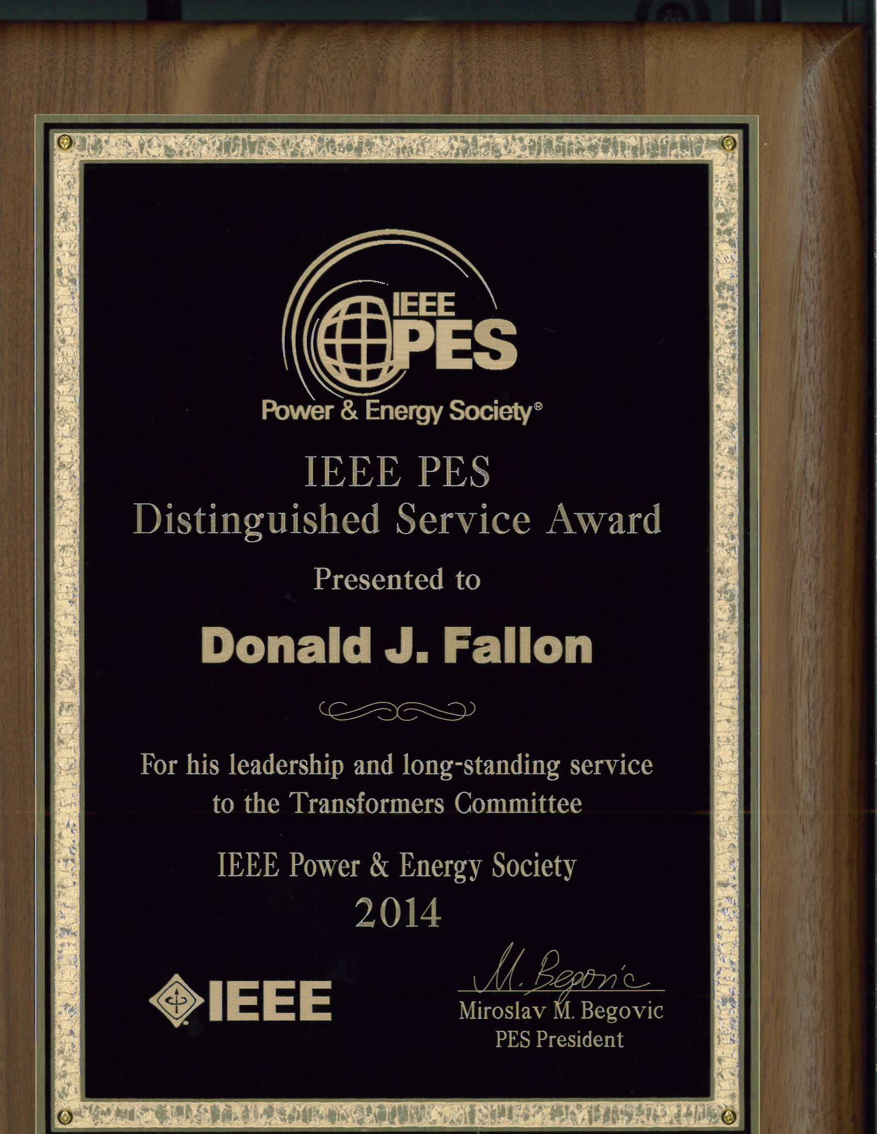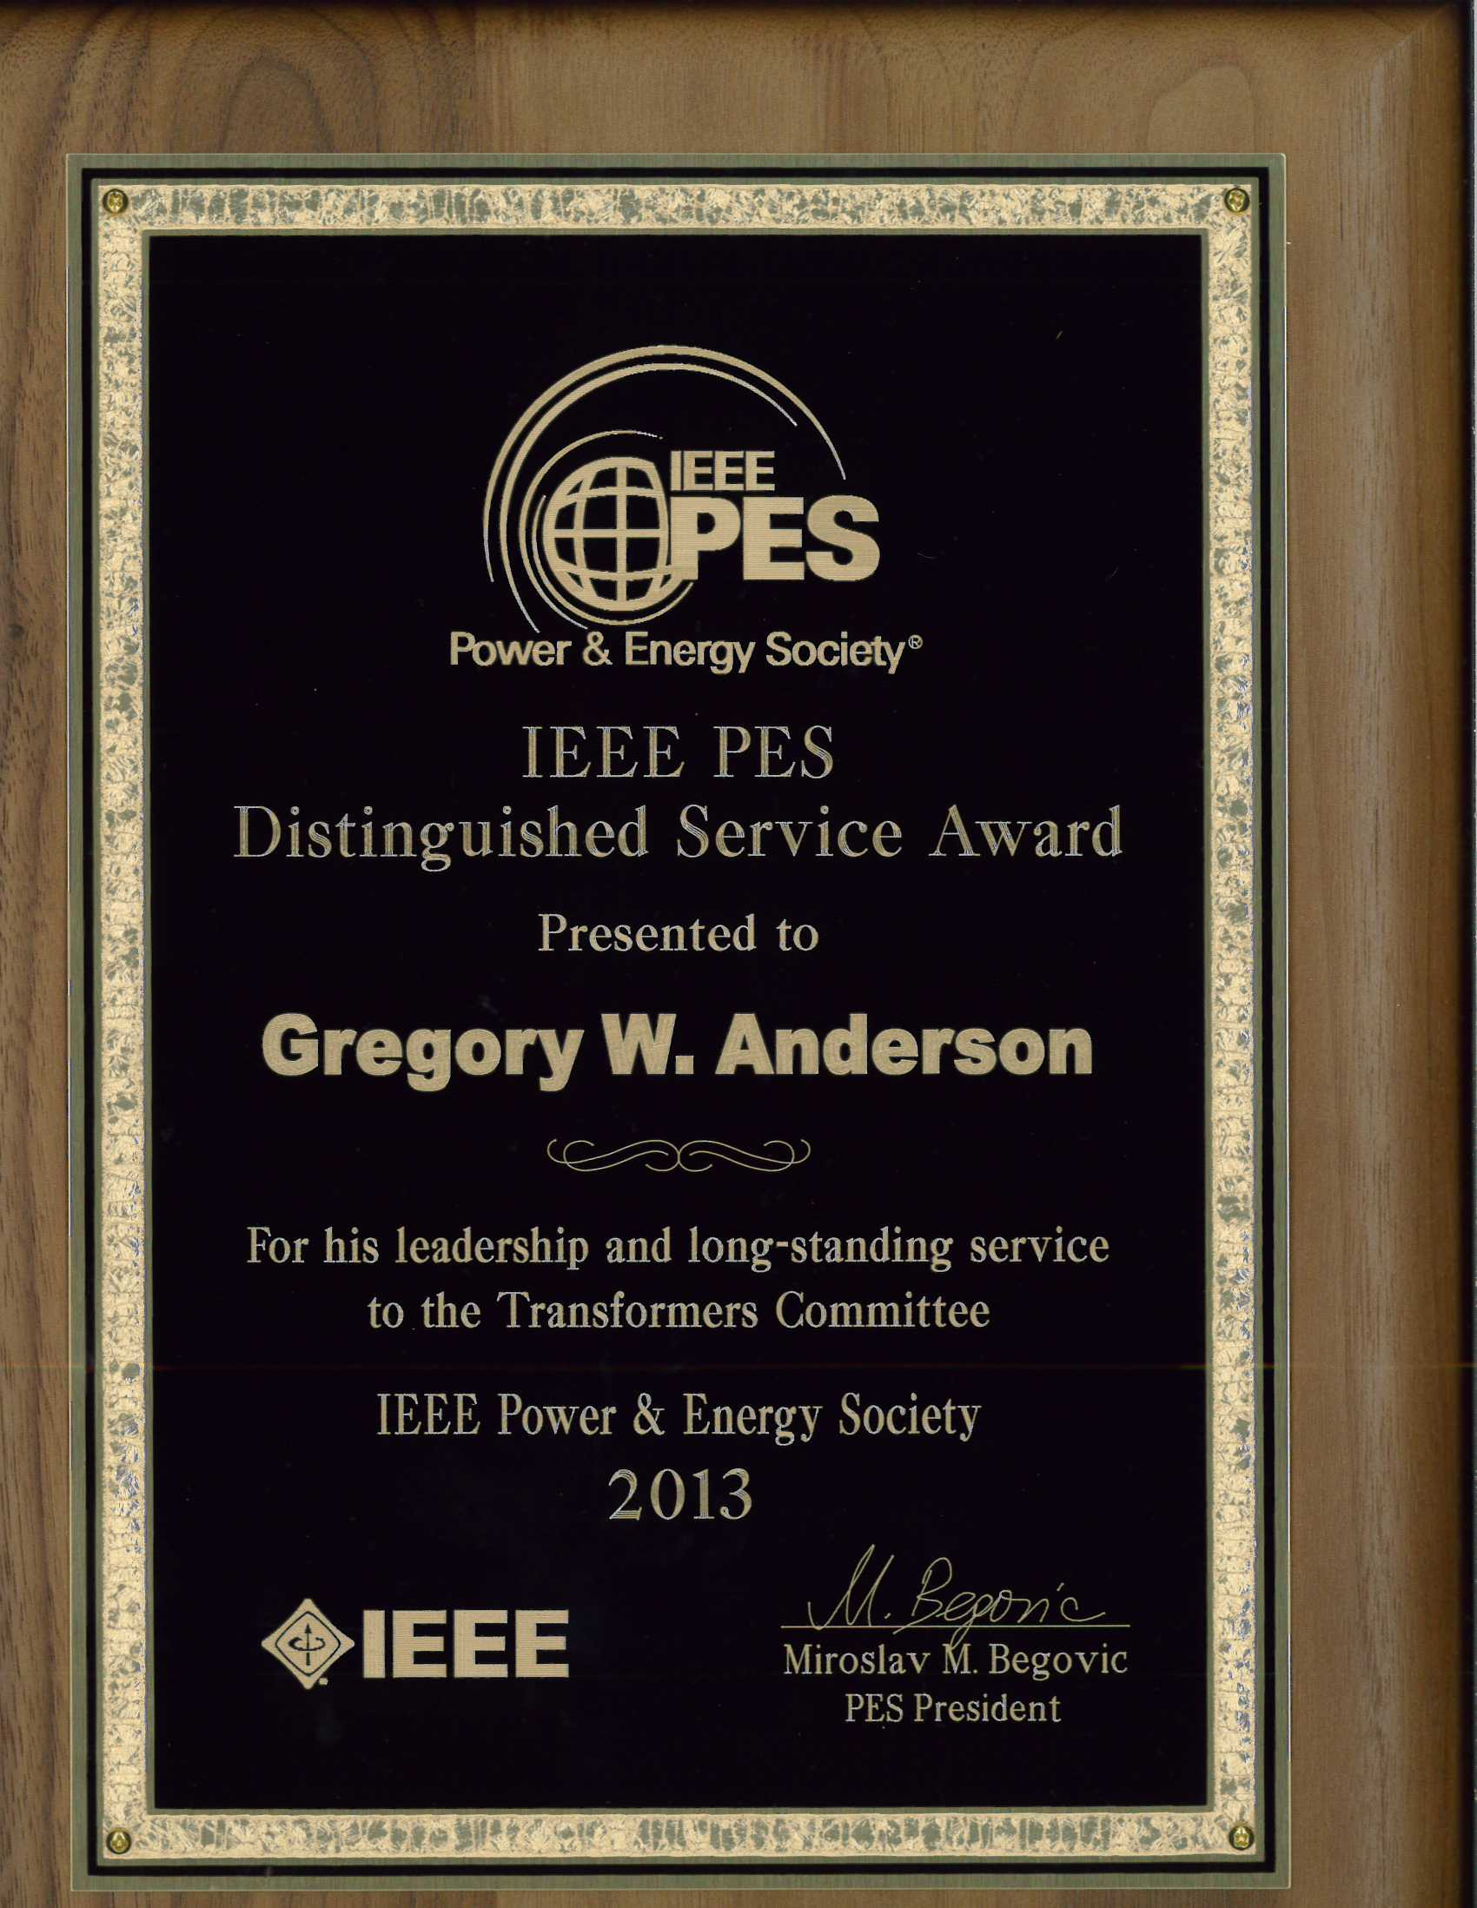
We will continue to present our PES Technical Committee Distinguished Service Award each year to one of our members who is recognized by his peers as having contributed significantly and consistently to Committee Standards activities. This personal recognition acknowledges the efforts of those individuals whose sustained performance, over many years, has contributed to the advancement of the committee technology. Please see the Awards Chair if you have suggestions for future recipients. We are always seeking nominations for this award.

Transformers Committee Meritorious Service Awards
There is also a process of additional recognition for Meritorious Service and Outstanding Contributions to the Committee. Suggested qualifications have been developed from a review of similar awards presented by other IEEE Technical Committees or Societies. General examples for qualification for the awards include the following:
- To recognize continuing exemplary service in notable technical contributions to multiple Committee projects/documents over a sustained period of time.
- To recognize an achievement of major value and significance to the Committee. The achievement can be a specific, concisely characterized accomplishment, as opposed to a collection of different efforts.
- As with the IEEE Education Society Meritorious Service Award – “to recognize pioneering contributions to the administrative efforts of the Society over a period of years, as evidenced by dedication, effort, and contributions.”

If you have any additional thoughts on qualifications for Meritorious Service Awards, and if you have potential nominees to suggest, please contact me. Award nominees will be reviewed by the Awards Chair and the SC Officers.

IEEE Standards Association (SA) Awards and Recognition
The IEEE SA sponsors additional awards besides the WG Chair Awards reviewed above. Discussion of these awards can be found on the IEEE SA Awards web pages (http://standards.ieee.org/sa/aw/). Note particularly the IEEE SA Standards Medallion. Excerpting from the website: “The Standards Medallion is awarded for major contributions to the development of standards. Examples of such contributions may include leadership in standardization of new technologies, assuring achievement of standards development goals, identifying opportunities to better serve the needs of standards users or other such contributions viewed as deserving of this award…” Please review, and if you have suggestions for nominations see our Committee Awards Chair.

Other IEEE PES Awards
The IEEE PES recognizes important technical, educational and service contributions through the conferral of numerous awards. The listing below highlights the various other awards that are available through the IEEE PES organization.
- IEEE PES Award for Excellence in Power Distribution Engineering
- IEEE PES IAS A.P. Seethapathy Rural Electrification Excellence Award
Nominations due by February 1st
- IEEE PES Charles Concordia Power Systems Engineering Award
Nominations due by January 31st
- IEEE PES Cyril Veinott Electromechanical Energy Conversion Award
Nominations due by February 1st
- IEEE PES Douglas M. Staszesky Distribution Automation Award
Nominations due by January 1st
- IEEE PES Lifetime Achievement Award
Nominations due by February 1st
- IEEE PES Leadership in Power Award
Nominations due by February 1st
- IEEE PES Meritorious Service Award
- IEEE PES Nari Hingorani Custom Power Award
Nominations due by January 31st
- IEEE PES Nari Hingorani FACTS Award
Nominations due by January 31st
- IEEE PES Outstanding Chapter Award
- IEEE PES Outstanding Power Engineering Educator Award
Nominations due by January 31st
- IEEE PES Outstanding Young Engineer Award
Nominations due by Februrary 1st
- IEEE PES Prabha S. Kundur Power System Dynamics and Control Award
Nominations due by January 31st - Call for Nominations
- IEEE PES Prize Paper Award
- IEEE Power & Energy Society Ramakumar Family Renewable Energy Excellence Award
- IEEE PES Robert P. Noberini Distinguished Contributions to Engineeering Professionalism Award Nominations due by February 1st
- IEEE PES G. Ray Ekenstam Memorial Scholarship
Nominations due by June 30th
- IEEE PES Scholarship Plus Initiative
Applications due by June 30th
- IEEE PES Roy Billinton Power System Reliability Award
Nominations due by February 1st
- IEEE PES Student Prize Paper Award in Honor of T. Burke Hayes
Nominations due by December 15th
- IEEE PES Uno Lamm High Voltage Direct Current Award
Nominations due by November 30th
- IEEE PES Wanda Reder Pioneer in Power Award
Nominations due by January 15th
- IEEE PES Working Group Recognition Awards
The PES Working Group Recognition Awards recognize “the most outstanding and timely publications” by a PES Working Group (or Committee or Subcommittee) from among the nominations. The PES Recognition Award is divided into two categories: 1) for technical reports; 2) standards and guides. Each Technical Council Committee may nominate one report from each category, published by IEEE, during the previous three year period.” This award consists of a plaque which will be presented to the Working Group Chair at the PES Summer Meeting Awards Luncheon. A framed certificate will be presented to each Working Group member at a designated meeting of the parent Technical Committee.
- IEEE PES CSEE Yu-Hsiu Ku Electrical Engineering Award

Respectfully submitted,

Bill Chiu
Chair, Awards Subcommittee

