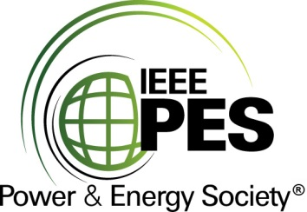

CERTIFICATE OF
EDUCATIONAL ACHIEVEMENT

This certificate is presented to

replace with your name

for attendance at the educational presentation:

"Condition Assessment of Power Transformers and Assessment Indices Cigré WG A2.49"

sponsored by the IEEE/PES Transformers Committee

and has earned one (1) Professional Development Hours (PDH) unit.
Fall 2018 Committee Meeting; Thursday, October 18, 2018

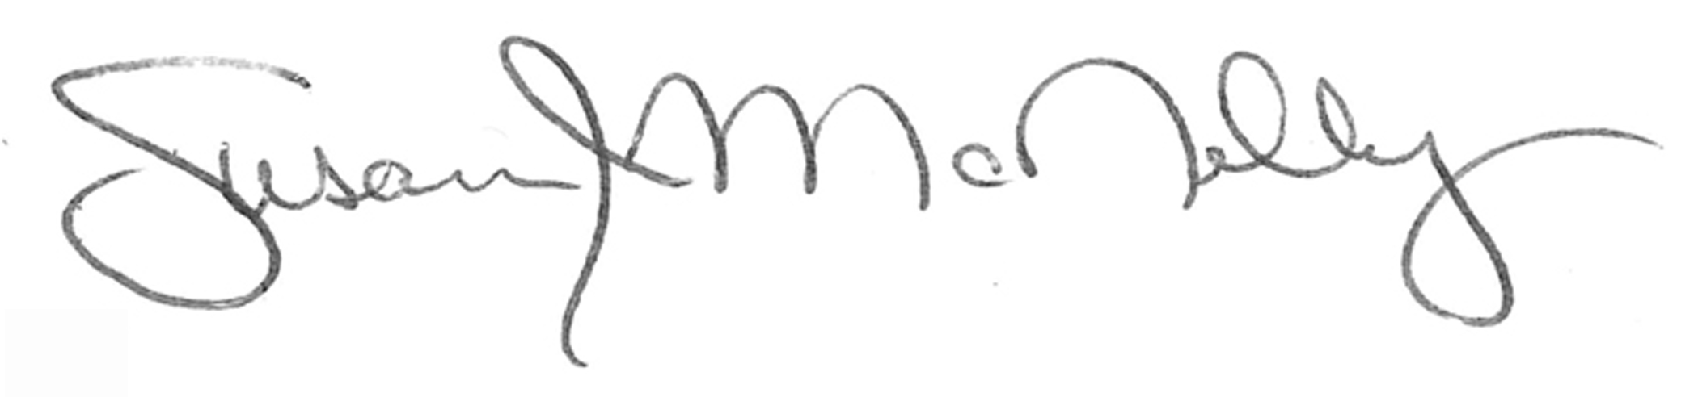

_________________________________ ___________________________________________________
Susan McNelly Instructors: Thomas Prevost, Brian Sparling, Ed teNyenhuis and
Committee Chair Joe Watson

