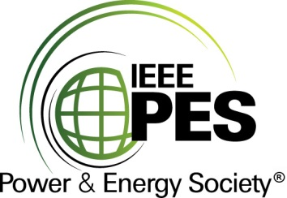

CERTIFICATE OF
EDUCATIONAL ACHIEVEMENT

This certificate is presented to

replace with your name

for attendance at the educational presentation:

" CIGRE WG D1.29: Partial Discharges in Transformers "

sponsored by the IEEE/PES Transformers Committee

and has earned one (1) Professional Development Hours (PDH) unit.
Fall 2019 Committee Meeting; Thursday, October 31, 2019
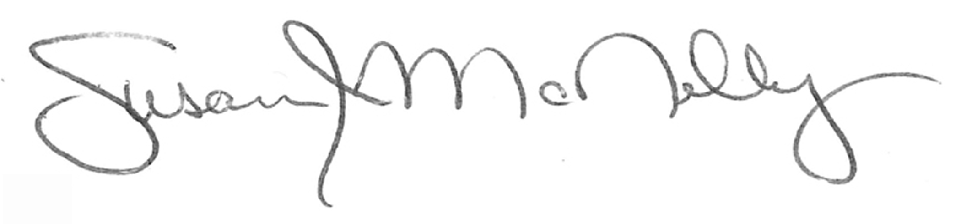

_________________________________ ___________________________________________________
Susan McNelly Instructors: Jitka Fuhr and Janusz Szczechowski
Committee Chair

