1. Administrative Subcommittee – Bill Chiu

Introductions

The attendees were asked to introduce themselves. The chair asked each attendee to state his/her affiliation. If the attendee is a consultant, the attendee must state if he is representing a company other than his own consulting interest. Introductions were made by members and guests.

Attendance

Members present: Members absent:

Gregory Anderson Peter Zhao

Stephen Antosz Charles Johnson

William Bartley Edward Smith

Ed teNyenhuis Carl Niemann

Bill Chiu

Ross McTaggart Guests present:

Susan McNelly Erin Spiewak

Donald Platts Casey Ballard for Chuck Johnson

Michael Sharp J.D. Brafa for Peter Zhao

Stephen Shull Tom Prevost

Bruce Forsyth

Michael Franchek

Joe Watson

* 1. Approval of Previous Meeting Minutes

The Chair asked for comments from the Milwaukee Administrative Subcommittee meeting minutes. Hearing no comments or requests to change the draft minutes, the Chair asked for a motion to approve. Vote Approved.

* 1. Approval of Agenda

The Chair reviewed the draft agenda with the attendees. There were no comments and the Chair declared the agenda approved.

Meeting Call to Order 10:00am

1. Introduction of Members and Guests (:05) All
2. Approval of Fall 2012 Minutes – Milwaukee (:03) B. Chiu
3. Additions to and/or Approval of the Agenda (:02) B. Chiu
4. Chair’s Report (:05) B. Chiu
5. Vice Chair’s Report (:05) D. Platts
6. Secretary’s Report (:10) S. Antosz
7. Treasurer’s Report (:05) G. Anderson
8. Awards Report (:10) E. Smith/B. Chiu
9. Meeting Planning (:10) G. Anderson
   1. Milwaukee Meeting Arrangements & Host Update
   2. Future Meetings
10. Standards Report (:20) B. Bartley
    1. Strategy for Upcoming Revisions B. Bartley/D. Platts
11. IEEE Staff Update (:05) E. Spiewak

BREAK (:10)

1. Old Business
   1. WG Data – Confidentiality, Storage, Access, & Use (:10) S. McNelly/E. Spiewak
   2. GMD/GIC Position Paper (:05) B. Chiu
   3. Committee O&P Revision, & New Member Category (:05) B. Chiu/S. Antosz
2. New Business
   1. Meeting Improvement Initiative (:05) D. Platts/B. Bartley
3. Subcommittee Reports - Roundtable
   1. Bushings (:05) J.D. Brafa for P. Zhao
   2. Dielectric Test (:05) M. Franchek
   3. Distribution Transformers (:05) S. Shull
   4. Dry Type Transformers (:05) C. Ballard for C. Johnson
   5. HVDC (:05) M. Sharp
   6. Instrument Transformers (:05) R. McTaggart
   7. Insulating Fluids (:05) S. McNelly
   8. Insulation Life (:05) B. Forsyth
   9. Performance Characteristics (:05) E. teNyenhuis
   10. Power Transformers (:05) J. Watson
   11. Underground Transformers & Network Protector (:05) C. Niemann
4. Adjourn
   1. **Chair’s Report – Bill Chiu**
      1. **IEEE Power & Energy Society Technical Council Activities**

The Technical Council of the IEEE Power Energy Society (PES) is presently composed of the Chairpersons of the PES Technical Committees, plus the Chairpersons of Standing Committees reporting to it. The Power Energy Society is Division VII of The Institute of Electrical and Electronics Engineers (IEEE). For operating functions it is responsible to the IEEE Technical Advisory Board and for technical activities to the IEEE Technical Activities Board.

The PES Technical Committees report to the Technical Council on matters concerning membership, technical publications, recognition, scope and the coordination of Power Energy Society generated standards. For standards relating to their technical scope, the Technical Committees work directly with the IEEE Standards Board and the Power Energy Society Standards Coordinating Committee.

Please see <http://www.ieee-pes.org/technical-activities/technical-council> for further details on the Statement of Purpose and Scope of Activities for the PES Technical Council.

* + 1. **Technical Council Officers & Membership**

Beginning with the 2013 calendar year, the Technical Council of the IEEE Power Energy Society (PES) has a new leadership team in place. The new officers and members of the Technical Council are listed below for your reference. Where available, the affiliation of the members is also shown in parentheses.

**TECHNICAL COUNCIL OFFICERS**

Jeffrey H. Nelson, *Chair (TVA)*S. S. (Mani) Venkata, *Vice Chair (Alstom)*

Ken Edwards, *Secretary (BPA)*Damir Novosel, *Past* *Chair (Quanta Technology)*

**STANDING COMMITTEES**

Awards Committee - John Randolph, *Chair (PG&E)*

Meetings & Marketing Committee - Mani Venkata, *Chair (Alstom)*

Organization & Procedures Committee - Ken Edwards, *Chair (BPA)*

Standards Coordination Committee - Bill Bartley, *Chair (HSB)*

Technical Sessions Committee **-** Mani Venkata, *Chair (Alstom)*

**COORDINATING COMMITTEES**

Emerging Technologies Coordinating Committee - Branislav Djokic, *Chair*

Intelligent Grid Coordinating Committee - Erich W. Gunther, *Chair*

Marine Systems Coordinating Committee - Paul Bishop, *Chair (consultant)*

Wind and Solar Power Coordinating Committee - Richard J. Piwko, *Chair*

**TECHNICAL COMMITTEES**

Electric Machinery Committee - Mike Sedlak, *Chair (Edison Mission Energy)*

Energy Development and Power Generation Committee - Om Malik, *Chair*

Insulated Conductors Committee - John Smith, *Chair (General Cables)*

Nuclear Power Engineering Committee - S. K (Satish) Aggarwal, *Chair*

Power System Analysis, Computing, and Economics Committee - Sandoval Carneiro, Jr., *Chair*

Power System Communications Committee - Dan Nordell, *Chair*

Power System Dynamic Performance Committee - Nikos Hatziargyriou, *Chair*

Power System Instrumentation and Measurements Committee - R. Arseneau, *Chair*

Power System Operations Committee - William (Bill) Cassel, *Chair (consultant)*

Power System Planning and Implementation Committee - M. L. Chan, *Chair (consultant)*

Power System Relaying Committee – Roger Hedding, *Chair (ABB)*

Stationary Battery Committee - William (Bill) Cantor, *Chair*

Substations Committee – Mike Dodd, *Chair (Sweitzer)*

Surge Protective Devices Committee - Ron Hotchkiss, *Chair*

Switchgear Committee – Ted Olsen, *Chair (Siemens)*

Transformers Committee - Bill Chiu, *Chair (SCE)*

Transmission and Distribution Committee - W. A. Chisholm, *Chair*

* + 1. **Highlights of PES Technical Council November 2012 Retreat**

The Technical Council held a retreat in November of 2012 to address some of the longer term strategic issues facing the PES organization. Members of the Technical Council were surveyed on a variety of issues and opportunities that are available to us. The survey and the response summary is included below for your reference. The Chair would like to thank the members of our own Administrative Subcommittee for providing input to the survey.

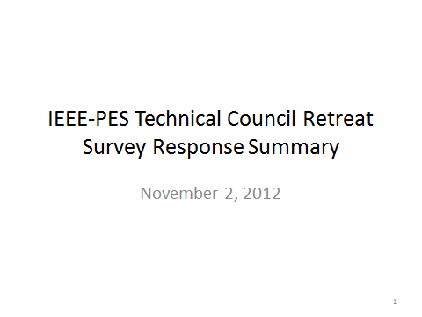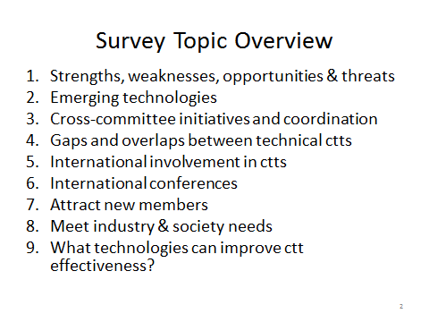

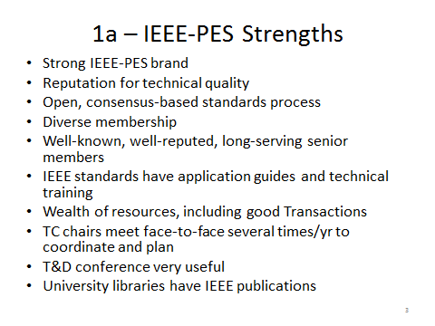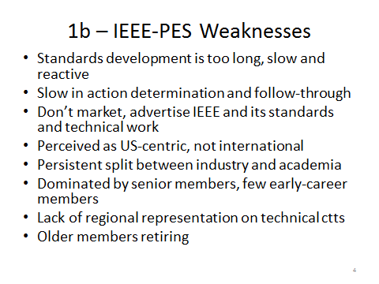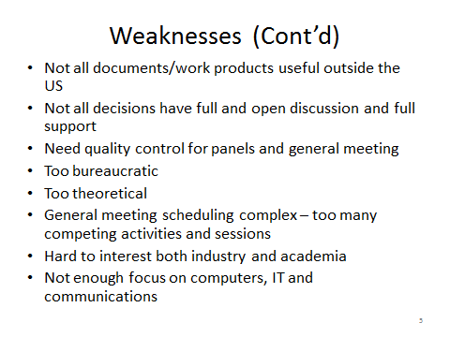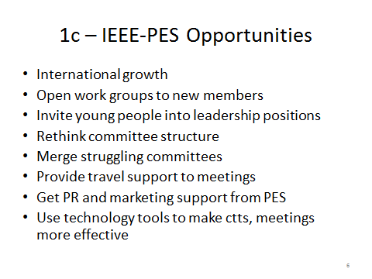

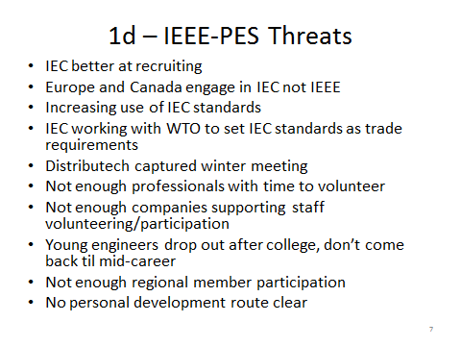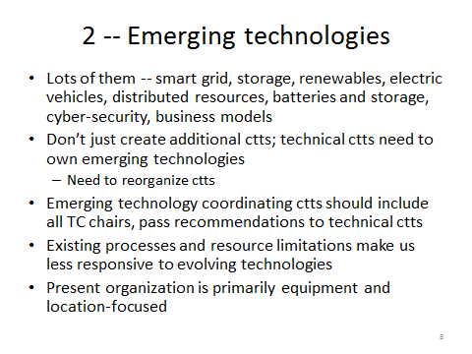

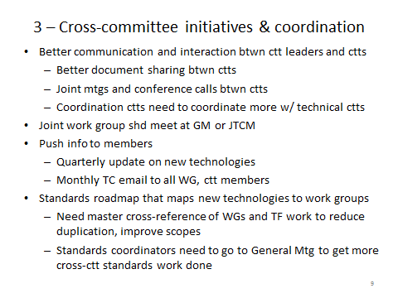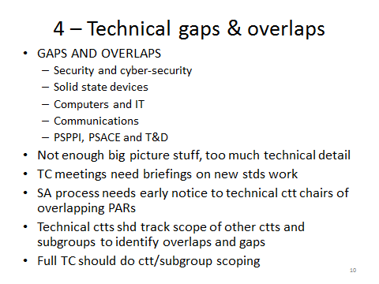

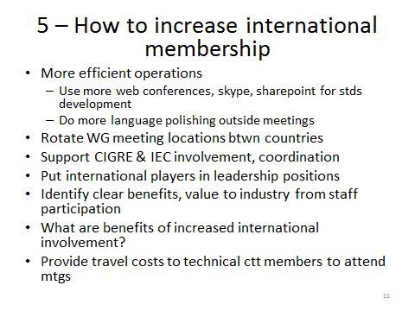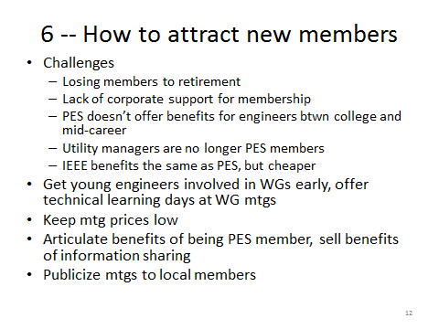

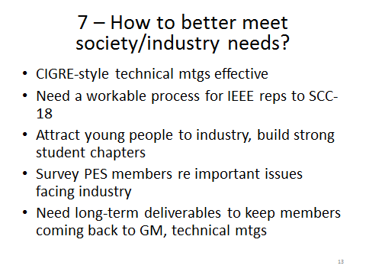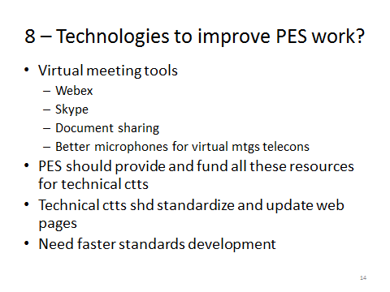

The variety of issues identified in the survey feedback were used as the starting point of the discussion at the retreat. After a day of dialogue, a shorten list of items were identified and prioritized through an informal voting process with the results shown below:

1. Tools to Enhance Technical Committee And Leaders’ Effectiveness (16 Votes)
2. Committee Structure And Coordination (15 Votes)
3. Improving International Involvement & Presence (11 Votes)
4. PES Leader Training (11 Votes)
5. PES Member Training (11 Votes)
6. Information Transmittal To Technical Committee Leaders (10 Votes)
7. Strengthening PES Technical Committee Awareness And Participation
   1. 7a) PES Technical Committee Membership And Recruiting (9 Votes)
   2. 7b) Articulate Benefits To Professionals Of PES Participation
   3. 7c) Improve Branding Of PES Technical Committees As Expert Technical Bodies (8 Votes)
8. Publications And Access Issues (8 Votes)
9. Identifying Best Practices For Standards Development (7 Votes)
10. PES Presentation To The World (6 Votes)
11. IEEE, IEC, CIGRE and PES (6 Votes)
12. Other Topics The Group Didn’t Address In Detail

The summary report from the Technical Council retreat is also included below for you reference

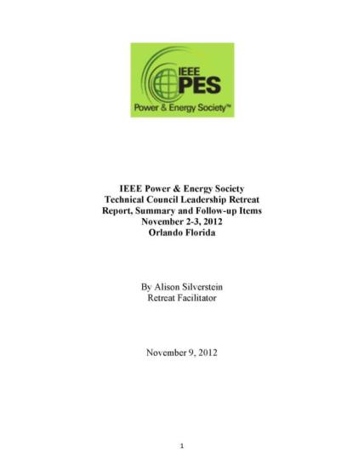

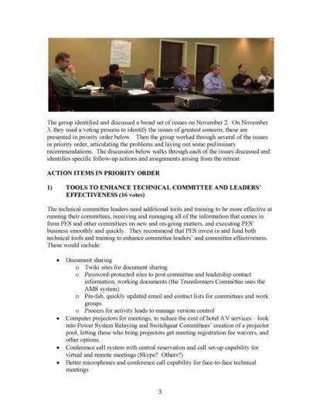

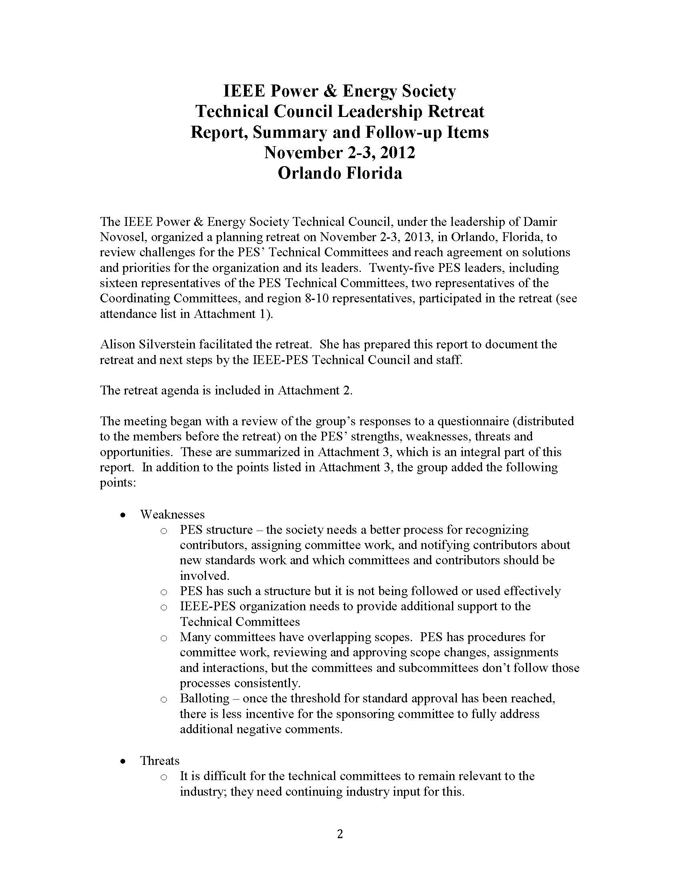

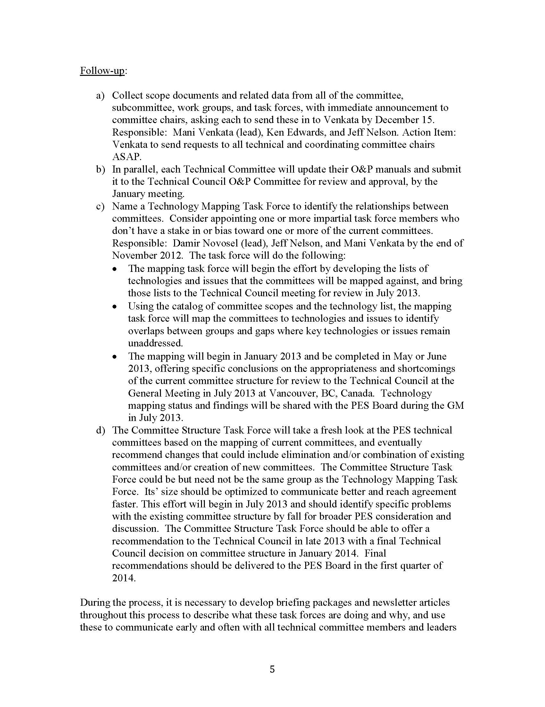

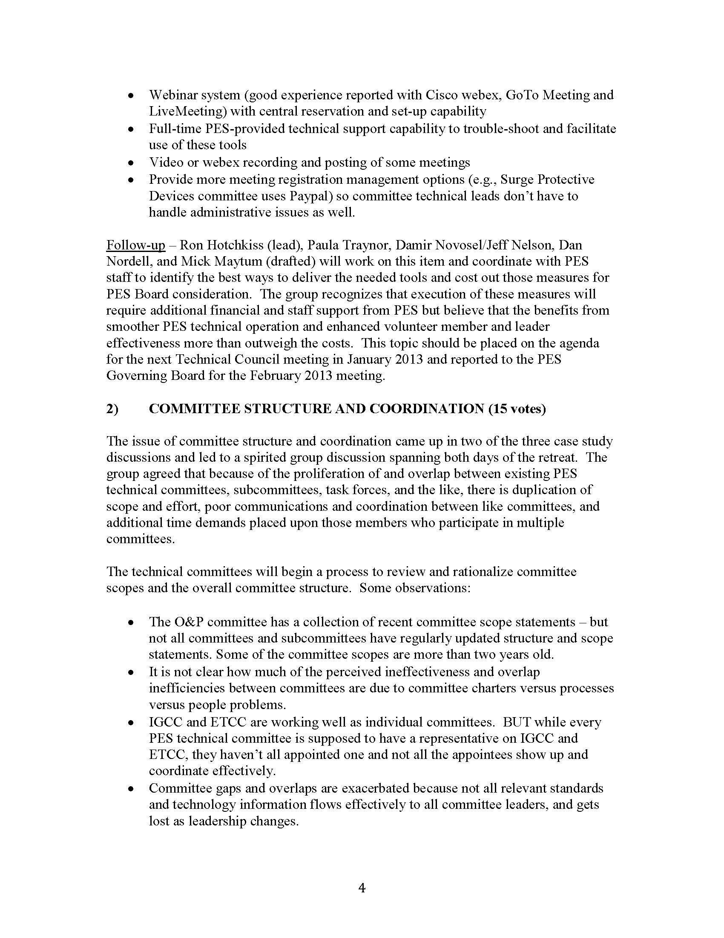

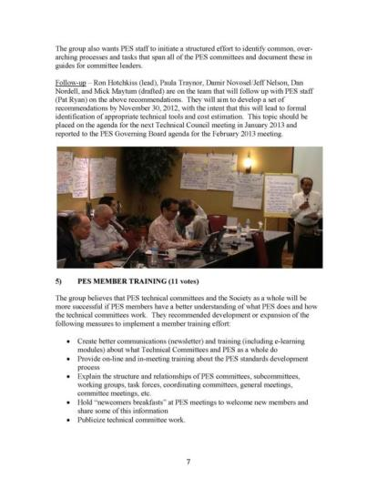

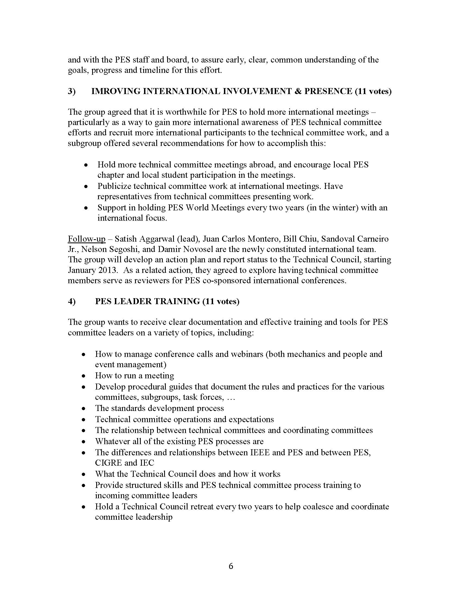

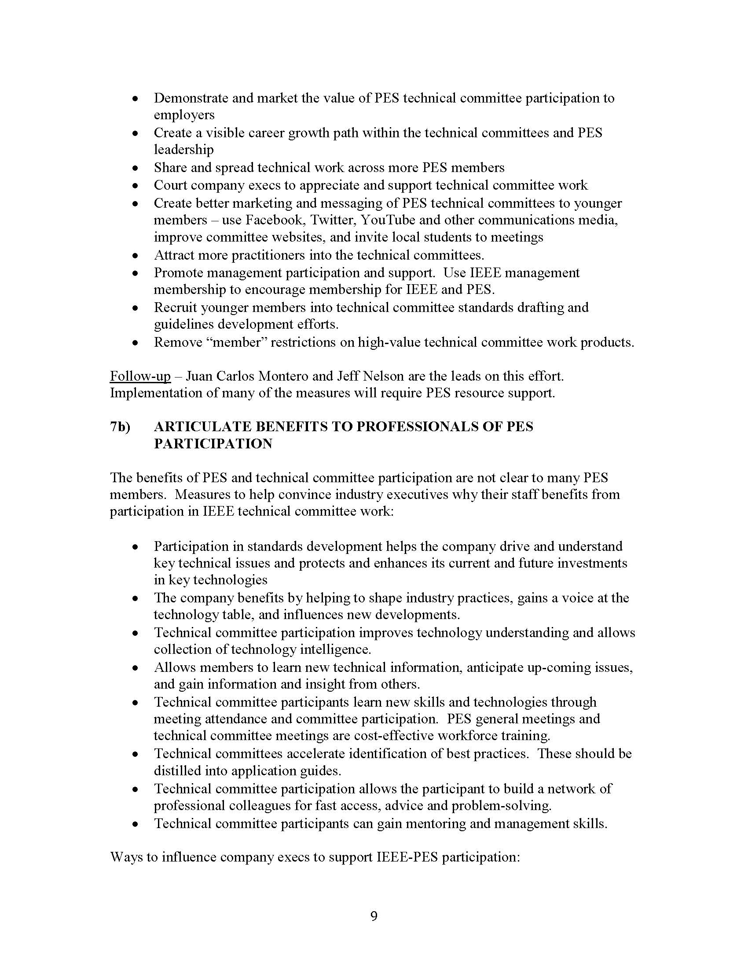

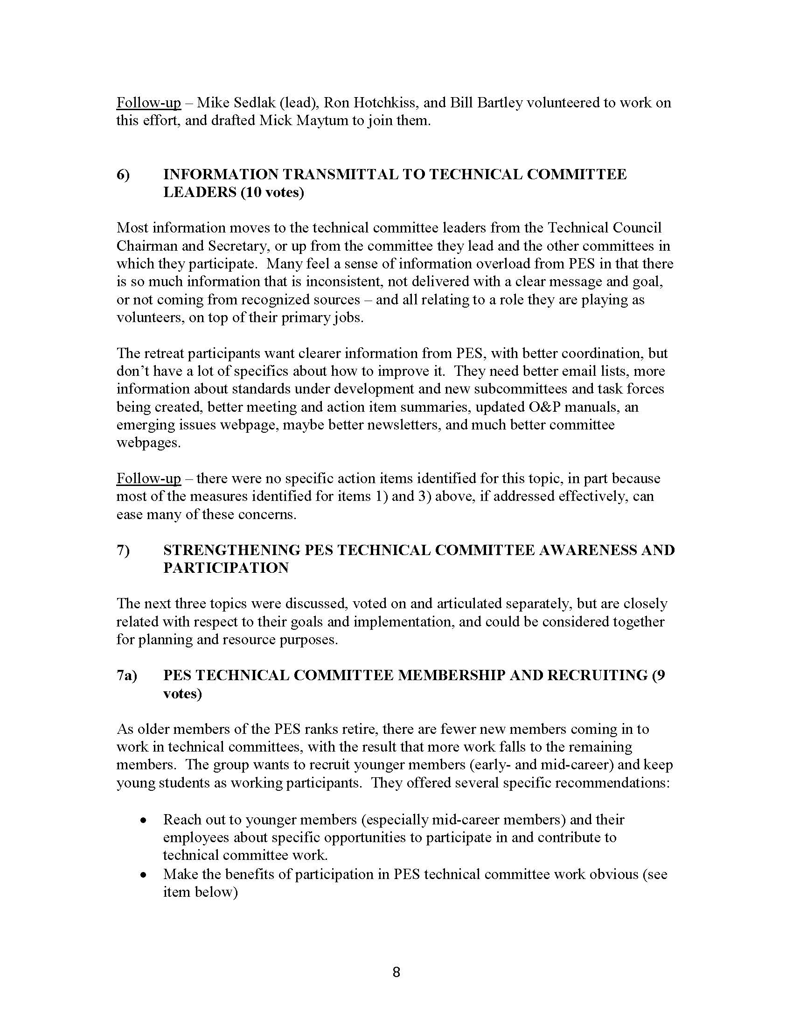

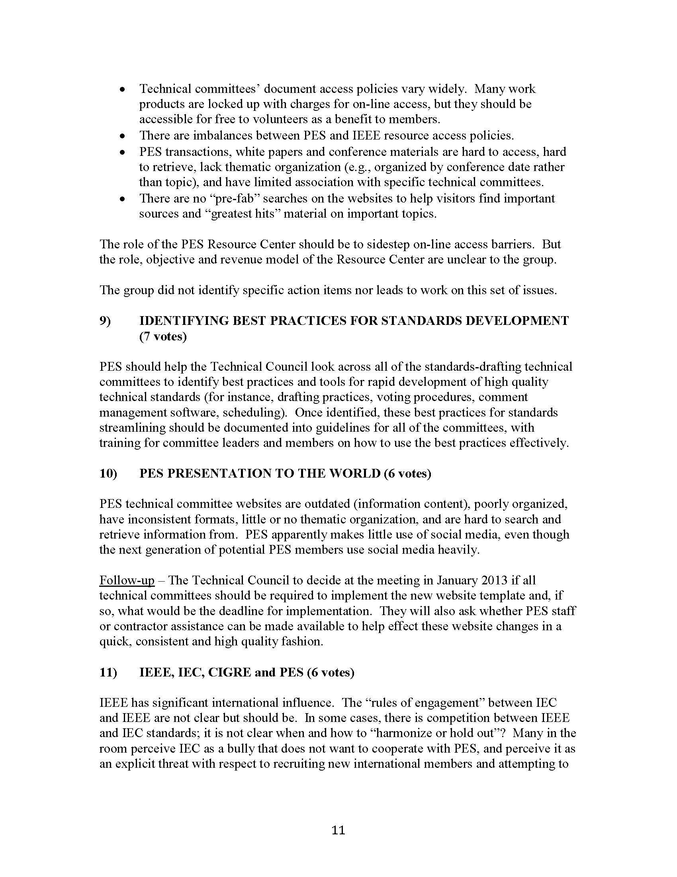

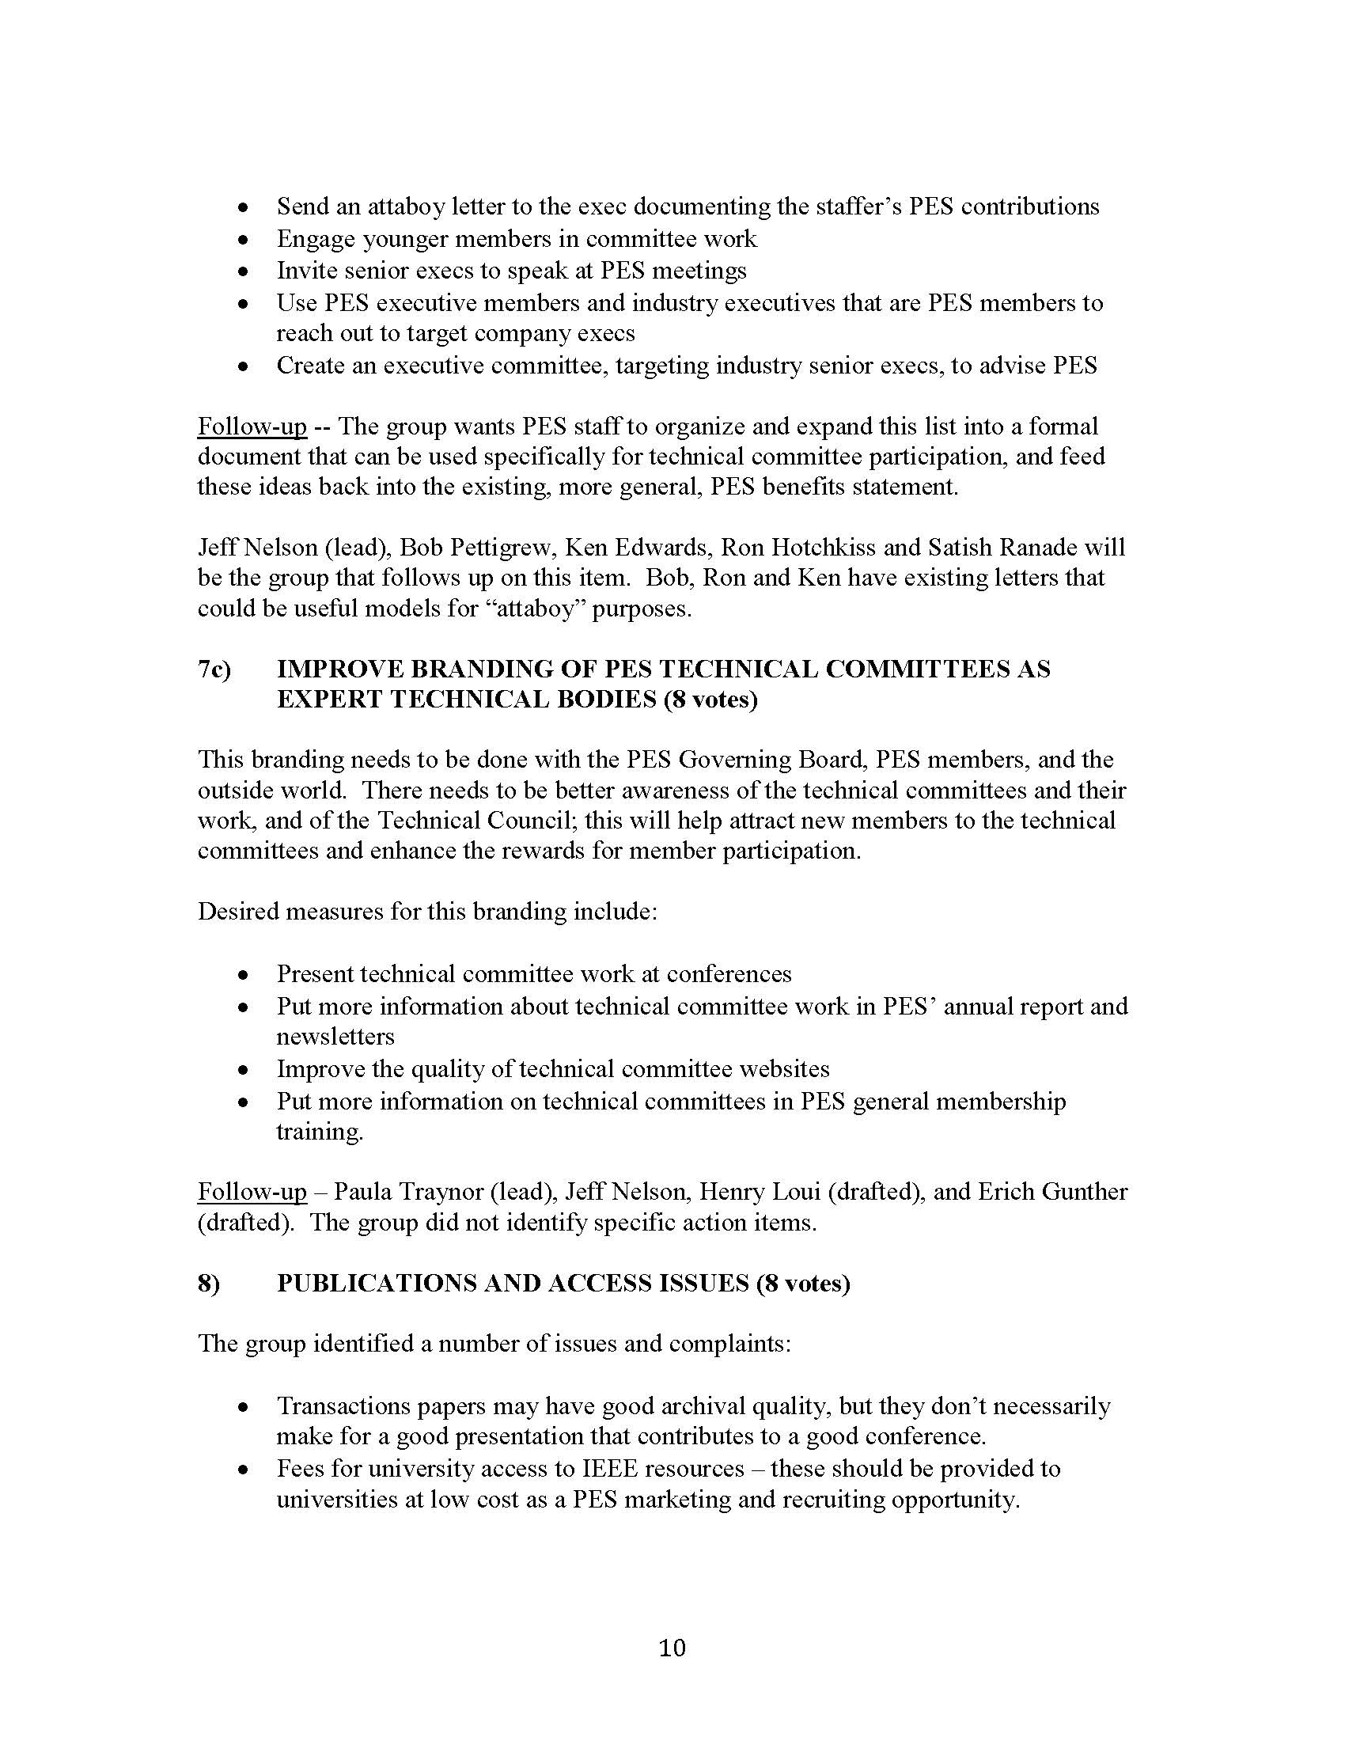

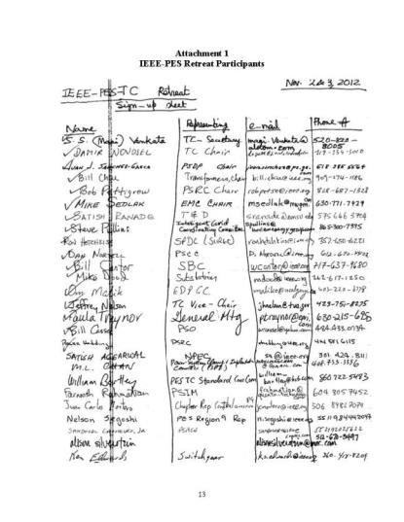

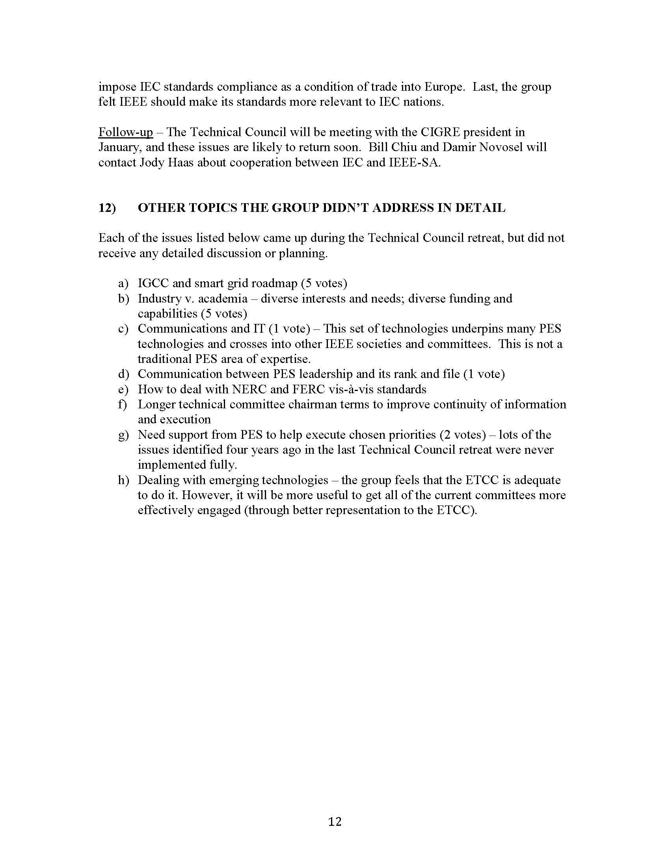

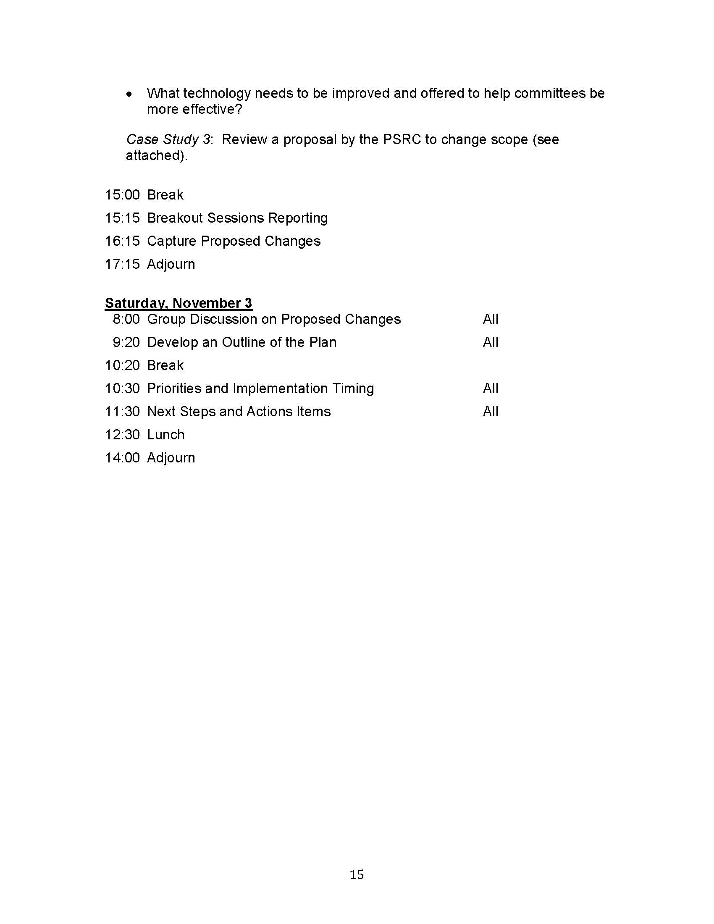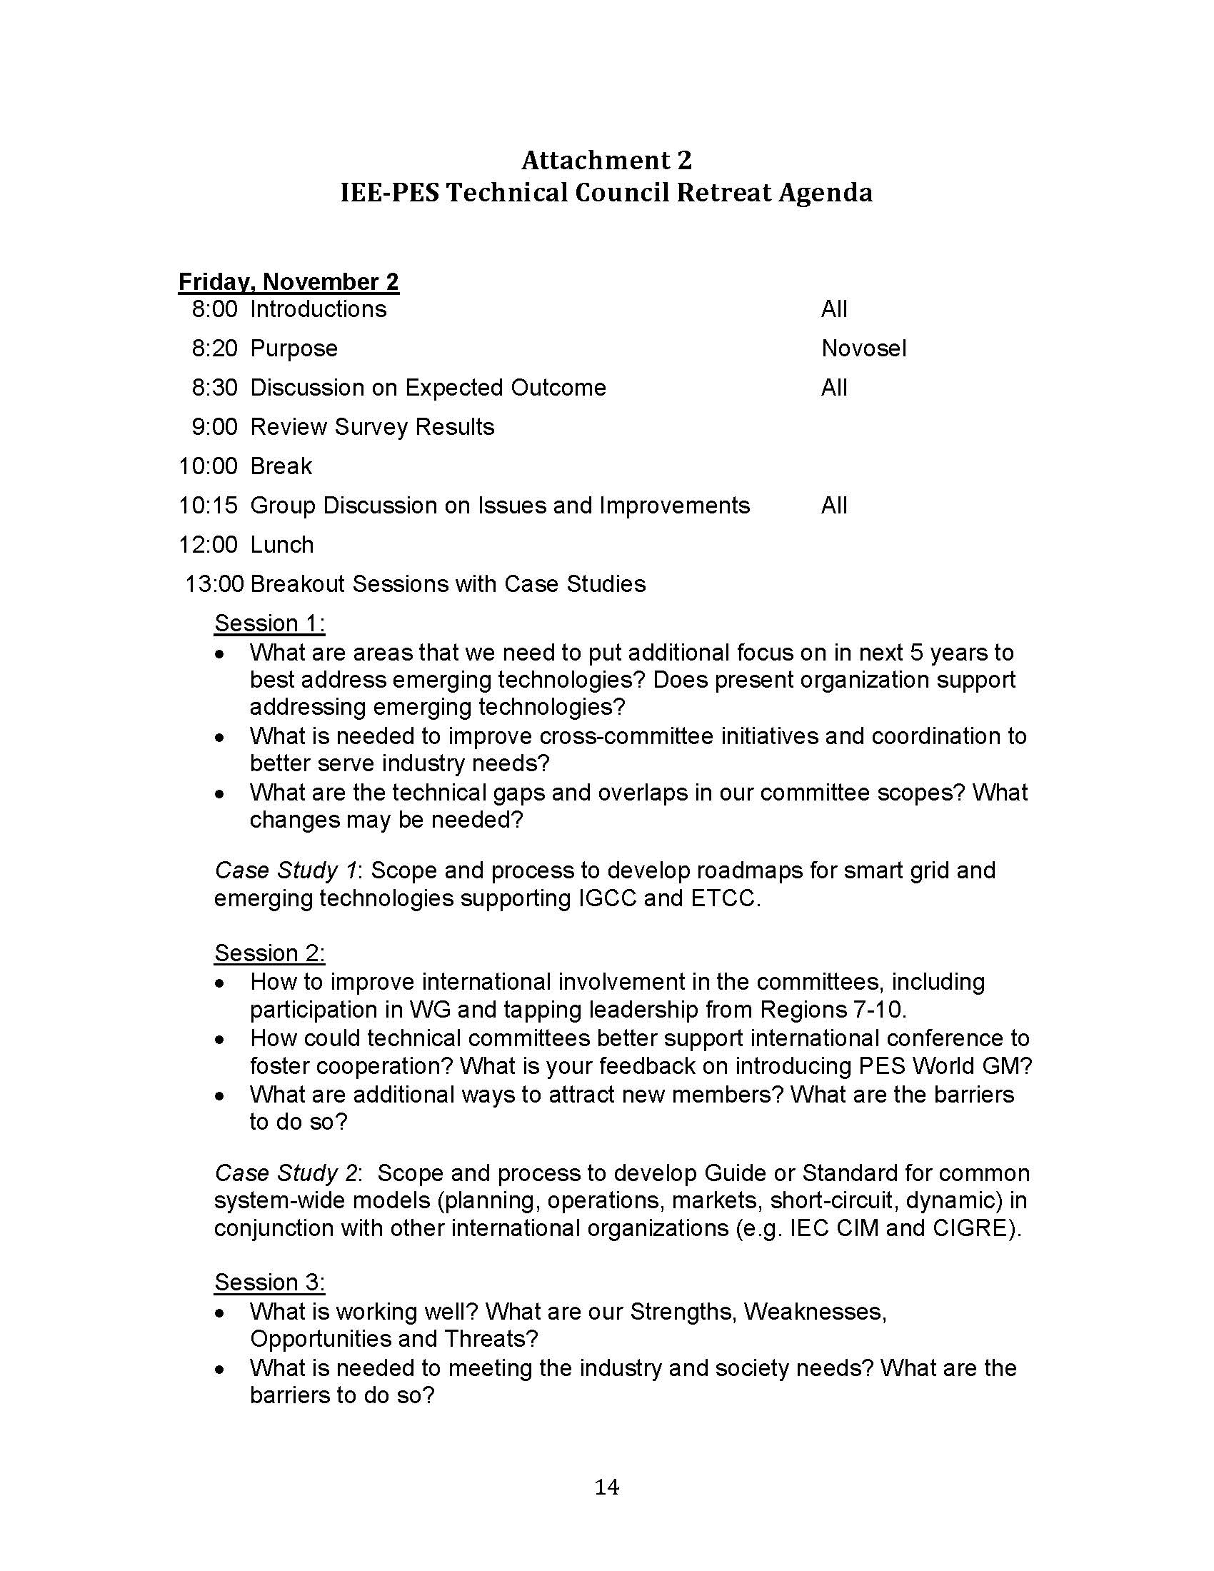

**3.3.4 Update on Geomagnetic Disturbance (GMD) Taskforce**

The Technical Council Taskforce on GMD is continuing to make progress on the development of the position paper since last year. At this point the taskforce is working on the third draft of the position paper. There is plan underway to seek publication of either the entire paper or a condensed version of the paper in the PES Power & Energy Magazine later this year to coincide with the GDM Super Session planned at the PES General Meeting in July, 2013 at Vancouver Canada. It is anticipated that the position paper will be completed in April of 2013. This is a little behind the original schedule set back at the end of last year, primarily due to the additional scope of further analysis on transformers hot spots based on a recorded GIC profile of the GMD event that occurred during the March 13-14, 1989 solar storm.

* + 1. **Transformers Committee Activities**
       1. **Subcommittee Chairpersons & Technical Editor**

I would like to extend a warm welcome to our newest member – Michael Franchek. Mike was appointed his new role earlier this year as our incoming Dielectric Tests Subcommittee Chair, replacing Loren Wagenaar who resigned at the end of last year. We will miss Loren as part of the leadership group and would like to thank Loren for his long tenure of dedicated service to the Transformer Committee and to our industry. We wish Loren all the best in the future. Our current roster of the Subcommittee Chairs and Editor are:

* Bushings Subcommittee **Peter Zhao**
* Dielectric Test Subcommittee **Michael Franchek**
* Distribution Transformers Subcommittee **Stephen Shull**
* Dry-Type Transformers Subcommittee **Charles Johnson**
* HVDC Converter Transformers & Smoothing Reactors Subcommittee **Michael Sharp**
* Instrument Transformers **Ross McTaggart**
* Insulating Fluids Subcommittee **Susan McNelly**
* Insulation Life Subcommittee **Bruce Forsyth**
* Meetings Subcommittee **Gregory Anderson**
* Performance Characteristics Subcommittee **Ed teNyenhuis**
* Power Transformers Subcommittee **Joe Watson**
* Standards Subcommittee **William Bartley**
* Underground Transformers & Network Protectors Subcommittee **Carl Niemann**
* Technical Editor **Sanjib Som**

All of them have committed to serve the duration of the calendar year 2013. PES Technical Council was notified of the Subcommittee Chairs and Technical Editor appointments for the calendar year 2013 in accordance with the guideline set forth in our O&P Manual.

* + 1. **IEEE Senior Membership**

IEEE membership has several categories, with the senior level being the highest grade which a member can apply. IEEE has developed a streamlined process for members to request elevation of their membership status. The process is simply and can be done entirely on-line. The Chair strongly encourages everyone that have been an active contributor to the industry for at least five years to apply for this elevation in membership status. The basic qualifications are:

* be engineers, scientists, educators, technical executives, or originators in IEEE-designated fields;
* have experience reflecting professional maturity;
* have been in professional practice for at least ten years;
* show significant performance over a period of at least five of their years in professional practice.

Benefits of becoming a senior member include:

* **Recognition**: The professional recognition of your peers for technical & professional excellence.
* **Senior member plaque**:  Since January 1999, all newly elevated Senior members have received an engraved Senior Member plaque to be proudly displayed for colleagues, clients and employers to see. The plaque, an attractive fine wood with bronze engraving, is sent within six to eight weeks after elevation.
* **US$25 coupon**:  IEEE will recognize all newly elevated Senior members with a coupon worth up to US$25.  This coupon can be used to join one new IEEE society. The coupon expires on 31 December of the year in which it is received.
* **Letter of commendation**: A letter of commendation will be sent to your employer on the achievement of Senior member grade (upon the request of the newly elected Senior member).
* **Announcements**: Announcement of elevation can be made in section/society and/or local newsletters, newspapers and notices.
* **Leadership Eligibility**: Senior members are eligible to hold executive IEEE volunteer positions.
* **Ability to refer other candidates**: Senior members can serve as a reference for other applicants for senior membership.
* **Review panel**: Senior members are invited to be on the panel to review senior member applications.
* **US$25 referral coupon**: Newly elevated Senior members are encouraged to find the next innovators of tomorrow and invite them to join IEEE.  Invite them to join and the new IEEE member will receive $25 off their first year of membership.
  + 1. **Committee Membership**

All are welcome to participate in the work of the Transformers Committee. Membership in the Committee provides recognition of your peers and indication to your co-workers and management of your active role in Committee work. If you are presently not a Main Committee Member, and you have been actively participating in our work for at least two full year – and can secure the acknowledgement and sponsorship of at least 3 activity Chairs (WGs, but must include at least one Subcommittee Chair) affirming that participation, the Committee will look forward to welcoming you as a member. Membership requirements and application forms can be found in the Organization and Procedures Manual posted on the Committee website.

As our organization is a 100% volunteer based organization, we are very much in need of all of your continued participation and sharing of your expertise towards our world-class standards development efforts. Many of our long-standing committee members have made tremendous contributions towards our standards development effort over the years and their contributions are greatly appreciated.

* 1. **Vice-Chair’s Report – Don Platts**
     1. **IEEE PES Calendar of Upcoming Events**

The list below shows the upcoming PES sponsored conferences and committee meetings. Please check the PES website at [**www.ieee-pes.org**](http://www.ieee-pes.org) for further details.

[PES 2013 General Meeting](http://pes-gm.org/2013/)  
*21-25 July, 2013, Vancouver, British Columbia, Canada*

[2013 North American Power Symposium (NAPS 2013)](http://www.ieee-pes.org/meetings-and-conferences/conference-calendar/monthly-view/166-technically-cosponsored-by-pes/195)

*Sept 22 - 24, 2013 Location: Manhattan, KS, USA*

2014 IEEE PES Joint Technical Committee Meeting (JTCM 2014)

*Date ? Location: To be determined*

[2014 IEEE/PES Transmission & Distribution Conference & Exposition (T&D)](http://www.ieee-pes.org/meetings-and-conferences/conference-calendar/monthly-view/165-sponsored-by-pes/160)

*Mon, Apr 14, 2014 - Thu, Apr 17, 2014 Chicago IL*

[PES 2014 General Meeting](http://pes-gm.org/2013/)

*Date ? Location: To be determined*

* + 1. **Conference Papers presented**

3.4.2.1 2013 PES General Meeting (Vancouver, Canada July 21-25)

A total of 22 conference papers were submitted. After review, 7 papers were scheduled for presentation at the Poster Session, 2 for the Paper Session and 4 for the Paper Forum. A large number -9 were rejected.

In addition, 4 authors of Transactions papers, that have been previously published, requested the opportunity to present their papers. Per the rules of the PES Tech Council, they will be scheduled, as requested. The presentation will be a joint session with PSIM, who will chair this session. The papers that were accepted for presentation are:



## **Upcoming Conference Papers Schedules**

### 2014 IEEE PES Power Systems Conference & Exposition

Chicago IL --The time line for paper submission is from July 22 to August 19 2013.

The Theme of the conference is *Fifty Years of Engineering Solutions*

### 2014 PES General Meeting

Location Not Yet Published --The deadline for paper submission will probably be in November 2013.

## **Changes to IEEE PES Conference Paper Rules**

This portion of the report is copied from the Falll 2012 meeting report. Changes or updates are shown in *italics.*

The IEEE PES explanation of these changes is published and can be reviewed at <http://pes-gm.org/2013/index.php/call-for-papers>.

### 3.4.4.1 Conference Paper Submission Requirements

The paper length has been reduced to 5 pages. Part 1 and Part 2 papers will not be permitted. The maximum paper length has been reduced to 5 pages. Papers that are divided into Part 1 and Part 2 will not be permitted.

### 3.4.4.2 Conference Paper Presentations

There will be no Transformers Committee Paper Presentation sessions. The majority of accepted conference papers will be scheduled for presentation at the Monday evening poster session. Presentation of an accepted paper at the conference is a requirement of publication. Any paper not presented at the conference will not be included in IEEE Xplore. *The papers judged to be in the top 60-80 of all accepted conference papers will be selected to be presented in a Conference Paper Session. [Each Committee will have an allocation of papers that they may submit].* The participating Author will be allowed 8 minutes to present the paper and will be allowed to use a maximum of 6 PowerPoint slides. A few of the top 60 to 80 conference papers will be chosen and recognized as General Meeting Conference Prize Papers, during the Tuesday Awards dinner.

### 3.4.4.3 *Paper Forum*

### *At the 2013 General Meeting, there will also be a paper forum session. The time allotted for presentation of Transactions papers was not filled, so a decision was made to insert the Paper Forum. Here a limited number of the conference papers accepted for publication will be scheduled for presentation. This will allow the author a 4 minute time slot to describe the paper. At the conclusion of the session, each author must be prepared to appear with a poster of the paper to be displayed at the back of the room. All questions will be addressed during this poster session.*

### 3.4.4.4 Transactions Paper Presentations

The PES Technical Committees will be selecting published Transactions papers for presentation at the 2013 General Meeting. An author of an accepted PES Transactions paper who is interested in presenting it at the 2013 PES General Meeting must upload the full paper, in addition to the paper's abstract, to the on-line submission and review site by the deadlines listed above. The appropriate Technical Committee Program Chair (TCPC) will determine if the topic of the paper is suited for presentation in one of the technical sessions.

### 3.4.4.5 Special Issue Transactions Paper Presentations:

Beginning in 2013, select papers from Special Issue PES Transactions will be presented at the PES General Meeting. The Special Issues have already been identified for 2013, but authors are encouraged to submit papers to future special issues. Information on planned Special Issue PES Transactions can be found at: [**http://www.ieee-pes.org/calls-for-transactions**](http://www.ieee-pes.org/calls-for-transactions)

### 3.4.4.6 Panel Sessions

The Transformers Committee will have the opportunity to sponsor a panel session at future conferences. We have not yet considered this type of presentation at any future conference. Panelists will not be required to write summary papers to participate in panel sessions. Only PowerPoint presentations are required. Invited panelists are free to submit a conference paper on the topic they are asked to present, if they so choose, but it must be submitted to the on-line submission and review site by the conference paper submission deadlines listed above and it will be reviewed for acceptance under the same criteria as all conference paper submissions. Participation as a panelist does not guarantee that your conference paper submission will be accepted and published.

* 1. **Secretary’s Report – Stephen Antosz**

### Membership Review

Voting Committee Members – Six new committee members were approved and added at the Milwaukee meeting as shown in the table below:

| **Name** | **Affiliation** | **Sponsor #1** | **Sponsor #2** | **Sponsor #3** | **Membership Category** |
| --- | --- | --- | --- | --- | --- |
| Jeremy A. Sewell | Quality Switch, Inc | Carl Nieman  UTNP SC  (7yrs) | Phil Hopkinson  WG C57.157 DETC (7yrs) | Brian Klaponski  WG C57.12.40 Network Xfmr(7yrs) | Producer |
| Robert T. Rasor | S.D. Myers, Inc. | Susan McNelly  Insulating Fluids SC (3 yrs) | Richard Ladroga  WG C57.104 DGA (7yrs) | Tom Prevost  TF Furans  (3yrs) | General Interest |
| David Archie Wallace | ABB/Kuhlman Electric | Loren Wagenaar  Dielectirc Test SC (2 yrs) | Ross McTaggert  Instrumnt Trans SC (2 yrs) | Pierre Riffon  WG Rev to Impulse Tests (2 yrs) | Producer |
| Roberto Asano Junior | ABB | Don Platts/Bruce Forsyth  Insulation Life SC (4 yrs) | Peter Zhao  WG C57.156 Tank Rupture (2yrs) | Richard Marek  WG C57.154 High Temp Insul (4yrs) | Producer |
| Brian R. Penny | American Transmission Company | Art Molden PC57.98 Impulse Guide (2 yrs) | Phil Hopkinson  WG C57.157 DETC (2 yrs) | Peter Zhao  Bushings SC  (2 yrs) | User |
| Subhas S. Sarkar | Virginia Transformer Corp | Sheldon Kennedy  WG C57.12.52  (2 yrs) | Tim Holdway  WG C57.12.01  (2 yrs) | Chuck Johnson  Dry Type SC  (>2 yrs) | Producer |

The Transformers Committee AMS database of people currently has three general categories of participation in our activities. These are: **Interested Individual**, **Active Participant**, and **Committee Member**. Anyone can join our AMS 123 system as the system is designed for self-registration. A new participant will automatically be assigned the role of Interested Individual when they first sign up. Based on the level of participation, the committee administrative staff will upgrade the participation status to “Active Participant” when appropriate. The Committee Member status however, can only be attained through a formal application with the sponsorship of minimum of three WG or SC chairmanships. Detail of the application requirements and approval process by the Administrative Subcommittee is outlined in our O&P manual.

The following table contains a count of the participants grouped by the three general categories.

|  |  |  |  |  |  |  |
| --- | --- | --- | --- | --- | --- | --- |
| Membership Status | Oct-10 | Apr-11 | Oct-11 | Mar-12 | Oct-12 | Mar-13 |
| Interested Individual | 843 | 997 | 1061 | 1132 | 1205 | 1277 |
| Interested Individual - IEEE Life Member | 6 | 2 | 4 | 6 | 7 | 8 |
| **Total Interested Individuals** | **845** | **999** | **1065** | **1138** | **1212** | **1285** |
|  |  |  |  |  |  |  |
| Active Participant | 227 | 230 | 218 | 232 | 231 | 173 |
| Active Participant - IEEE Life Member | 7 | 5 | 5 | 6 | 6 | 5 |
| **Total Active Participants** | **234** | **235** | **223** | **238** | **237** | **178** |
|  |  |  |  |  |  |  |
| Committee Member | 211 | 210 | 218 | 182 | 182 | 186 |
| Committee Member - Emeritus Member | 8 | 1 | 8 | 6 | 6 | 6 |
| Committee Member - IEEE Life Member | 26 | 31 | 31 | 29 | 30 | 31 |
| Committee Member - Corresponding | 1 | 1 | 1 | 0 | 0 | 0 |
| **Total Committee Members** | **246** | **243** | **258** | **217** | **218** | **223** |
|  |  |  |  |  |  |  |
| **TOTAL IN AMS DATABASE** | **1391** | **1478** | **1546** | **1593** | **1667** | **1686** |

It is the responsibility of each individual to keep his/her profile updated, (except for the category).

**3.5.2 New Member Applications**

Six new applications for Committee Membership have been received since our previous meeting in Milwaukee. They will be submitted for approval at the Munich meeting on March 17, 2013. Details of the membership applications and sponsors are listed in the following table.

| **Name** | **Affiliation** | **Sponsor #1** | **Sponsor #2** | **Sponsor #3** | **Membership Category** |
| --- | --- | --- | --- | --- | --- |
| James Bruce Fairris | Nashville Electric Service | Wally Binder  WG’s C57.117 & C57.125 (2yrs) | Joe Watson  WG C57.148 Cont Cab (3yrs) | Joe Watson  Power Transformer SC (4yrs) | User |
| J. Arturo Del Rio | Trench Ltd | Thang Hochanh  PD Bushings & IT TF (5yrs) | Bertrand Poulin  Low Frequency Test WG (5yrs) | Peter Zhao  Bushings SC (5yrs) | Producer |
| David E. Buckmaster | Shaw Power | Philip Hopkinson WG C57.157 DETC (3yrs) | Peter Zhao  Bushings SC (5yrs) | Joe Watson  Power Transformer SC (3.5yrs) | User |
| Charles Sweetser | Omicron Electronics Corp USA | Jane Ann Verner WG C57.152 Field Test Guide (3yrs) | Stephen Shull  WG C57.12.70 Terminals (2yrs) | Stephen Antosz  PCS SC for C57.149 FRA(8yrs) | Producer |
| Hali Moleski | S.D. Myers, Inc. | H. Jin Sim IEC/IEEE Cross Reference (3yrs) | Richard Ladroga  WG C57.104 DGA (3yrs) | Susan McNelly  Insulating Fluid SC (3yrs) | General Interest |
| David Brender | Copper Development Assoc, Inc. | David Buckmaster TF/WG Wind Xfmrs (2yrs) | Derek Foster C57.12.91 Dry Type Test Code | Jeewan Puri  Audible Sound SC (5yrs) | General Interest |

The Committee welcomes and encourages active participants to become Members of the Committee. Requirements and application forms can be found in the Organization and Procedures (O&P) Manual, accessible on the Committee website. A copy of the Membership Application is attached as an Annex to this Secretary’s Report. Subcommittee Chairs are encouraged to recommend new members, and to communicate the process of attaining membership through **active participation** and **contribution** at the WG and SC level. WG and SC Chairs are reminded also that signing an application sponsoring a new member signifies their sponsorship that the applicant has met the requirement of membership and active participation for at least one year in the WG or SC they Chair. New member applications may be submitted to the Committee Secretary’s attention at any time. Applications will be collected for review and approval in batches at each Administrative Subcommittee meeting.

* + 1. **Committee, Subcommittees, and Working Group Rosters**

In order to provide indemnification to working group and subcommittee members it is crucial that membership lists be maintained. Our AM system has these functions built-in to ease these administration tasks. It is important that each subcommittee and working group chair keep the rosters updated so that this information can be provided to the IEEE SA.

A similar main committee roster has also been developed to track attendance for the Main Committee General Session meeting on Monday & Thursday. The data will be used to update participant’s membership profile.

* + 1. **IEEE/PES and IEEE/SA Membership Requirements**

As a reminder, all members of the Transformers Committee must also be members in good standing of the Power & Energy Society (IEEE/PES) and the Standards Association (IEEE/SA). There are a number of Transformers Committee members who have lapsed and must renew their SA and/or PES affiliation. These memberships are renewed annually along with your IEEE Membership renewal, which typically occurs at the end of each year.

Reminder that WG Chairs must also be a member of the SC, IEEE, PES, and SA.

There are a number of Transformers Committee Members who are not PES or SA members. They will be given a reminder to renew these required memberships. If they do not comply then they will be dropped as Members. It is not fair to the other Members who adhere to this rule and pay the annual fees. Moreover, a person CANNOT participate in any ballot activity if they are not an SA member, and this is one of the basic responsibilities of an active member.

* + 1. **Committee Membership Maintenance & New Category – “Past Member”**

The committee roster has been reviewed and there are many members that are not attending, not actively participating, and/or are not members of IEEE, PES, or SA, as required. See the list attached on the last 4 pages of this report. This has been an ongoing issue, i.e., what to do with previous members who for whatever reason are no longer active, or able to meet the requirements. It was felt that simply removing them was too disrespectful, so it has been suggested to create a new category of inactive “Past Member”, whereby a previously active Committee Member would be placed in this category for a period of 3 years, before being removed altogether. This temporary category is intended to maintain some honor and prestige of previous committee membership, rather than abruptly and unceremoniously ending it. Moreover, for those that desire, it gives a person the opportunity to be reinstated as a Committee Member if so desired. Past Members have no voting rights.

This category does not yet exist in the O&P Manual, and may not even get approved by RevCom, but in the meantime, we will try this out. Comments are welcome.

* + 1. **Consistent Guidelines for Membership Maintenance**

Due to varying application of removal of members from individual SC’s & WG’s, the Secretary has reviewed the rules and reminded the SC Chairs for consistent application. Per the present Section 7.2 of the Working Group P&P Manual, following are some key points, that can also apply to Task Force and Subcommittee membership maintenance. I paraphrase and summarize here the key points:

* Membership is automatically granted to anyone requesting it at the first meeting of a new WG or TF.
* Thereafter, membership is granted after a prospective member attends two consecutive meetings as a guest AND actively participates in the work of the TF/WG/SC. A former member may be reinstated if the same criterion is met.
* Ongoing membership is maintained by consistent attendance at TF/WG/SC meetings, participation in internal TF/WG/SC surveys, or technical/editorial contribution to the TF/WG/SC’s document or work.
* Membership may be revoked if a member fails to attend two consecutive meetings or fails to respond to two consecutive surveys. The chair has discretion in not removing members who cannot attend but are still participating via survey responses and/or other written contributions.
* Another key point not mentioned is that each TF/WG/SC Chair (or Secretary) must keep regular logs of attendance and participation and update the roster after each meeting.
* The main benefit of membership is the privilege of voting on TF/WG/SC issues.
  + 1. **Essential Patent Claims**

The Transformers Committee asks each participant at the time of meeting registration if they are aware of an essential patent claim, and if so to provide details. An Essential Patent Claim is any Patent Claim the use of which was necessary to create a compliant implementation of the IEEE Standard when there was no commercially and technically feasible non-infringing alternative. In other words, if an IEEE Standard REQUIRES the use of a product or process that is already patented, then this could be an essential patent claim. If they did, they would be instructed to have the patent holder’s legal team file a Letter of Assurance (LOA) with the IEEE-SA Standards Board Patent Committee. There is a link to this information on the transformerscommittee.org website under Patent Disclosure Requirements. For this Munich meeting there were 8 people who answered YES that they were aware of an essential patent claim. 6 of the 8 provided no details and were therefore not considered any further. The other 2 were reviewed and both referred to the same issue which is that PC57.139 DGA of LTC’s has had a Letter of Assurance (LOA) submitted in Jan 2012 by Reinhausen and IEEE Legal Department is reviewing it. Nothing further for the committee to do at this point.

* + 1. **Meeting Minutes**

The minutes of the Milwaukee Transformers Committee Fall 2012 meeting were posted to the committee website in December 2012.

Subcommittee Chairs are requested to submit their SC Minutes from the Munich meeting by May 17, 2013.

The minutes should be submitted via e-mail to the Committee Secretary, Stephen Antosz at [santosz@ieee.org], with a copy to Susan McNelly [sjmcnelly@ieee.org] for posting on the Committee website.

The submittal file should be saved as a Word document formatted similar to this report and the assembled Minutes. The numbering for your report should match the numbering as indicated in the Main Committee General Session Meeting Agenda. Please indicate attendance count for each SC, WG, and TF meeting in your Minutes.

Respectfully,

Stephen Antosz

Secretary

IEEE PES Transformers Committee



March 27, 2013

**Annex - Membership Application and Eligibility Requirements**

Date:

Applicant Name ______________________________________________________________________

Company ___________________________________________________________________________

Address ____________________________________________________________________________

____________________________________________________________________________

Email Address _______________________________________________________________________

Telephone ___________________________________Fax ____________________________________

IEEE Member Grade ______________________IEEE Member # ______________________________

Member IEEE-PES?  Yes  No Member IEEE-SA?  Yes  No

List principal subcommittee and working group activity you have participated in:

1. _____________________________________________________________________________

2. _____________________________________________________________________________

3. _____________________________________________________________________________

Examples of typical statements you may use to explain your participation:

I participated in the review of the draft of _______ and provided comments.

I participated in the survey of the draft of _______ and provided comments.

I have committed to participate in development of the draft of _______ and the WG Chair concurs.

I wrote (or worked with others to write) section ___ of the draft of _______.

This application is to be signed by the respective chairs as references. At least one reference must be a subcommittee chair, who will sponsor the applicant.

1. _______________________________ ____________ _________________________  
 Subcommittee/Working Group Duration Chair (Signature)

2. _______________________________ ____________ _________________________  
 Subcommittee/Working Group Duration Chair (Signature)

3. _______________________________ ____________ _________________________  
 Subcommittee/Working Group Duration Chair (Signature)

Membership Application Page 1 of 2

Applicant Name _____________________________________________________________________

Check the classification most appropriate for your position:

 Producer or Manufacturer Interests - Those directly concerned with the production of products which are covered by documents prepared by the Transformers Committee.

 Consumer or User Interests - Those who apply or use products which are covered by documents prepared by the Transformers Committee.

 General Interest - Those who have interests other than those described above.

Signed_________________________________________ Date__________________________

Approved by Administrative Subcommittee:

____________________________________________ ___________________________________

Chair Date

*Membership Eligibility Requirements*

Member in good standing of the IEEE Power & Energy Society and IEEE Standards Association.

1. A demonstrated interest and knowledge of the fields of Distribution, Power and/or Regulating transformers as expressed by working on standards, publishing papers, taking part in discussions of technical papers and presentations thereof.
2. Technical competence in one or more particular branch(s) of engineering as specified in the scope of the Committee.
3. Contributing regularly as a member of Subcommittee(s) and Working Group(s) during a two-year apprenticeship period.
4. Willingness to devote time and effort to contribute to the advance of the art by:

* Regular attendance at meetings and participation at the Subcommittee and Working group level
* Reviewing technical papers for presentation and publication, as may be assigned by the Vice Chair of the Committee.
* Committing to timely return of Committee ballots.

1. Continued participation in Committee functions such as serving as an officer, liaison representative, Subcommittee member, or Working Group member.
2. Actively participating in balloting of Technical Committee issues. SA membership is required for balloting.
3. Regular attendance at meetings. When a member is absent for two consecutive scheduled regular meetings and fails to participate by correspondence, the member will be removed from committee membership, subject to a review of extenuating circumstances by the Administrative Subcommittee. The designation of a representative (non-Transformers will count as attendance for the member.

Membership Application Page 2 of 2







* 1. Treasurer’s Report – Greg Anderson

The finances of the Committee are in excellent condition. As of February 25, 2013 (end of this reporting period), the balance was $83,852.95. There were no assets (PC projectors, etc.) purchased during this reporting period. There was a substantial "intentional gain" during this reporting period in anticipation of expenses associated with the Munich Meeting. See following "balance sheet" for this reporting period and the previous period.



* 1. **Recognition and Awards Report – Bill Chiu for James Edward Smith**

**3.7.1 Committee Certificates of Appreciation**

Transformers Committee Certificates of Appreciation have been obtained, with approval of the PES Awards & Recognition Chair, for the following Award recipients:

**3.7.1.1 General Service Awards**

Bernhard Kurth Host-Spring 2013 Meeting, Munich Germany

Reinhausen Manufacturing Inc Host Company-Spring 2013 Meeting, Munich Germany

Thomas G. Lundquist Past Chair, Power Transformer Subcommittee

**3.7.1.2 Special Awards**

Thomas G. Lundquist Spring 2013 Distinguished Service Award

James W. Harlow 2012 Promotion to IEEE FELLOW

Peter M. Balma 2012 Promotion to IEEE FELLOW

**3.7.1.3 Membership Certificates**-For distribution at the Spring 2013 Munich Meeting

Baitun Yang Approved at the Spring 2012 Nashville Meeting

Thomas Sizemore Approved at the Spring 2012 Nashville Meeting

Jeremy A. Sewell Approved at the Fall 2012 Milwaukee Meeting

Robert T. Rasor Approved at the Fall 2012 Milwaukee Meeting

David Archie Wallace Approved at the Fall 2012 Milwaukee Meeting

Robert Asano Junior Approved at the Fall 2012 Milwaukee Meeting

Brian R. Penny Approved at the Fall 2012 Milwaukee Meeting

Subhas S. Sarkar Approved at the Fall 2012 Milwaukee Meeting

These candidates will be nominated and voted on during the Munich ADCOM meeting. If accepted the following awards will be available for distribution at the Munich meeting.

James Bruce Ferris Subject to approval at the Spring 2013Munich Meeting

J. Arturo del Rio Subject to approval at the Spring 2013Munich Meeting

David E. Buckmaster Subject to approval at the Spring 2013Munich Meeting

Charles Sweetser Subject to approval at the Spring 2013Munich Meeting

Hali Molewski Subject to approval at the Spring 2013Munich Meeting

**3.7.1.4 Task Force Service Awards**

No Task Force Awards were reported for recognition at the Spring 2013 Munich Meeting

**3.7.2 IEEE SA Standards Board Awards**

In addition to the Committee Awards above, the IEEE SA SB presents its own Award to the WG Chair upon publication of a new or revised document, and offers the WG Chair the opportunity to nominate significant contributors to the project for an IEEE SA SB Certificate of Appreciation. All Working Group Chairs chose to have their awards sent direct to their residence or place of business. No awards will available for distribution at the Spring 2013 Munich meeting the list below should be called forward for recognition only.

**IEEE SA Award Recipients:**

**C57.148 Standard for Control Cabinets for Power Transformers\***

Joe Watson WG Chair, C57.148

Steven Schappell WG VCo-Chair, C57.148

Peter Balma Outstanding Contributor C57.148

Saurabh Ghosh Outstanding Contributor C57.148

Gary Hoffman Outstanding Contributor C57.148

**\*Should have been recognized at Spring 2012 Transformers Committee meeting**

**C57.150 IEEE Guide for Transportation of Transformers and Reactors Rated 10,000kVA**

**or Higher**

Gregory W. Anderson WG Chair, C57.150

Ewald Schweiger WG Vice Chair, C57.150

Susan J. McNelly Technical Editor C57.150

Thomas G. Lundquist Outstanding Contributor C57.150

Kipp J. Yule Outstanding Contributor C57.150

**C57.19.100 IEEE Guide for Application of Power Apparatus Bushings**

Tommy Spitzer WG Chair, C57.19.100

Jesse Patton WG Vice Chair, C57.19.100

Peter Balma Outstanding Contributor C57.19.100

Devki Sharma Outstanding Contributor C57.19.100

Shibao Zhang Outstanding Contributor C57.19.100

**C57.12.52 IEEE Standard for Sealed Dry-Type Power Transformers, 500kVA and**

**Higher, Three Phase, with High-Voltage 601 to 34500 Volts, Low Voltage 208Y/120 to 4160**

**Volts-General Requirements**

Sheldon P. Kennedy WG Chair, C57.12.52

Robert C. Ballard Outstanding Contributor C57.11.52

Gene Blackburn Outstanding Contributor C57.11.52

Charles W. Johnson Outstanding Contributor C57.11.52

Dhiru Patel Outstanding Contributor C57.11.52

Subhas Sarkar Outstanding Contributor C57.11.52

**C57.149 IEEE Guide for the Application and Interpretation of Frequency Response**

**Analysis for Oil-Immersed Transformers**

Charles Sweetser WG Chair, C57.149

Peter Balma WG Vice Chair, C57.149

Jeffrey Britton Outstanding Contributor C57.149

Alan Darwin Outstanding Contributor C57.149

Alexander Kraetge Outstanding Contributor C57.149

Mario Locarno Outstanding Contributor C57.149

Peter Werelius Outstanding Contributor C57.149

**C57.12.10 Corrigenda for Standard Requirements for Liquid-Immersed Power**

**Transformers**

Garry Hoffman WG Chair, C57.12.10

William Bartley WG Vice Chair, C57.12.10

Thomas G. Lundquist Technical Editor C57.12.10

Joshusa Herz Outstanding Contributor C57.12.10

Rowland James Outstanding Contributor C57.12.10

Timothy Holday Outstanding Contributor C57.12.91

Roger Wicks Outstanding Contributor C57.12.91

**\* * * * * REQUEST’S TO BE RECOGNIZED AT THE FALL 2013 ST LOUIS MEETING * * * * \***

**C57.17 IEEE Standard for Arc Furnace Transformers**

Robert G. Ganser Sr. WG Chair, C57.17

Robert G. Ganser Jr. Secretary, C57.17

Peter Balma Outstanding Contributor C57.17

William Bartley Outstanding Contributor C57.17

Dominico Corsi Outstanding Contributor C57.17

Frank Damico Outstanding Contributor C57.17

Thomas Lundquist Outstanding Contributor C57.17

**3.7.3 IEEE Standards Association (SA) Awards and Recognition**

The IEEE SA sponsors additional awards besides the WG Chair Awards reviewed above. Discussion of these awards can be found on the IEEE SA Awards web pages (<http://standards.ieee.org/sa/aw/>). Note particularly the IEEE SA Standards Medallion. Excerpting from the website: “The Standards Medallion is awarded for major contributions to the development of standards. Examples of such contributions may include leadership in standardization of new technologies, assuring achievement of standards development goals, identifying opportunities to better serve the needs of standards users or other such contributions viewed as deserving of this award…” Please review, and if you have suggestions for nominations see our Committee Awards Chair.

**2012 Standards Medallion Award for Presentation at the Spring 2013 Munich Meeting**

On behalf of the IEEE we are very pleased to present Mr. Philip J. Hopkinson, PE with his IEEE Standards Medallion award for his many accomplishments and years of dedicated service to the Transformers Committee, IEEE, PES and our industry as a whole.

**3.7.4 PES Transformers Committee Distinguished Service Award**

We will continue to present our PES Technical Committee Distinguished Service Award each year to one of our members who is recognized by his peers as having contributed significantly and consistently to Committee Standards activities.  Excerpting from the PES Awards website: “Each Technical Committee is encouraged to make one award for outstanding service. This personal recognition acknowledges the efforts of those individuals whose sustained performance, over many years, has contributed to the advancement of the committee technology.” Please see the Awards Chair if you have suggestions for future recipients. We are seeking nominations for this award.

**Spring 2013 Distinguished Service Award-Munich, Germany**

For his many years of dedicated service to the IEEE Transformers Committee we are very please to present Mr. Thomas G. Lundquist with the Spring 2013 Distinguished Service Award.

**3.7.5 PES Working Group Recognition Awards**

In addition to the Technical Committee distinguished service Awards, PES sponsors Working Group Recognition awards. The awards are related to “outstanding and timely” publications of technical reports, or of standards and guides. Excerpting from the PES website (http://www.ieee.org/portal/site/pes/) Awards pages:

“The PES Working Group Recognition Awards recognize “the most outstanding and timely publications” by a PES Working Group (or Committee or Subcommittee) from among the nominations. The PES Recognition Award is divided into two categories: 1) for technical reports; 2) standards and guides. Each Technical Council Committee may nominate one report from each category, published by IEEE, during the previous three year period.”  This award consists of a plaque which will be presented to the Working Group Chair at the PES Summer Meeting Awards Luncheon. A framed certificate will be presented to each Working Group member at a designated meeting of the parent Technical Committee.

**3.7.6 Transformers Committee Meritorious Service Awards**

There is also a process of additional recognition for Meritorious Service and Outstanding Contributions to the Committee. Suggested qualifications have been developed from a review of similar awards presented by other IEEE Technical Committees or Societies. General examples for qualification for the awards include the following:

* To recognize continuing exemplary service in notable technical contributions to multiple Committee projects/documents over a sustained period of time
* To recognize an achievement of major value and significance to the Committee. The achievement can be a specific, concisely characterized accomplishment, as opposed to a collection of different efforts.
* As with the IEEE Education Society Meritorious Service Award – “to recognize pioneering contributions to the administrative efforts of the Society over a period of years, as evidenced by dedication, effort, and contributions.”

If you have any additional thoughts on qualifications for Meritorious Service Awards, and if you have potential nominees to suggest, please contact me. Award nominees will be reviewed by the Awards Chair and the SC Officers.

**3.7.7 Member Certificates**

The Framed Transformer Committee Membership Certificates were distributed beginning with our Fall 2012 Milwaukee meeting. Those that were not handed out in Milwaukee will be available for pick up at our Munich, Germany and/or St Louis, Missouri meeting. All Transformers Committee members should make sure to pick-up your certificate sometime during the Munich meeting. If you know of any member that is not present in Munich and you have the ability to deliver his/her certificate, please consider taking it to them.

This program is one small way of recognizing your support for the Committee.  The Certificates represent the appreciation of the Committee, and of your Committee Officers, for your service to the Committee, to IEEE, and to our Industry. We hope you will display your Membership Certificate proudly at your place of business, and encourage others to join us in our work. See section 6.1.1.2 of this report for the new membership certificates approved since last meeting.

**3.7.8 Nominations for IEEE, PES, and Technical Council Awards**

Regarding IEEE Fellow Nominations, we need to think about nominations for 2013. Borrowing from the IEEE Awards web page . . . (<http://www.ieee.org/web/membership/grade_elevation/grade_elevation.html>): “The grade of Fellow recognizes unusual distinction in the profession and shall be conferred only by invitation of the Board of Directors upon a person of outstanding and extraordinary qualifications and experience in IEEE-designated fields, and who has made important individual contributions to one or more of these fields.”  Nominations, including references by at least five present IEEE Fellows and optional additional endorsements, must be completed and submitted by March 1 of each year for the following year’s Class of Fellows.

* 1. Meeting Planning Report – Greg Anderson

No written report.

Munich attendees, preliminary count – 334 attendees; 108 spouses/guests.

* + 1. St Louis Meeting

No written report.

* + 1. Future Meetings

No written report.

* 1. **Standards Report – Bill Bartley**

The report was presented and discussed. It is extensive. See website for report.

* 1. **IEEE Staff Update – Erin Spiewak**
     1. Policy Changes since last meeting to the IEEE-SASB Operations Manual
  2. Ballot timeframe terms are now defined as: Sponsor Ballot 30 days and Recirculation 10 days. Previously these were not mandatory, just the typical/suggested time frame.
  3. Technical appeals – there are no technical appeals and the Operations Manual has been updated to reflect this. This is because technical issues are handled/discussed at the working group level or through Sponsor Ballot.
  4. JSA Template – Joint Sponsorship Agreement. If the committee wishes to work jointly with another IEEE Committee they will be required to fill out a JSA when submitting a PAR. The JSA will cover the dissolution of the co-sponsorship, ownership after completion, responsibility of maintenance, P&P’s etc.
     1. Public Review

Recent talks at the Standards Board meeting series that there could be a public review period, not just Sponsor Ballot. This is only at the discussion stage and no final decision one way or the other. More information to come as it is received.

* 1. **Old Business**
     1. **WG Data – Confidentiality, Storage, Access, and Use**

An important issue came up that merits further explorations regarding the lack of a Transformers Committee policy that deals with data and other information that is submitted to our committee for use in developing standards. In general, the issues fall in two categories:

1. the secure storage and access to the data, and
2. the commitment by all those who have access to the data to abide by the intended use of the committee as understood by the contributors.

In regards to the first issue, the AdminSC has reached a preliminary solution and Sue McNelly has the lead on crafting some procedural protocols  to document how we will manage these data moving forward.  We anticipate having that done before our next meeting in St. Louis in October.

In regards to the second issue, the AdminSC has approved the formation of a taskforce, to be led by Tom Prevost, to evaluate the straw man proposal indicated below, and to consider other related guideline as necessary and make a recommendation prior to the St. Louis meeting with the intent of the proposal being officially acted upon at the St. Louis meeting. The following people volunteered or were appointed to the Task Force:

Tom Prevost, Chair

Sue McNelly Mike Franchek

Bill Bartley Erin Spiewak

Joe Watson Peter Balma

The following points were shared with the AdminSC group as a part of our discussion. (The source of this information is from Dave Hanson's email to Rick Ladroga dated 1/25/2013). Recommendations for a Data Contribution policy:

1. The intended use of contributed data should be explicitly stated by the Working Group.
2. The limited use of a contributor’s data should be explicitly stated by the contributor.
3. The Working Group should limit use of the data to comply with these statements.
4. A desire to change the use of the data should be explicitly presented to the contributors
5. Contributors should explicitly agree to this changed use.
6. The Working Group should limit use of the data to comply with these statements
7. Data contributed by a commercial entity should not be shared with commercial competitors or other parties who may derive commercial benefit from intended or even unintended uses of the data.
8. Data contributed by commercial entities should not be processed and/or presented for comparison of the data. Such comparisons may have commercial consequences.
9. All publications using work derivative of the contributed data should be within the scope of the intended use and should declare the Working Group as the author and credit individuals only through acknowledgments in the paper.
10. All individuals who handle contributed data should sign an agreement to abide by the policy and further sign a non-disclosure agreement. Data contributors may want to be party to the agreements.
    * 1. **GMD/GIC Position Paper –Bill Chiu**

Status update as of March 13, 2013 on the latest developments on the draft of the position paper we have been working on and also on the appointment of additional leadership roles to our Taskforce.

First, I am pleased to announce that Randy Horton has agreed to support our effort as the Vice Chair of this taskforce, Additionally, Steve Antosz also agreed to serve as our taskforce Secretary. Please join me in welcoming Randy and Steve to their new role.

Over the past month and a half, we have made significant progress thanks to many of you spending long hours from your busy schedule to help review the draft and made some wonderful contributions. Central to this latest revision is the additional analysis on transformer hot spot calculations based on a given GIC profile derived from the March 1989 event. I have incorporated the transformer section based on Ramsis' and Jim's rewrite, coupled with Randy's and Luis' comments and suggestions as the starting base. Additionally, introduction and conclusion section has also gone through several rounds of the edits with contributions from Randy, Bill Bartley, Don Platts. In consolidating this latest draft, some adjustments were necessary to streamline the flow of the contents and also in several cases remove redundant information. Due to the many layers of track changes, it became very difficult to manage, so track changes were removed in consolidating this latest draft with a clean start.

I am pleased to present the third draft of this position paper (start with draft 0, draft 1, and now draft 2). Special thanks also goes to Bill Bartley and Don Platts for assisting with some details editing throughout. It's still a work in progress, but it's coming together nicely.

I have also been connecting with Mel Olken, P&E Editor, to discuss the next step in publishing this in the P&E. I plan on forwarding this latest draft to him as a preview so he could provide some guidance on how best to adjust/fit the magazine format. Based on the recent conference call I had with Mel Olken and Jeff Nelson (PES Tech Council Chair), it is likely that we may have to produce a condensed version (with reference to the full length paper) for publication. More to come on that later.

With the Transformers Committee meeting in this coming week in Munich, Germany, many of us will travelling in the next couple of weeks, thus logistically challenging to conduct a webex meeting soon.

Our next task would be to review this latest draft with the goal of finalizing it in the first part of April as the publication submittal deadline is essentially upon us.

* + 1. **Committee O&P, WG P&P Manual Update – Bill Chiu**

Peter Balma continues to work on updating the O&P and P&P Manuals. A more detailed summary report will be available at our next meeting in St Louis in October.

* 1. **New Business**

**3.12.1 Meeting Improvement Initiative – Activity Leader Training Guide**

A Task Force was formed to make recommendations for activity leader training and development of an internal guide for best practices in managing the work and flow of Task Forces and Working Groups. The following people volunteered or were appointed:

Gary Hoffman – Chair Bruce Forsyth – Member

Don Platts - Vice Chair John D. (J.D.) Brafa – Member

Bill Bartley - Member

* 1. **Subcommittee Reports**

|  |  |  |
| --- | --- | --- |
| Subcommittee | Report | Hot Topic |
| Bushings – J.D. Brafa for P. Zhao |  | C57.19.100 Bushing Application Guide has been published.  IEC/IEEE 60570.19.03 DC Bushings PAR expires at end of 2013. A ballot must be submitted or a PAR extension requested.  S. Shull asked about an old business item for development of a standard on distribution (<15kV) bushings. An Update will have to be provided later. |
| Dielectric Test – M. Franchek |  | Got updates from Loren. Two new WG’s:  C57.161 DFR and Acoustic PD Detection |
| Distribution Transformers – S. Shull |  | DOE efforts stopped.  Gassing of wind-farm transformers and possible PD causes |
| Dry Type Transformers – C. Ballard for C. Johnson |  | C57.12.01 Draft is out  C57.12.91 will open back up  C57.12.55 Enclosures. Overlap in IEEE and IEC will be explored. |
| HVDC – M. Sharp |  | Converter standard is only one. Should it be dual logo with IEC? |
| Instrument Transformers – R. McTaggart |  | C57.13 reviewing comments; struggling with PD issues. Substation PT’s may need to develop a stand-alone guide. |
| Insulating Fluids – S. McNelly |  | No hot topics |
| Insulation Life – B. Forsyth |  | Four meetings and have concerns with keeping the work moving expeditiously. |
| Performance Characteristics – E. teNyenhuis |  | FRA Guide is done and published. Congrats to Charles Sweetser. |
| Power Transformers – J. Watson |  | C57.131 LTC was balloted and agreed to adopt parts of IEC so consider dual logo. |
| Underground Transformers & Network Protector – C. Niemann |  | Not present. No report |
| Standards SC – Bill Bartley |  | Insulating Fluid terminology TF is still working on consistent use of liquid/fluid/oil |

* 1. **Adjourn Yes**