1.0 Chair’s Report – B. Chiu

  - IEEE Power & Energy Society Technical Council Activities
The Technical Council of the IEEE Power Energy Society (PES) is presently composed of the Chairpersons of the PES Technical Committees, plus the Chairpersons of Standing Committees reporting to it. The Power Energy Society is Division VII of The Institute of Electrical and Electronics Engineers (IEEE). For operating functions it is responsible to the IEEE Technical Advisory Board and for technical activities to the IEEE Technical Activities Board.

The PES Technical Committees report to the Technical Council on matters concerning membership, technical publications, recognition, scope and the coordination of Power Energy Society generated standards. For standards relating to their technical scope, the Technical Committees work directly with the IEEE Standards Board and the Power Energy Society Standards Coordinating Committee.

Please see http://www.ieee-pes.org/technical-activities/technical-council for further details on the Statement of Purpose and Scope of Activities for the PES Technical Council.

    - Technical Council Officers & Membership
Beginning with the 2013 calendar year, the Technical Council of the IEEE Power Energy Society (PES) has a new leadership team in place. The new officers and members of the Technical Council are listed below for your reference. Where available, the affiliation of the members is also shown in parentheses.

TECHNICAL COUNCIL OFFICERS
Jeffrey H. Nelson, Chair (TVA)
S. S. (Mani) Venkata, Vice Chair (Alstom)
Ken Edwards, Secretary (BPA)
Damir Novosel, Past Chair (Quanta Technology)

STANDING COMMITTEES
Awards Committee - John Randolph, Chair (PG&E)
Meetings & Marketing Committee - Mani Venkata, Chair (Alstom)
Organization & Procedures Committee - Ken Edwards, Chair (BPA)
Standards Coordination Committee - Bill Bartley, Chair (HSB)
Technical Sessions Committee - Mani Venkata, Chair (Alstom)

COORDINATING COMMITTEES
Emerging Technologies Coordinating Committee - Branislav Djokic, Chair
Intelligent Grid Coordinating Committee - Erich W. Gunther, Chair
Marine Systems Coordinating Committee - Paul Bishop, Chair (consultant)
Wind and Solar Power Coordinating Committee - Richard J. Piwko, Chair

TECHNICAL COMMITTEES
Electric Machinery Committee - Mike Sedlak, Chair (Edison Mission Energy)
Energy Development and Power Generation Committee - Om Malik, Chair
Insulated Conductors Committee - John Smith, Chair (General Cables)
Nuclear Power Engineering Committee - S. K (Satish) Aggarwal, Chair
Power System Analysis, Computing, and Economics Committee - Sandoval Carneiro, Jr., Chair
Power System Communications Committee - Dan Nordell, Chair
Power System Dynamic Performance Committee - Nikos Hatziargyriou, Chair
Power System Instrumentation and Measurements Committee - R. Arseneau, Chair
Power System Operations Committee - William (Bill) Cassel, Chair (consultant)
Power System Planning and Implementation Committee - M. L. Chan, Chair (consultant)
Power System Relaying Committee – Roger Hedding, Chair (ABB)
Stationary Battery Committee - William (Bill) Cantor, Chair
Substations Committee – Mike Dodd, Chair (Sweitzer)
Surge Protective Devices Committee - Ron Hotchkiss, Chair
Switchgear Committee – Ted Olsen, Chair (Siemens)
Transformers Committee - Bill Chiu, Chair (SCE)
Transmission and Distribution Committee - W. A. Chisholm, Chair

    - Highlights of PES Technical Council November 2012 Retreat
The Technical Council held a retreat in November of 2012 to address some of the longer term strategic issues facing the PES organization. Members of the Technical Council were surveyed on a variety of issues and opportunities that are available to us. The survey and the response summary is included below for your reference. The Chair would like to thank the members of our own Administrative Subcommittee for providing input to the survey.

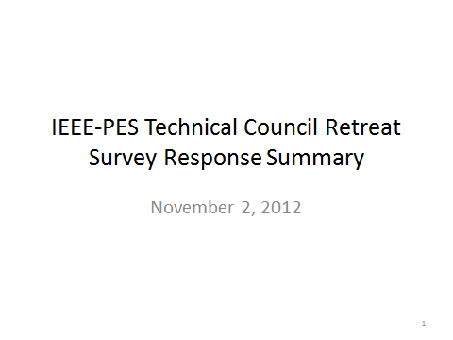
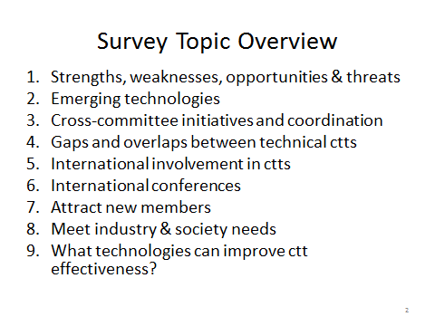
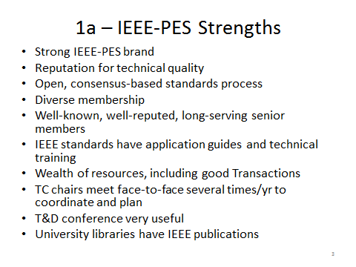
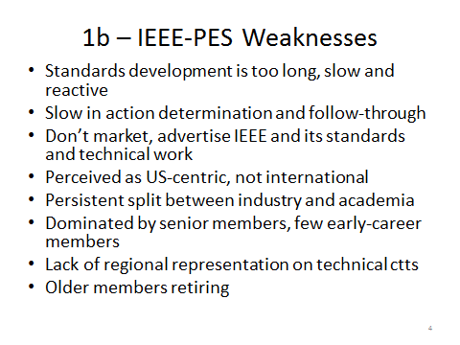
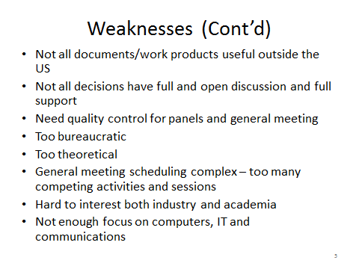
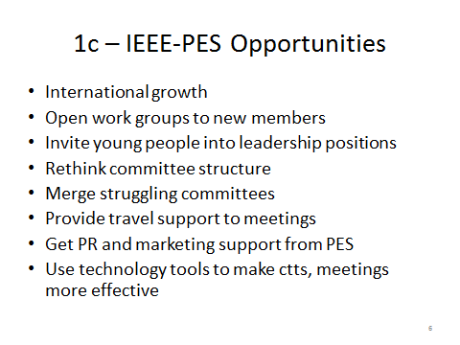
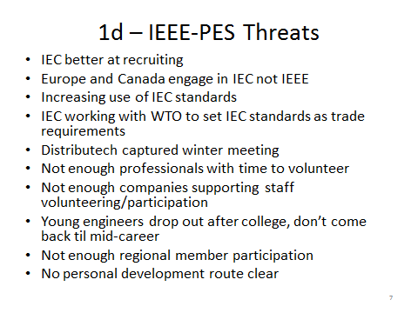
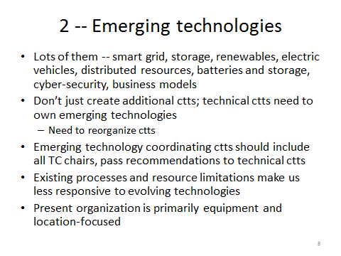
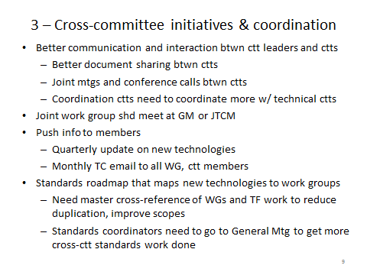
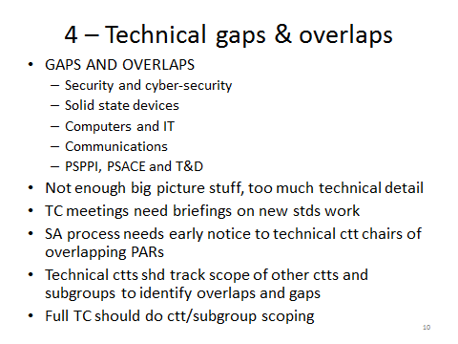
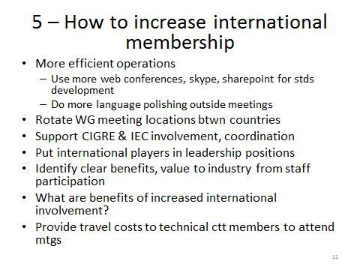
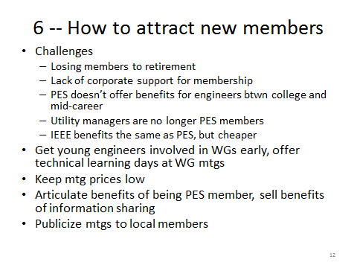
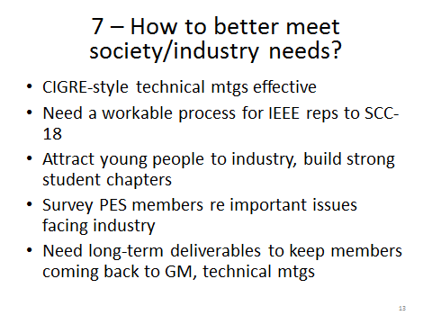
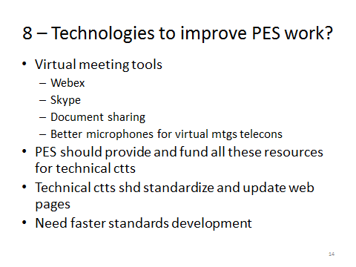

The variety of issues identified in the survey feedback were used as the starting point of the discussion at the retreat. After a day of dialogue, a shorten list of items were identified and prioritized through an informal voting process with the results shown below:
- Tools to Enhance Technical Committee And Leaders’ Effectiveness (16 Votes)
- Committee Structure And Coordination (15 Votes)
- Improving International Involvement & Presence (11 Votes)
- PES Leader Training (11 Votes)
- PES Member Training (11 Votes)
- Information Transmittal To Technical Committee Leaders (10 Votes)
- Strengthening PES Technical Committee Awareness And Participation
  - 7a) PES Technical Committee Membership And Recruiting (9 Votes)
  - 7b) Articulate Benefits To Professionals Of PES Participation
  - 7c) Improve Branding Of PES Technical Committees As Expert Technical Bodies (8 Votes)
- Publications And Access Issues (8 Votes)
- Identifying Best Practices For Standards Development (7 Votes)
- PES Presentation To The World (6 Votes)
- IEEE, IEC, CIGRE and PES (6 Votes)
- Other Topics The Group Didn’t Address In Detail
The summary report from the Technical Council retreat is also included below for you reference.
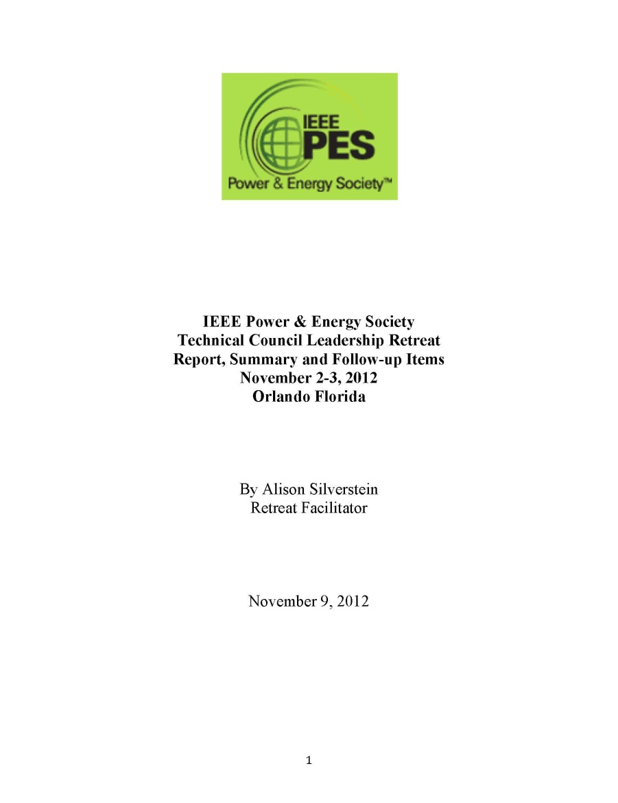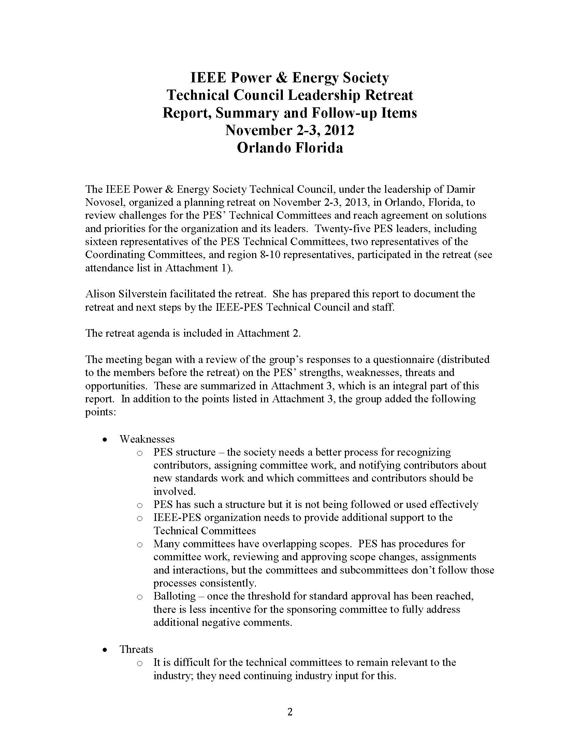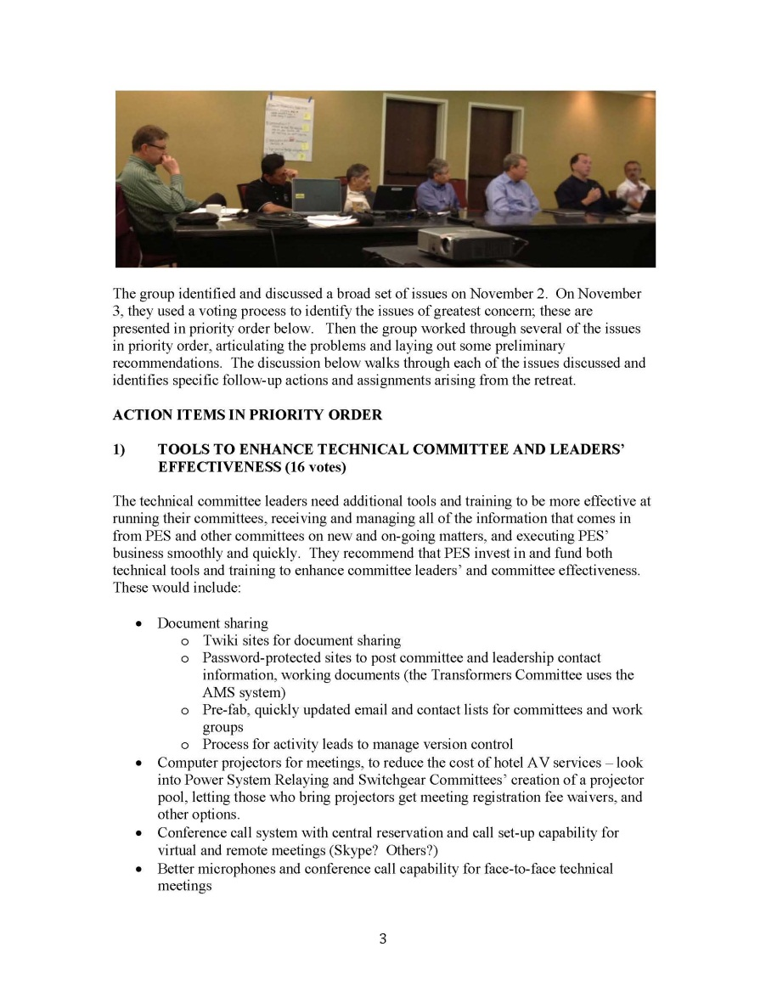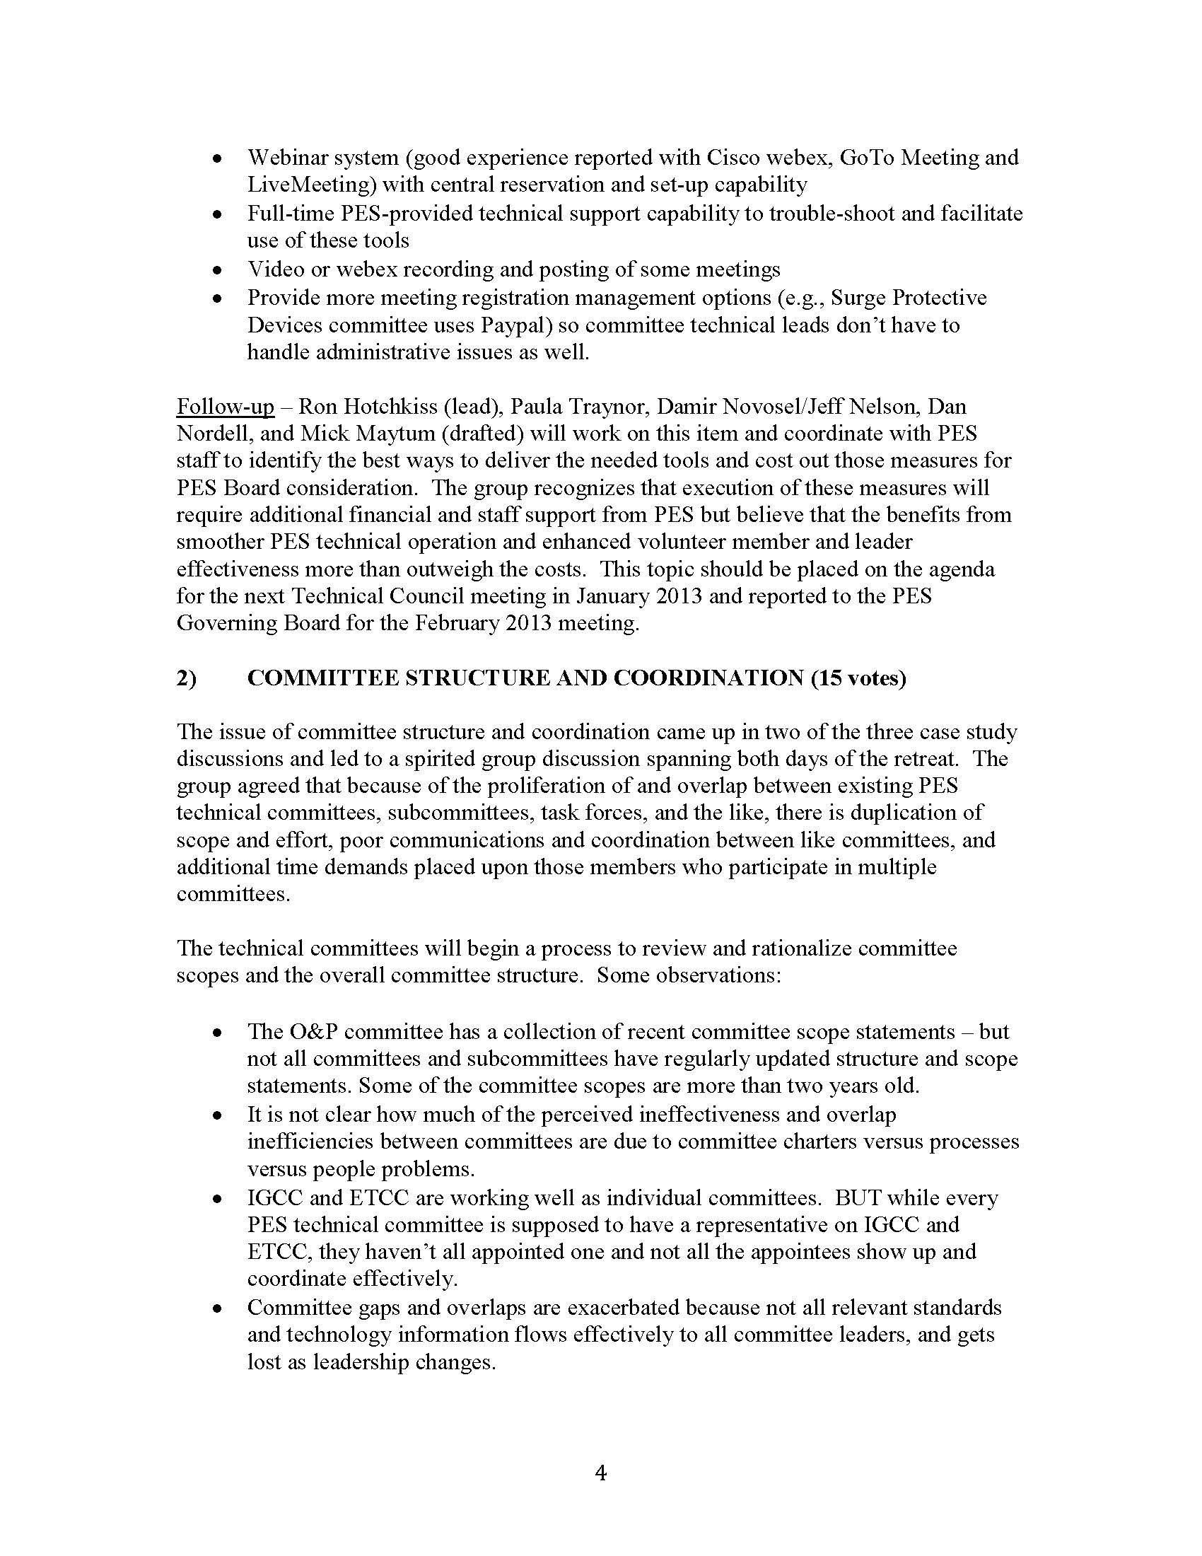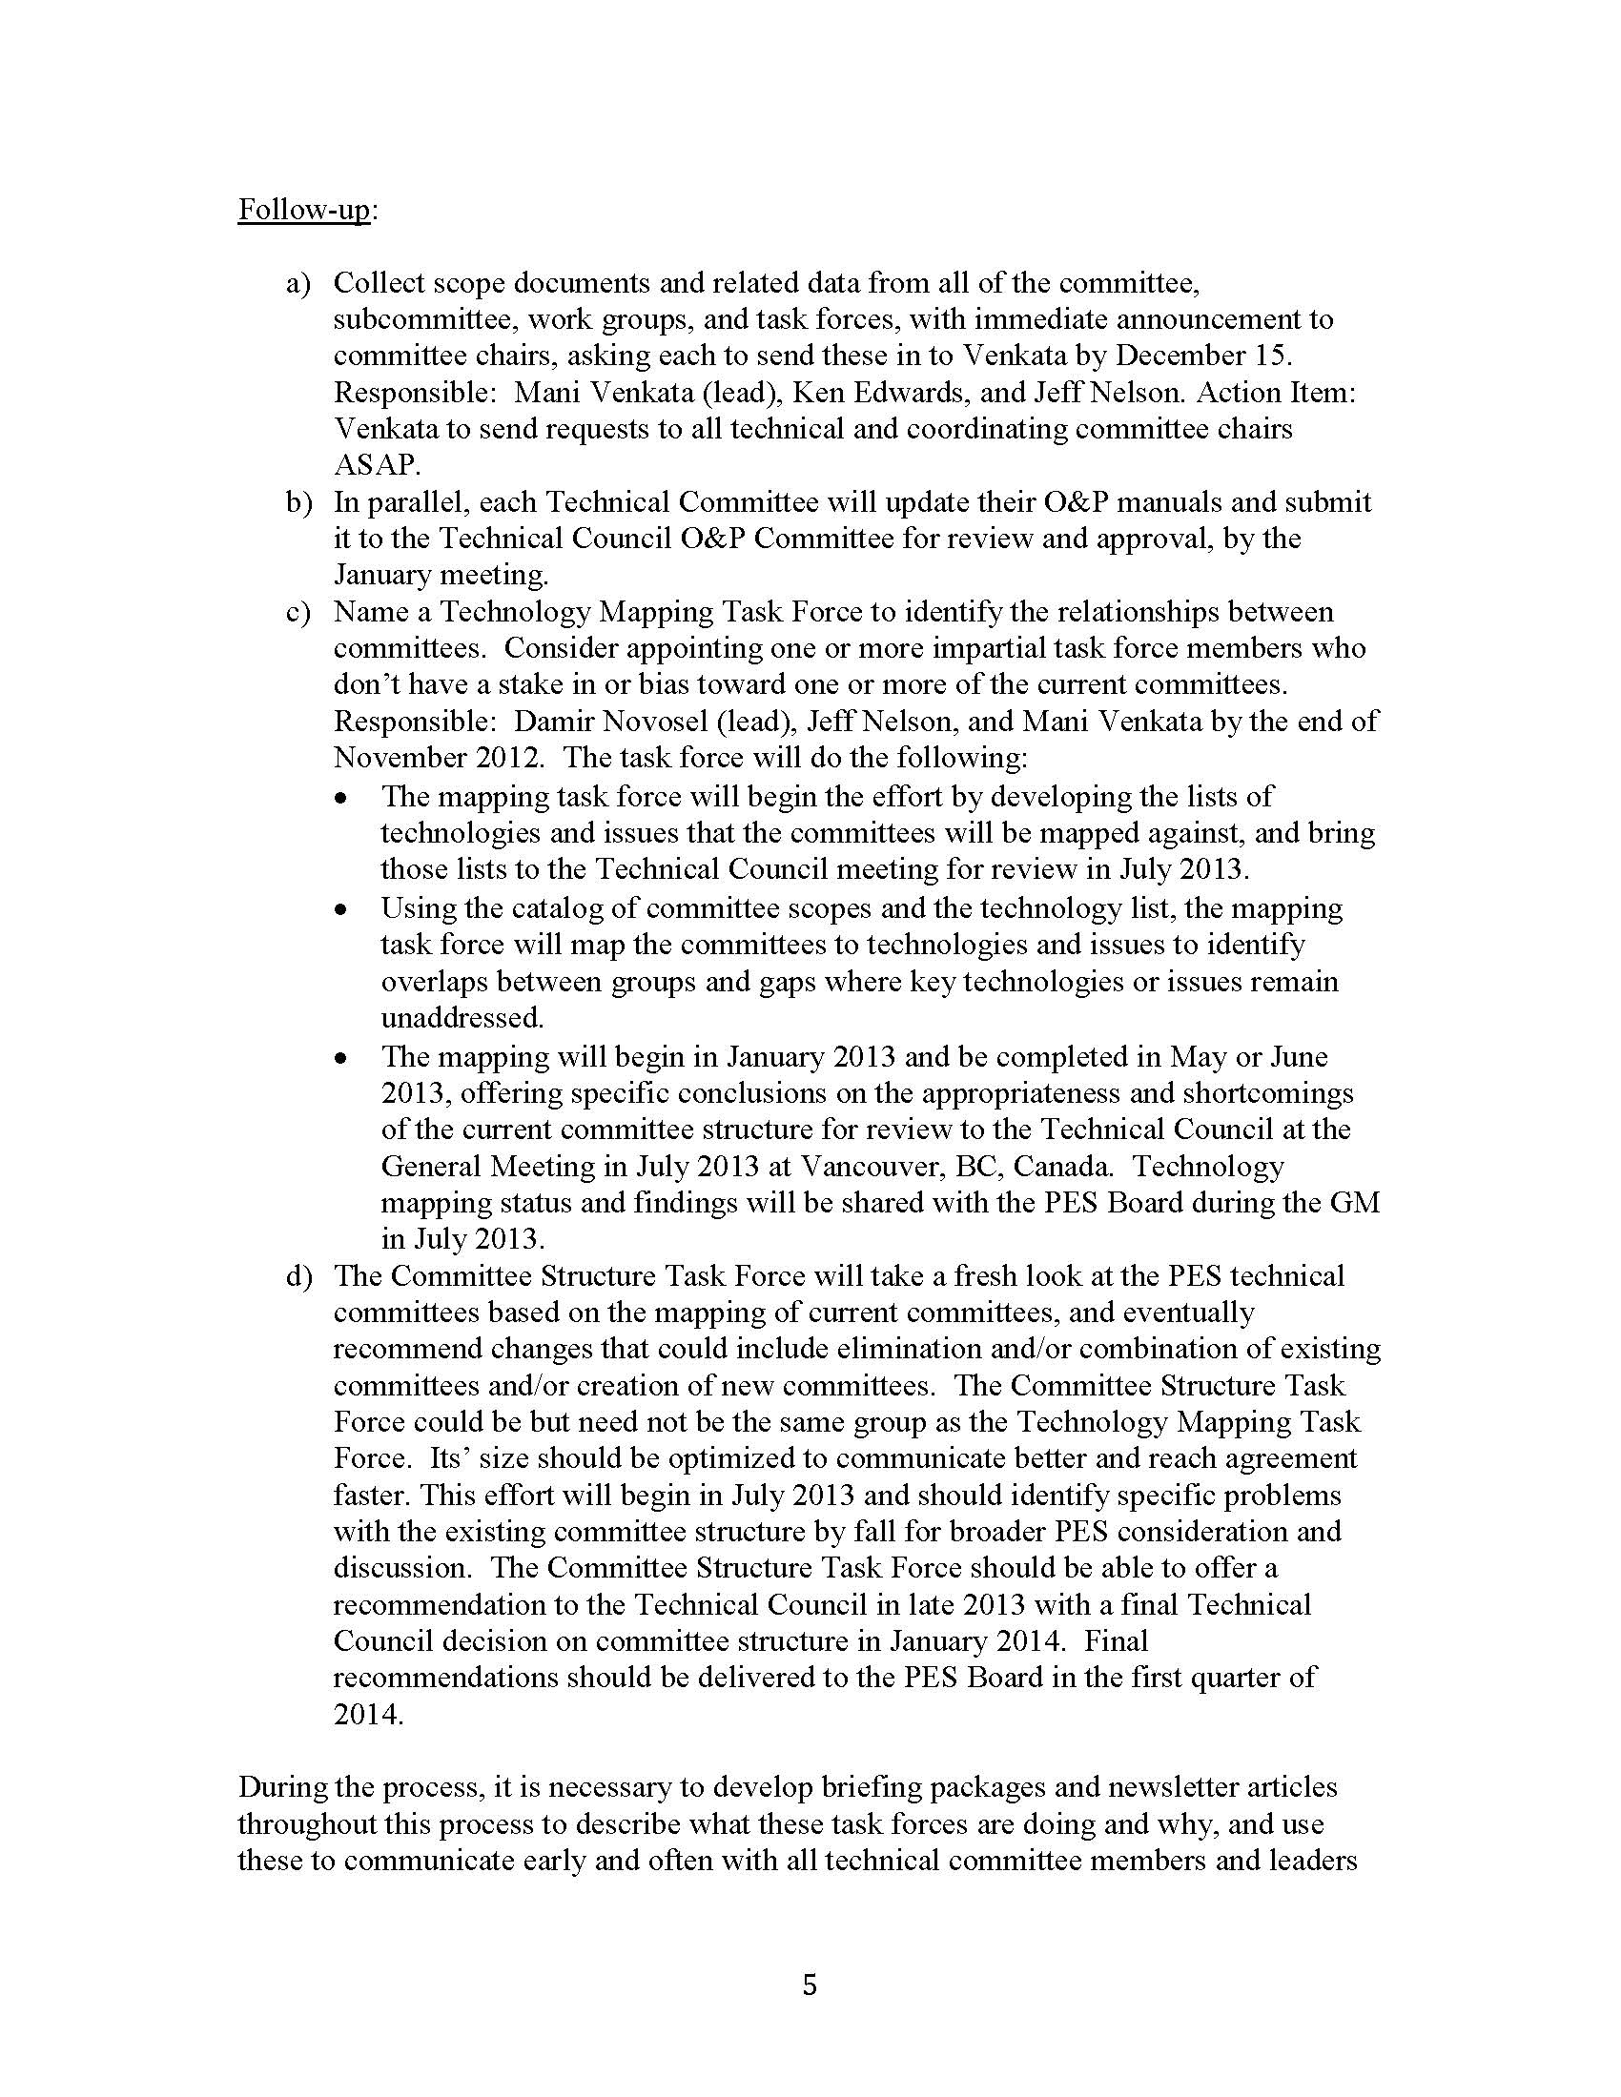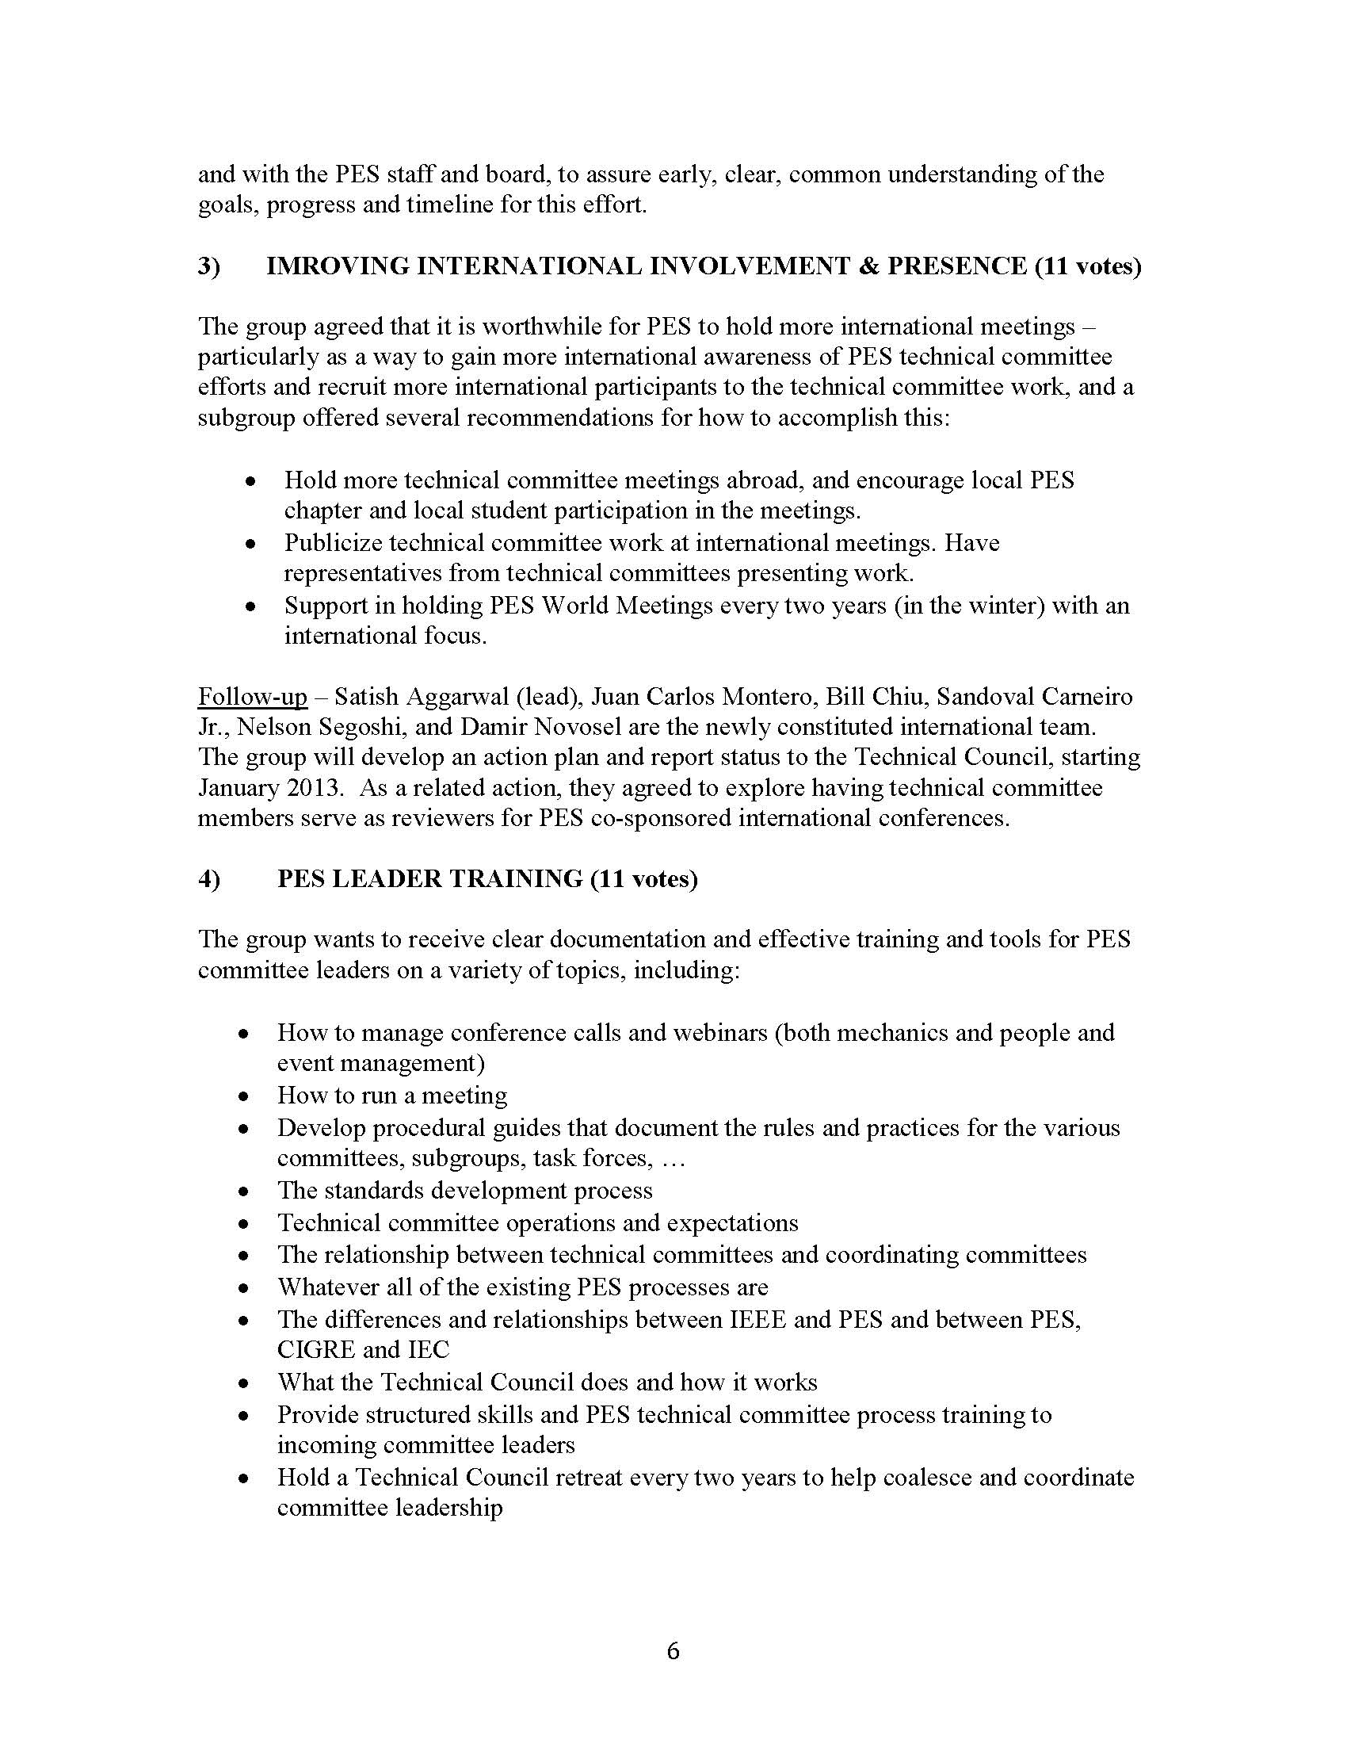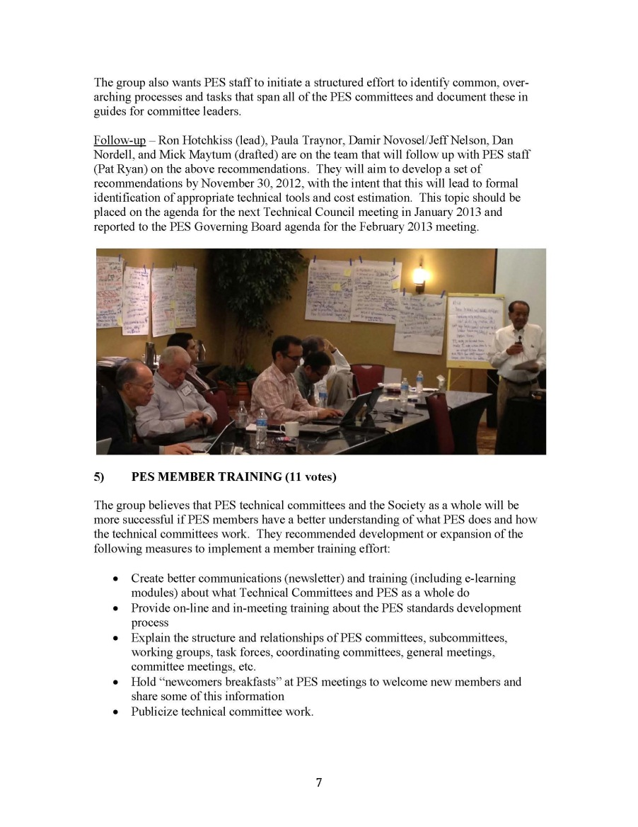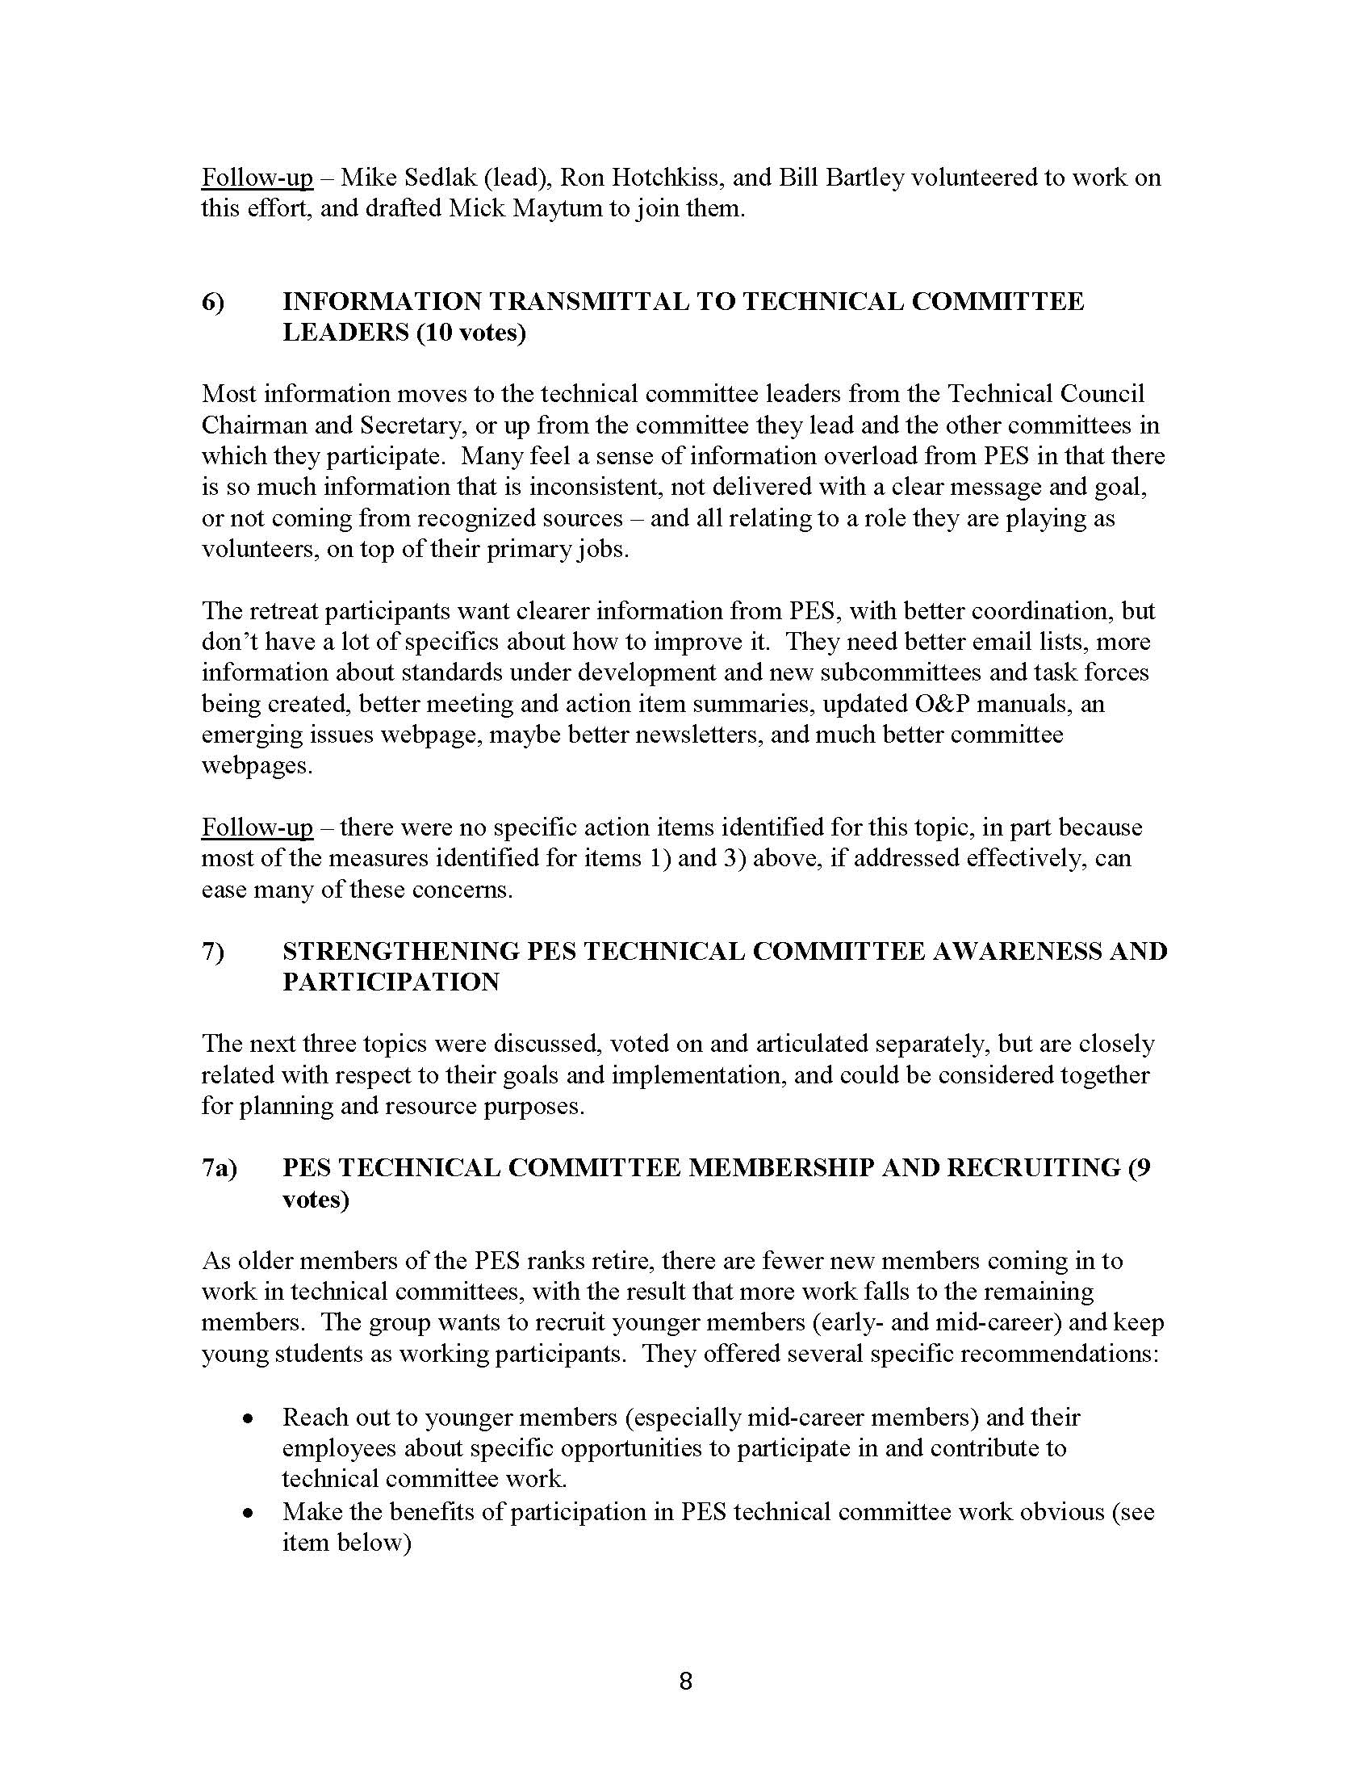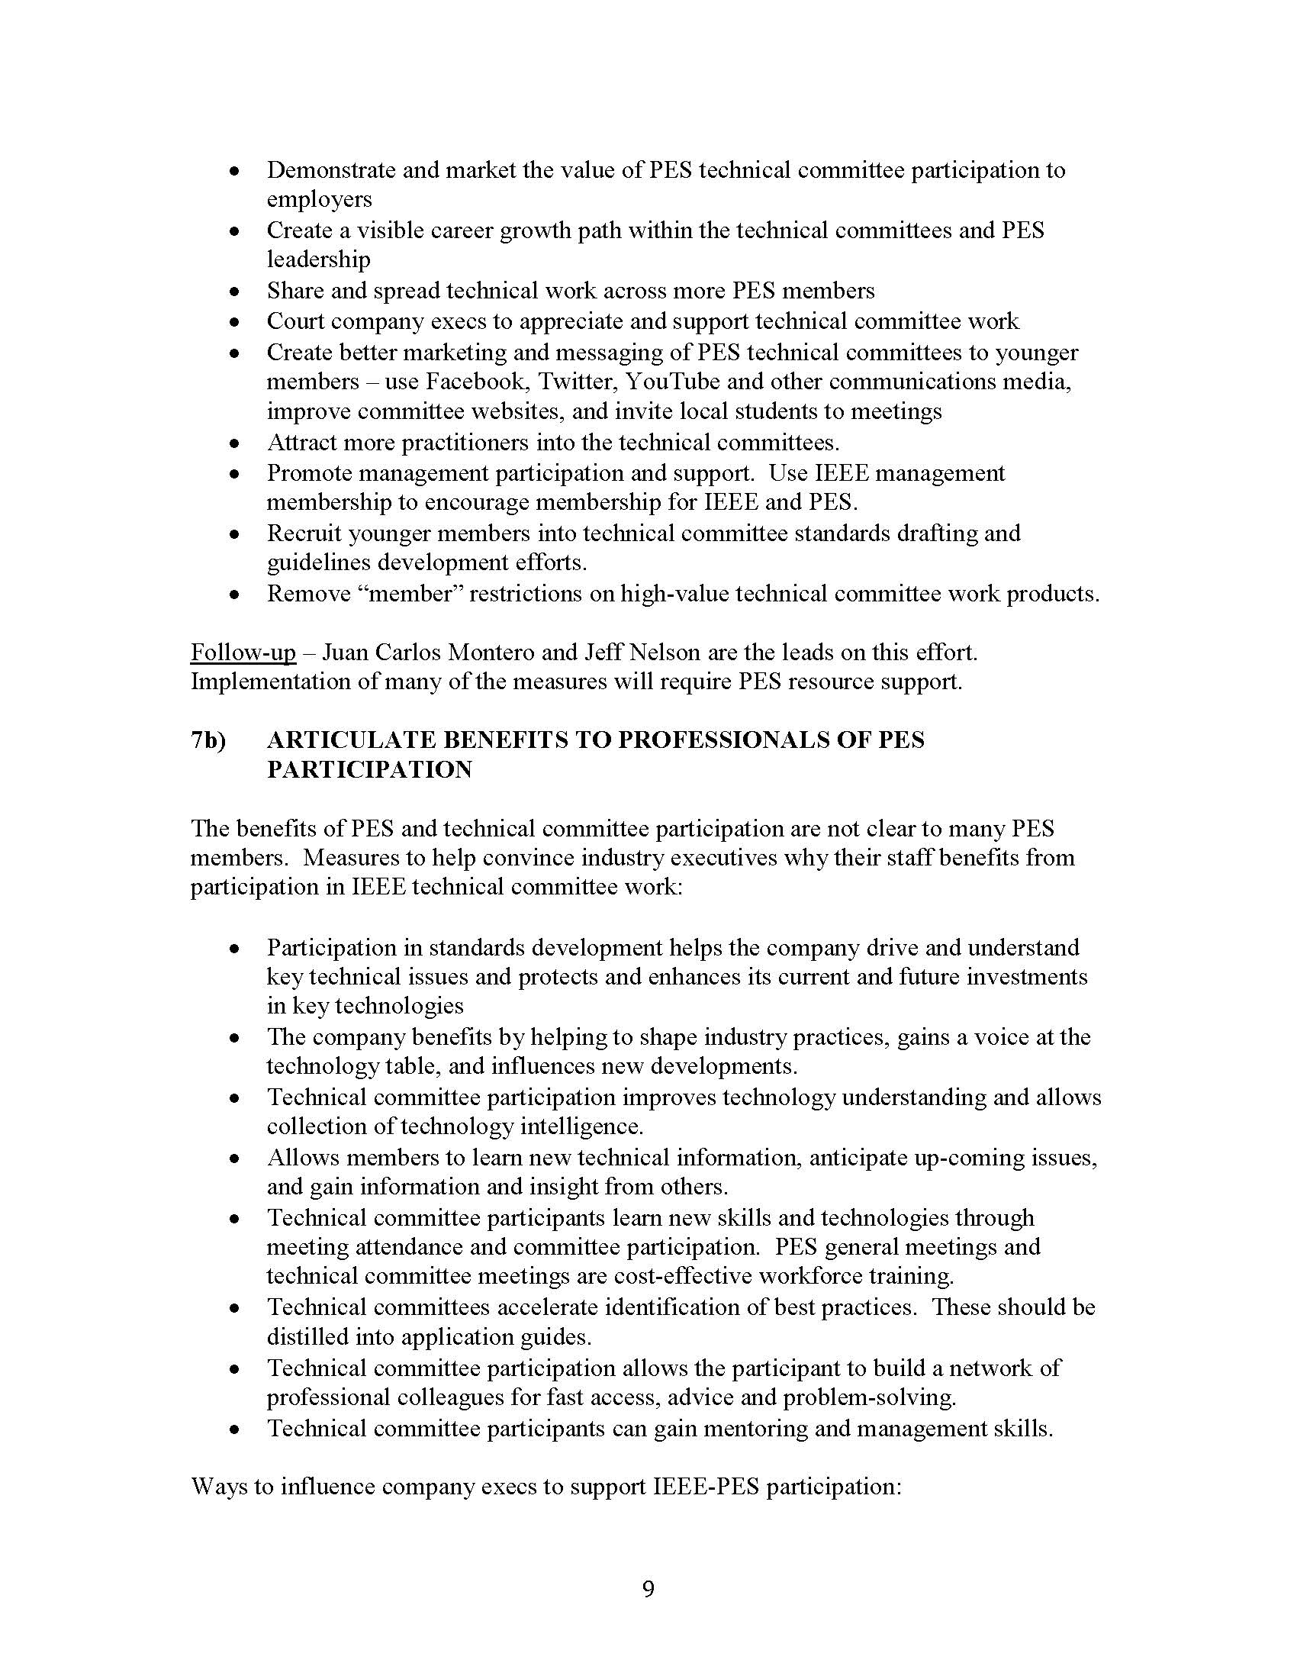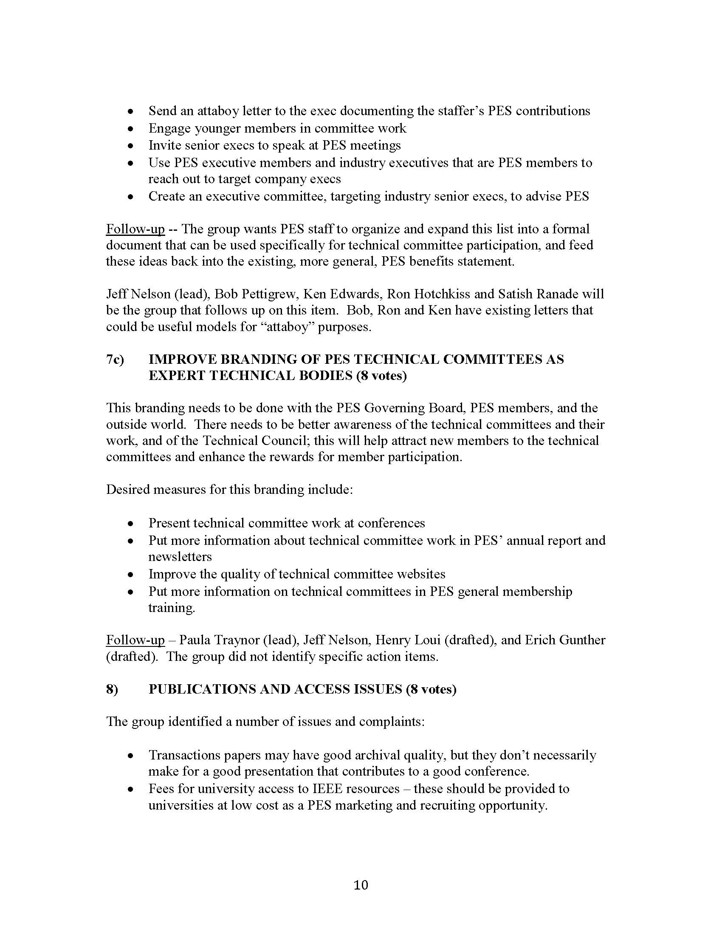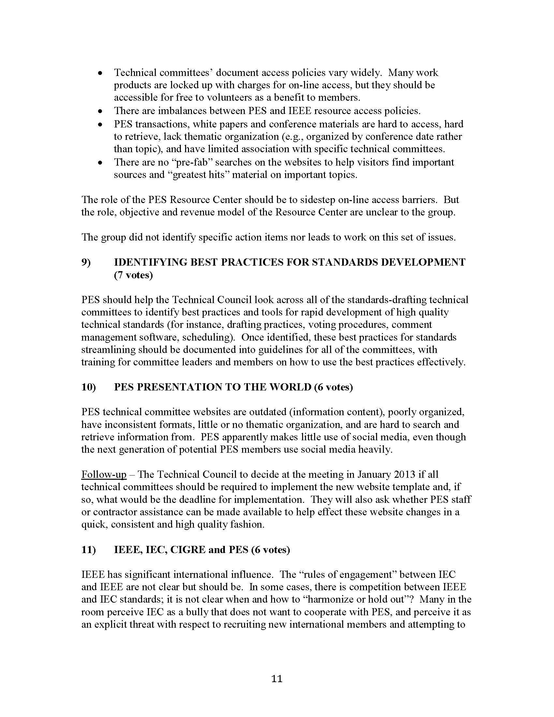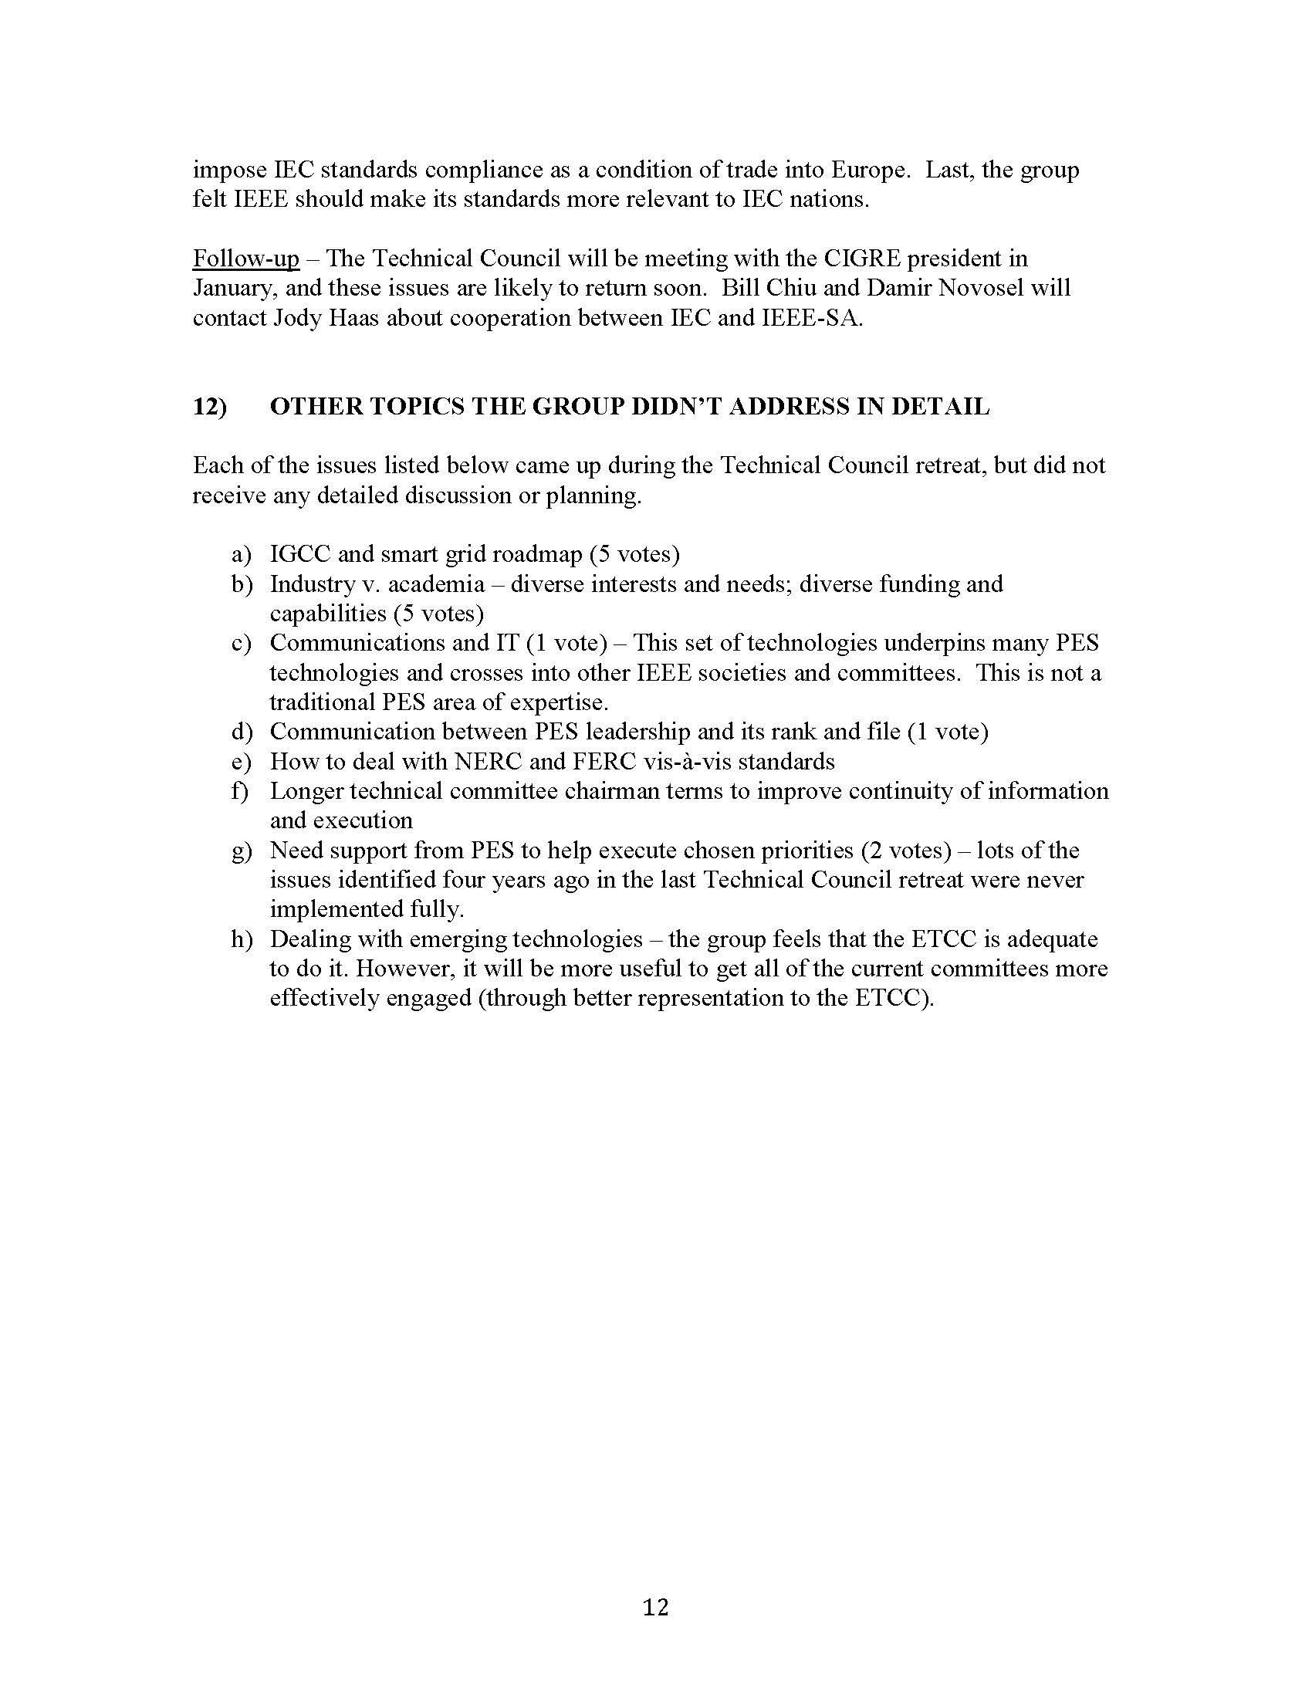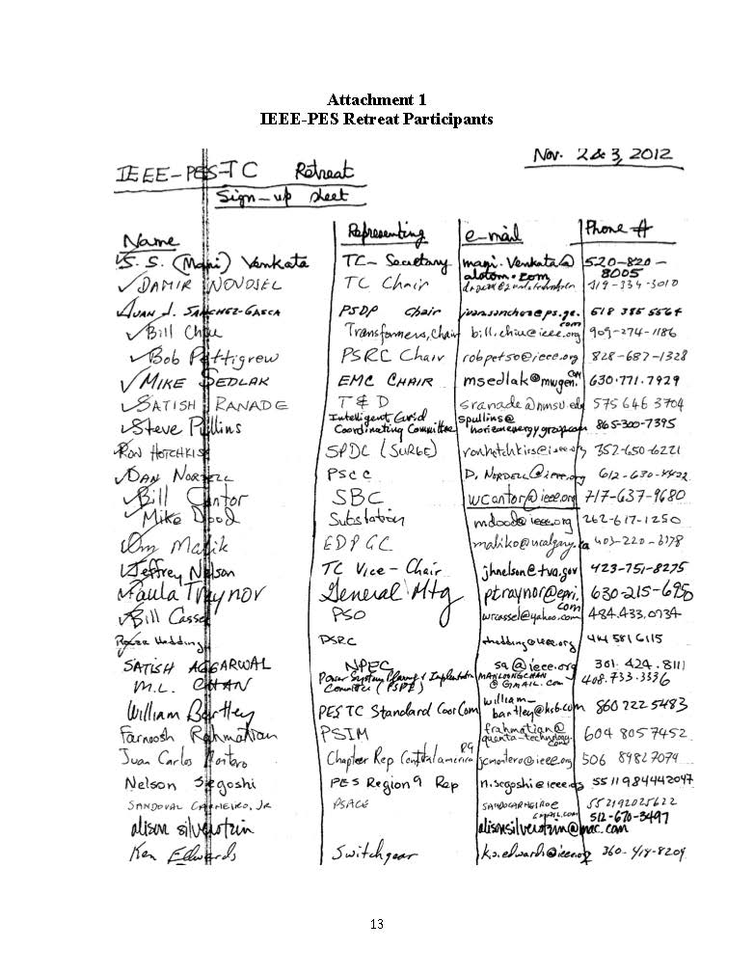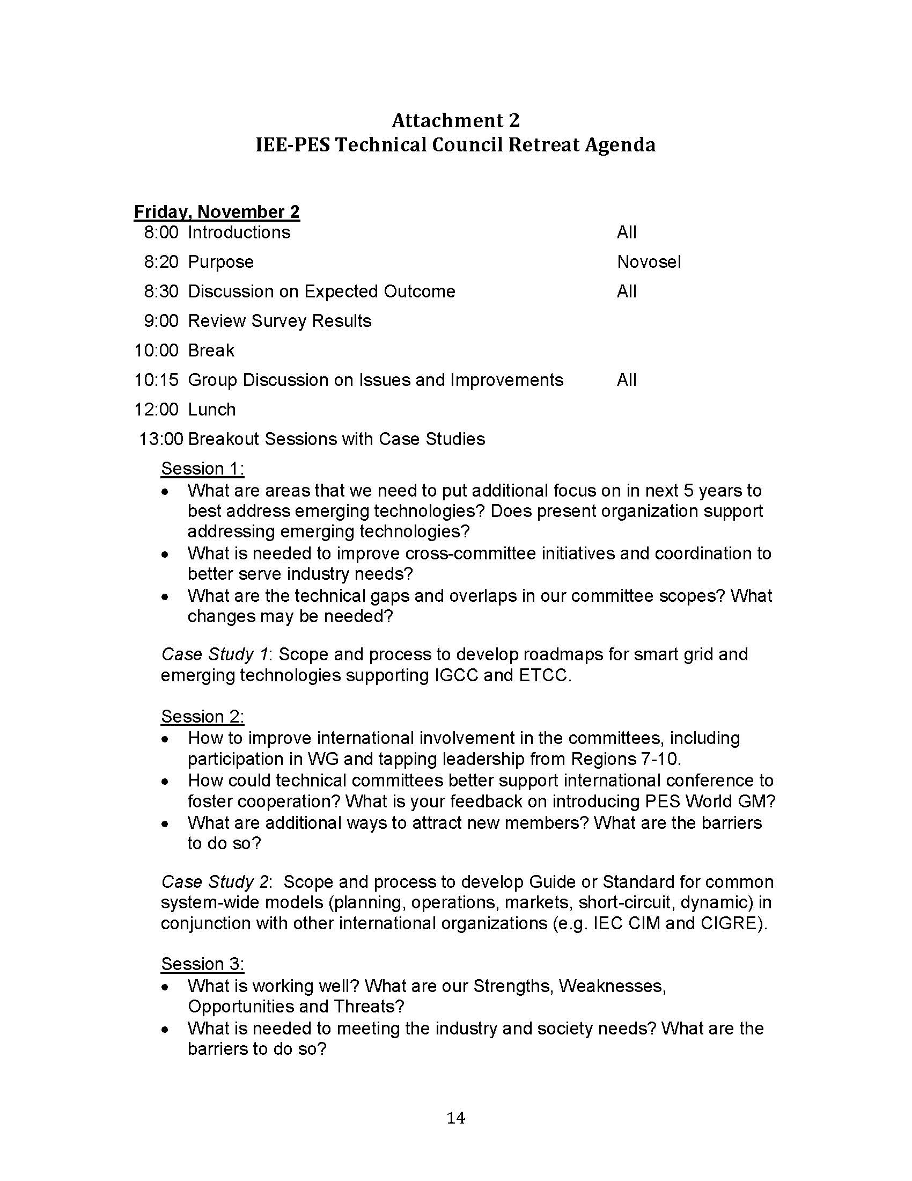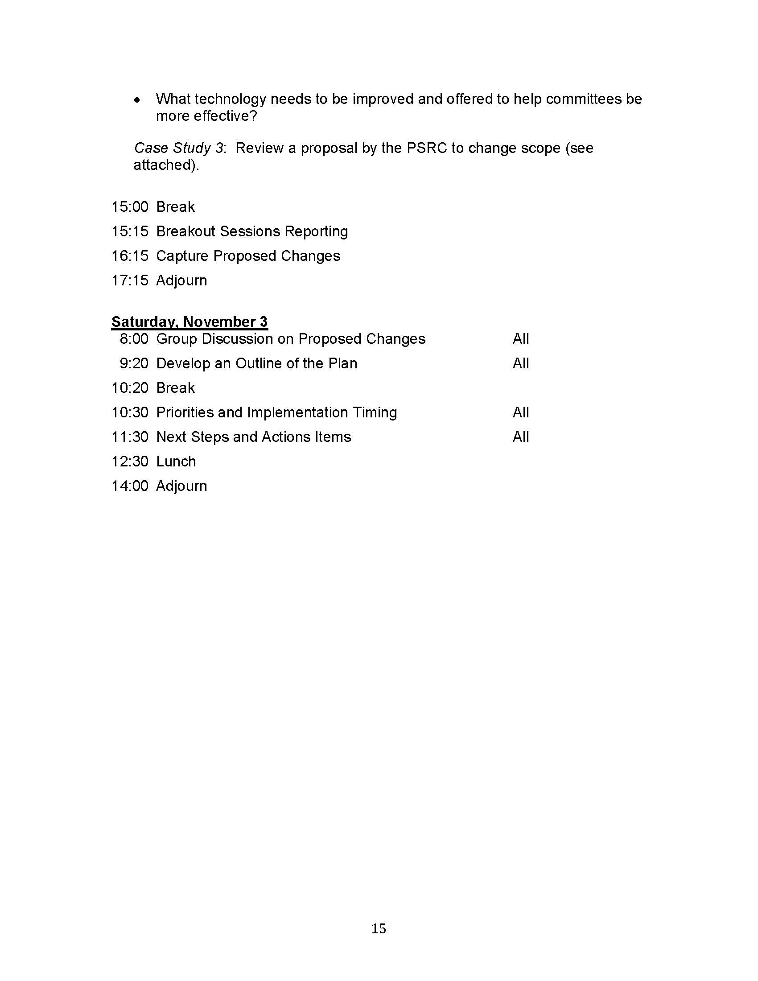
    - Update on Geomagnetic Disturbance (GMD) Taskforce
The Technical Council Taskforce on GMD is continuing to make progress on the development of the position paper since last year. At this point the taskforce is working on the third draft of the position paper. There is plan underway to seek publication of either the entire paper or a condensed version of the paper in the PES Power & Energy Magazine later this year to coincide with the GDM Super Session planned at the PES General Meeting in July, 2013 at Vancouver Canada. It is anticipated that the position paper will be completed in April of 2013. This is a little behind the original schedule set back at the end of last year, primarily due to the additional scope of further analysis on transformers hot spots based on a recorded GIC profile of the GMD event that occurred during the March 13-14, 1989 solar storm.
  - Transformers Committee Activities
    - Subcommittee Chairpersons & Technical Editor
I would like to extend a warm welcome to our newest member – Michael Franchek. Mike was appointed his new role earlier this year as our incoming Dielectric Tests Subcommittee Chair, replacing Loren Wagenaar who resigned at the end of last year. We will miss Loren as part of the leadership group and would like to thank Loren for his long tenure of dedicated service to the Transformer Committee and to our industry. We wish Loren all the best in the future. Our current roster of the Subcommittee Chairs and Editor are:

- Bushings Subcommittee Peter Zhao
- Dielectric Test Subcommittee Michael Franchek
- Distribution Transformers Subcommittee Stephen Shull
- Dry-Type Transformers Subcommittee Charles Johnson
- HVDC Converter Transformers and Smoothing Reactors Subcommittee Michael Sharp
- Instrument Transformers Ross McTaggart
- Insulating Fluids Subcommittee Susan McNelly
- Insulation Life Subcommittee Bruce Forsyth
- Meetings Subcommittee Gregory Anderson
- Performance Characteristics Subcommittee Ed teNyenhuis
- Power Transformers Subcommittee Joe Watson
- Standards Subcommittee William Bartley
- Underground Transformers & Network Protectors Subcommittee Carl Niemann
- Technical Editor Sanjib Som

All of them have committed to serve the duration of the calendar year 2013. PES Technical Council was notified of the Subcommittee Chairs and Technical Editor appointments for the calendar year 2013 in accordance with the guideline set forth in our O&P Manual.

    - IEEE Senior Membership
IEEE membership has several categories, with the senior level being the highest grade which a member can apply. IEEE has developed a streamlined process for members to request elevation of their membership status. The process is simply and can be done entirely on-line. The Chair strongly encourages everyone that have been an active contributor to the industry for at least five years to apply for this elevation in membership status. The basic qualifications are:

- be engineers, scientists, educators, technical executives, or originators in IEEE-designated fields;
- have experience reflecting professional maturity;
- have been in professional practice for at least ten years;
- show significant performance over a period of at least five of their years in professional practice.
Benefits of becoming a senior member include:
- Recognition: The professional recognition of your peers for technical and professional excellence.
- Senior member plaque: Since January 1999, all newly elevated Senior members have received an engraved Senior Member plaque to be proudly displayed for colleagues, clients and employers to see. The plaque, an attractive fine wood with bronze engraving, is sent within six to eight weeks after elevation.
- US$25 coupon: IEEE will recognize all newly elevated Senior members with a coupon worth up to US$25. This coupon can be used to join one new IEEE society. The coupon expires on 31 December of the year in which it is received.
- Letter of commendation: A letter of commendation will be sent to your employer on the achievement of Senior member grade (upon the request of the newly elected Senior member).
- Announcements: Announcement of elevation can be made in section/society and/or local newsletters, newspapers and notices.
- Leadership Eligibility: Senior members are eligible to hold executive IEEE volunteer positions.
- Ability to refer other candidates: Senior members can serve as a reference for other applicants for senior membership.
- Review panel: Senior members are invited to be on the panel to review senior member applications.
- US$25 referral coupon: Newly elevated Senior members are encouraged to find the next innovators of tomorrow and invite them to join IEEE. Invite them to join and the new IEEE member will receive $25 off their first year of membership.
    - Committee Membership
All are welcome to participate in the work of the Transformers Committee. Membership in the Committee provides recognition of your peers and indication to your co-workers and management of your active role in Committee work. If you are presently not a Main Committee Member, and you have been actively participating in our work for at least two full year – and can secure the acknowledgement and sponsorship of at least 3 activity Chairs (WGs, but must include at least one Subcommittee Chair) affirming that participation, the Committee will look forward to welcoming you as a member. Membership requirements and application forms can be found in the Organization and Procedures Manual posted on the Committee website.
As our organization is a 100% volunteer based organization, we are very much in need of all of your continued participation and sharing of your expertise towards our world-class standards development efforts. Many of our long-standing committee members have made tremendous contributions towards our standards development effort over the years and their contributions are greatly appreciated.

Respectfully submitted,

Bill Chiu
Chair, IEEE/PES Transformers Committee

