## SC Insulating Fluids Meeting Minutes

**March 20, 2013;**

**Munich, Germany**

## Chair: Susan McNelly

## Vice-Chair: Jerry Murphy

## Secretary: C. Patrick McShane

### Introduction/SC Member Roll Call/New SC IF Members

The Chair started the meeting with a welcome and polled the attendees to determine if the quorum requirements were met. Unfortunately the requirements were missed by just one. There were 22 members and 34 guests. Eight of the guests requested membership.

Guests requesting membership since F12 membership meeting:

Josh Herz

Jose Izquierdo

Min Jea Lee

John K. John

Guests meeting the requirements for membership status after the S13 meeting:

Dave Hanson

James Rowland

Robert Kinner

Jimmy Rasco

### Approval of the posted minutes from Fall 2012

Due to lack of a quorum, the minutes approval motion could not be made.

### Working Group and Task Force SC Reports and Submitted Unapproved Minutes

#### C57.104 – IEEE Guide for the Interpretation of Gases Generated in Oil – Immersed Transformers

**WG Chair: Rick Ladroga, Vice-Chair: Claude Beauchemin, Secretary: Sue McNelly**

**The WG Report at the Sub-Committee Meeting: Presented by Claude Beauchemin:**

The key topic discussed at the meeting was gas saturation and reviewing the method of “number crunching” of the very large data base. The WG has been active, including a meeting held in January. Confidentiality and access to the data received is still an issue. There is still a lot of work to be done with the data to make it user friendly.

There was no discussion or questions from the attendees.

**The Minutes (unapproved) of C57.104 WG Meeting as Submitted:**

**C57.104 – IEEE Guide for the Interpretation of Gases Generated in Oil – Immersed Transformers**

**Tuesday, March 19, 2013**

**Munich, Germany**

**Minutes of WG Meeting**

The meeting was called to order by Chair Rick Ladroga at 3:17pm. Vice Chair Claude Beauchemin and Secretary Susan McNelly were also present.

There were 30 of 94 members present. There were 29 guests, and 5 guests requesting membership. A membership quorum was not achieved; the membership list will be reviewed before the next meeting. Guests attending the WG meeting for the first time who request membership will be deferred until the next meeting attended.

Guests requesting membership were (those identified with an asterisk (4 of the 5) will be added as WG members):

Stephanie Denzer * David Murray *

Rainer Frotscher * V K Lakhiani

Zan Kiparizoski *

Agenda

1. Welcome & Introductions
2. Quorum Check
3. Approval of Minutes from fall 2012 Milwaukee meeting.
4. Chair’s Remarks
5. Presentations
   1. Data - Claude Beauchemin – Full presentation was not completed
   2. Case Studies – Paul Boman – Time expired before this could be presented.
6. Adjourn

The minutes from the fall 2012 Milwaukee, Wisconsin meeting were not approved due to a lack of quorum.

**Chair’s Remarks:**

The C57.104 Executive Leadership (Chair, Vice-Chair, and Task Force Leaders) team met in Newport Beach, California over the two day period of January 22-23, 2013. The following persons were in attendance:

Rick Ladroga, Claude Beauchemin, Dave Hanson, Michel Duval, Luiz Cheim, Arturo Nunez, Norm Field, Paul Boman. Paul Boman acted as Secretary for the meeting.

The primary agenda for the California meeting was to review the progress and status of the Data Task Force, specifically to lock down categories, classifications, and essentially to organize the data into a useful tool for the new Guide.

The group looked at the volume of work completed to date which is significant. Claude Beauchemin will make a presentation during today’s Working Group meeting today to illustrate some of the things we are looking at.

Some other significant issues came to light during the meetings in California, related to the data specifically. A concern was raised about the security of the data, which led to a discussion about data commercial value, security, protection, authorized use of the data, release of information, etc. An action item was developed to address these issues. Rick Ladroga took ownership of the action item. Dave Hanson offered to develop a list of concerns and suggestions as we move forward to develop a data protocol and authorized use policy.

**Resolve**

Rick Ladroga reviewed Dave Hanson’s draft work and discussed the various items, concerns, and suggestions for resolution. Rick then contacted the IEEE PES Transformers Committee Chairman, Bill Chiu, along with Sue McNelly (Insulating Fluids Sub-Committee Chair), and Tom Prevost via an email dated February 20, 2013, and advised those Executives of the recent developments within the Working Group. The email essentially contained an Executive Brief, and specifically requested that the executive management look very closely at this issue, and include it in the SC meeting in Munich. Rick Ladroga then spoke directly with Bill Chiu, Don Platts, Tom Prevost, and Sue McNelly prior to the meeting to advise them and bring them up to speed.

The SC meeting was held on Sunday, March 17, 2013 in Munich, Germany. The executive leadership of the Transformer Committee met at this meeting and the issues involving data were presented to the group for discussion and consideration. The following action items were agreed to and assigned as follows:

**Data Storage, Archival, and Authorized Use of Data By and For the Working Group**

Sue McNelly has been assigned to lead the development of a protocol to address this item. Specifically, the protocol will involve assigning responsible parties to have control of the data repository, which will probably include the IEEE PES Transformer Committee Chair, Insulating Fluids Subcommittee Chair, and Working Group Chair at a minimum. These individuals will have authorization to approve access of the data repository to WG representatives who demonstrate need. The document is intended to be a living document, and is expected to grow in size as time goes on. Sue will establish a method of data storage with the IEEE and their facilities. The data will then be loaded onto IEEE servers for archiving and security purposes. The data repository will be accessed upon an as-need basis only, and will updated accordingly. The data repository will also include an archival history log, which at a minimum, will record the date the data is accessed, by whom, purpose, actual work done, date of newly archived revision, and revision number. The new revision data, and the previous revision data shall always be maintained, i.e. Rev 16 & rev 17, then a new revision is made and the data is updated. Revision 17 & 18 are stored, and Revision 16 can be deleted, if necessary, but the repository must have at a minimum the most recent revision along with the new revision. Rick offered to help Sue work on the action item if she needs help. The deadline for completion of this action item is the Fall 2013 IEEE PES Transformers Committee meeting in St Louis.

**Data Contribution and Use Policy**

Tom Prevost has been assigned the lead role to develop a policy to address the need for an organized set of procedures that can be utilized by all interested groups within the Transformer Committee, including but not limited to C57.104, C57.106, C57.139, factory Heat Run, etc. Tom will address the commercial, collection, security, protection, and use issues that the group has identified. Rick offered to help Tom and his task Force to complete the action item. It is due and expected no later than the fall 2013 meeting in St Louis.

Work will continue within the Working Group, while simultaneously working to develop these policies and procedures. It has been duly noted that the PAR for the C57.104 Guide shall expire in December 2014.

**Presentation – Data Analysis to date**

By M Duval, N Field, J Dukarm, L Cheim, L Lin, and C Beauchemin

Presented by Claude Beauchemin

Factors influencing 90 Percentile

What parameter influence 90% value

* Age
* MVA
* kV
* %O2

To evaluate the influence of each parameter, the data was subdivided into groups according to each parameters values. One parameter at a time was studied.

All data sources were combined for each group and the percentile computed. Results are as follows:

The following Tables were shown:

Age Table

MVA Table

kV Table

%O2

Claude indicated that there was a tremendous amount of effort to develop the above tables. The tables show results for the 90 percentile values for each of the categories shown.

The tables were not built on a theory of explanation. The effort was mearly to look at whether size, age, etc matter.

A question on why %O2 was used was asked. Claude indicated that when he reviewed this, he started seeing significant differences due to whether a unit was a free breathing type or sealed tank design. So when the larger database was available, he felt it would be worthwhile to further study this.

Fredi Jacob indicated that there is one parameter that influences gas generation rate is the loading factor. Claude and Rick indicated that this data is just not available. The documentation for the data is fairly poor in many cases. Rick indicated that this was a good point and that the guide would recommend that this type of information be tracked for future data collection as well as other parameters.

Comparison of 90% Spread Tables

Comparison of 95% Spread Tables

**Observations:**

When data is divided according to characteristics such as %O2, Age, Power, and Voltage, large variations between sub populations were observed.

The largest variation were with O2, followed by Age, MVA and with the smallest variation by voltage.

Use of statistical values, such as 90 percentile, will need to be qualified by a more precise description of the population used as reference. Multi-factors selection will likely be required. Example: Division by %O2 by Age.

The following Tables were shown:

90% O2 and Age Table

Comparison 90% O2 and Age Table

For given equipment, this table is closer to actual situations than Table 1 in the present Guide. However, the tables have inconveniences, such as they are difficult to read, indicate a false sense of precision, and need further subdivision.

Simplification will be required, such as grouping to reduce the number of categories and rounding of values.

The following Tables were shown:

90% O2 and Age Table

Light rounding Table

Heavy rounding Table

Reducing subdivision Table

Tom Prevost indicated that he didn’t like the direction that this Guide is going. He indicated that our goal needs to be very simple. He indicated that we should have an open breathing and closed breathing table. Claude indicated that it will likely not so simple to do this. The comments indicated that some practical way to present this and provide recommendations on values for the Guide. Claude indicated he definitely agrees that we need to try and simplify it, but it will not be easy to do.

There was considerable further discussion on how to best approach a manageable way to present the information in the Guide.

Bill Chiu indicated that his sense is that we are too early in the process as to a direction that will be taken. He indicated that hopefully as we continue on this path in evaluating the data that we will be able to move more in a direction of simplifying the data results.

Rick cautioned that we can’t make operability decisions for the field. We can only help them to make that decision by providing some general guidelines.

Time ran out before Claude could finish his presentation.

A comment was made that a 90th percentile value will still not guarantee that a unit will not fail that falls within this range.

Rick welcomed feedback and comments from people be sent to him.

The meeting was adjourned at 4:30 pm.

Rick Ladroga

WG Chair

Claude Beauchemin

WG Vice-Chair

Susan McNelly

#### C57.106 - Guide for the Acceptance and Maintenance of Insulating (Mineral) Oil - Chair: Bob Rasor

#### The WG Report Given at the Sub-Committee Meeting: Presented by Bob Rasor:

The WG met but without a quorum. Three sections of the draft document were reviewed. There are many more sections to go through, so the WG Chair is working on ratcheting up review progress. Bob mentioned that even the title of the Guide created a lot of discussion. Another topic of significant discussion is whether or not to re-include value limits using ASTM D877 Dielectric Breakdown Voltage Testing. If re-included in the revised Guide, should the test be limited to new oil or used in other tables. Further discussion is needed to determine which test limit tables D877 would still be relevant.

**The Minutes (unapproved) of WG Meeting as Submitted:**

**Tuesday 19March2013**

**8 a.m. to 9:15 am**

The meeting was called to order by Chair Bob Rasor at 8:00 am. Secretary Claude Beauchemin was present to help run the meeting in the absence of vice chair Jim Thompson. The roster was passed out and it was asked for the members (28 total on the roster) to raise their hands. With only 10, we did not have a quorum.

There were 33 attendees by the end of the meeting with 14 members – 1 short of a quorum. The following 6 people indicated they would like to become members:

1. Dieter Dohnal
2. Dharam Vir
3. V.K. Lakhiani
4. Derek Baronowski
5. Mike Lapota
6. Roberto Asano

Minutes from the Milwaukee meeting were not voted upon due to a lack of quorum. Bob presented an introduction and review of the current version’s Scope and Purpose. It was noted that there are some suggested changes but it is too early to adjust the PAR as there could be more changes.

It was clarified that the PAR will last 4 years if ideally done without an extension. It was stated that even though we have met 10 different times between meetings and phone conferences, the progress for 1 year is slow and more aggressive progress is needed to make this goal. TF teams can be created to address sections that do not require the entire group’s input – such as definitions.

Keeping in mind that without a quorum, there were no final draft decisions made, the draft document with track changes was reviewed with the following discussion points:

* The title itself was thought better to include some current changes in other groups for wording consistency. This led to a long discussion. Eventually, tentatively, we agreed to change the Title of the Guide. Instead of “Insulating Liquid”, the Guide should use “Mineral Oil Insulating Liquid”.
* A further discussion was concerning the nomenclature “Liquid Immersed” This was challenged by some, as this is an oil guide and the transformer nomenclature may not be necessary.
* The D877 test is being kept in Table 1 – as many of the buyers use ASTM and also that particular test as part of their specification. Move D877 into the first box in Table 1 along with the D1816 test.
* There was a lengthy discussion on the inhibitor values in Table 1 and Table 2. Minimums in table 1 are not used by refineries so those values are to be removed. It is up to the refineries to meet the acceptance requirements for oxidation stability. They can however be listed in the agreement between the owner and the oil supplier.
* Table 2 keeps the minimums for Type II oil and add a note that the owner is to refer to the supplier for this information
* Oil in Table 2 to is new oil, but there was a discussion that once it is in the transformer it is technically not new oil. If we remove the word “New” from the Table 2 title, does this mean manufacturers can use used oil if it meets the criteria? That was not the intent and wording can be added to the
* There was discussion about the tables and who uses them for what reasons. A suggestion was made that for the next meeting, we should first look at the tables and see if they really accomplish what we want --- rather than revising the existing tables.

Time was out – a motion was raised to dismiss and it was seconded.

Meeting was adjourned at 9:20 am.

#### C57.130 Trial-Use Guide for Dissolved Gas Analysis During Factory Temerature Rise Tests for the Evaluation of Oil-Immersed Transformers and Reactors. WG Chair Jim Thompson

**The C57.130 WG Report Given at the Sub-Committee Meeting: Presented by Sue McNelly:**

##### The SCIF Chair stated that no meeting was held for this WG and indicated that The PC57.130 straw ballot is in process.  It is being reviewed and will be discussed at an interim teleconference meeting before the St. Louis meeting and then again at the F13 St. Louis Transformer Committee meeting.  Some negatives have been received, some of which will require time to resolve, however Jim Thompson expects to complete the project on time.

#### C57.139 - Guide for Dissolved Gas Analysis of Load Tap Changers

#### WG Chair: David Wallach, Secretary: Sue McNelly:

**The C57.139 WG Report Given at the Sub-Committee Meeting: Presented by** **David Wallach**

The discussion at the WG meeting included reviewing the intended focus of the revision of the guide. To They are looking at an hybrid approach factoring in both the Triangle method and a new anagram discussed in a recent technical article. Information is available on the TC web site. Their goal is to complete the work in 2014.

**The Minutes (unapproved) of WG Meeting as Submitted:**

**WG Meeting C57.139 - Draft IEEE Guide for Dissolved Gas Analysis of Load Tap Changers**

**Tuesday, March 19, 2013 Munich, Germany**

Chair Dave Wallach called the WG meeting to order at 11:00 am. Secretary Susan McNelly was also present. There were 24 of 63 members present (Quorum requirement was not met). There were 34 guests present with 9 guests requesting membership. Guests attending the WG meeting for the first time who request membership will be deferred until the next meeting attended. The membership roster and attendance will be recorded in the Committee AM System.

The following guests requested membership in the WG and will be added as members:

Stephanie Denzer Craig Stiegemeier

Don Angell Pontus Sundqvist

Rainer Frotscher Jane Ann Verner

Michael Lau Dharam Vir

Oleg Roizman

**Agenda:**

1. Introductions/Member Roll Call
2. Approval of minutes from past meeting
3. Presentation/Update on Nomogram – Fredi Jacob
4. General /Refocusing
5. Task Force Updates – Dave Wallach for Jim Dukarm
6. Old Business
7. New Business
8. Adjourn

Introductions and member roll call were performed. A quorum was not achieved. Maintenance of the membership roster will be performed prior to the fall 2013 meeting.

The minutes from the Fall 2012 Milwaukee, Wisconsin meeting were not approved due to the lack of quorum.

**Presentation/Update: Nomograms,** by Fredi Jacob and Jim Dukarm, presented by Fredi Jacob

**Advantages**

* No calculations needed to plot data, plot ppm directly
* Cannot plot very low ppm values
* Not limited to three gases
* Ratio calculated and evaluated on plot
* Condition code shown directly on plot
* Multiple dates plotted to show trend
* Easily Generated for Specific LTC models

**Gas Ratio Nomogram Ethylene/Acetylene Ratio**



**Gas Ratio Nomogram for Nitrogen/Oxygen Ratio**



**Case Study 1**

**Westinghouse UTT-A Sealed LTC - Had a fault due to contact misalignment**

**ETHYLENE/ACETYLENE**

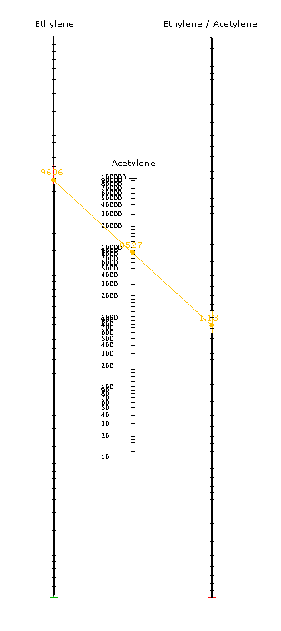

**Case Study 2**

**ETHYLENE/ACETYLENE NITROGEN/OXYGEN**

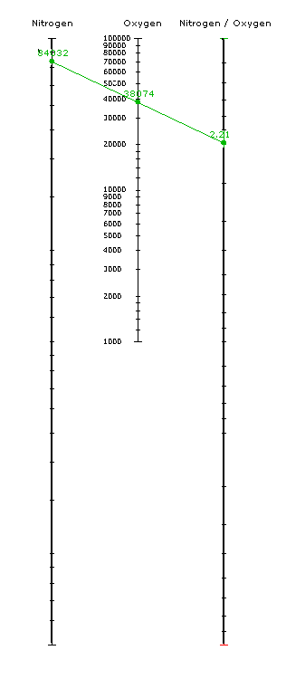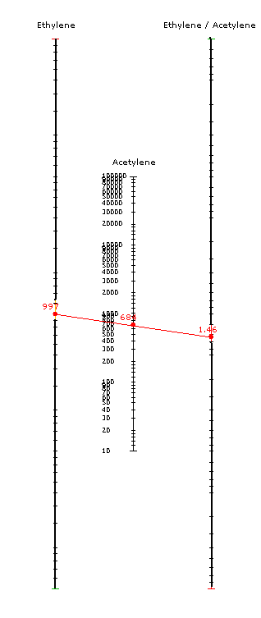

**Case Study 2 - Problem found**

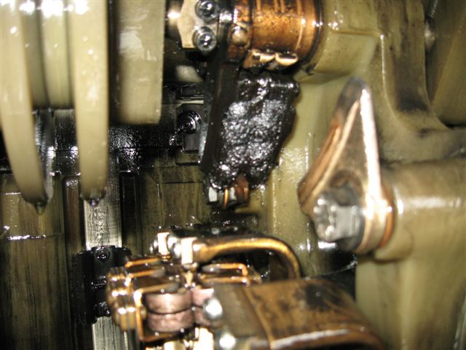

**Case Study 3 - Federal Pacific TC-25Sealed**

**ETHYLENE/ACETYLENE**

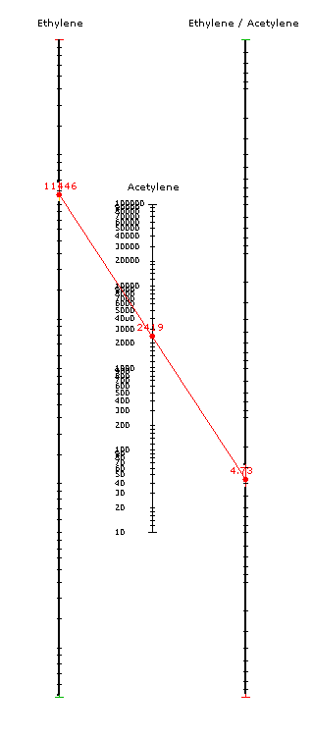

**Case Study 3 - Problem found**

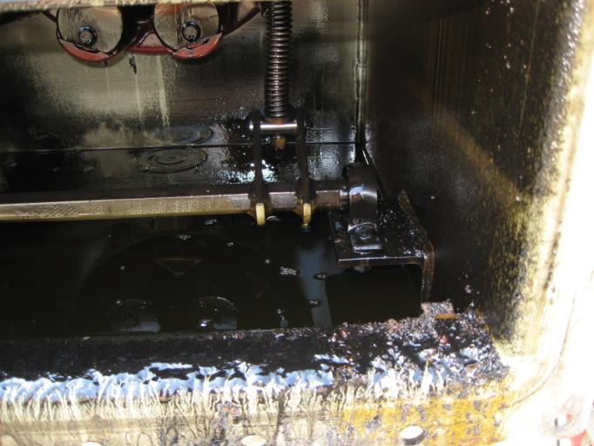

Discussion of the presentation followed.

Dave Wallach asked how the Nomograms are beneficial to a user if you have already calculated the statistical ratios of concern using C57.139-2010. Fredi answered that it is strictly a graphical presentation of the statistical norms that were selected. A user could develop a nomogram for a given model on their system and plot the ratio based upon sample data by connecting two points. The color coding would alert the user if there is a concern.. Not everyone has enough of the same LTC (minimum of 50) to generate their own nomograms, in that case they would use one of the 16 categories as a starting point or work with a laboratory that has a database of more units of this type for the evaluation of the results. (Some of the population concerns may be able to be overcome using a hybrid approach discussed later this meeting.)

**General/Refocusing**

A draft of the Guide and Appendix D for the Duval Triangle have been developed and are now available for review on the website and on the Central Desktop.

Dave indicated that he has been thinking about where we are at with the Guide.  One of the main reasons this document was immediately carried into a revision after publishing was to work on norms for different types of LTCs.  He indicated that from his perception we have arrived at a key decision point that at least for now given the different types, different maintenance practices, and different loading profiles that we will not be able to accomplish this goal at this time. However, Jim Dukarm and Michel Duval have been considering this point and may have a solution using a ratio and triangle hybrid approach (presented later this meeting)..

From previous ballot comments there was a commenter who suggested we consider benzene and toluene analysis in this next revision. The commenter promised to provide more background on this suggestion but has not to date. We will not pursue this topic without a sponsor or interest.

One of the ballot comments from the published guide was concern over using the word “fault” with a DGA interpretation. This term is commonly used with the topic of DGA. Any change would have to be coordinated through the Insulating Fluids Subcommittee since this term is used in other standards such as C57.104. We are not planning to pursue any change at this time and will see if it comes up again during the next ballot.

**Task Force Updates**

* **Task force Report submitted** by Jim Dukarm, presented by Dave Wallach

1. Statistical Method Summarized

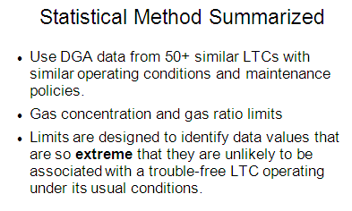

C57.139-2010 provides a respectable way to derive gas concentration and gas ratio limits from DGA data for a population of **50 or more, and preferably 100 or more** LTCs of the same model with similar operating conditions and maintenance. (See bullet 3 on slide). These limits are designed to identify data values that are so **extreme** that they are unlikely to be associated with a trouble-free LTC operating at its usual frequency.

2. Problems with C57.139-2010 Statistical Method

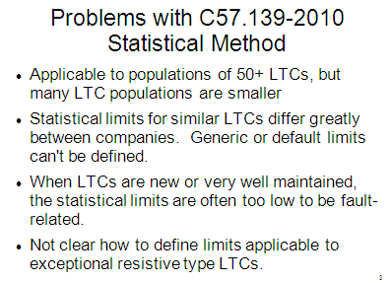

2.1. It is applicable to large LTC populations, but many LTC populations are smaller.

2.2. Limits for similar LTCs are known to differ greatly between companies, so "generic" or default limits, for generalized LTC types or for specific LTC models, could not be defined.

2.3. For companies with new LTCs or very effective maintenance practices, the statistical limits are often found to be too low to be fault-related.

2.4. It is not clear how to define limits by this method that will be useful for exceptional resistive type LTCs (those that while fault-free sometimes generate relatively large proportions of heating gas under ordinary operating conditions).

Problem 2.1 can be addressed by a modification of the statistical procedure, making it applicable to small populations of LTCs, at least for derivation of workable "first guess" limits. Such a modified procedure has been worked out and is being tested.

Problems 2.2 and.2.3 both arise because of the focus on defining what is extremely unusual for a given population. That is drastically affected by peculiarities (e.g. thick or thin tails) of the empirical distributions of gas concentrations or gas ratios. It is also related to the fact that **relative unusualness is not straightforwardly related to risk of failure**.

3. The Duval Triangle 2 for LTCs was published in late 2008 [D1], during preparation of the first version of C57.139.

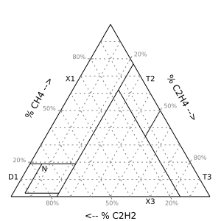

3.1 Unlike the "classic" Duval Triangle for transformer DGA, Triangle 2 has an N ("normal") zone in which the methane-ethane-acetylene data from LTCs in known good condition almost invariably fall.

3.2 The rest of the triangle is divided into zones identifying various abnormal conditions.

3.3 Experience, since the beginning [Duval, "A review of faults detectable by gas-in-oil analysis in transformers", IEEE Electr. Insul. Mag., 2002], has shown that it is extremely useful to plot sequences of samples in Triangle 2 for visualizing fault evolution.

3.4 For each of several exceptional resistive type LTCs, it is possible to define a second N zone representing its pattern of generating heat gas during normal operation [Duval, ref. D2].

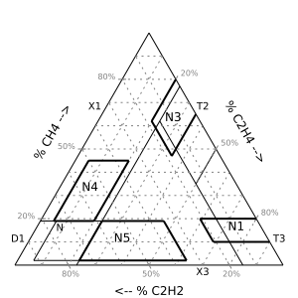

4. Extra N Zones for Exceptional Types

Duval Triangle 2 is based on documented cases and internal inspections of a variety of different LTC types. Its very general usefulness is due to a difference of emphasis between it and C57.139-2010. Triangle 2 characterizes **what is most definitely normal instead of what is highly abnormal**.

The degree of abnormality in each case is apparent visually by the distance of the plotted point from the N zone. The presence or absence of a trend indicates whether the LTC's condition is stable; if it is not stable, the approximate nature of the problem and its relative rate of worsening are visually apparent.

5. Gas Ratio Limits are Straight Lines

For the next version of C57.139, problem (2.1) can be addressed by modifying the statistical procedure. Problems (2.1) through (2.4) can be addressed by adopting a hybrid approach based on Triangle 2 with statistically or empirically determined features superimposed on it

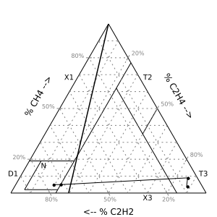

A C2H4/C2H2 ratio limit (in this case. **0.42**) can be represented by a line from the apex to the base.

CH4/C2H4 and C2H2/CH4 (or their inverses) are represented by lines from the other corners to the opposite side.

Example 3 (Burned Reversing Switch) from C57.139-2010 is plotted as 2 points in N followed by 2 points in T3. Thin line joining them indicates order of occurrence.

5.1. A locally defined population-specific gas ratio limit involving any two of the gases methane, ethylene, and acetylene can be plotted on the triangle as a straight line from one apex to the opposite side. Such superimposed limit lines can help to prioritize LTCs for maintenance or inspection.

5.2. Points representing samples where any of TDHG, ethylene, or acetylene exceeds its limit can be color-coded or plotted as a distinctive symbol. Statistically defined limits for gas concentrations are still required for detecting abnormally high gas concentrations.

5.3. For exceptional resistive type LTCs, an extra N zone, defined empirically or based on information provided by the manufacturer, can be plotted on the triangle. Sample points falling well outside of both the standard and the custom N zone represent cases that may need followup.

5.4. For populations where the statistical procedure for deriving gas ratio limits produces values known to be too conservative, the triangle defines (by the boundaries of the N zone(s)) default limits. For example, the rightmost edge of the N zone corresponds to an ethylene/acetylene ratio value of about 0.4, and the leftmost edge to a value of about 0.1, below which abnormal D1 arcing can be suspected.

6. Summary of the hybrid approach proposed for consideration is as follows:

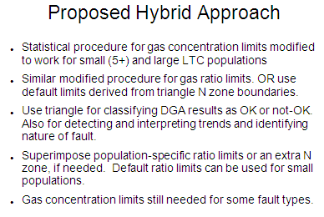

6.1. A modified statistical procedure that works for small and large LTC populations can be used for defining gas concentration outlier limits.

6.2. For small LTC populations, a similar modified procedure can be used for defining gas ratio limits. For the ethylene/acetylene ratio, default limits of 0.4 and 1.0 can be used and adjusted as required for good performance. For methane/acetylene and methane/ethylene, limits based on the boundaries of the N zone can be used as defaults.

6.3. Duval Triangle 2 is recommended for classifying DGA results as acceptable or not and for detecting and interpreting trends and the general nature of possible faults. Population-specific gas ratio limits superimposed on the triangle can provide additional indication of how extreme the results are. For exceptional LTC types, additional N zones can be superimposed on the triangle. The boundaries of those zones can be obtained from [D2] or from the LTC manufacturer, or defined empirically.

6.4. For cases where the sample point lies in or near the N zone, it is still necessary to consider whether acetylene, TDHG, or ethylene exceed a gas concentration limit, which can indicate unusual operating frequency, high load, or some kind of LTC problem that does not affect the gas ratios.

Discussion:

While there was not a quorum at this meeting, a poll was taken and the majority of the attendees agreed that this hybrid approach should be pursued by preparing the text to be included in the draft.

Dave indicated that after this version is published, he expects that it will need some time in the industry to develop more users and to collect feedback.

There were no comments or discussion. Dave indicated that we would continue on with additions to the document to present to the group at the next meeting.

Fredi Jakob indicated that the trending is the most significant item to look at. He indicated that is what he would be more concerned with rather than looking at absolute values. Fredi indicated that you can’t detect mechanical issues as they don’t have a DGA signature.

George Forrest asked if there was going to be some logical application notes or directions provided for how to use the guide. Dave W indicated that we need to be able to serve all types of users, experienced and non-experienced so there should be some direction provided for the non-experienced users.

The purpose of the guide is to give the user the tools to develop their own guidelines or baselines for different LTC types.

Dave indicated that it is still unclear whether the triangle belongs in the main body of the document or as an appendix. He will ask Jim Dukarm and Michel Duval for their thoughts on this.

The plan for the Working Group going forward from Munich to the St. Louis meeting is to:

* 1. Finish up Appendix D – Triangle (Wallach/Dukarm/Duval)
  2. Add Appendix E – Nomogram (Jakob/Dukarm)
  3. Create text and graphics to describe the hybrid approach discussed at the Munich meeting
  4. Generate draft and send to Working Group in advance of St. Louis meeting for review and comments.
  5. Resolve comments from Working Group
  6. Straw ballot by Working Group for approval to begin ballot process
  7. MEC & Legal Review
  8. Form Ballot Pool
  9. Ballot

**Old Business**

No old business was discussed.

**New Business**

No new business was discussed.

The meeting was adjourned at 11:56 am.

Dave Wallach, Chair

Mark Cheatham, Vice-Chair

Susan McNelly, Secretary

#### Working Group PC57.147, Guide for the Acceptance and Maintenance of Natural Ester Fluids in Transformers

TF Chair: Patrick McShane, Vice-Chair: Clair Claiborne, Secretary: Jim Graham

**The C57.147 WG Report Given at the Sub-Committee Meeting:** **Presented by Patrick McShane**

The WG had 59 members and guests sign-in, and the quorum requirements were met. Only TF1 and TF teams reported their progress, so a clear time line was determined, with the goal of publication of the revised standard by 2016. Rainer Frotscher of MR stated that their testing results indicate a need for a recommendation for fluids to determine significance and set limits to breakdown differentiation due to relative streamer velocity. During discussion it was stated that the IEC does not have a standard test method or requirement regarding streamers, and the issue doesn’t appear to be as relevant for transformers with their designs avoiding highly non-uniform fields. An ad hoc committee led by Rainier Frotscher was formed to research this issue, particularly as it may relate to LTCs.

The WG had a lengthy discussion whether or not a 300º C fire point should be a part of the requirements for continued use of service-aged natural ester insulating liquids (Table 5). Roberto Asano made a motion which carried to remove the fire point properties from Table 5 and move this information elsewhere within the guide. It was mentioned that insurance companies require equipment filled with natural esters to have nameplates identifying the fluid as a natural ester and meet the 300º C fire point and this requirement needs to be included in the guide.

The current standard (2008) is available at the IEEE TC web site in Word for WG members use to make recommended revisions.

**Minutes (unapproved) of the PC57.147 WG meeting as submitted:**

**PC57.147** **March 18, 2013**

**Munich, Germany**

**Chair: Patrick McShane, Vice-Chair: Clair Claiborne, Secretary: Jim Graham**

### Call to Order was made at 1:45 PM.

### Introductions/Membership Attendance/Quorum Check

* Attendance:
  + 21 of 36 members present, quorum was achieved
  + 38 guests
  + total attendance = 59
  + 8 guests requested membership

### A motion to approve the Fall 2012 minutes was made by David Sundin, seconded by Don Cherry, and approved.

* Chair's Remarks, Patrick McShane:
* WG Time Line:
  + Draft 1 – Ready for review at F13
  + 1st Straw Vote – Between F13 and S14
  + Draft 2 – Ready for review at F14
  + 2nd Straw Vote - Between F14 and S15
  + Final Draft Review and WG Vote - F15
  + Initiate Ballot Pool (IEEE SA) - ASAP
  + Ballot (IEEE SA)
  + Ballot Resolution (BRG formed and complete task)
  + Successful Vote (Mid Year 2016)
* Finalize Key Issues TF Final Reports
  + Key Issues: New Item – streamer velocity and breakdown in non-uniform fields. Rainer Frotscher of MR stated that their testing results indicate a need for a recommendation for fluids to determine significance and set limits to breakdown differentiation due to relative streamer velocity. According to Mr. Frotscher, Load Tap Changers (LTCs) typically have some non-uniform fields. Transformer designs on the other hand are designed to minimize non-uniformity. Asked if IEC has a standard test for streamer velocity, the answer was no. He added there is no IEC equivalent to ASTM D3300 impulse test either. Mr. Frotscher asked if the working group could create design rules for the dimensioning of dielectric gaps for contacts when using natural ester fluids. The WG Chair replied that SCIF scope is related to insulating liquids and particulars on equipment design is outside its scope. After some discussion, Raj Ahuja suggested adding a caution note about determining the proper dielectric gaps for natural esters for non-uniform stress design. The Chair added that transformer designs minimize non-uniform stress fields and no known field issue has come to his attention. Also, if any significant abnormal field stress should show up during routine power transformer production test, showing up as partial discharge. An ad hoc committee led by Rainier Frotscher was formed to research this issue, particularly as it may relate to LTCs.

### Task Force Reports

* + Stephanie Denzer reported TF8 had met and submitted a revised draft of section 8. The task force recommended removing Table 4, Test Limits for New Natural Ester Fluids, and modifying Table 5, Test Limits for Service Aged Natural Ester Fluids. The origin of the test limits used previously was questioned. The limits were copied from C57.106.
  + Don Cherry reported TF1 had met and submitted an updated draft of section 4 of the guide. The changes recommended were too numerous to discuss in detail.
  + The drafts received will be made available to the working group to review.
* Old Business
  + All task force chairs were directed by the chair to prepare their recommended revisions and submit them before the fall 2013 meeting
  + WG officers will review the C57.93 installation guide to determine if any of the items of interest for revision would be more appropriately addressed in the installation guide.
* New Business
  + Insurance companies require equipment filled with natural esters to have nameplates identifying the fluid as a natural ester. A suggestion was made to address this requirement in the guide.
  + Roberto Asano made a motion to remove the fire point properties from Table 5 and move this information elsewhere within the guide. Don Cherry seconded the motion. After spirited debate, a motion was made by Jim Graham to close discussion, seconded by Don Cherry. The motion to close discussion carried, and Mr. Asano’s motion also carried.

### The meeting adjourned at 3:00 pm.

Respectively submitted,

Jim Graham, Secretary

#### PC57.155 Natural Ester and Synthetic Ester DGA Guide

Chair: Paul Boman, Secretary: John Luksich

The C57.155 WG Report Given at the Sub-Committee Meeting: Presented by Paul Boman

No quorum was present. The current draft will be circulated for comments for next two weeks, then a straw ballot will issued, working on Draft 3. Insulating liquid terms will be included in Draft 3. There was discussion on how to make the data summary table more acceptable. Claude Beauchemin recommended rounding the values in the table, or it may be perceived to be more exact that the data justifies. Freddie Jacobs recommended stating that the math is correct. Claude said that may be used, but it is more an issue of psychology (perception of precision) than of technical correctness. After discussion the consensus was that next revision will include the confidence interval for the table.

It was suggested that this guide could be a candidate for dual logo. Draft 2 included some unreferenced documents in the normative reference section so those were moved to the bibliography. The Chair will E-mail the IEC TC10 Chairman about the prospects of making C57-155 a dual logo document.

**Minutes (unapproved) of the WG meeting as submitted:**

**Paul Boman– Chair, John Luksich - Secretary**

**Meeting Date: March 19, 2013 Time: 9:30 AM**

**Attendance: 12 members out of 57 members were in attendance, total attendance was 48 and 2 people requested membership.**

- Quorum not present

- Intend to approve minutes at next meeting with quorum

- review Spring 2011 minutes

**Continued business**

- Individual introductions

- Draft guide

- everyone received a copy (no hands raised when asked who did not receive it)

- resolution review group: Craig Stiegemeier, Jerry Murphy, Paul Boman, John Luksich

- asked everyone to check scope against draft to make sure all scope topics are addressed

- Comments to date 8 technical, 1 general and 17 Editorial

- some changes already made in draft 3

- “dielectric fluids” changed to “insulating liquids”

- moved the unused normative references to bibliography

- Jim Dukarm reviewed the C57.104 data to produce a statistical evaluation of ester data

- We should change “range” to “confidence interval”, as that’s what it really is

- Claude B suggested rounding table values to avoid a false sense of precision. Fredi J suggested using scientific notation. Jesse questioned the confidence interval (95 percent). Craig said rounding should be done, as it still gives a reasonable representation of the data.

- The next revision will include the confidence interval

- Should the document include some discussion of sample container handling? Fredi J said D3016 should be referenced, as pertinent instructions are given there. It was noted that it’s hard to control how the sample is handled. Appendix C discusses stray gases due to light exposure.

- In Section 6.2.1, “annual sampling” was changed to “routine sampling frequency”. In addition to baseline sampling, Rowland J. suggested that we add sampling after an event. Another suggestion was sample after a change in equipment status. Jim G. asked if a subsection should be added discussing re-energizing after an event. Some discussion of the section’s title. Roberto questioned whether 6.2.1 was needed at all. Perhaps remove the subsection and move everything up. Craig added that some discussion of establishing a baseline be added.

General comments on content?

- Rainer F. noted that IEC 60422 has a discussion of sampling frequency.

- C57.152 should be included in the references

- We use three Duval triangles. Is that confusing? We cannot use trade names, so they are labeled by base oil.

- Claude B. suggested that we show the differences in the three triangles, and that we should check with M. Duval as he has refined them a bit.

- Patrick M. asked what IEC is doing on DGA of alternate fluids. No ongoing work. Paul B. will inquire about dual logo. Claude noted that CIGRE has a working group.

The deadline for comments is April 2 (two weeks from today’s meeting).

Actions following Workgroup ballot include comment resolution and re-ballot if necessary. The document is then sent for the MEC review and establishing a ballot pool within IEEE SA Group.

Add as member:

Nick Perjanik

Jesse Inkpen

Send draft to:

Nick Perjanik (need Nick’s email)

Jesse Inkpen (sent)

**End of meeting.**

#### WG PC57.637 Guide for the Reclamation of Insulating Oil and Criteria for Its Use

WG Chair Jim Thomson, Vice-Chair TV Oommen

**The C57.637 WG Report Given at the Sub-Committee Meeting:**

There was no meeting held in Munich. The latest draft of the document was sent out for straw ballot to the WG in early March. The straw ballot will close April 20.

#### TF on Particle Count Limits in Mineral Oil

**Chair: Mark Scarborough, Vice-Chair T.V. Oommen, Secretary: Paul Boman**

**The TF Report given at the Sub-Committee Meeting:**

There was no meeting held in Munich. The TF was tasked with writing a white paper on the results of the research and survey done at the last meeting..

#### TF on Moisture in Oil

**Chair: Bob Rasor**

**The TF Report given at the Sub-Committee Meeting: Presented by Bob Rasor:**

There were 43 attendees at the meeting, however a quorum was not achieved. There were three presentations given:

* Bob Rasor on a recent interesting field example of a “very wet” transformer
* Valery Davydov on moisture solubility, and how important it is to factor “solubility limit” which is oil condition dependent. The more the oil is oxidized, the higher to potential over estimation of moisture in the transformer.
* Oleg Roizman on the use of the EPRI color chart with on line sensors – resulting in his creation of the moisture profile “cloud”.

**The TF Meeting Minutes (unapproved) as Received:**

**Monday March 18, 2013**

**3:15 to 4:30 pm Munich, Germany**

The meeting was called to order by Chair Bob Rasor at 3:15pm. There were 43 attendees. 18 of the 63 members were present. Two requested membership.

Attendees requesting membership:

Roberto Asano

Jimmy Rasco

1. Roster was distributed
2. Introductions took place
3. A general discussion of the minutes to last meeting were discussed briefly but not approved.
4. Scope was reviewed with a brief history of the TF.
5. Three presentations were given
   * 1. Bob Rasor on a recent field example
     2. Valery Davydov on the importance of a parameter call the Solubility Limit (SL) of the oil
     3. Oleg Roizman on the use of the color chart with on line sensors – creation of the moisture profile “cloud”
6. TF has now met for the 7th time.

**Bob Rasor presented** for about 15 minutes with 5 slides of review and 5 slides from a case study where a transformer was very wet and had been flagged by an elevated saturation. The water content of the oil in PPM stayed acceptable but saturation was over 20% continually. It was odd that the owner performed electrical testing and found it acceptable, yet as the photos in the slides showed, a large amount of water had come in through a faulty bushing gasket and rusted the top of the core steel and structures. Free water was also in the unit. Another clue the unit was wet was the lack of pressure year after year – it had a nitrogen blanket preservation system.

A few questions about the case study followed that were just clarifications.

**Dr. Valery Davydov** next presented 11 slides. The content was about the importance ofwhat is called the Solubility Limit (SL) of the oil. The data demonstrated that oil with properties normally associated with aging (significantly oxidized) has a different SL and therefore can overstate an estimate of the moisture in the transformer as compared to new or un-oxidized oil.

The data included a case study and graphs showing the need to consider this parameter. Ignoring the SL was represented to create a 100% error in the calculation of the oil ppm level and a 30% error in estimating the moisture in the paper insulation.



A few questions resulted which Valery answered. One question was "How do you test for the SL parameter". He answered there are labs that can provide this service and the values are then used to correctly calculate the ppm level of moisture in oil using the on-line Relative Saturation and Temperature data measured by the sensors.

**Dr. Oleg Roizman** next presented new information and data on the use of the EPRI color chart. Shown previously, his first slide was to review the concept of the color chart and how it uses temperature and ppm to indicate the condition of the insulation’s water content.

* Points on the chart with low temperatures and lower PPMs are considered less certain than samples with higher temperatures and/or higher ppms.



* The time for the sample to reach equilibrium was also considered in the chart. Lower temperatures and lower PPMs took a longer time period to reach equilibrium.
* With hundreds of samples from an on-line monitor, a plotting profile created what Oleg referred to as a “cloud”. The cloud uses many, many data points and was presented as an accurate estimation.
* The cloud exhibited an estimation for the already known moisture content in the winding. The top portion of the curve is a “false high” that is a result of cooling oil (moisture moves back into the insulation slower than it leaves). The ***location*** of the cloud on the chart (more than its upper and lower limits) is its importance. It shows the moisture content as very high (>3%), high (2-3%), questionable (1-2%) and dry(<1%)
* It was noted that the cloud for the same transformer showed lower moisture in the paper when using the TOP sample valve for the sensor location as compared to the BOTTOM valve. This is consistent with the accepted concept that the water content is highest in the lower sections of the transformer.



A question was raised as to the type of the sensor and how the algorithm works for the cloud. The sensor was from Visalia and the algorithm and its explanation are proprietary.

Another question was regarding the location of the probe for the bottom reading being in the sample valve. It was thought this location was “stagnant” and known to yield inconsistent results. The reply from Dr. Roizman was that this location is often reported to have temperature swings representative of moving oil and therefore appropriate given the findings.

The Power Point for this presentation will be posted on the IEEE website.

A motion was made to end the meeting

Motion seconded.

Meeting was adjourned at 4:20 pm

Submitted by: Bob Rasor, Chair – TF Moisture in Oil

#### TF on Consolidation of Insulating Fluid Guides

### Chair: Tom Prevost

#### The TF Report given at the Sub-Committee Meeting

No TF meeting was held in Munich. Susan McNelly apologized for not on getting a meeting time slot for the TF. A meeting will be set up for the St. Louis Meeting in October.

### Old Business:

### C57.121 Revision of the Less-Flammable Hydrocarbon Insulating Fluid Guide: A PAR request for revision of this document will be submitted. This was approved at the Milwaukee meeting. Dave Sundin has agreed to chair this effort. A meeting timeslot will be requested for the Fall meeting in St. Louis.

### Status of data storage and confidentiality issue: Presented by Sue McNelly

Susan stated that she is working on a protocol for access to stored data. Tom Prevost will be chairing and effort to deal with the confidentiality aspect. This issue has held up progress by the work on C57.104.

### New Business:

**Review of membership guidelines for WGs and TFs:** **Presented by Sue McNelly**

Susan reviewed the requirements for membership and the importance of maintaining rosters. She also indicated that the WG and TF Chairs must keep regular tabs on attendance and keep the membership status up to date in the IEEE TC AMS system. They should also assure that the Secretary or Vice Chair note the names of members who make motions and second motions, and report them in the meeting minutes.

Question by Bob Rasor to the Chair: Do the names of those who make comments during the meeting need to be recorded? Answer: Not required, but it is recommended.

**The Chair adjourned the meeting at 4:15PM**

**Respectfully Submitted:**

**Susan McNelly, Fluids SC Chair**

**Jerry Murphy, Fluids SC Vice-Chair**

**Patrick McShane, Fluids SC Secretary**