1. **Recognition and Awards – Chair: Bill Chiu**

## Special Tributes

Over the course of the past several months since our previous meeting in October 2014 at Washington DC, the Transformers Committee and the industry lost four of our life-long contributors. At our Awards luncheon on Tuesday, the meeting attendees gathered to pay special tributes to the four friends who passed away recently.

**David A. Keithly (1942 – 2015)**

David passed away on Saturday, March 14, 2015.

David started in 1966 at Allis-Chalmers in West Allis, Wisconsin (of which the electrical division became Siemens-Allis). He then worked 11 years at RTE-ASEA in Waukesha (which later became Magnetek, then Waukesha Electric, and now SPX), before moving to North Carolina to work for Siemens. He retired from Siemens in 2008. Dave was an active participant in the IEEE Transformers Committee, and he and his wife Joanne were regular attendees at those meetings. For those of you who knows Dave and live near Raleigh, you may want to take note of the memorial service that will be held on May 9 (Dave's birthday) at 11 am at Grace Lutheran Church in Raleigh.

A couple of representative remarks shared are include below:

*“I knew Dave fairly well. He was a VERY active participant in the Committee, and he and his wife Joanne regularly attended the meetings for many years. He retired from Siemens 6-7 years ago, and the last meeting he attended was in 2006 (Montreal). I know he's been short of breath for many years. I remember in 2009-10, he was in the hospital for several weeks, and in a nursing home / rehab center for 3-4 months after that. Shortly after that, he had an operation to remove some clots in his lungs, and he's been in fairly good health since then. We stayed in occasional contact by email.” - G. W. Anderson*

*“Echoing Phil Hopkins’s thoughts – another Good Man lost to us.  In addition to learning a few things, you did feel good just being in Dave’s company - so we’re all diminished a bit, and saddened, by his passing.” - D. J. Fallon*

**Alexander D. “Don” Kline (1925 - 2014)**

Don passed away on Monday, November 24, 2014

Don was born in Newark, New Jersey in 1925. Don received his Bachelor of Science degree in Mechanical Engineering from Columbia University in 1946. Like many able young men at that time, he served in the military to protect our country in his early years. He was a member of the Navy College Training V-12 Program, and was a Commissioned Officer of the Naval Reserves and again from 1953-1955 as a Junior Grade Lieutenant. He first joined GE in 1946 after having earned his BSME degree from Columbia University and worked in the transformer departments of Pittsfield, Massachusetts from 1946-1953. He worked at Rome Georgia from 1955-1962, and at the Philadelphia Switchgear Department from 1964-1966. During his Rome, GA assignment, Don received the coveted Cordiner Award (named after GE’s Chairman Ralph Cordiner) for his exceptional work on Transformer Design and Value Analysis. He also became an expert in dry-type transformer design. From 1966-1969, Don worked for Ensign Electric & Manufacturing Co. in Huntington, West Virginia, a new plant where Nomex Insulation was introduced for dry-type transformers. Then from 1969-1991, he founded and ran the Southern Transformer Company in East Point, Georgia (near Atlanta), which produced 15-5000 kVA dry-type transformers. Don could not retire; instead he became a consultant in 1991 until his passing. He specialized in dry-type transformers, rectifiers, and transit duty transformers. He was a Registered PE in Georgia and New York. Don was also a Senior Life member of IEEE, and for many years he participated in the Transformers Committee and also in the Rail Transit Committee.

He leaves behind his dear wife, Carolyn, who he married in 1953 while at GE Pittsfield. There is a little known fact that Don’s wife Carolyn designed the power transformers that continue to operate at Hoover Dam.

**Jeewan L. Puri (1938 – 2014)**

Jeewan passed away suddenly on Monday, November 17, 2014.

Jeewan was born in New Delhi, India in 1938 and received his Bachelor of Science degree from Punjab University. He moved to the United States where he obtained his Master’s Degree in Electrical Engineering from the Illinois Institute of Technology in Chicago. In 1967, Jeewan joined Westinghouse Electric and had numerous assignments in Large Power Transformers in Muncie, Indiana; High Voltage Bushings in Alamo, Tennessee; and Distribution Transformers in Athens, Georgia. He was awarded the "George Westinghouse Signature Award" for Engineering Excellence at Westinghouse Electric Corporation in 1988. Jeewan also held assignments with Cooper Industries in Canonsburg, Pennsylvania and with Square D in Monroe, North Carolina.

While he was with Square D/Schneider Electric, Jeewan earned the "People Who Made a Difference Award" in 1997. In 2001, Jeewan started his own Transformer Consulting firm, called Transformer Solutions, Inc. which he managed until his passing.

Jeewan was a long time member of the IEEE Transformers Committee in which he rose quickly to chair of the Audible Sound & Vibrations Subcommittee. He also actively participated as a member of the US Technical Advisory Group for IEC TC 14 (Power Transformers Section of the International Electro-Technical Commission).

*“….. Jeewan was one of a handful of my earlier mentors when I first started attending the Transformer Committee meetings. I know I speak for many in sharing that Jeewan was truly a gentleman, always kind to me despite of my earlier ignorance. He welcomed me to the group and was very patient to have explained some of the unwritten rules of the how the committee functions and some of the dos and don’ts and the professional etiquette of how to get things done……In the earlier years, there was a more stringent requirement to have at least two subcommittee chairs to be willing to be your sponsor, and Jeewan was one of the two subcommittee chairs who sponsored my committee membership…and I can honestly say that I would not have been given the great opportunity to serve the committee if it wasn’t for Jeewan’s sponsorship.” - B. Chiu*

**William (Bill) J. McNutt (1927 - 2014)**

Bill passed away on Friday, November 14, 2014.

Bill was born in Philadelphia, Pennsylvania on Aug. 31, 1927. He was the son of Thomas and Mary V. McNutt. He graduated from high school at Germantown Friends School in Philadelphia in 1945. He served in the Navy from 1945 to 1946, and on his return he earned a BSEE degree from Tufts College, Medford, Mass. in 1950 and an MSEE degree from the Illinois Institute of Technology in 1952. He joined General Electric Company's Large Power Transformer Department from 1952 until its closure in 1986. After that, he continued his career as Berkshire Transformer Consultants and provided worldwide transformer consulting services.

Bill was an active participant in IEEE and CIGRE. He was recognized as an IEEE Fellow in 1976 for contributions to the design of power transformers and standardization of test procedures, and was awarded the Charles Proteus Steinmetz award for sustained contributions and leadership in the development of standards for power transformers. He was chair of the IEEE Transformers Committee from 1981 to 1982, and was recognized twice with the Transformers Committee's Distinguished Individual Service Award. The recognition of his key role to the industry went beyond the Committee when he was elected to the National Academy of Engineering for his contributions to the design and development of large power transformers. Bill was committed to his family and was an active participant in his church and local community. In addition, he found time for recreation, enjoying square dancing, bridge, golf, and tennis.

The Transformer World lost a giant on November 14, 2014. Bill McNutt, who was 87, was a leader, teacher, mentor and friend to all of us in the committee and across the industry.

Below are few thoughts and remembrances for Bill:

*"He took time to mentor me as a young engineer, and later worked for me when I returned to Pittsfield, where he continued to mentor me! Bill was the engineer's engineer and fully enjoyed his opportunities to attend IEEE and associate with each of us and those that went before. I remember how he delighted in downplaying shell-form construction and how absolutely sure he was that core-form was the only way to build a transformer!" - P. J. Hopkinson*

*"What can I say - he was such a good person - such a loss. To me, Bill was always the standard against which you graded your work. In my experience, he was a technical giant but also a very caring person, looking out for the best for his people. There are very few like him." - R. C. Degeneff*

*"The Transformer Industry lost one of its giants who I believe, probably contributed more to this industry than anyone I know in our lifetime. He is one of the greats of our time. One day in July 1979, I interviewed with Bill, Bob Degeneff, and Joe MacDonald in Pittsfield for a job there; a day after I interviewed with Harold Moore for a job at Westinghouse Muncie. The rest is history.” - R. Girgis*

*"The summer that Ramsis was interviewing with Bill, I was just starting out on my career at GE. Little did I know how much I would benefit from Bill's mentoring! His advice & personal interest shaped both my career and my way of living. It was truly a lifetime legacy that Bill gave me." - J. McIver*

*"He was a teacher, mentor, and friend when I was a young engineer just starting to learn about how transformers worked. We are all fortunate to have known Bill." - D. J. Fallon*

*"As for me personally, I can say that I was one of the privileged few to have been his student in a week-long intensive transformer class that he personally thought back in 1993 in Schenectady, New York. Thinking back, it was really my formal technical indoctrination to the field of power transformers and as some have said before, the rest is history.” - B. Chiu*

## Committee Membership Certificates

The Transformers Committee welcomes three new full committee members. Each of the following new members was presented with a membership certificate:

|  |  |
| --- | --- |
| New Member | Affiliation |
| ***Josh Herz*** | *Qualitrol LLC* |
| ***George Payerle*** | *Carte International Inc.* |
| ***Shibao Zhang*** | *Pcore Electric* |

## IEEE Fellow – Class of 2015

IEEE Fellow is a distinction reserved for select IEEE members whose extraordinary accomplishments in any of the IEEE fields of interest are deemed fitting of this prestigious grade elevation. This Fellow’s Nomination Process involves a lengthy nomination documents describing the accomplishments and contributions in details. It requires a number of references, and also a number of endorsers, who each also have to write a separate endorsement that describe why the candidate is deserving of this prestigious recognition.

At this meeting, the Transformers Committee is honored to have one of our very own active member and contributor, **Mr. Gary Hoffman**, to be selected to the 2015 class of IEEE Fellow for his leadership in the advancement of monitoring systems for power transformers and power line protection*.*

Garyis Founder, President and CEO of Advanced Power Technologies where he has been for the last 15 years. Previous to starting APT, Gary was General Manager of ALSTOM T&D Protection and Control Division in the US where he spent three years. Prior to ALSTOM, he was with RFL Electronics where he held various executive positions including Senior Vice President of Sales and Marketing, Vice President of Operations, and Vice President of Engineering over an 8-year period. Mr. Hoffman holds 9 U.S. and Foreign Patents.

Gary’s many contributions to the IEEE Transformers Committee include the Chair of Working Groups C57.12.10 and C57.116 as well as Vice Chair of PC57.163. He is also a member of the IEEE SA Standards Board, member AudCom and ICCom past member of RevCom, ProCom, and PatCom. He is the author of Chapter 24 of a book titled On-Line Monitoring of Liquid-Immersed Power Transformers. This book is edited by James H. Harlow. Mr. Hoffman’s chapter deals with economic justification for on-line monitoring and covers the various techniques used to perform on-line monitoring major power transformer components including Power Transformer Core, Coil, and insulation systems; Power Transformer bushings; Load Tap Changers; Instrument Transformers. He is also a contributor to EPRI’s The Copper Book, Chapter 9--Monitoring and Diagnostics. Gary holds a B.S. Engineering and M.S. Electrical Engineering from the State University of New York at Stony Brook.

The Transformers Committee presented a heartfelt congratulatory certificate of merit to recognize and celebrate Mr. Hoffman’s achievement.

The list of IEEE Fellows from the Transformers Committee as included below for reference (in alphabetical order the last name).

|  |  |  |
| --- | --- | --- |
| **Name of IEEE Fellow** | **Year** | **Citation** |
| Dennis J. Allan (Life Fellow) | 1992 | for contributions to the design and development of power transformers |
| Peter M. Balma | 2013 | for leadership in developing technical guides for electric power equipment |
| Ray Bartnikas (Life Fellow) | 1977 | for contributions to the field of dielectric and corona loss mechanisms in electrical insulating systems. |
| William H. Bartley | 2014 | for contributions to the development of generator and transformer standards for life cycle planning and risk assessment |
| Robert C. Degeneff (Life Fellow) | 1993 | for contributions to the modeling and computation of transient voltages in transformer windings |
| Ramsis S Girgis (Life Fellow) | 1993 | for contributions to reductions in the losses of large power transformers |
| James H. Harlow (Life Fellow) | 2013 | for leadership in IEEE technical and standardization committees on transformer technology |
| Philip John Hopkinson (Life Fellow) | 2002 | for contributions to the reliability of distribution transformers and the development of related standards for testing and application |
| Gary Hoffman | 2015 | for leadership in the advancement of monitoring systems for power transformers and power line protection |
| William J McNutt (Life Fellow) | 1976 | for contributions to the design of power transformers ad standardization of test procedures |
| Harold R. Moore (Life Fellow) | 1997 | for leadership in the development, design, and application of power transformers and associated equipment |
| Linden W. Pierce (Life Fellow) | 2000 | for contributions to the understanding of heat transfer and loading of liquid-immersed and dry type power and distribution transformers |
| Robert A. Veitch (Life Fellow) | 1998 | for leadership in the development and design of very large and extra high voltage transformers, shunt reactors and associated equipment |
| Loren B. Wagenaar (Life Fellow) | 1996 | for contributions to transformer and bushing test standards and specifications |
| Dean A. Yannucci (Life Fellow) | 1990 | for leadership in the development and manufacture of large power transformers |

Committee members are encouraged to nominate our fellow contributors for this distinguished recognition of Fellow. Nominations, including references by at least five present IEEE Fellows and optional additional endorsements, must be completed and submitted by March 1 of each year for the following year’s Class of Fellows.

## Special Service Awards & Certificate of Appreciation

In any successful organization, there are always a handful of hard working individuals behind the scene that put in the sweat and tears year after year in contributing to our success at each one of our meetings. Often the real contributors are not necessarily those who held the official titles. The Transformers Committee wishes to take a pause and recognize **Mr. Sheldon Kennedy** for his manyyears of service to us and also to the industry.

Sheldon graduated with a Bachelor of Science degree in Electrical Engineering from the Pennsylvania State University in 1975. Upon graduation he worked for the Allegheny Power Service Corporation in Greensburg, Pennsylvania as a Transmission Substation Engineer and as a Rate engineer. In 1982 he joined the R. E. Uptegraff Manufacturing Company, a transformer manufacturer, in Scottdale, Pennsylvania as Chief Electrical Engineer. He also served as a part time Electrical Engineering Instructor in Electrical Engineering and for Professional Engineering Exam Review Classes at the Pennsylvania State University Fayette Campus in Uniontown, Pennsylvania from 1981 to 1985. He is the United States industrial convertor transformers representative to IEC from the ANSI National Committee Technical Advisory Group. He was the NEMA Transformer Section Chairman from 2000 to 2003. He was the past Chairman of the Accredited Standards Committee C57 – Transformers, Regulators, and Reactors from 2002 to 2005. In addition, he is also a member of the Industry Applications Society and Chairman of the Electrochemical Subcommittee of the PCIC - Petroleum and Chemical Industry Committee. He is the author of the Rectifier Transformer chapter in the CRC book, “Electric Power Transformer Engineering”.

Sheldon is not only a long time attendee, but most importantly, a steadfast contributor and a technical leader to many of our specialty product standards such as the semiconductor power rectifier transformers, arc furnace transformers, neutral grounding devices, and also the non-ventilated dry type transformers. Sheldonis currently employed by Niagara Transformer Corporation as their Vice President of Engineering.

The Transformers Committee presented a heartfelt congratulatory certificate of appreciation to recognize and celebrate Sheldon’s contributions to the IEEE Transformers Committee and to our industry.

|  |  |  |
| --- | --- | --- |
| Name of Award Recipients | Affiliation | Contributions |
| ***Sheldon P. Kennedy*** | *Niagara Transformer Corporation* | *“Outstanding Contributor”*  *to the Transformers Committee* |

## IEEE SA Standards Board Awards

In addition to the Committee Awards above, the IEEE SA SB presents its own Award to the WG Chair upon publication of a new or revised document, and offers the WG Chair the opportunity to nominate significant contributors to the project for an IEEE SA SB Certificate of Appreciation. All Working Group Chairs chose to have their awards sent direct to their residence or place of business. The award recipients were called forward for recognition during our Awards Luncheon on Tuesday.

**IEEE SA Award Reccipients:**

**Revisions to C57.12.01 - Standard for General Requirements for Dry-Type Dist. & Power Transformers**

***Timothy L. Holdway*** *- Working Group Chair*

***Casey Ballard*** *– Working Group Vice Chair*

***Rick Marek*** *- Significant Contributor*

***Aleksandr Levin*** *- Significant Contributor*

***Marcel Fortin*** *- Significant Contributor*

***Roger Wicks*** *- Significant Contributor*

**C57.153 - Guide for Paralleling Power Transformers**

***E. Tom Jauch*** *- Working Group Chair*

***James Graham*** *- Working Group Vice Chair*

***Stephen Anthony*** *- Significant Contributor*

***Jim Harlow*** *- Significant Contributor*

***Dave Harris*** *- Significant Contributor*

***Mark Tostrud*** *- Significant Contributor*

***Karsten Viereck*** *- Significant Contributor*

**C57.155 - Guide for Interpretation of Gases Generated in Natural and Synthetic Esters**

***Paul Bowman*** *- Working Group Chair*

***John Luksich*** *- Working Group Secretary*

***Jim Dukarm*** *- Significant Contributor*

***Dave Hanson*** *- Significant Contributor*

## Other IEEE PES Awards

The IEEE PES recognizes important technical, educational and service contributions through the conferral of numerous awards. The listing below highlights the various other awards that are available through the IEEE PES organization.

* [IEEE PES Award for Excellence in Power Distribution Engineering](http://grouper.ieee.org/groups/td/dist/distaward.html)
* [IEEE PES IAS A.P. Seethapathy Rural Electrification Excellence Award](http://www.ieee-pes.org/iaspes-ap-seethapathy-rural-electrification-excellence-award)  
  Nominations due by February 1st
* [IEEE PES Charles Concordia Power Systems Engineering Award](http://www.ieee-pes.org/charles-concordia-power-system-engineering-award)  
  Nominations due by January 31st
* [IEEE PES Cyril Veinott Electromechanical Energy Conversion Award](http://www.ieee-pes.org/cyril-g-veinott-electromechanical-energy-conversion-award)  
  Nominations due by February 1st
* [IEEE PES Douglas M. Staszesky Distribution Automation Award](http://www.ieee-pes.org/douglas-m-staszesky-distribution-automation-award)  
  Nominations due by January 1st
* [IEEE PES Lifetime Achievement Award](http://www.ieee-pes.org/lifetime-achievement-award)  
  Nominations due by February 1st
* [IEEE PES Leadership in Power Award](http://www.ieee-pes.org/leadership-in-power-award)  
  Nominations due by February 1st
* [IEEE PES Meritorious Service Award](http://www.ieee-pes.org/meritorious-service-award)
* [IEEE PES Nari Hingorani Custom Power Award](http://www.ieee-pes.org/nari-hingorani-custom-power-award)  
  Nominations due by January 31st
* [IEEE PES Nari Hingorani FACTS Award](http://www.ieee-pes.org/nari-hingorani-facts-award)  
  Nominations due by January 31st
* [IEEE PES Outstanding Chapter Award](http://www.ieee-pes.org/pes-communities/awards/chapter-awards)
* [IEEE PES Outstanding Power Engineering Educator Award](http://www.ieee-pes.org/outstanding-power-engineering-educator-award)   
  Nominations due by January 31st
* [IEEE PES Outstanding Young Engineer Award](http://www.ieee-pes.org/outstanding-young-engineer-award)  
  Nominations due by Februrary 1st
* [IEEE PES Prabha S. Kundur Power System Dynamics and Control Award](http://www.ieee-pes.org/ieee-pes-prabha-s-kundur-power-system-dynamics-and-control-award)  
  Nominations due by January 31st - [Call for Nominations](http://www.ieee-pes.org/call-for-nominations-for-the-2014-ieee-pes-prabha-s-kundur-power-system-dynamics-and-control-award)
* [IEEE PES Prize Paper Award](http://www.ieee-pes.org/prize-paper-award)
* [IEEE Power & Energy Society Ramakumar Family Renewable Energy Excellence Award](http://www.ieee-pes.org/ieee-pes-ramakumar-family-renewable-energy-excellence-award)
* [IEEE PES Robert P. Noberini Distinguished Contributions to Engineeering Professionalism Award](http://www.ieee-pes.org/robert-p-noberini-distinguished-contributions-to-engineering-professionalism-award) Nominations due by February 1st
* [IEEE PES G. Ray Ekenstam Memorial Scholarship](http://www.ieee-pes.org/g-ray-ekenstam-memorial-scholarship)Nominations due by June 30th
* [IEEE PES Scholarship Plus Initiative](http://www.ee-scholarship.org/)Applications due by June 30th
* [IEEE PES Roy Billinton Power System Reliability Award](http://www.ieee-pes.org/roy-billinton-power-system-reliability-award)  
  Nominations due by February 1st
* [IEEE PES Student Prize Paper Award in Honor of T. Burke Hayes](http://www.ieee-pes.org/student-prize-paper-award-in-honor-of-t-burke-hayes)  
  Nominations due by December 15th
* [IEEE PES Uno Lamm High Voltage Direct Current Award](http://www.ieee-pes.org/uno-lamm-high-voltage-direct-current-award)  
  Nominations due by November 30th
* [IEEE PES Wanda Reder Pioneer in Power Award](http://www.ieee-pes.org/ieee-pes-wanda-reder-pioneer-in-power-award)  
  Nominations due by January 15th
* [IEEE PES Working Group Recognition Awards](http://www.ieee-pes.org/working-group-recognition-awards)  
  The PES Working Group Recognition Awards recognize “the most outstanding and timely publications” by a PES Working Group (or Committee or Subcommittee) from among the nominations. The PES Recognition Award is divided into two categories: 1) for technical reports; 2) standards and guides. Each Technical Council Committee may nominate one report from each category, published by IEEE, during the previous three year period.” This award consists of a plaque which will be presented to the Working Group Chair at the PES Summer Meeting Awards Luncheon. A framed certificate will be presented to each Working Group member at a designated meeting of the parent Technical Committee.
* [IEEE PES CSEE Yu-Hsiu Ku Electrical Engineering Award](http://www.ieee-pes.org/yu-hsiu-ku-electrical-engineering-award)

## Presentation Slides from the Awards Luncheon

The slides from the presentation used at the Tuesday’s Awards Luncheon are included below for reference.

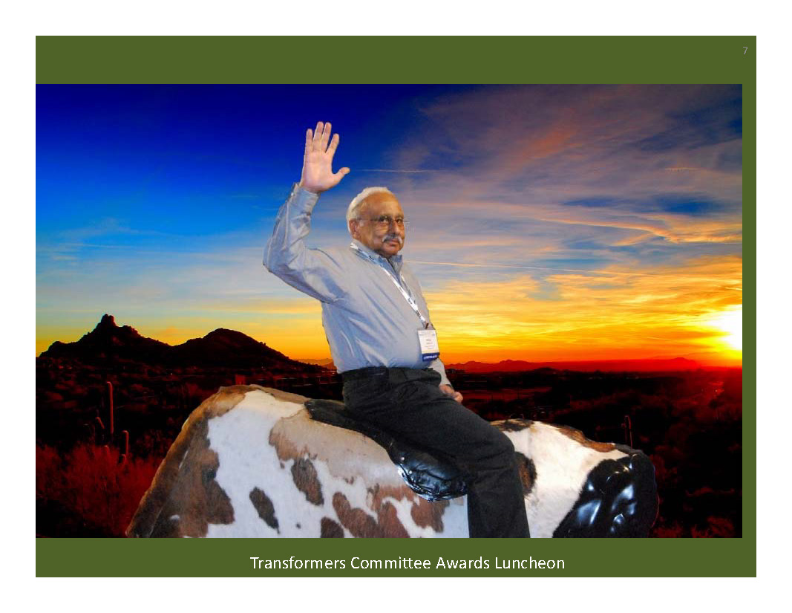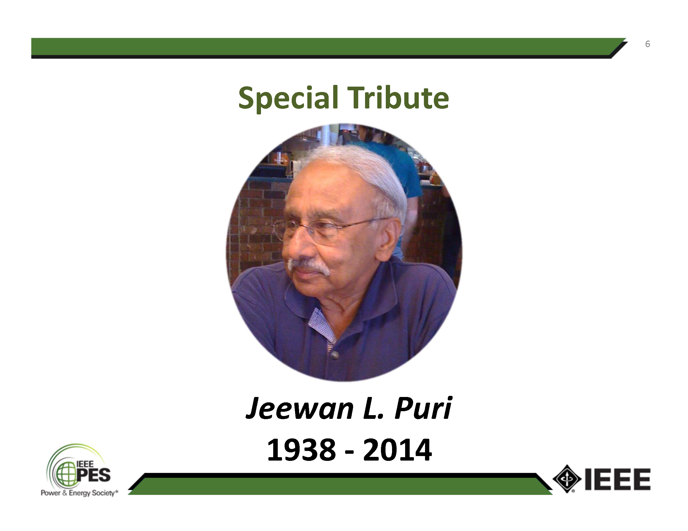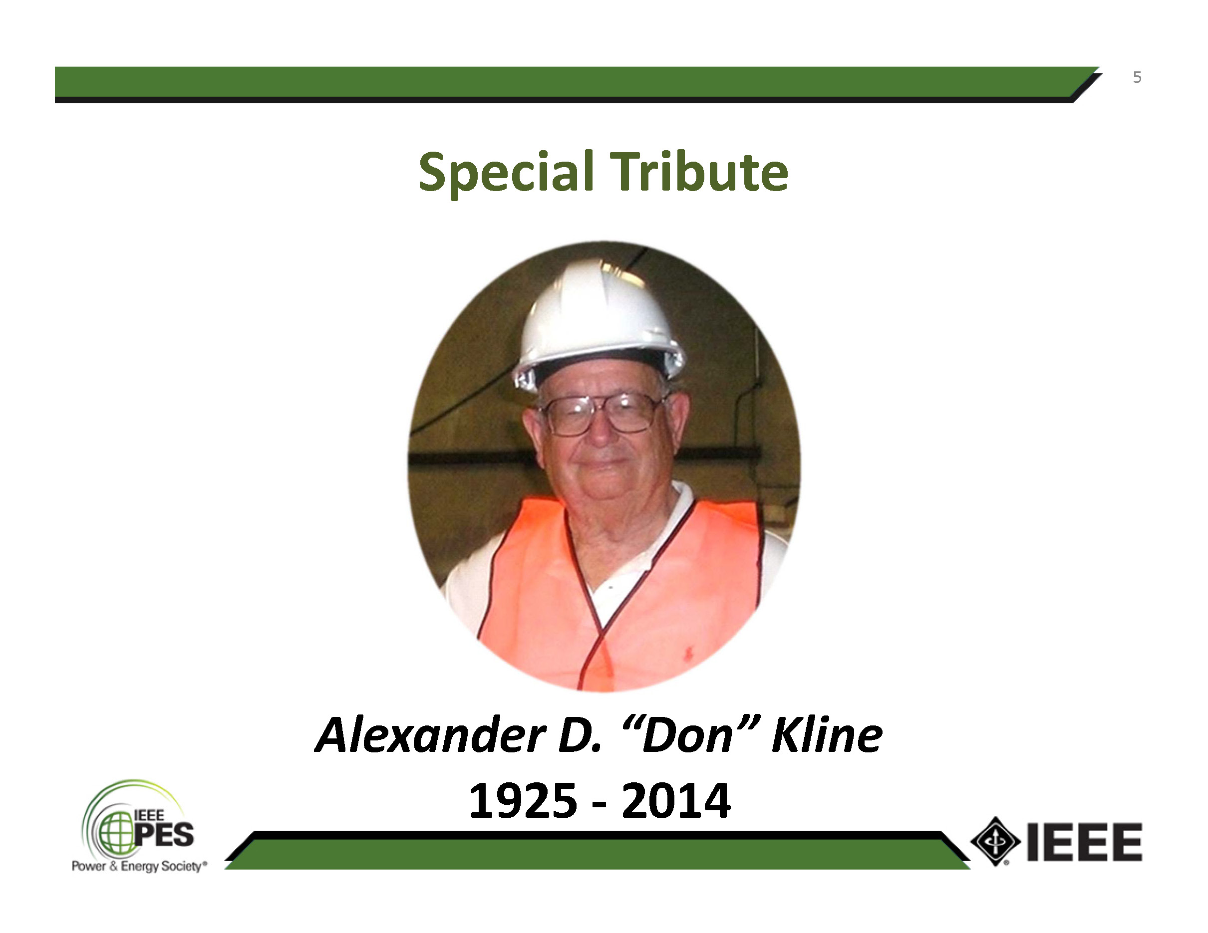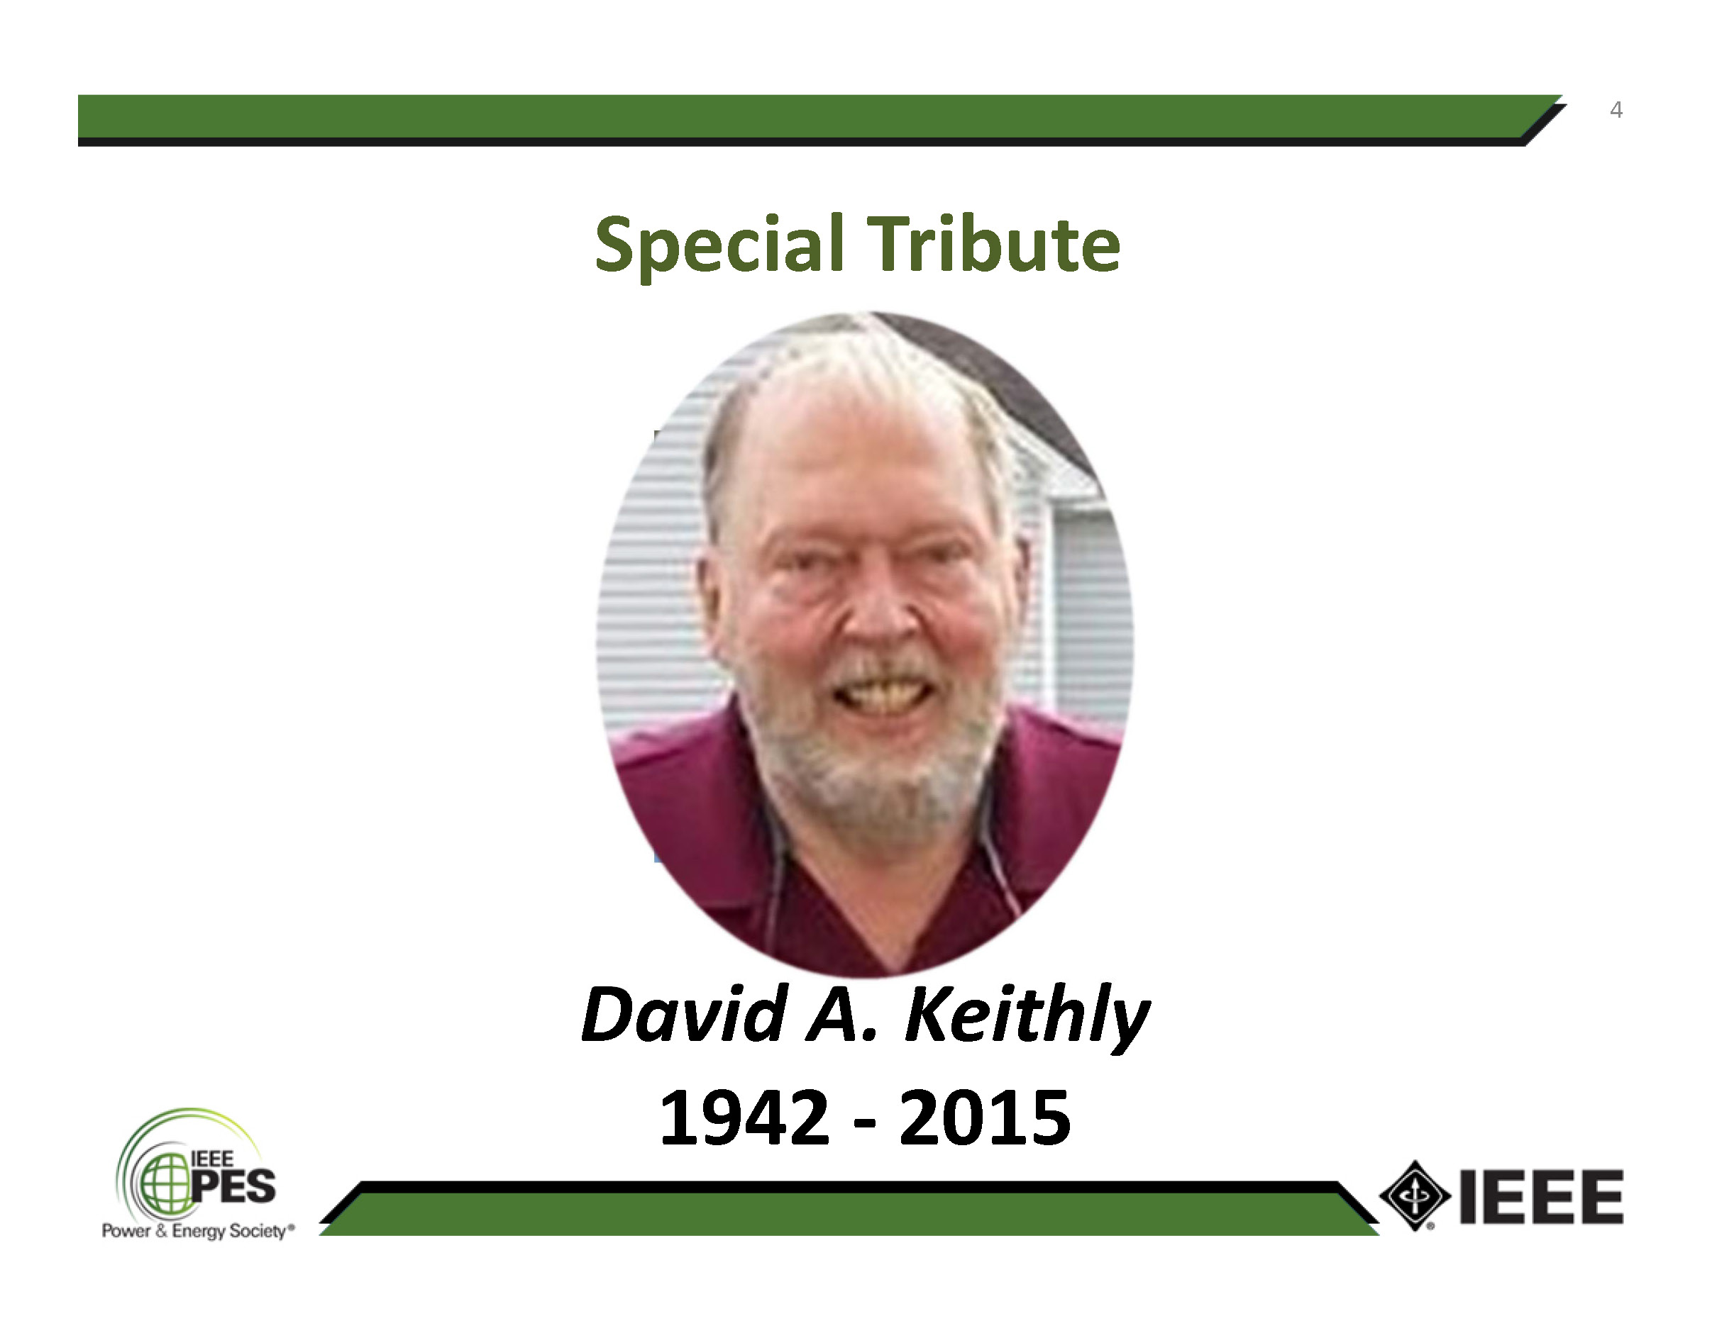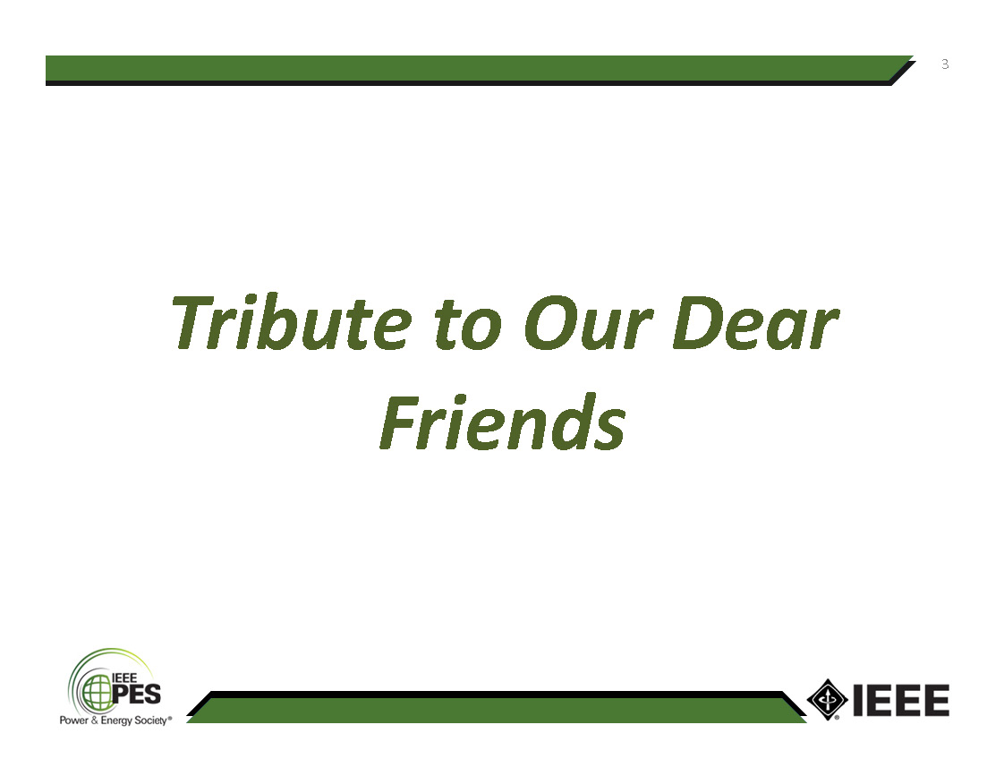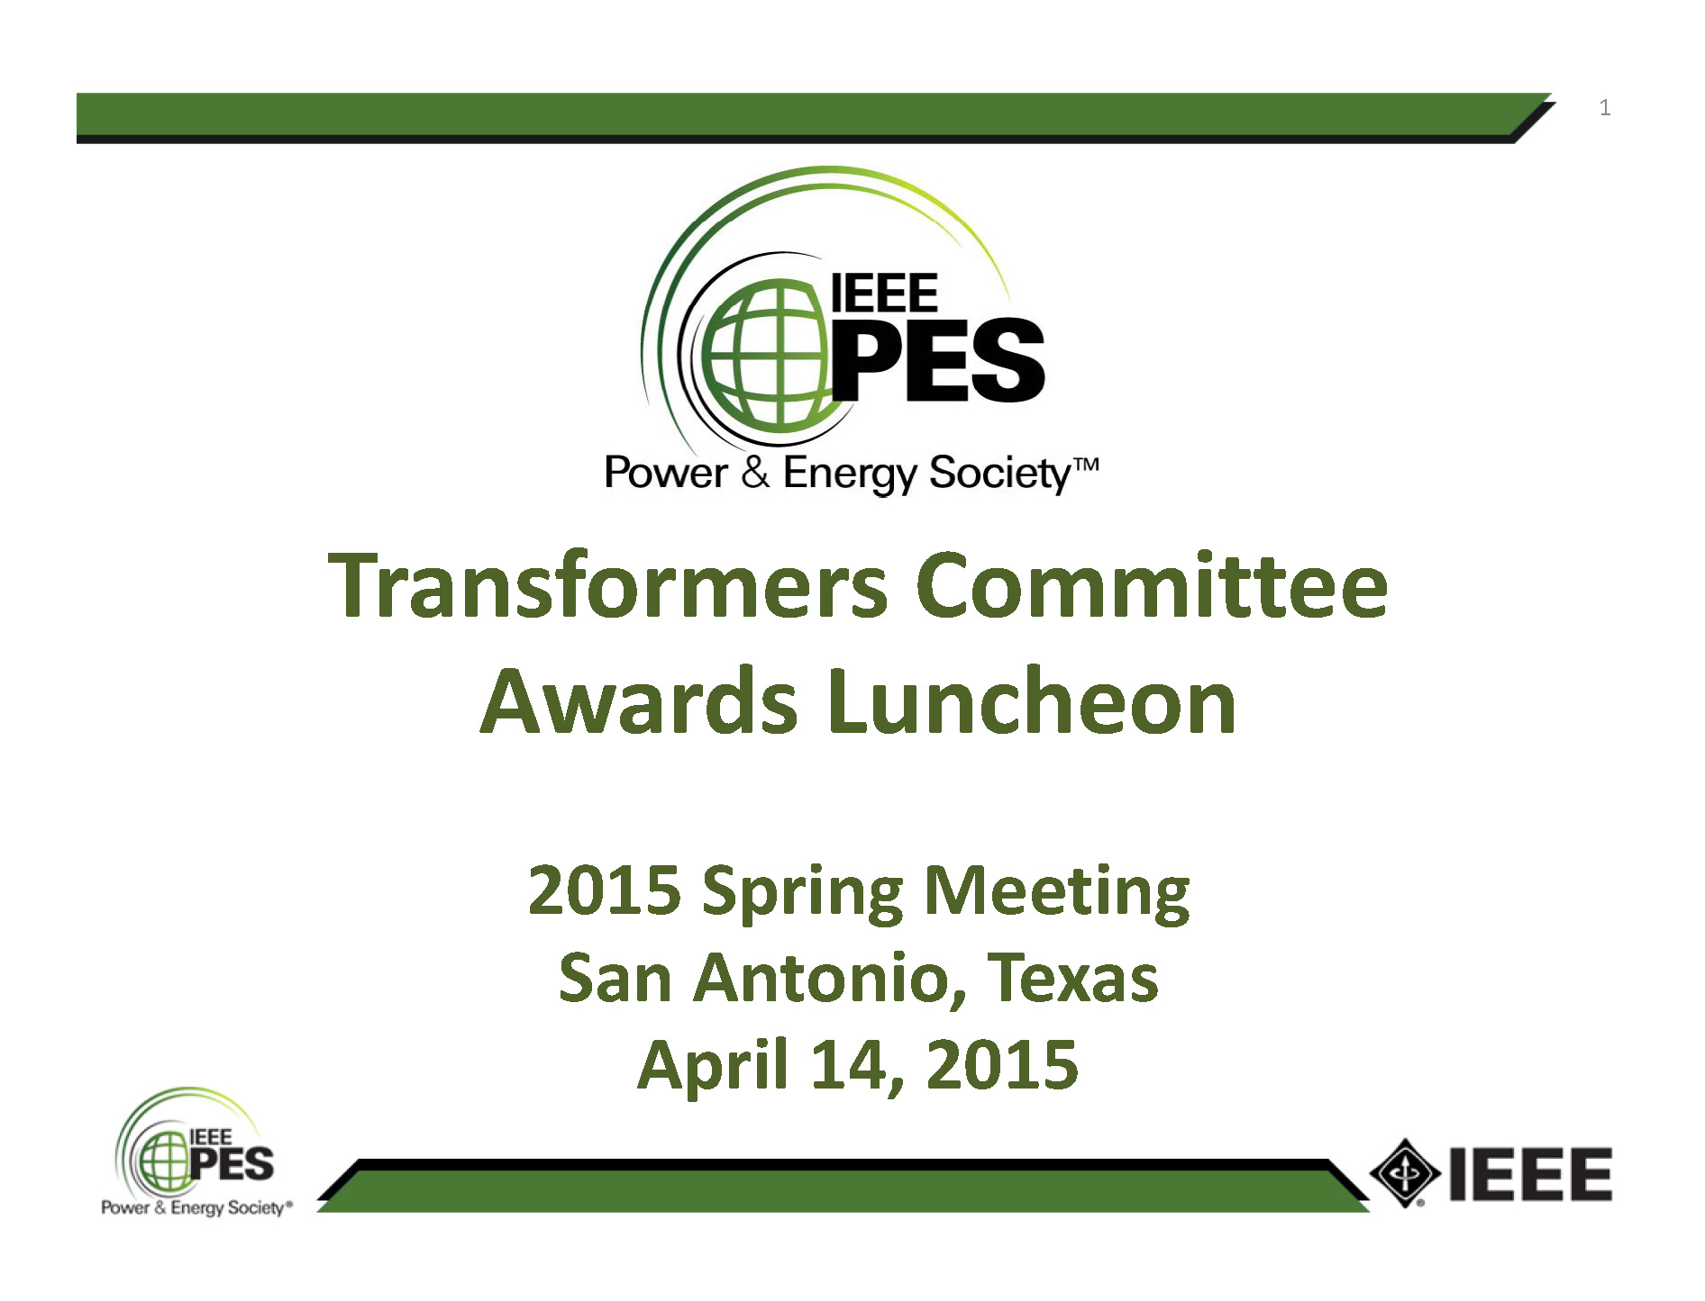

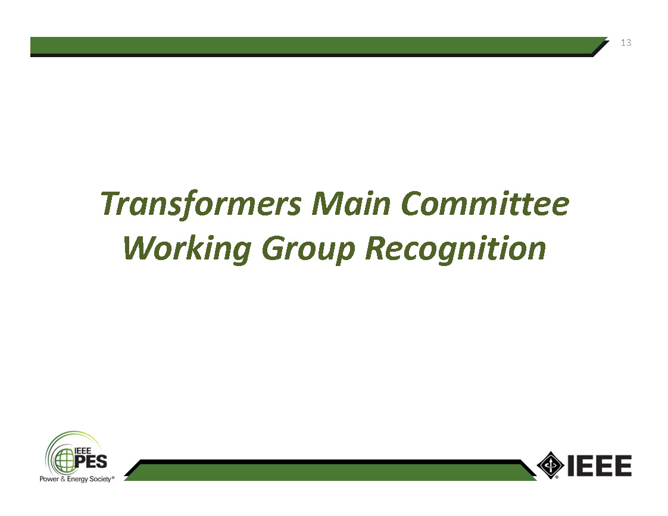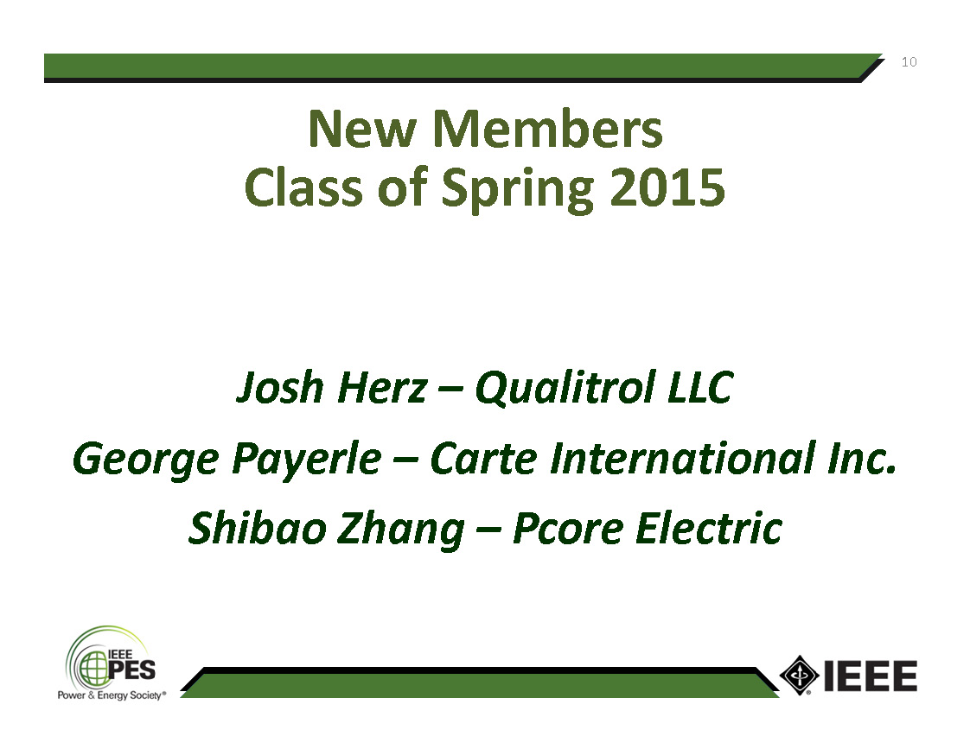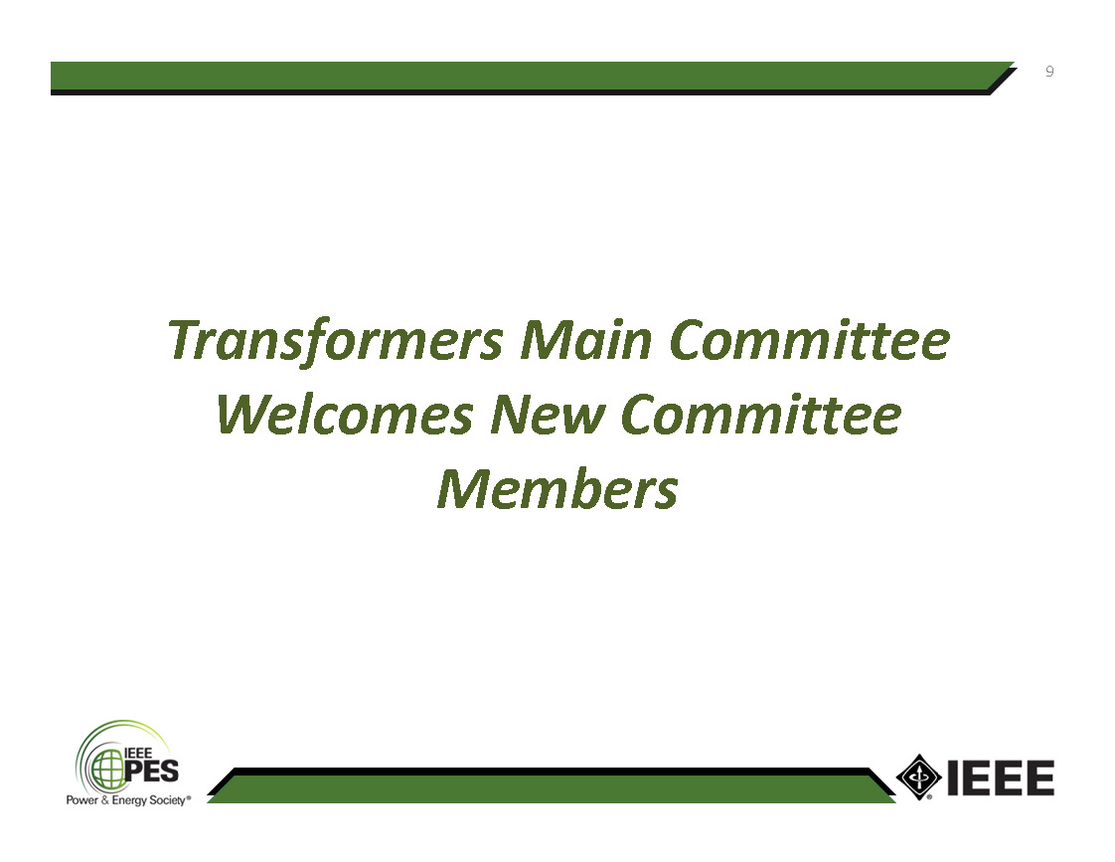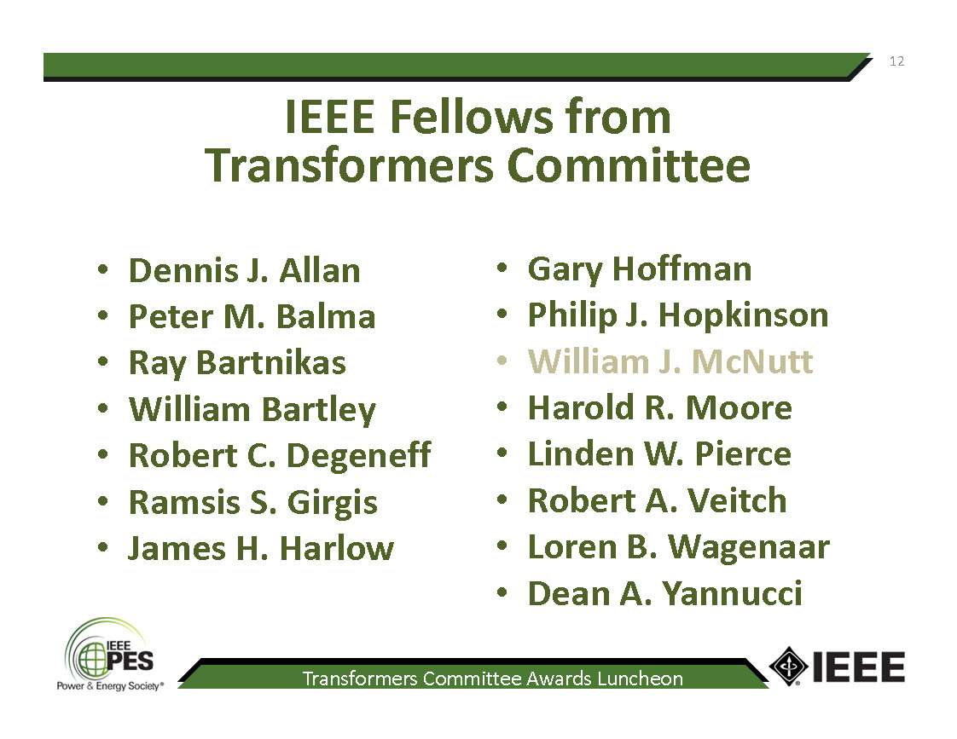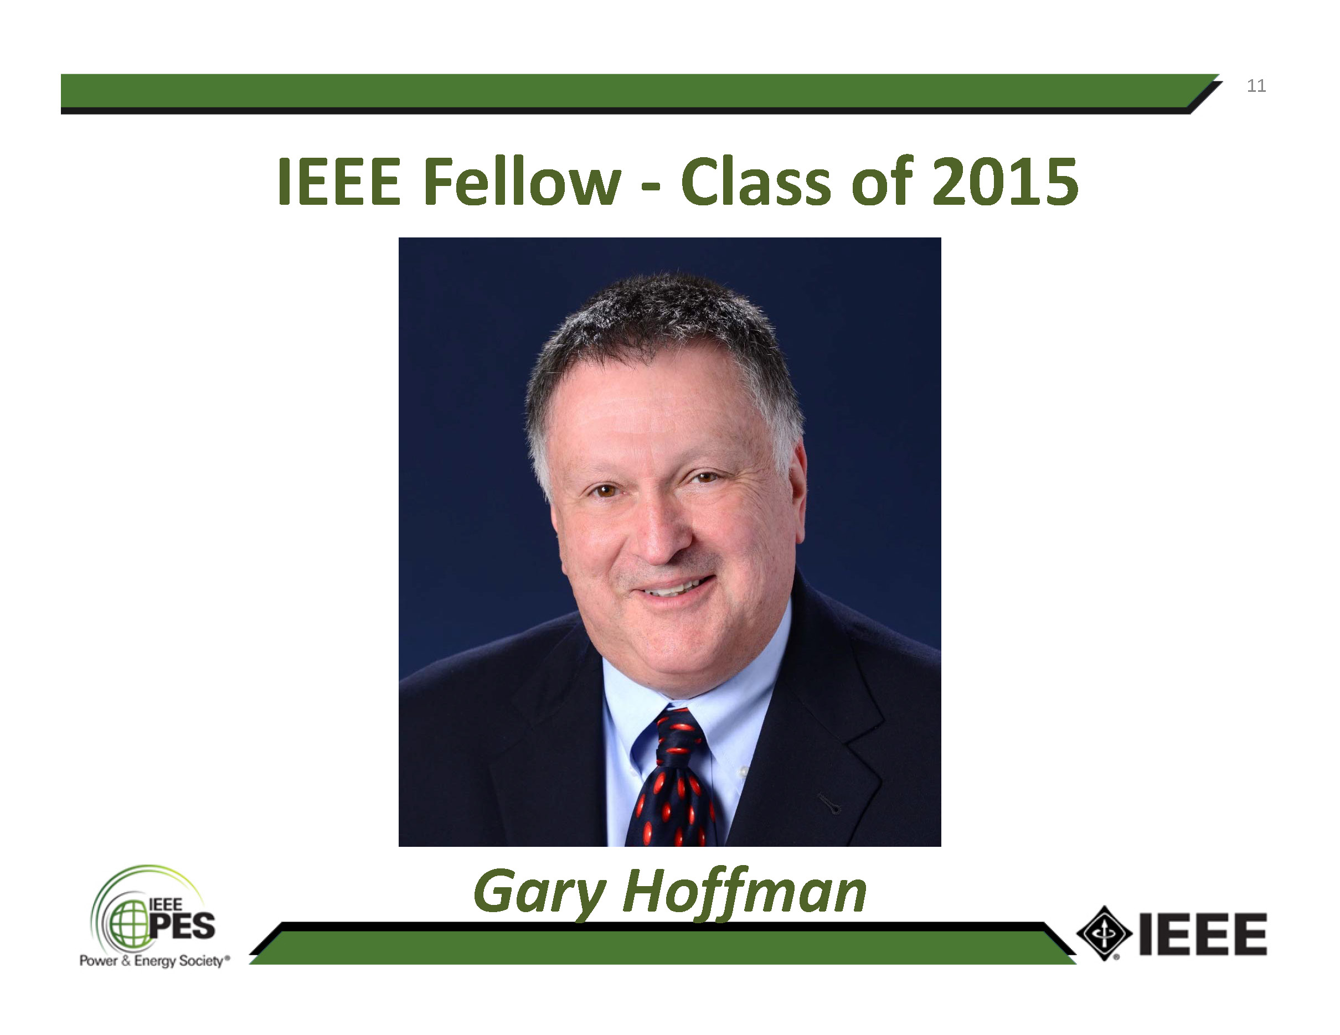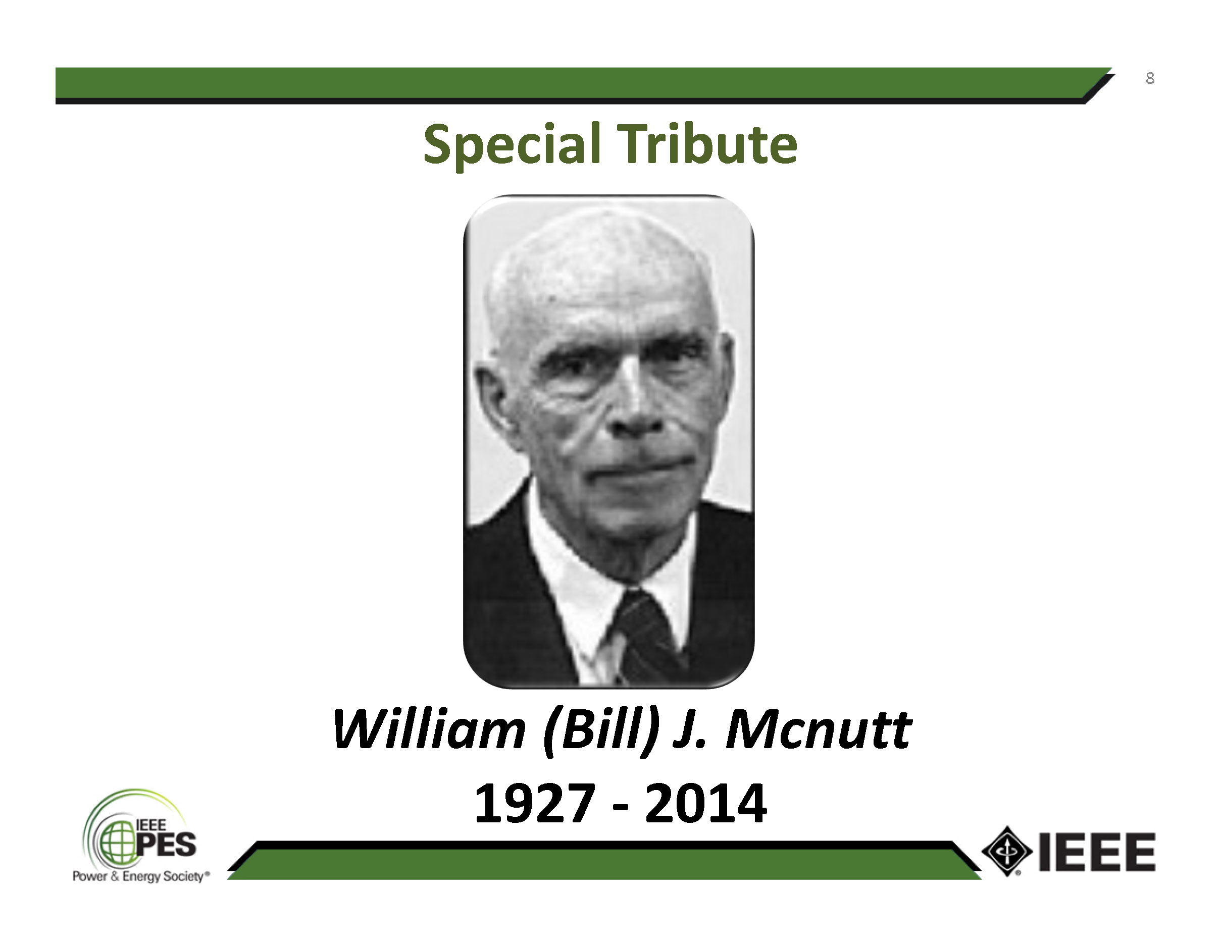

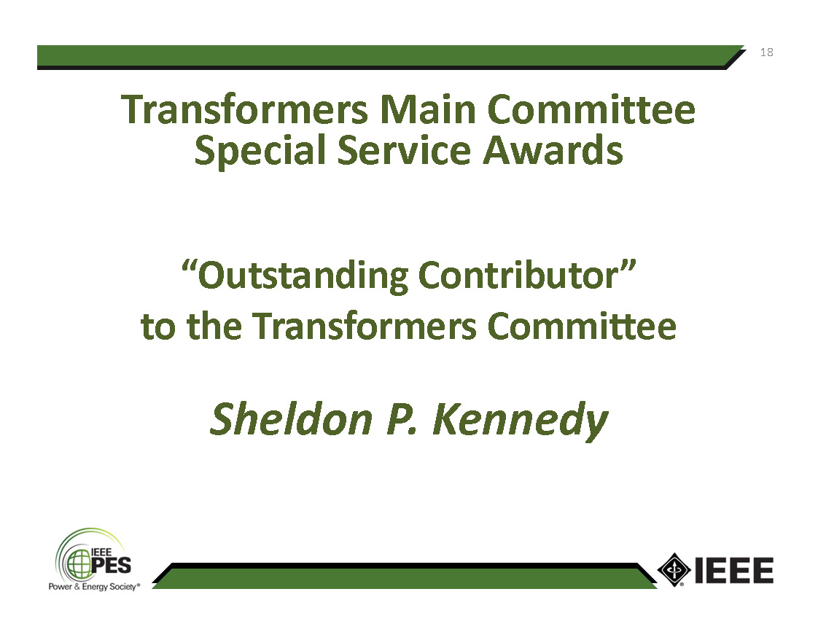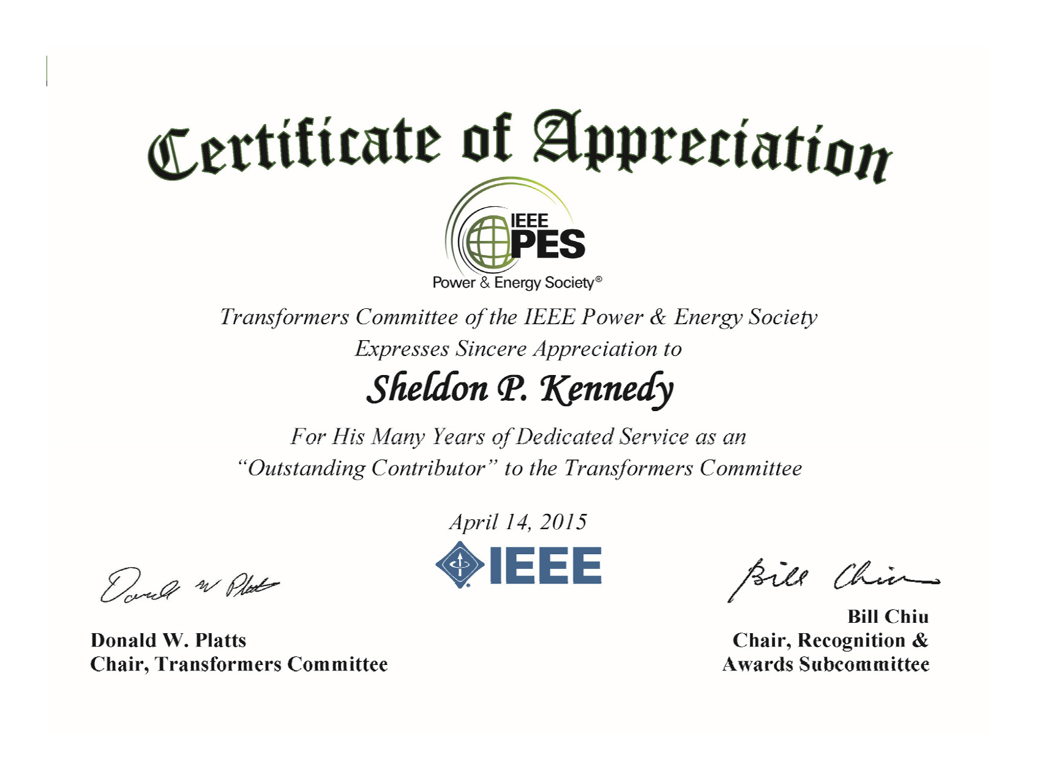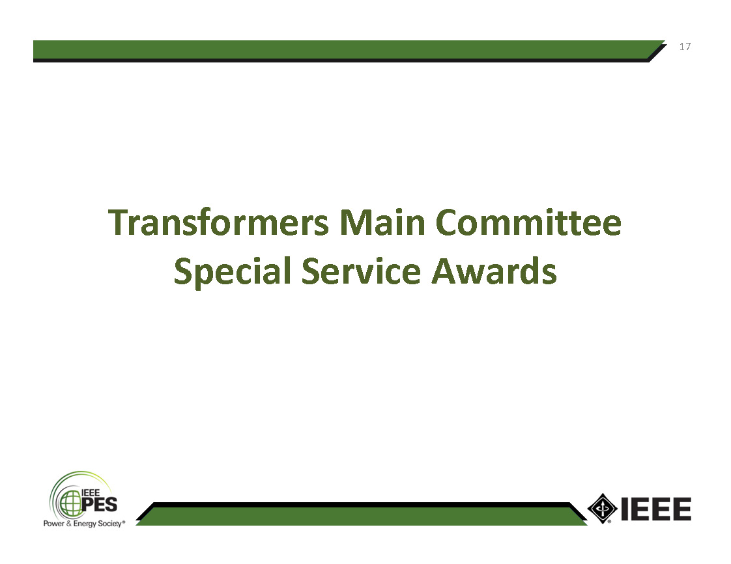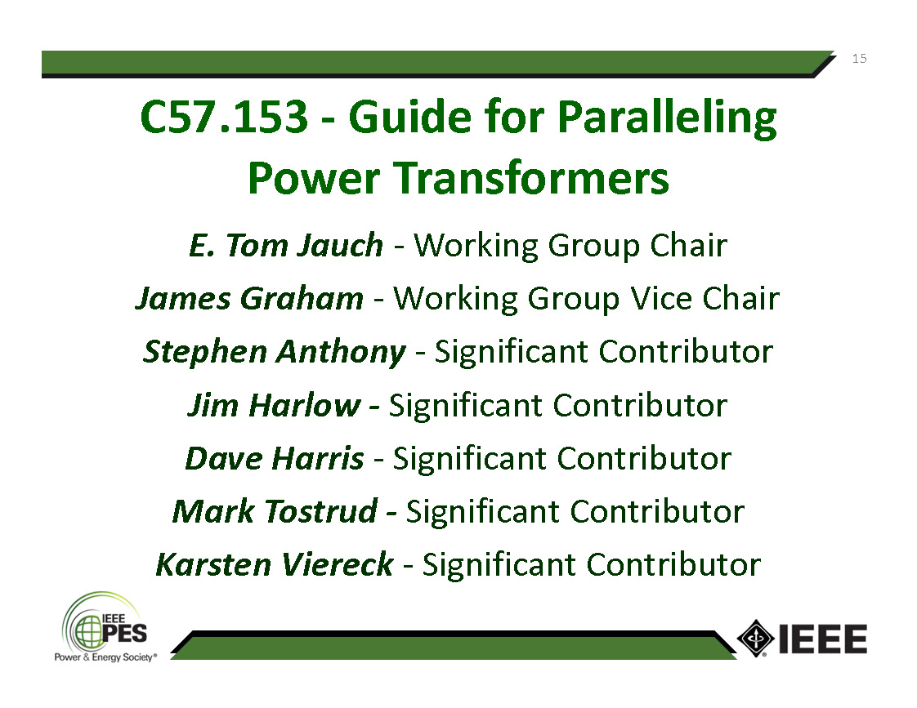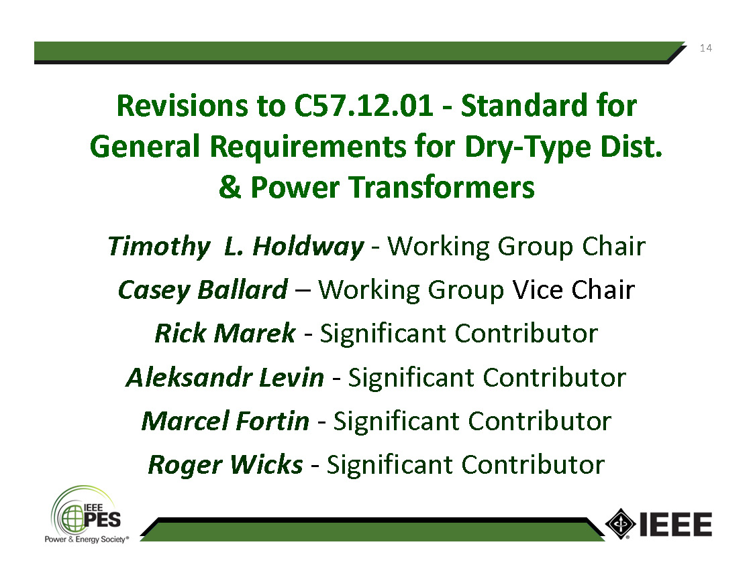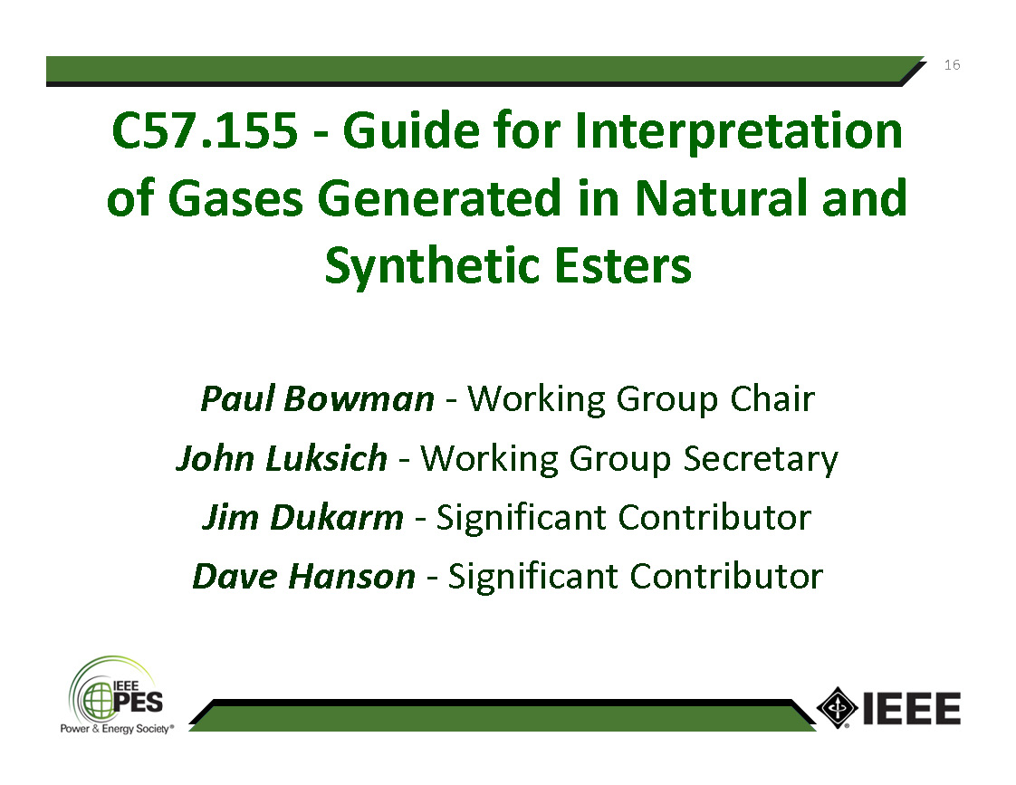

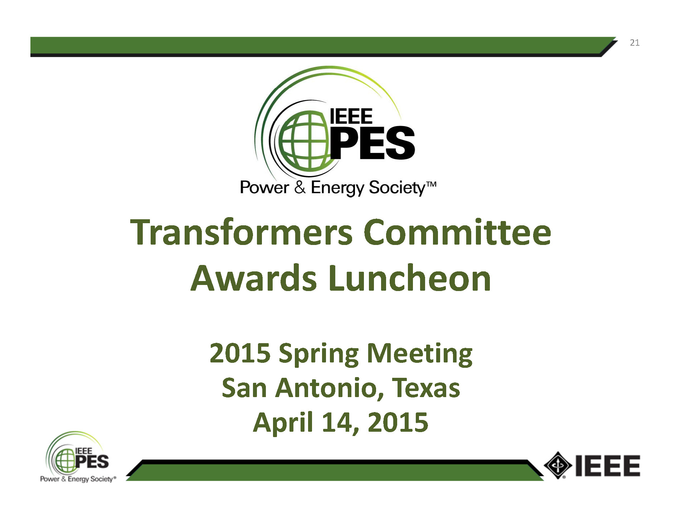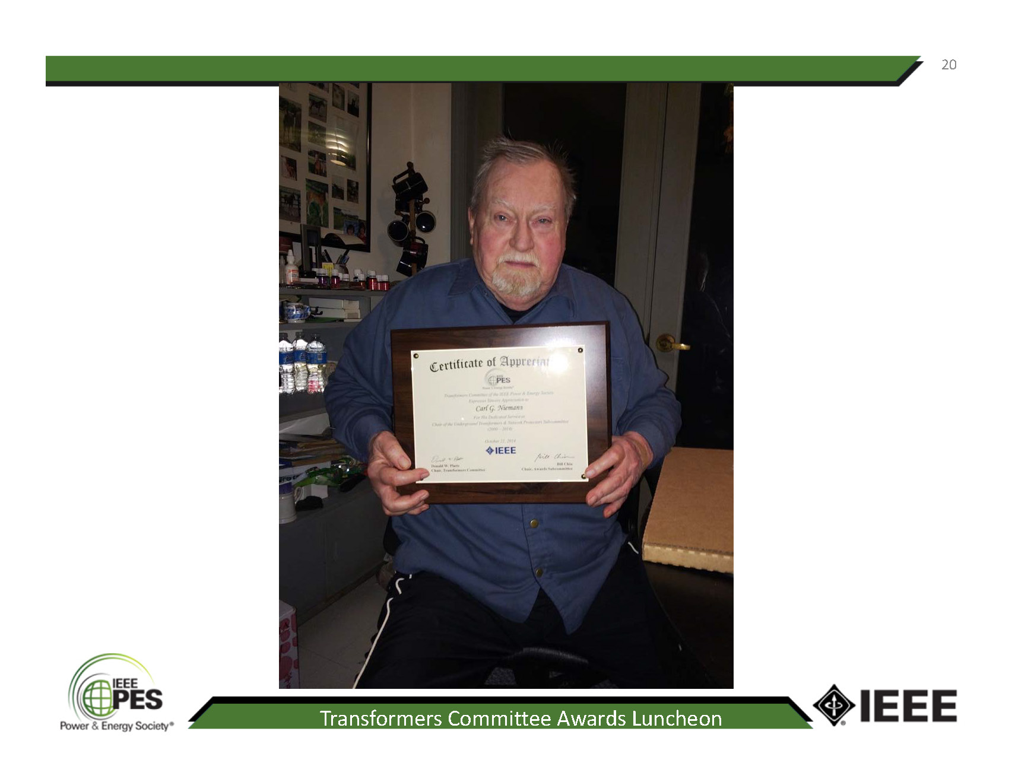

Respectfully submitted,



Chair, Recognitions and Awards Subcommittee