- Recognition and Awards – Chair: DON PLATTS

Special Tributes
During the past several months since our previous meeting in October 2015 in Memphis TN, the Transformers Committee and the industry lost two of our long time contributors. At our Awards luncheon on Tuesday, the meeting attendees gathered to pay special tribute to these two friends who passed away in November.

Carl G. Niemann (1939 – 2015)
Carl passed away suddenly in his home, on Nov. 14, 2015, at age 75.
Carl was a veteran of the US Army serving from 1960 to 1962. He married his wife Janet in 1963, and they and their 2 sons resided in the Chicago area. He was active in his community where he served on the Village Board, the Zoning Board and had been a member of St. Peter Lutheran Church.
Carl was an electrical engineer with ComEd (Commonwealth Edison) for 24 yrs., retiring in 2003. He was an active participant in the IEEE Transformers Committee, where he served as the Chair of the Underground Transformers and Network Protectors Subcommittee from 2000 to 2014.
As one of Carl's many friends said, "He was the kind of guy who you could talk to without pulling any punches. He was always fun to be around and dedicated to his work." His sense of humor and honest laugh will be deeply missed.

Arthur Conway "Sam" Hall
Sam passed away November 20, 2015 after a short stay in the hospital.

Sam was a Past Member of the Committee. The last time Sam attended our meetings was at the Porto Meeting in 2008. He was also involved with CIGRE and IEC.

From his family: “It is with great sadness that we write to inform you of the death of Arthur Conway Hall, known as Sam, who passed away on 20th November after a short stay in hospital.
Sam had been unwell with respiratory problems for some time, and the past few months had seen a downturn in his condition. Despite his admittance to hospital, you will be cheered to hear that he retained his sense of humor and we, his family, were able to be with him, talking, laughing and remembering happy times.”

Paul Jarman “In memory of Sam, an exceptional friend, colleague and mentor who made a lasting contribution to a vital industry.”

Committee Membership Certificates
The Transformers Committee welcomes eight new full committee members. Each of the following new members was presented with a membership certificate:

New Member | Affiliation
Ajith M. Varghese | SPX Transformers Solutions
Ryan Thompson | Burns & McDonnell
Stephanie Denzer | GE
Ronald Hernandez | Doble Engineering Company
Zan Kiparizoski | Howard Industries
Shamaun Hakim | CG Power Systems
George Payerle | Carte International Inc.
Shibao Zhang | Pcore Electric

IEEE Fellow – Class of 2015
IEEE Fellow is a distinction reserved for select IEEE members whose extraordinary accomplishments in any of the IEEE fields of interest are deemed fitting of this prestigious grade elevation. The Fellow’s Nomination involves a lengthy nomination process with documents describing the accomplishments and contributions in details. It requires a number of three references, and also a number of endorsers, who each also have to write a separate endorsement that describes why the candidate is deserving of this prestigious recognition.

At this meeting, the Transformers Committee is honored to have a very active member and contributor of our team, Mr. Sheldon Kennedy, to be selected to the 2016 class of IEEE Fellow for leadership in the technology and standards for rectifier, inverter and harmonic-mitigating transformers.

Sheldon is currently employed by Niagara Transformer Corporation as their Vice President of Engineering.
He is the United States industrial convertor transformers representative to IEC from the ANSI National Committee Technical Advisory Group.
He was the NEMA Transformer Section Chairman from 2000 to 2003. He is the past Chairman of the Accredited Standards Committee C57 – Transformers, Regulators, and Reactors, 2002 - 2005.
In addition, he is also a member of the Industry Applications Society and Chairman of the Electrochemical Subcommittee of the PCIC - Petroleum and Chemical Industry Committee. He is the author of the Rectifier Transformer chapter in the CRC book, “Electric Power Transformer Engineering”.

He also served as a part time Electrical Engineering Instructor at the Pennsylvania State University.
He has a Bachelor of Science degree in Electrical Engineering from the Pennsylvania State University and is a licensed professional engineer.

Now bringing it a little closer to home here at Transformers Committee, this individual is not only a long time attendee, but most importantly – a steadfast contributor and a technical leader to many of our specialty product standards such as the semiconductor power rectifier transformers, arc furnace transformers, neutral grounding devices, and also the non-ventilated dry type transformers. He most recently completed the project for C57.12.32. And now he serves as our Insulation Life Subcommittee Chair.

The Transformers Committee presented a heartfelt congratulatory certificate of merit to recognize and celebrate Mr. Kennedy’s achievement.

The list of IEEE Fellows from the Transformers Committee as included below for reference (in alphabetical order the last name).

Name of IEEE Fellow | Year | Citation
Dennis J. Allan  (Life Fellow) | 1992 | for contributions to the design and development of power transformers
Peter M. Balma | 2013 | for leadership in developing technical guides for electric power equipment
Ray Bartnikas  (Life Fellow) | 1977 | for contributions to the field of dielectric and corona loss mechanisms in electrical insulating systems.
William H. Bartley  (Life Fellow) | 2014 | for contributions to the development of generator and transformer standards for life cycle planning and risk assessment
Robert C. Degeneff  (Life Fellow) | 1993 | for contributions to the modeling and computation of transient voltages in transformer windings
Ramsis S Girgis  (Life Fellow) | 1993 | for contributions to reductions in the losses of large power transformers
James H. Harlow  (Life Fellow) | 2013 | for leadership in IEEE technical and standardization committees on transformer technology
Philip J Hopkinson  (Life Fellow) | 2002 | for contributions to the reliability of distribution transformers and the development of related standards for testing and application
Gary R Hoffman | 2015 | for leadership in the advancement of monitoring systems for power transformers and power line protection
Sheldon P Kennedy | 2016 | for leadership in the technology and standards for rectifier, inverter and harmonic-mitigating transformers.
William J McNutt  (Life Fellow) | 1976 | for contributions to the design of power transformers ad standardization of test procedures
Harold R. Moore  (Life Fellow) | 1997 | for leadership in the development, design, and application of power transformers and associated equipment
Linden W. Pierce  (Life Fellow) | 2000 | for contributions to the understanding of heat transfer and loading of liquid-immersed and dry type power and distribution transformers
Robert A. Veitch  (Life Fellow) | 1998 | for leadership in the development and design of very large and extra high voltage transformers, shunt reactors and associated equipment
Loren B. Wagenaar  (Life Fellow) | 1996 | for contributions to transformer and bushing test standards and specifications
Dean A. Yannucci  (Life Fellow) | 1990 | for leadership in the development and manufacture of large power transformers

Committee members are encouraged to nominate our fellow contributors for this distinguished recognition of Fellow. Nominations for the next year’s Class of Fellows must be completed and submitted by March 1 of each year, including references by at least five active IEEE Fellows and optional additional endorsements.

Recognition of IEEE Standards Association Awards
In any successful organization, there are always a handful of hard working individuals behind the scene that put in the sweat and tears year after year in contributing to our success at each one of our meetings. The Transformers Committee is proud to acknowledge that Mr. Peter Balma has received the IEEE STANDARDS ASSOCIATION 2015 DISTINGUISHED SERVICE AWARD. We would like to take this occasion to also take a pause and recognize Peter for his many years of service to our committee and also to the industry.

Peter has been recognized for his leadership in the IEEE-SA Standards Board and his work towards Standards development within our IEEE PES Transformers Committee.
Peter has been a tireless member of the Board, member of NesCom, Chair and member of AudCom and Ad-Hoc Chair of numerous IEEE-SASB Ad-Hoc’s, that by his leadership, resulted in important and needed revisions of the IEEE-SA Standards Board Operations Manual.
Peter continues to be a dedicated and tireless leader and admired and respected contributor to the development of IEEE PES Transformer Committee Standards.

The Distinguished Service Award is made annually to current member(s) or past member(s) of the IEEE-SA Standards Board to recognize distinguished service to the IEEE-SA based on major contributions to the standards development process.

Name of Award Recipients | Affiliation | Contributions
Peter Balma | Peter Balma | leadership in the IEEE-SA Standards Board and his work towards Standards development within our IEEE PES Transformers Committee

General Service Awards

Certificate of Appreciations were presented to the following list of recipients for their contributions to the Transformers committee:

Name of Award Recipients | Affiliation | Contributions
Alan Traut | Power Partners, Inc. | Meeting Host – Spring 2016
Power Partners, Inc. | Power Partners, Inc. | Host Company– Spring 2016
Bruce Forsyth | Southwest Electric | Chair of Insulation Life Subcommittee  (2010–2015)

IEEE SA Standards Board Awards
In addition to the Committee Awards above, the IEEE SA SB presents its own Award to the WG Chair upon publication of a new or revised document, and offers the WG Chair the opportunity to nominate significant contributors to the project for an IEEE SA SB Certificate of Appreciation.

IEEE SA Award Recipients:
Since our last meeting, we had one document that was recognized after being approved by RevCom, and subsequently the SA Board. The members have received their recognition through the mail, but we have acknowledged them here at the Awards Lunch.

Revision to C57.12.59 - Guide for Dry-Type Transformer Through-Fault Current Duration
Paulette Payne Powell - Working Group Chair
Bipin Patel - Vice Chair
Other Significant Contributors
Charles Johnson
Rick Marek
Timothy Holdway

We have a number of working groups that have completed their projects, their standards documents have been published, but IEEE SA has failed to recognize them by awarding the SA plaques and Certificates of Appreciation. The Awards Chair will be working with IEEE SA to get these logistical and administrative problems resolved.

The 9 Working Groups were again recognized as a group, at our Tuesday luncheon, with the understanding that they may still request that the official plaque award ceremony be at a future Transformers Committee meeting.

NEW Transformer Standards Approved
C57.130 2015- Guide for the Use of Dissolved Gas Analysis Applied to Factory Temperature Rise
Tests for the Evaluation of Mineral Oil-Immersed Transformers and Reactors
C57.157 2015- Guide for Conducting Functional Life Tests on Switch Contacts Used in Insulating Liquid Transformers
C57.163 2015- Guide for Establishing Power Transformer Capability while under Geomagnetic
Disturbances

REVISIONS to Transformer Standards approved
C57.12.34 2015- Standard for Requirements for Pad-Mounted, Compartmental Type, Self-
Cooled, Three Phase Distribution Transformers, 10 MVA and Smaller;
C57.12.37 2015- Standard for the Electronic Reporting of Distribution Transformer Test Data
C57.12.59 2015- Guide for Dry-Type Transformer Through-Fault Current Duration
C57.125 2015- Guide for Failure Investigation, Documentation, Analysis, and Reporting for
Power Transformers and Shunt Reactors
C57.637 2015- Guide for the Reclamation of Mineral Insulating Oil and Criteria for Its Use
NEW Amendments Approved
1538a 2015- Guide for Determination of Max Winding Temp Rise in Liquid Transformers - Amendment#1

Best Subcommittee Award
One of the key contributing factors to our success is how well the meetings are being conducted. A good meeting starts with planning ahead of the meeting. Prior to the meeting, the officers in charge will have to decide on a list of meaningful agenda topics, plan ahead on the amount the time it takes for each of the discussion items and getting the relevant information out to the meeting attendees so everyone can come prepared for a meaningful discussion. During the meeting, lots of things could easily go off on a tangent. Keeping the attendees aligned and on track with the agenda takes not only planning, but also on the spot leadership to facilitate the discussion during the meeting. Then there is the documentation of the discussion after the meeting in the meeting minutes. For these reasons, the award subcommittee will be recognizing our hard working activity leaders that are doing a great job of conducting the subcommittee meetings on a going forward basis.

The informal judging criteria consist of:
- Well established agenda ahead of time, with relevant and meaningful topics
- Good control of the meeting, following the established agenda
- Balanced discussions from the meeting participants, guided by the facilitation from the meeting chair
- Keeping track of time so the meeting ends on time, etc.

Based on these criteria, the Best Subcommittee Meeting Award from the Memphis meeting was evaluated by Bill Chiu. As recognition for their team work in conducting a well-run meeting we presented the award to the Distribution Transformer Subcommittee, with Steve Shull as the Chair, Jerry Murphy as the Vice Chair, and Secretary.

Other IEEE PES Awards
The IEEE PES recognizes important technical, educational and service contributions through the conferral of numerous awards. The listing below highlights the various other awards that are available through the IEEE PES organization.
- IEEE PES Award for Excellence in Power Distribution Engineering
- IEEE PES IAS A.P. Seethapathy Rural Electrification Excellence Award
Nominations due by February 1st
- IEEE PES Charles Concordia Power Systems Engineering Award
Nominations due by January 31st
- IEEE PES Cyril Veinott Electromechanical Energy Conversion Award
Nominations due by February 1st
- IEEE PES Douglas M. Staszesky Distribution Automation Award
Nominations due by January 1st
- IEEE PES Lifetime Achievement Award
Nominations due by February 1st
- IEEE PES Leadership in Power Award
Nominations due by February 1st
- IEEE PES Meritorious Service Award
- IEEE PES Nari Hingorani Custom Power Award
Nominations due by January 31st
- IEEE PES Nari Hingorani FACTS Award
Nominations due by January 31st
- IEEE PES Outstanding Chapter Award
- IEEE PES Outstanding Power Engineering Educator Award
Nominations due by January 31st
- IEEE PES Outstanding Young Engineer Award
Nominations due by Februrary 1st
- IEEE PES Prabha S. Kundur Power System Dynamics and Control Award
Nominations due by January 31st - Call for Nominations
- IEEE PES Prize Paper Award
- IEEE Power & Energy Society Ramakumar Family Renewable Energy Excellence Award
- IEEE PES Robert P. Noberini Distinguished Contributions to Engineeering Professionalism Award Nominations due by February 1st
- IEEE PES G. Ray Ekenstam Memorial Scholarship
Nominations due by June 30th
- IEEE PES Scholarship Plus Initiative
Applications due by June 30th
- IEEE PES Roy Billinton Power System Reliability Award
Nominations due by February 1st
- IEEE PES Student Prize Paper Award in Honor of T. Burke Hayes
Nominations due by December 15th
- IEEE PES Uno Lamm High Voltage Direct Current Award
Nominations due by November 30th
- IEEE PES Wanda Reder Pioneer in Power Award
Nominations due by January 15th
- IEEE PES Working Group Recognition Awards
The PES Working Group Recognition Awards recognize “the most outstanding and timely publications” by a PES Working Group (or Committee or Subcommittee) from among the nominations. The PES Recognition Award is divided into two categories: 1) for technical reports; 2) standards and guides. Each Technical Council Committee may nominate one report from each category, published by IEEE, during the previous three year period.” This award consists of a plaque which will be presented to the Working Group Chair at the PES Summer Meeting Awards Luncheon. A framed certificate will be presented to each Working Group member at a designated meeting of the parent Technical Committee.
- IEEE PES CSEE Yu-Hsiu Ku Electrical Engineering Award

Presentation Slides from the Awards Luncheon
The slides from the presentation used at the Tuesday’s Awards Luncheon are included below for reference.
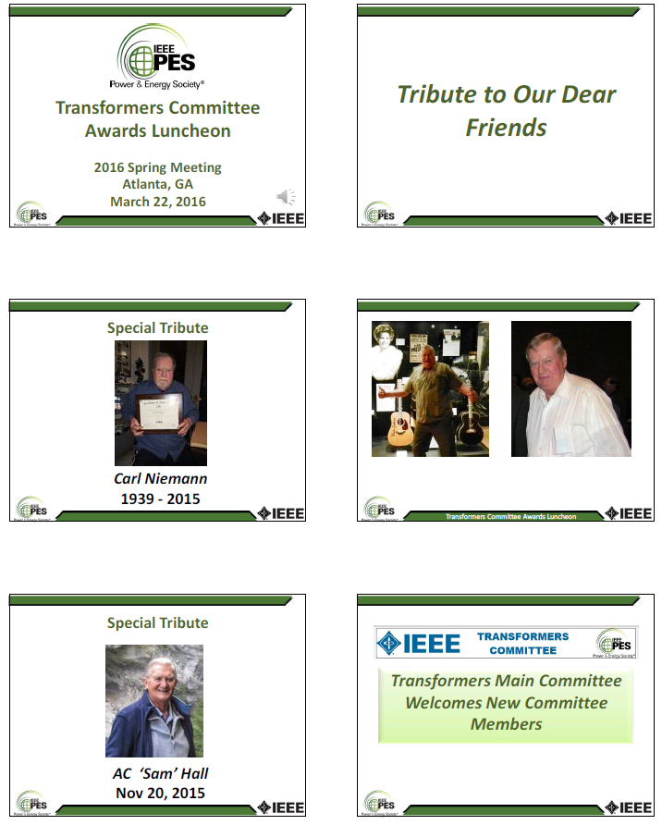
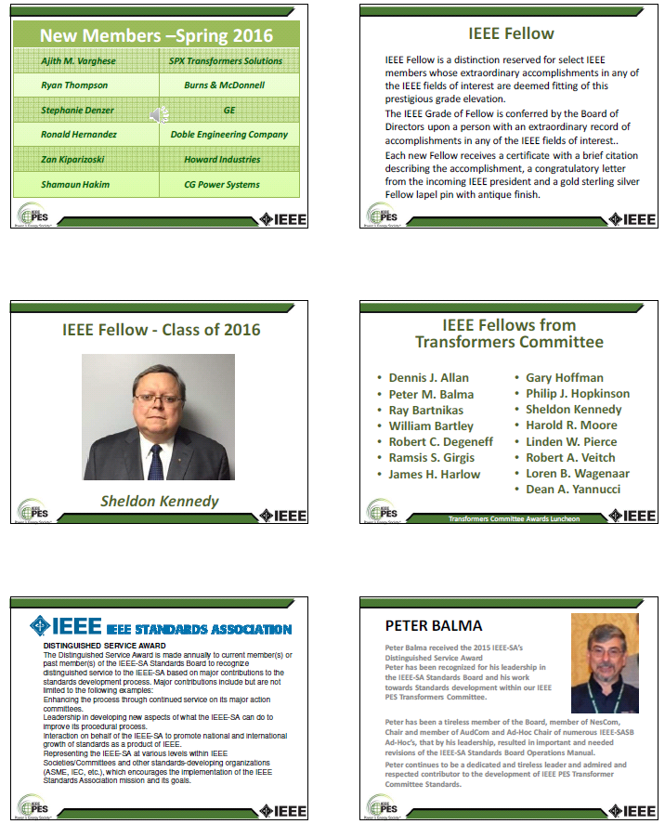

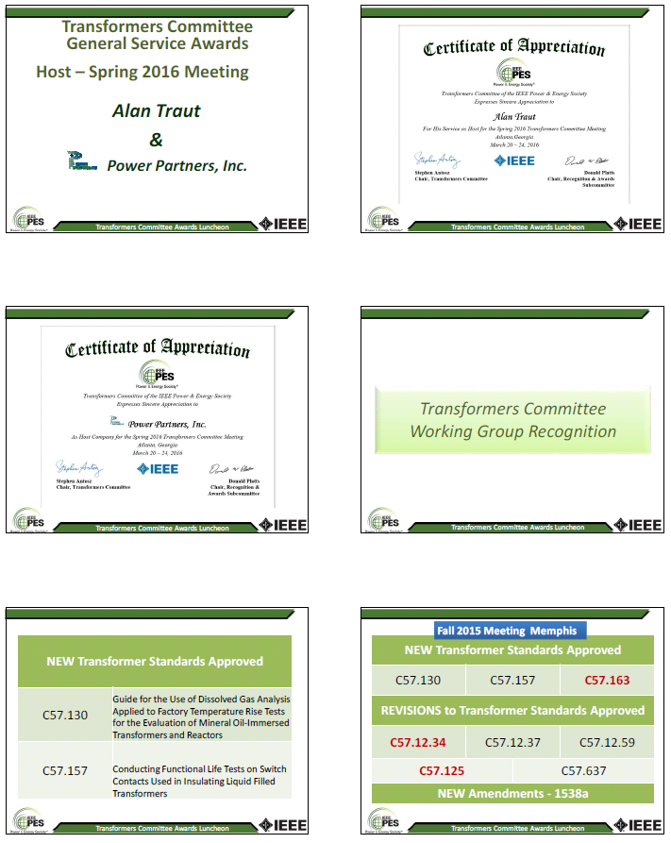

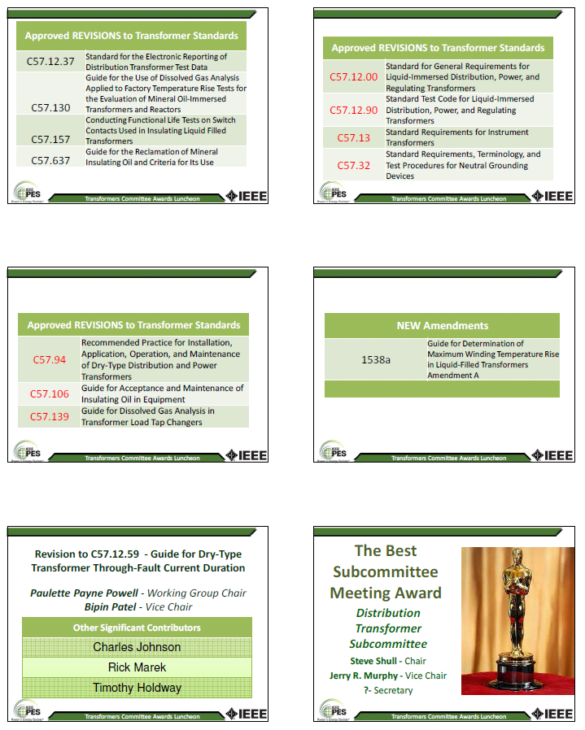
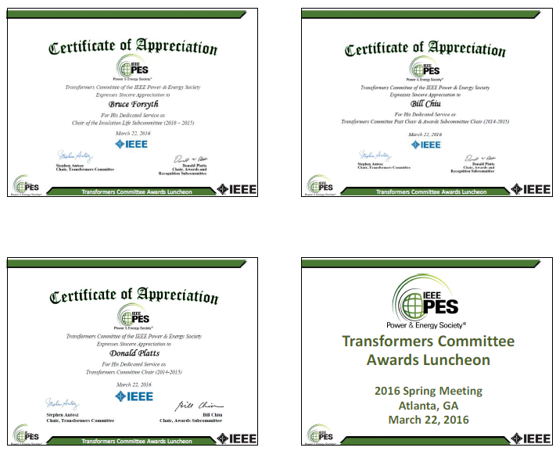

Respectfully submitted,

Donald W Platts

Chair, Recognitions and Awards Subcommittee

