# Meetings Subcommittee

March 28, 2018

Pittsburgh, PA

Chair: Tammy Behrens

Vice Chair: OPEN

## Meeting Administration

**Introductions** – The meeting began at 7:00 AM Wednesday, March 28, 2018 in the Riverboat room of the Omni William Penn Hotel in Pittsburgh, PA. Introductions were made, and sign-in sheet was routed.

**Attendees** – Twenty-four people attended the meeting. Anyone not already in AMS as a member was added as a member after the meeting.

## Working Group Business

## Meeting began with a recap of meeting attendance from S16 meeting in Atlanta through S18 meeting in Pittsburgh. With 626 registered meeting attendees (not including spouses/companions), the S18 meeting broke the previous record of 601 (S17 New Orleans). Talked about attendance numbers at the Sunday event (capacity crowd of 424), Monday and Tuesday lunches, Early Bird event and spouse/companion tours. See presentation for actual numbers.

## Next topic of business was a feedback discussion around the S18 100th Anniversary meeting. No negative feedback was given with the exception of some continued glitches in the RFID system programming that required some working groups to take attendance on paper and the relative small size of some of the meeting rooms at the Omni compared to other venues. Overall, everyone was pleased with the hotel, hotel staff and flow of the meeting and extracurricular events.

Third topic of business was a discussion around considerations for future meeting sites. Committee chair put forth the following list of considerations:

potential hosts in the area  
# of attendees we need to accommodate  
availability of technical tours and activities  
walking distance restaurants  
proximity to an international airport

Discussed the purpose of hosts and some ideas on how to find hosts, i.e. solicit at opening/closing bi-annual meeting sessions, have officers reach out to long-time attendees in potential meeting cities. Idea also mentioned about adding more sponsorships in place of hosts. F18 in Jacksonville, Florida, will be a host-less meeting (Hyatt Regency is host hotel with hotel reservations being accepted starting 3/29/18). S19 meeting will be in either Kansas City, Missouri, or Anaheim, California, with the lead going to Anaheim after a show of hands and previous discussion with the Committee officers. F19 is leaning toward Columbus, Ohio; however, preliminary dates include Canadian Thanksgiving, so we will check with Columbus venue for any additional availability.

Thanked meeting hosts, Dennis and Janet Blake and Pennsylvania Transformer Technology, for all their time and effort put into helping organize such an historical meeting and shared a list of volunteer opportunities with the group with some new volunteers stepping up for future meetings:

Jerry Murphy – meeting schedule (will work with Sue on this for F18 meeting in Jacksonville)  
Daniel Weyer – RFID assistant for Kris Zibert

Finally, we received updates from the different Task Forces within the Meetings Subcommittee:

### Presentations & Tutorial – Tom Prevost Tom was not in attendance, but chair reached out to him after the meeting, and Tom is working on some presentations for the F18 meeting, including a tutorial on Roberts rules that needs to first be discussed with the officers before becoming feasible.

### Break Sponsor – Ed Smith Ed was also unable to make the meeting, but he informed the Chair that sponsorships are booked out through F19 meeting; first available break sponsorship is for S20 meeting.

### Historian – Peter Balma Peter updated attendees on what it took to put the 100th anniversary meeting together and thanked everyone who sent photos for the booklet and posters as well as everyone who participated in the planning calls over the last 18 months. Peter hopes to attend more meetings in the future and continue to host History sessions at those meetings.

### Website – Sue McNelly Sue will continue to update the current website on the current platform. She has received no new information on when the new web platform/Word Press will be available or when training will occur. Once the new website becomes a reality, Sue will be looking for volunteers to help with the development and editing, as needed.

### Mobile App/Guidebook – David Wallach Consensus was to continue using the Guidebook app while advertising it more at registration as well as in pre-meeting emails and on the website. David has a graphic he can post on the schedule boards at each meeting that gives directions for use. The idea was also floated about introducing it to IEEE to see if other Committees may be interested in using it which could help defer some of our costs, either through referral credit or promoting it enough that IEEE will sponsor the cost. Current cost of this app is $2000 for two meetings (we will owe Guidebook again in Fall 2018 – no charge for the spring meeting as that was prepaid last fall). Chart below shows downloads compared to registered attendance to calculate adoption/usage; we seem to hover around 50%. Other Guidebook metrics for S18 meeting also attached.



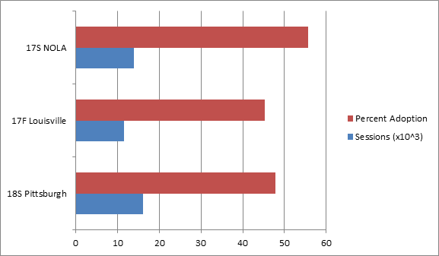

### RFID – Kris Zibert Kris presented his own slides as a post-mortem on the RFID system at the S18 meeting as well as a road map for future enhancements (see attached slides for reference). In short, attendees were able to scan in with varying degrees of success, some Kindles displayed incorrect working group at time of meeting and some officers did not receive report emails. For all three of these issues, Kris identified corrective actions for the next meeting that should clear up most – if not all – of the issues. Short term roadmap options include the development company implementing a “live” feed of attendees and quorum status with a final report at the end or whatever point in time is chosen sent to officers. Cost would be a one-time setup fee of $5000. Data info/privacy issues were brought up in regards to this, so Kris will investigate this with SerialIO/development company and Committee officers before pursuing approval. Finally, Kris included some other needs, including money to replace/refurbish one of our blue boxes that appears to have a bad power connection, purchase another Kindle Fire and another blue box for when we run seven concurrent sessions (approx. $1000 needed before F18 meeting). Other needs were for the Chair to publicize Directions/Guidelines for RFID use to both attendees and working group leaders. Final need was a call for help, which was answered by Daniel Weyer who Kris has already started training on the system.

### Meeting Schedule – Sue McNelly / Jerry Murphy This was a new request to help maintain and modify the meeting schedule master Excel file Sue McNelly put together for the S18 meeting for all subsequent meetings. Jerry Murphy volunteered to take this on for subsequent meetings. Sue will work with Jerry for the fall meeting and then turn it over to him for future meeting schedule management.

## Chair Presentation/Slides

