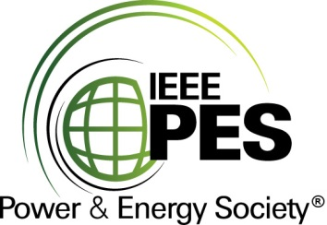

CERTIFICATE OF
EDUCATIONAL ACHIEVEMENT

This certificate is presented to

replace with your name

for attendance at the educational presentation:

" Keeping Grids Resilient: Maximizing Network Stability with Rapid Transformer Exchange by Using Advanced Insulation Systems and State-of-the-Art Connectivity "

sponsored by the IEEE/PES Transformers Committee

and has earned one (1) Professional Development Hours (PDH) unit.
Spring 2019 Committee Meeting; Thursday, March 28, 2019
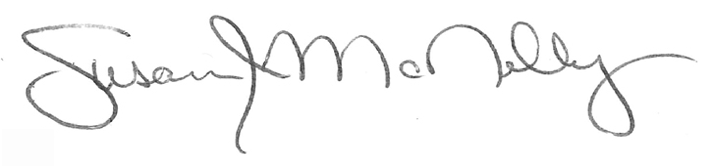

_________________________________ ___________________________________________________
Susan McNelly Instructors: Richard Marek, Peter Mueller, Anastasia O’Malley Committee Chair Ewald Schweige

