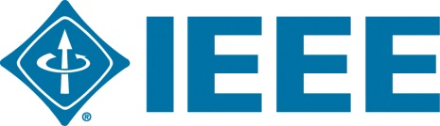
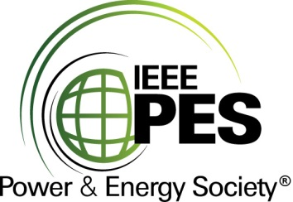

CERTIFICATE OF
EDUCATIONAL ACHIEVEMENT

This certificate is presented to

replace with your name

for attendance at the educational presentation:

" Tutorial on IEEE C57.104-2019 “Guide for the Interpretation of Gases Generated in Mineral Oil-Immersed Transformers "

sponsored by the IEEE/PES Transformers Committee

and has earned one (1) Professional Development Hours (PDH) unit.
Spring 2020 Committee Meeting; Thursday, March 26, 2020
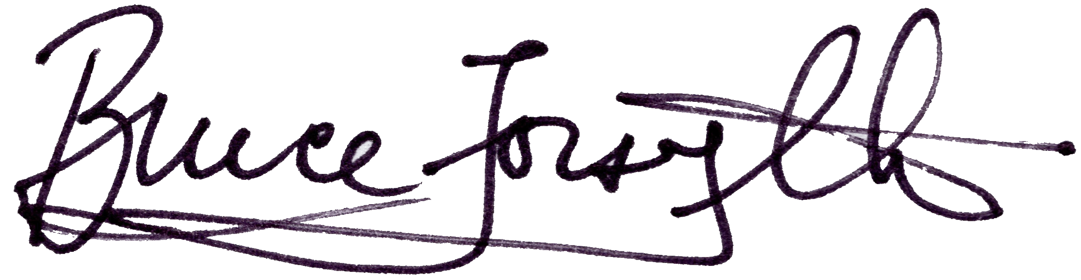

_________________________________ ___________________________________________________
Bruce Forsyth Instructors: Claude Beauchemin, Luiz Cheim, Norman Field and
Committee Chair Tom Prevost

