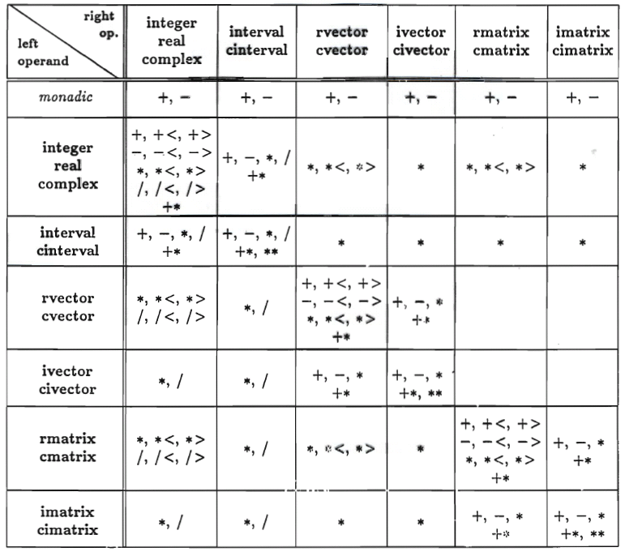
Predefined Arithmetic Operators of Pascal-XSC

