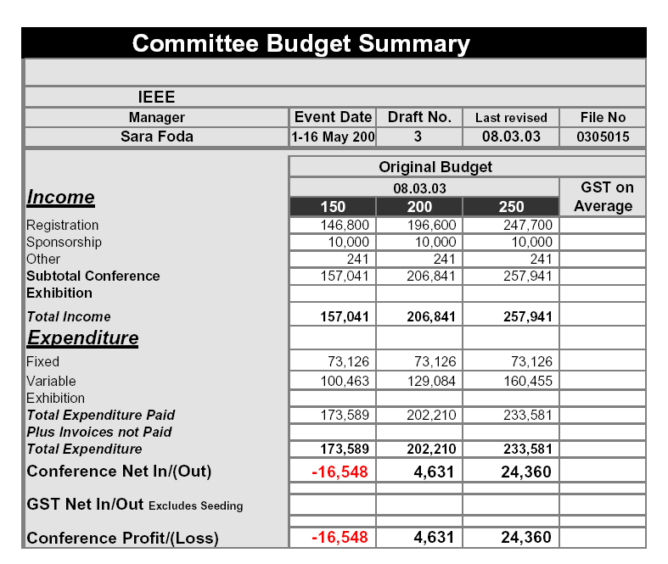
Pre-registration fee (until 11:59 GMT, April 12, 2003): AU$970
Late/On-site registration fee: AU$1100

 |  | Reg Fee | 6 nights | Hotel US$ | Reg US$ | Total US$ |  | exchange rate
Sydney |  | AU$880 | AU$1410 | $ 761.40 | $ 475.20 | $1,236.60 |  | 0.54 | au-us
Vancouver |  | US$250 | CA$1680 | $1,114.74 | $ 250.00 | $1,364.74 | w/o lunch | 0.66 | ca-us
Monterey |  | US$350 | US$1014 | $1,014.00 | $ 350.00 | $1,364.00
Kauai |  | US$250 | US$990 | $ 990.00 | $ 250.00 | $1,240.00 | w/o lunch
Ft Lauderdale |  | US$350 | US$774 | $ 774.00 | $ 350.00 | $1,124.00
DFW |  | US$300 | US$834 | $ 834.00 | $ 300.00 | $1,134.00 | w/o lunch
Singapore |  | AU$970 | S$1140 | $ 661.20 | $ 591.70 | $1,252.90 |  | 0.61 | au-us
 |  |  |  |  |  |  |  | 0.58 | sin-us

Call for Projectors
Need volunteers to bring projectors-see Stuart or me

