PROPOSING RESOLUTIONS TO COMMENTS BY OTHERS
[..]
Note that proposed resolutions should not be made against comments that the Working Group member has submitted himself or herself. It is presumed that the originator of the comment has provided a proper and valid remedy, and no further suggestions are needed. Also, the resolution proposal process is not intended as a substitute for the 802.20 e-mail reflector, and Working Group members should refrain from conducting a dialog via the comment records in the CRD.
The proposal of resolutions to Working Group comments is done via the same CRD used to enter and submit comments. The following process may be used:
- Open the CRD, select the Comment List view, and scroll to the comment for you want to recommend a resolution.
- Click on the “Marked” box at the top of the window, so that the box is checked (if already checked, leave it alone):
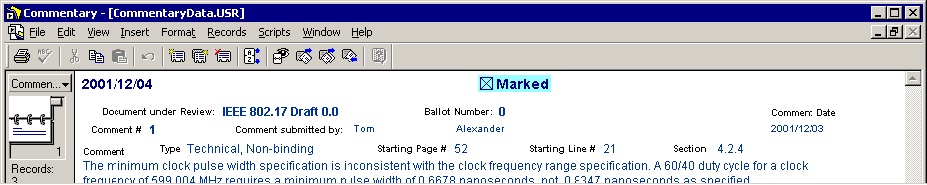
- Now click on the “Recommendation” box (next to “Proposed Resolution”); select one of the choices on the list of acceptable recommendations:
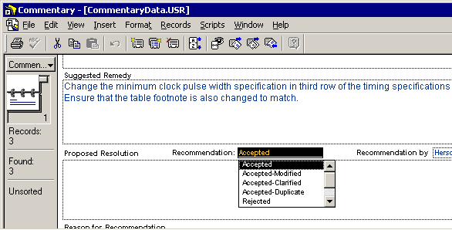
The various recommendations are interpreted as follows:
Recommendation | Interpretation
Accepted | Accept comment and suggested remedy EXACTLY as-is
Accepted-Modified | Accept comment, but propose an alternate remedy
Accepted-Clarified | Accept comment and suggested remedy, but offer additional explanations
Accepted-Duplicate | Duplicate comment (indicate which one is duplicated)
Rejected | Reject comment
- Fill in your name in the “Recommendation by” box.
- Click in the “Proposed Resolution” box and type in any explanatory information relating to your recommendation. For “Accepted” and “Accepted-Duplicate” recommendations, no additional information is necessary. For all other recommendations, you should enter an alternate suggested remedy or a reason why the comment is invalid.
- In the “Reason for Recommendation” box, enter any additional explanations or justification for why your proposed resolution should be adopted in place of the one in the original comment.
A typical proposed resolution for a rejected comment appears as follows:
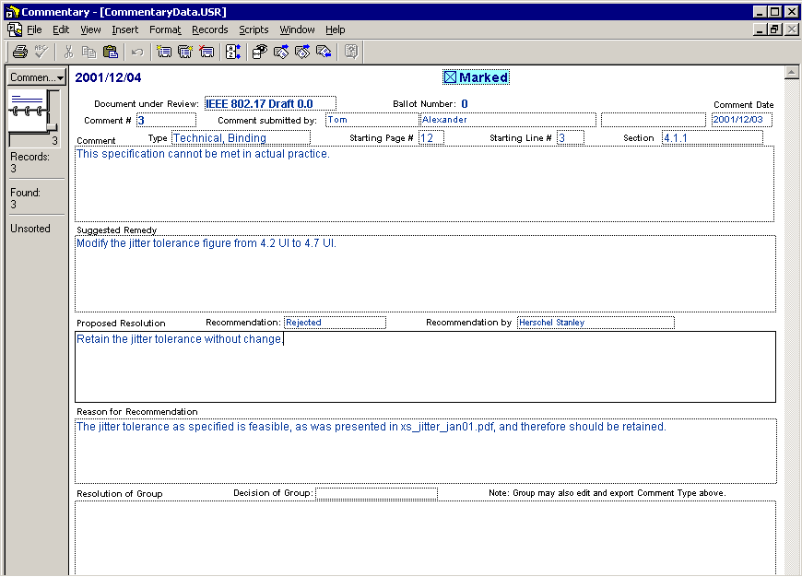
- Steps 2 through 6 above complete the process of entering a proposed resolution for one comment. You may now scroll through the CRD and enter proposed resolutions to as many comments as you wish (excepting your own, of course). Only one proposed resolution may be entered per comment. Remember to check the “Marked” box for each comment to which you have entered a proposed resolution.
- After you have finished entering all of your proposed resolutions, ensure that the selected view is Comment List, and then select “Find Marked Records” under the “Scripts” menu:
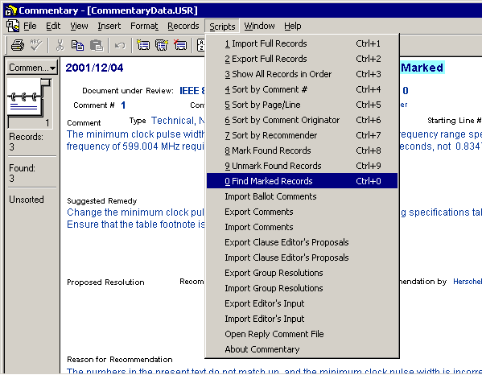
- All of the comments against which you have entered proposed resolutions should now be accessible, and all other comments should not be accessible. Scroll through the comment records to ensure that all the comments you marked in Step 2 above are visible.
- Now select “Export Clause Editor’s Proposals” under the “Scripts” menu. This will bring up a dialog box requesting a file name to save in:
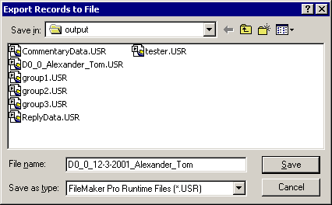
Select an appropriate directory or folder into which the output will be saved, and enter a file name of the form
Draft number_PROP_today’s date_lastname_firstname
An example of a properly formatted file name for proposed resolutions is:
D_0_1_PROP_2-22-02_Alexander_Tom.USR
Separate the fields with underscores as shown for the example in the figure above. The file type should be “FileMaker Pro Runtime Files (*.USR)”.
** EDITORS NOTE:
For this cycle, please save the reply comment file that you create as
SRD_VER13_PROP_date_lastname_firstname.USR
- Click on “Save” to save your proposed resolutions. The process for submitting the output will be described later.

The Commentary program contains the WRONG instructions with regard to the file type. Follow the instructions presented here exactly. Ignore any conflicting instructions that the program may give you.

