IEEE 802 Wireless Interim Meeting IN TAIWAN
13 – 18 January 2008
Howard Plaza Hotel, Taipei, Taiwan
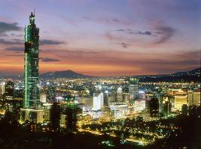

VENUE – HOWARD PLAZA HOTEL TAIPEI, TAIWAN

The hotel’s location at the heart of the city with convenient access to the comprehensive transportation network, most of Taipei’s tourist highlights are within easy distance.

Address: No.160 Renai Road, Sec.3, Taipei, Taiwan 10657, R.O.C.
TEL：886(2)2700-2323
FAX：886(2)2700-0729

Web: http://www.howard-hotels.com.tw/



The Howard Plaza Hotel in Taipei sports a gigantic pale red stuccoed building in the Jen Ai Road of Taipei and is one of the Hotels in Taipei in Taiwan that is situated on a road lined with impressive coconut trees. The hotel is regarded as the first selection of corporate visitors among the several Hotels in Taiwan because of its nearness to the Taipei World Trade Center and other commercial centers of Taiwan.
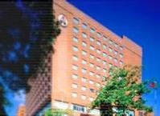
Location of Howard Plaza Hotel in Taipei
FROM THE AIPRORT
From the Airport to the Hotel: Airport Bus – Airport to hotel NT$145/per trip (approx US$4.40) and takes approximately 50 minutes.
Limousine Service – NT$1,470/per trip (approx US$45)
After completing the arrival norms at the Chiang Kai Shek (CKS) International Airport, hail a cab and instruct the driver to drive down the ChungShan highway. After a few twists and turns, you will reach the Howard Plaza Hotel in Taipei which is at a distance of fifty kilometers from the CKS International Airport. The hotel is only one-and-a-half kilometers away from the Taipei World Trade Center, a hub for business activities of the East Asian and South-East Asian regions and a favorite haunt of the hotel’s corporate guests. Residents of the hotel flock to the Chinese Handicraft Arena because it is only a kilometer away from the premises of the hotel. The famous Hsing Tien Temple built in honor of Kuan Kung, the god of war, is only a kilometer away from the Howard Plaza Hotel in Taipei and is frequented by the guests of the hotel.

HOTEL ROOMS AT THE HOWARD PLAZA HOTEL, TAIPEI



Room rate includes breakfast – bookings through Tour Hosts.

Below is an estimate of the room rate. Final room rate will be available on the online registration form. Meeting registration and accommodation can be booked together on the one online form.

 | US DOLLARS  Approx only | NT – NEW TAIWAN DOLLAR
Superior Single  Including 1 breakfast | US$165.00 | NT$4,800 + 10%
Superior Twin  Including 2 breakfasts | US$175.00 | NT$5,200 + 10%

Room rates include
- One welcome drink / per person
- Fruit basket / per room
- Daily Newspaper / per room
- Free use of Health Centre, sauna

Features & Amenities of the room include:

- 29 inch television
- Dual line IDD telephone
- Broadband internet
- Personal Electronic safe
- Mini bar
- Bathroom telephone
- Hair dryer
- Emergency torch
- Magnifying mirror

Check in time after 3pm, Check out time before 12 noon

MORE INFORMATION

PASSPORT & VISA FOR U.S. PASSPORT HOLDERS

ENTRY REQUIREMENTS: U.S. passport holders will be allowed to enter Taiwan without a visa for up to thirty days (no extensions allowed) if their passport is valid for at least six months from the date of entry into Taiwan and the traveler has a confirmed return or onward air ticket. Travelers must have already met any additional visa requirements for the next destination, if applicable. If the passport is valid for less than six months from the date of entry into Taiwan, travelers may apply for a landing visa that has a duration of stay of no more than thirty days. The processing fee is NT$4,400.00 and no extensions are allowed. Travelers also have the additional option of applying for and receiving a Taiwan visa prior to arrival in Taiwan. The processing fee is US$100.00.

Information above is taken from http://travel.state.gov/travel/cis_pa_tw/cis/cis_1036.html on 12 July 2007

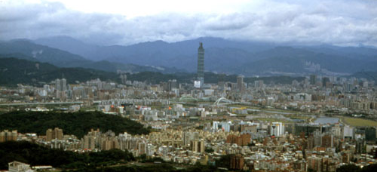

USEFUL INFORMATION

Location: Norther Taiwan, in the Taipei Basin. Boardered on all sides by Taipei County

Population: approximately 2.62 million

Languages: Taiwan’s official language is Mandarin: English and Japanese are also commonly used.

Climate: Taipei has a subtropical climate with an annual average temperature of 22 degrees Celsius (71.6 degrees Fahrenheit) and an annual average rainfall of 2,325 millimeters. Summers are hot with occasional afternoon thunderstorm; winters are chilly and frequent drizzles.

Taxi Fares: NT$70 upon entry, good for 1.5 kilometers; each additional 300 meters is NT$5, and there is a waiting charge of NT$5 for each 2 minutes when the speed drops below 5 kph. From 2300 to 0600 an extra 20% is added to the meter.

Websites:

http://www.taiwan.net.tw

www.taipeitravel.net

REGISTRATION FEE
To view the current foreign exchange rates, please visit www.x-rates.com

 | AUD DOLLARS
Early Registration Fee  Before 28 November 2007 | A$1,000
Standard Registration Fee  After 28 November 2007 | A$1,250
Onsite Registration Fee  After 7 January 2008 | A$1,500

Payment will be made in Australian Dollars

TIMETABLE AND DEADLINES

Early Registration Fee before 28 November 2007
Standard Registration Fee After 28 November 2007
Onsite Registration Fee After 7 January 2008

PAYMENT OF FEES
Registrations will not be processed or confirmed until payment in full is received. Please also note that we ask for all registration fees to be paid in Australian Dollars.

Within Australia
Payment may be made by personal cheque or credit card. American Express, Mastercard, Diners and Visa are the credit cards accepted at the conference. Please note all transactions by credit card will appear on your statement as payment to Conference by THPL. Cheques should be made payable to the IEEE 802 Wireless Interim Meeting 2006.

International
Payments from overseas must be made by credit card or bank cheque in Australian Dollars only, drawn on an Australian Bank. Your name and full address should be typed or printed clearly on the back of the cheque. You may not pay your fees by direct transfer.

ACKNOWLEDGEMENTS
Your registration and payment will be acknowledged in writing with confirmation of your requirements according to your registration form. Your registration will not be processed or confirmed if payment does not accompany your form.

You will not receive any further publications before the conference. Your letter of acknowledgment will include any further advice necessary prior to your arrival at the conference. At the conference you will receive the final program and a list of delegates.

ADDRESS FOR COMMUNICATIONS
Tour Hosts Pty Limited
GPO Box 128
SYDNEY NSW 2001 AUSTRALIA
Tel: +61 2 9265 0700
Fax: + 61 2 9267 5443
Email: ieee802wireless@tourhosts.com.au

INSURANCE
Registration fees do not include insurance of any kind. It is strongly recommended that at the time you register for the conference and book your travel you take out an insurance policy of your choice. The policy should include loss of fees/deposit through cancellation of your participation in the conference, or through cancellation of the conference, loss of international/domestic air fares through cancellation for any reason, loss of tour monies through cancellation for any reason including airline or related services strikes within Australia, failure to utilise tours or pre booked arrangements due to airline delay, Force Majeure or any other reason, medical expenses (including sickness and accident cover), loss or damage to personal property, additional expenses and repatriation should travel arrangements have to be altered. The Conference Managers cannot take any responsibility for any participant failing to arrange their own insurance. This insurance is to be purchased in your country of origin.

CONTACT DETAILS
Tour Hosts Pty Limited
GPO Box 128
Sydney NSW 2001
AUSTRALIA
Email: ieee802wireless@tourhosts.com.au
Tel: + 61 2 9265 0700
Fax: + 61 2 9267 5443

TAIWAN General Information

Where is Taiwan?

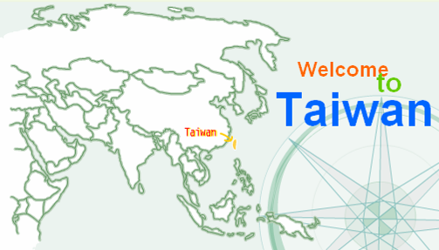

The City
Taipei is the capital of the Republic of China, a city that blends traditional culture and cosmopolitan life. As the political, economic, educational, and recreational center of the country, Taipei offers an array of significant cultural sights.

Climate
Taipei has a humid, subtropical climate, with temperatures as high as 33° in summer which is when the rainfall is highest.

Local Time
GMT +8 hours

Electricity
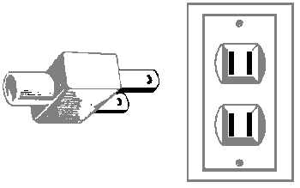

Currency
The Republic of China's unit of currency is the New Taiwan Dollar (NT$)

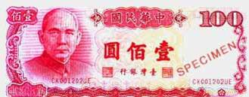

The New Taiwan Dollar (NT$) is the currency used in Taiwan. Paper money is currently available in NT$100, NT$200, NT$500, NT$1,000, and NT$2,000 bills. Coins are NT$1, NT$5, NT$10 and NT$50 denominations.
Recent exchange rates (August 13, 2003):
US $1 = NT$34.3
CA $1 = NT$24.6
Japanese ¥1 = NT$0.286
Australian $1 = NT$22.3
NZ $1 = NT$19.9
EUR €1 = NT$38.4
GB £1 = NT$54.7
Visas
Visa free entry - No visa is required for stays of up to 14 days in Taiwan. Such visas cannot be extended and you will have to leave after 14 days.

Foreign nationals may obtain tourist visas if they hold foreign passports or travel documents valid for more than six months in the ROC for purposes of sightseeing, business, family visits, study or training, medical treatment, or other legitimate activities.
14-day visa-free privileges are afforded to citizens of 18 countries: Australia, Austria, Belgium, Canada, Costa Rica, France, Germany, Greece, Italy, Japan, Luxembourg, New Zealand, the Netherlands(Holland), Portugal, Spain, Sweden, U.K. and the U.S.A.
30-day landing visas are afforded to citizens of 21 countries: Australia, Austria, Belgium, Canada, Costa Rica, Czech Republic, France, Germany, Greece, Hungary, Italy, Japan, Luxembourg, New Zealand, the Netherlands (Holland), Poland, Portugal, Spain, Sweden, Switzerland, U.K. and the U.S.A.

Banks and Foreign Exchange
There are no legal private money changers in Taiwan, but some jewellery shops will change cash.

Travellers cheques and credit cards
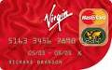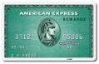

Travellers' cheques and cash can be changed at international airports and large banks. Major international credit cards can be used at big hotels and flash restaurants or to get cash advances at your card's offices.

Tipping
Service charges in restaurants tend to be included in the bill. If not, then about 10% is a standard tip. For most services you are not expected to tip, with the exception of bellboys and porters who will tend to expect about AUD 1.00 per bag.

Customs
As in mainland China, 'face' is a crucial element in Taiwanese culture and society. 'Face' to the Chinese has no direct translation in the West, though the closest comparison would be 'pride'. It is considered the height of bad manners to cause someone else to lose face, so most Taiwanese do not show much emotion or express extreme opinions for fear of causing offence. In order to impress and avoid any social mistakes, it is wise to follow the same approach. This extends to very generous gift giving, offering to pay for restaurant bills and general flattery of your hosts.

Claiming VAT refund
Visit: http://www.taipeitravel.net/unusual.asp?pcode=2&indexId=16&mrtId=-1&uId=2984&pageNo=1

