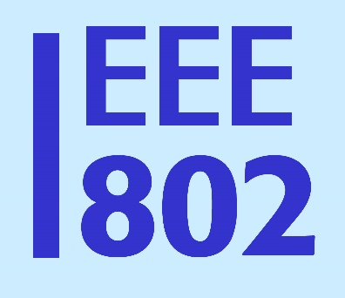
IEEE 802
Local and Metropolitan Area Network Standards Committee

Date [ DATE ]
DCN IEEE 802-EC-17-00XX-0X-00EC {How about a new 00LS file code for liaisons?}
Source IEEE 802 LMSC
To | Name | Position, organization  email@address.something
 | Name | Position, organization  email@address.something
CC | John D’Ambrosia | IEEE 802 LMSC Recording Secretary  jdambrosia@ieee.org
 | Name | Position, organization  email@address.something
 | Name | Position, organization  email@address.something
 | Konstantinos Karachalios | Secretary, IEEE-SA Standards Board  Secretary, IEEE-SA Board of Governors  sasecretary@ieee.org
From | Paul Nikolich | Chairman, IEEE 802 LMSC  IEEE Fellow  p.nikolich@ieee.org
Subject | Liaison [statement to ..]/[reply to ..]
Re | [reference to prior statement received, numbered per external org]
Approval | Approved by IEEE 802, [date]

Dear [Name],

[Content]

Sincerely,
Paul Nikolich
Chair, IEEE 802 LMSC

This document represents the views solelt of the IEEE 802 LMSC and does not necessarily represent a position of the IEEE or the IEEE Standards Association.

