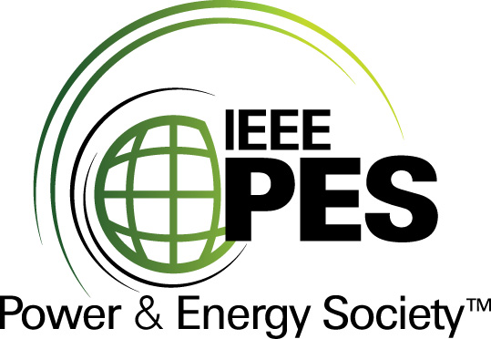


CERTIFICATE OF
EDUCATIONAL ACHIEVEMENT

This certificate is presented to

replace with your name

for attendance at the educational presentation:

"Fault Current Limiting
High Temperature Superconducting Transformers"

sponsored by the IEEE/PES Transformers Committee

and has earned one (1) Professional Development Hours (PDH) unit.
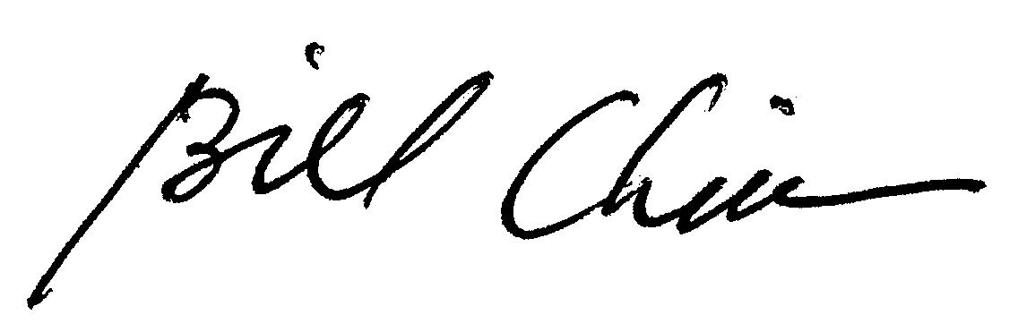
Fall 2012 Committee Meeting; Thursday, October 25, 2012

Bill Chiu Instructors: Russell Neal, Sam Mehta and others

