1. Administrative Subcommittee – Bill Chiu

Introductions

The attendees were asked to introduce themselves. The chair asked each attendee to state his/her affiliation. If the attendee is a consultant, the attendee must state if he is representing a company other than his own consulting interest. Introductions were made by members and guests.

Attendance

Members present: Members absent:

Gregory Anderson Thomas Lundquist

Stephen Antosz Charles Johnson

William Bartley

Ed teNyenhuis

Bill Chiu Guests present:

Ross McTaggart Peter Balma

Susan McNelly Erin Spiewak

Carl Niemann Joe Watson for Tom Lundquist

Donald Platts Casey Ballard for Chuck Johnson

Michael Sharp Jin Sim

Stephen Shull Tom Prevost

Edward Smith Ramsis Girgis

Loren Wagenaar

Peter Zhao

Bruce Forsyth

* 1. Approval of Previous Meeting Minutes

The Chair asked for comments from the Nashville Administrative Subcommittee meeting minutes. Hearing no comments or requests to change the draft minutes, the Chair asked for a motion to approve. Vote Approved.

* 1. Approval of Agenda

The Chair reviewed the draft agenda with the attendees. There were no comments and the Chair declared the agenda approved.

Meeting Call to Order 2:00pm

1. Introduction of Members and Guests (:05) All
2. Approval of Spring 2012 Minutes – Nashville, TN (:03) B. Chiu
3. Additions to and/or Approval of the Agenda (:02) B. Chiu
4. Chair’s Report (:05) B. Chiu
5. Vice Chair’s Report (:05) D. Platt
6. Secretary’s Report (:10) S. Antosz
7. Treasurer’s Report (:05) G. Anderson
8. Awards Report (:10) E. Smith
9. Meeting Planning (:10) G. Anderson
   1. Milwaukee Meeting Arrangements & Host Update
   2. Future Meetings
10. Standards Report (:20) B. Bartley
11. IEEE Staff Update (:05) E. Spiewak
12. BREAK (:10)
13. Old Business
    1. Corresponding Members and Meeting Quorum (:10) S. Antosz
    2. WG Data – Confidentiality, Storage, Access, & Use (:10) S. McNelly/E. Spiewak
    3. Access to Tutorial Presentations & Copyright release (:10) TBD
    4. GMD/GIC Position Paper (:05) R. Girgis/B. Bartley/B. Chiu
    5. Committee O&P, WG P&P Manual Update & Learnings (:05) P. Balma
14. New Business
    1. Meeting Schedule – Thursday General Session & Tutorial Sequence (:10) S. Antosz/G. Anderson
    2. Confirmation of Liaison Appointments (:05) B. Chiu
       1. IEEE SA SCC18 – Edwin (Ned) Brush
       2. CIGRE – Raj Ahuja
    3. Transformers Committee History and Award History (:05) P. Balma
15. Subcommittee Reports - Roundtable
    1. Bushings (:05) P. Zhao
    2. Dielectric Test (:05) L. Wagenaar
    3. Distribution Transformers (:05) S. Shull
    4. Dry Type Transformers (:05) C. Ballard (for C. Johnson)
    5. HVDC (:05) M. Sharp
    6. Instrument Transformers (:05) R. McTaggart
    7. Insulating Fluids (:05) S. McNelly
    8. Insulation Life (:05) B. Forsyth
    9. Performance Characteristics (:05) E. teNyenhuis
    10. Power Transformers (:05) J. Watson (for T. Lundquist)
    11. Underground Transformers & Network Protector (:05) C. Niemann
16. Adjourn
    1. Chair’s Report – Bill Chiu

**3.3.1 IEEE Power & Energy Society Technical Council**

The Technical Council of the IEEE Power Energy Society (PES) is presently composed of the Chairpersons of the PES Technical Committees, plus the Chairpersons of Standing Committees reporting to it. The Power Energy Society is Division VII of The Institute of Electrical and Electronics Engineers (IEEE). For operating functions it is responsible to the IEEE Technical Advisory Board and for technical activities to the IEEE Technical Activities Board. Please see <http://www.ieee-pes.org/technical-committees/statement-of-purpose-and-scope-of-activities-for-the-pes-technical-council> for further details on the Statement of Purpose and Scope of Activities for the PES Technical Council. The membership of the Technical Council is listed below.

**TECHNICAL COUNCIL OFFICERS**

Damir Novosel, *Chair*Jeffrey H. Nelson, *Vice* *Chair*S. S. (Mani) Venkata, *Secretary*Rick Taylor, *Past* *Chair*

**STANDING COMMITTEES**

Awards Committee - John Randolph, *Chair*

Meetings & Marketing Committee - Jeffrey H. Nelson, *Chair*

Organization & Procedures Committee - Mani Venkata, *Chair*

Standards Coordination Committee - Bill Bartley, *Chair*

Technical Sessions Committee **-** Jeffrey H. Nelson, *Chair*

**COORDINATING COMMITTEES**

Emerging Technologies Coordinating Committee - Branislav Djokic, *Chair*

Intelligent Grid Coordinating Committee - Don Von Dollen, *Chair*

Marine Systems Coordinating Committee - Paul Bishop, *Chair*

Wind and Solar Power Coordinating Committee - Richard J. Piwko, *Chair*

**TECHNICAL COMMITTEES**

Electric Machinery Committee - Mike Sedlak, *Chair*

Energy Development and Power Generation Committee - Om Malik, *Chair*

Insulated Conductors Committee - John Smith, *Chair*

Nuclear Power Engineering Committee - S. K (Satish) Aggarwal, *Chair*

Power System Analysis, Computing, and Economics Committee - Sandoval Carneiro, Jr., *Chair*

Power System Communications Committee - Dan Nordell, *Chair*

Power System Dynamic Performance Committee - Nikos Hatziargyriou, *Chair*

Power System Instrumentation and Measurements Committee - R. Arseneau, *Chair*

Power System Operations Committee - William (Bill) Cassel *Chair*

Power System Planning and Implementation Committee - M. L. Chan, *Chair*

Power System Relaying Committee - Robert D. Pettigrew, *Chair*

Stationary Battery Committee - William (Bill) Cantor, *Chair*

Substations Committee - John D. Randolph, *Chair*

Surge Protective Devices Committee - Dr. A. J. (Tony) Surtees, *Chair*

Switchgear Committee - Ken Edwards, *Chair*

Transformers Committee - Bill Chiu, *Chair*

Transmission and Distribution Committee - S. J. Ranade *Chair*

**3.3.2 Highlights of PES Technical Council Activities**

The most recent Technical Council meeting took place on July 25, 2012, at the PES General Meeting in San Diego, CA. Highlights of several activities of Technical Council and its Committees are included below.

**3.3.2.1 Conference Paper Review/Acceptance Criteria**

Based on many of the feedbacks from the various technical committees within PES over the past several years, the Technical Council has identified an opportunity for improvement by providing consistent guideline for the review and acceptance of the PES sponsored conference papers. Over the course of the past year, there were additional efforts completed towards developing a general guideline. A taskforce was formed to address the paper review and acceptance criteria. Key members of this taskforce are representatives of the following technical committees:

* Power System Relaying Committee - Robert D. Pettigrew, *Chair*
* Transformers Committee - Bill Chiu, *Chair*
* Transmission and Distribution Committee - S. J. Ranade, *Chair*

The deliverable of this Taskforce is a set of guidelines for paper review and acceptance criteria. The taskforce completed its work and reported its recommendation at the Tech Council meeting during the PES GM in San Diego that took place in July 2012. The recommendations included high level review and acceptance guideline for both the authors and the reviewers of the paper. The Taskforce’s recommendations were accepted by the Technical Council and criteria will be proposed to the IEEE PES Governing Board for final approval. The presentation slides were included below for reference.

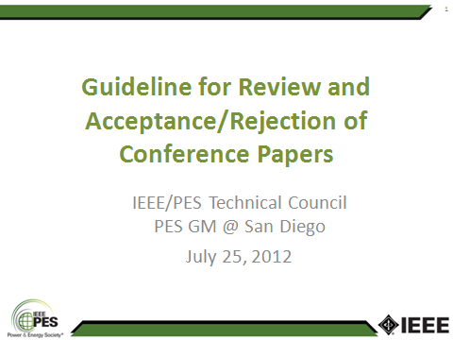 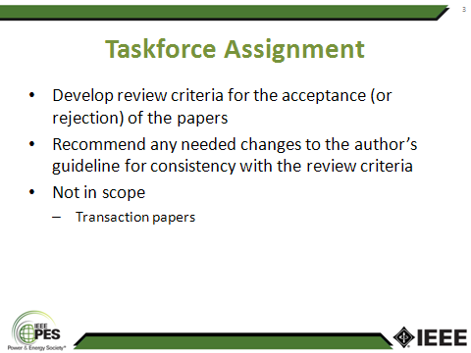

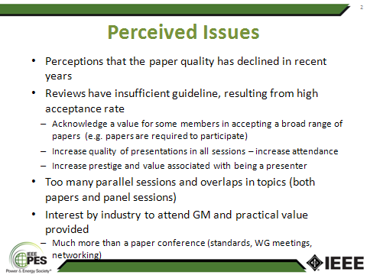 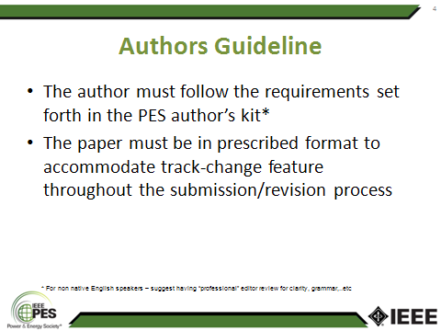

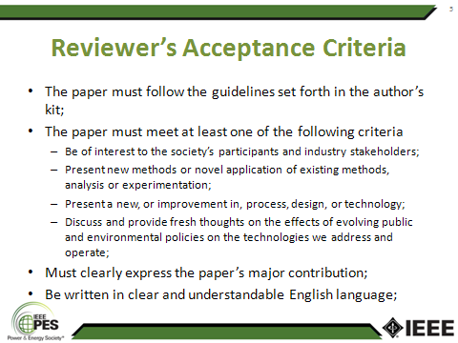 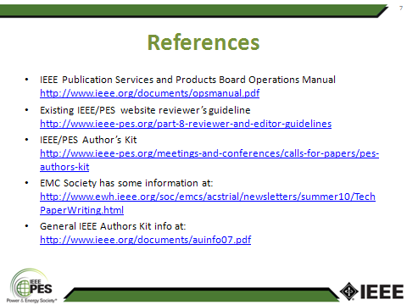

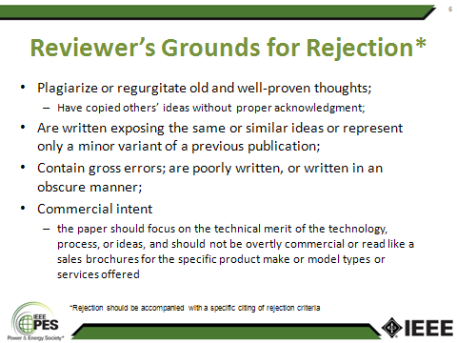

The Chair notes with appreciation that many key contributors within the Transformers Committee have authored papers and also took active roles in reviewing conference papers over the years. They also offer their experience and perspectives in this effort and many of their suggestions were also incorporated in the final recommendations.

**3.3.2.2 Geomagnetic Disturbance (GMD) Taskforce**

As a follow up to the discussion at the Transformers Committee meeting in Nashville back in March 2012, the concerns expressed by the members of the Transformers Committee GMD Taskforce members in regards to the IEEE Spectrum article published in February 2012 were elevated to the officers of the PES Technical Council and the representatives of the various technical committees. Many of the other PES technical committees also expressed similar concerns. Upon further dialogues over the course of several months leading up to the PES General Meeting at San Diego in July, the PES Technical Council expressed interested in having a coordinated response. The presentation slides that were the basis of the discussion at the July, 2012 Technical Council meeting are included below for reference:

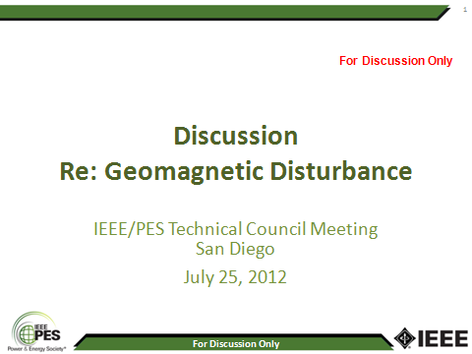 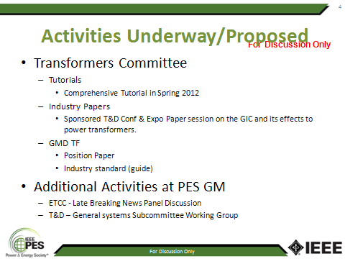

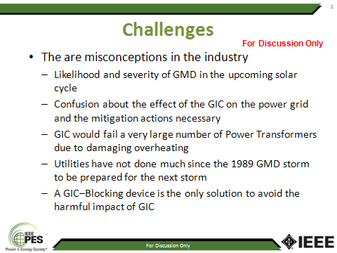 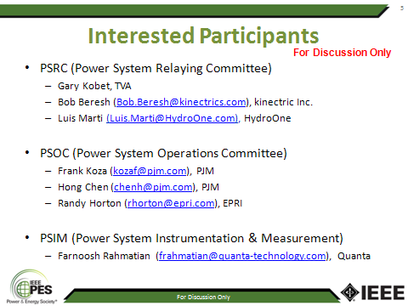

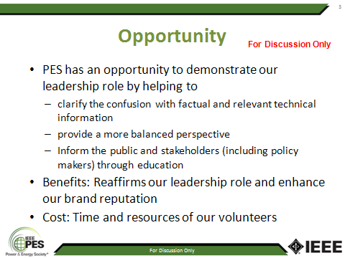 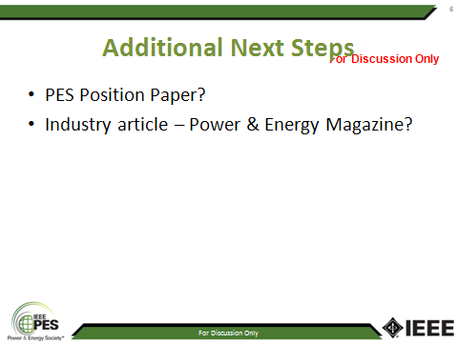

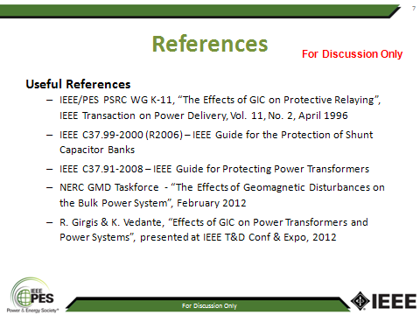

Following the discussion there was a motion made to form a Technical Council Taskforce to develop an industry white paper. The goal of this white paper is to provide additional technical information to demystify the many mis-information that has been circulating in various publications. The motion passed and subsequently the Transformers Committee Chair was appointed the Chair this Taskforce. The Technical Council also expressed its desire to have a joint white paper at the IEEE PES Technical Council level rather than independent efforts by the various technical committees.

**3.3.3 Transformers Committee Activities**

**3.3.3.1 Subcommittee Chairperson & Technical Editor**

Our current roster of the Subcommittee Chairs and Editor are:

* Bushings Subcommittee **Peter Zhao**
* Dielectric Test Subcommittee **Loren Wagenaar**
* Distribution Transformers Subcommittee **Stephen Shull**
* Dry-Type Transformers Subcommittee **Charles Johnson**
* HVDC Converter Transformers and Smoothing Reactors Subcommittee **Michael Sharp**
* Instrument Transformers **Ross McTaggart**
* Insulating Fluids Subcommittee **Susan McNelly**
* Insulation Life Subcommittee **Bruce Forsyth**
* Meetings Subcommittee **Gregory Anderson**
* Performance Characteristics Subcommittee **Ed teNyenhuis**
* Power Transformers Subcommittee **Tom Lundquist**
* Standards Subcommittee **William Bartley**
* Underground Transformers & Network Protectors Subcommittee **Carl Niemann**
* Technical Editor **Sanjib Som**

All of them have confirmed their commitment to serve the duration of the calendar year 2012. As we approach the end of 2012, the volunteer subcommittee leaders and editor will have the opportunity to reaffirm their desire to continue their service in the respective capacity in accordance with the established guideline in the Transformers Committee O&P Manual.

PES Technical Council was notified of the Subcommittee Chairs and Technical Editor appointments for the calendar year 2012 in accordance with the guideline set forth in our O&P Manual.

**3.**3.3.2 **Association Management (AM) System**

The AM system continues to serve important administrative functions in supporting the membership roster. This system is designed with self-administered features for updates of individual contact information. The system also serves to facilitate attendance record keeping and email distribution list for the various subgroups within the Transformers Committee.

All Subcommittees, Working Group (WG), and Taskforce (TF) Chairs are requested to use the AM system for assigning and tracking membership within their groups and for communication with their group members. All Committee members, active participants, and interested individuals are reminded also that you are responsible personally for maintaining the accuracy of your contact information, through the AM system, for Committee activities and communication. Keeping your contact information maintained in the AM system assures that the Chair of any Subcommittee, WG, or TF you are involved with will be able to contact you in a timely manner. Details on enrolling and maintaining your contact information in the AM system can be found on the Committee website.

**3.3.3.3 Committee Membership**

All are welcome to participate in the work of the Transformers Committee. Membership in the Committee provides recognition of your peers and indication to your co-workers and management of your active role in Committee work. If you are presently not a Main Committee Member, and you have been actively participating in our work for at least two full year – and can secure the acknowledgement and sponsorship of at least 3 activity Chairs (WGs, but must include at least one Subcommittee Chair) affirming that participation, the Committee will look forward to welcoming you as a member. Membership requirements and application forms can be found in the Organization and Procedures Manual posted on the Committee website.

As our organization is a 100% volunteer based organization, we are very much in need of all of your continued participation and sharing of your expertise towards our world-class standards development efforts. Many of our long-standing committee members have made tremendous contributions towards our standards development effort over the years and their contributions are greatly appreciated.

* 1. Vice-Chair’s Report – Don Platts

## IEEE PES Calendar of Upcoming Events

The table below lists the upcoming PES sponsored conferences and committee meetings. Please check the PES website at [**www.ieee-pes.org**](http://www.ieee-pes.org) for further details.

2013 IEEE PES Joint Technical Committee Meeting (JTCM 2013)

*Jan 13 – 17, 2013, Memphis, Tennessee, USA*

[2013 IEEE PES Innovative Smart Grid Technologies Conference](http://ieee-isgt.org/)   
*24-28 February, 2013, Washington D.C., USA*

[PES 2013 General Meeting](http://pes-gm.org/2013/)  
*21-25 July, 2013, Vancouver, British Columbia, Canada*

## 3.4.2 Conference Papers presented since spring 2012

3.4.2.1 2011 IEEE PES Power Systems Conference & Exposition  
(Orlando, FL, May 7, 2012)

A total of 20 papers have been submitted. After review, 10 of these papers were presented in the Paper Session.

|  |  |
| --- | --- |
| ID | Title |
| 2012TD0052 | [**Low-Cost Amorphous-Metal Rolled-up-Core Distribution Transformer**](http://submissions.miracd.com/TD2012/ChairSubmissionDetail.asp?mode=sbs&sbmID=52) |
| 2012TD0130 | [**Transformer Insulation Dry Out as a Result of Retrofilling with Natural Ester Fluid**](http://submissions.miracd.com/TD2012/ChairSubmissionDetail.asp?mode=sbs&sbmID=130) |
| 2012TD0203 | Measurement and Computation of Transient Recovery Voltage of Transformer Limited Fault in 525kV-1500MVA Three-Phase Transformer |
| 2012TD0261 | [**Gas insulated transformer application for an environmentally-friendly power station upgrade**](http://submissions.miracd.com/TD2012/ChairSubmissionDetail.asp?mode=sbs&sbmID=261) |
| 2012TD0311 | [**Statistical Insights into Furan Interpretation Using a Large Dielectric Fluid Testing Database**](http://submissions.miracd.com/TD2012/ChairSubmissionDetail.asp?mode=sbs&sbmID=311) |
| 2012TD0383 | [**Construction of a High Voltage Test Facility**](http://submissions.miracd.com/TD2012/ChairSubmissionDetail.asp?mode=sbs&sbmID=383) |
| 2012TD0454 | [**Power Grid Stability Protection against GIC Using a Capacitive Grounding Circuit**](http://submissions.miracd.com/TD2012/ChairSubmissionDetail.asp?mode=sbs&sbmID=454) |
| 2012TD0463 | [**Effects of GIC on Power Transformers and Power Systems**](http://submissions.miracd.com/TD2012/ChairSubmissionDetail.asp?mode=sbs&sbmID=463) |
| 2012TD0561 | [**Evaluation of Distribution Network Transformer Dissolved Gas Analysis (DGA) Data**](http://submissions.miracd.com/TD2012/ChairSubmissionDetail.asp?mode=sbs&sbmID=561) |
| 2012TD0590 | [FEM Analysis of the Transformer Insulation XY Model](http://submissions.miracd.com/TD2012/ChairSubmissionDetail.asp?mode=sbs&sbmID=590) |

## 3.4.2.2 2012 PES General Meeting (San Diego, CA July 23- 24, 2012)

A total of 12 papers were submitted. After review, 6 papers were presented in the Paper Session.

|  |  |
| --- | --- |
| ID | Title |
| 2012GM0281 | Demagnetization of a Large Power Transformer Based on Calculation of the Flux Linkage |
| 2012GM0693 | Effects of Iron-Core Topology on Inrush Currents in Three-Phase Multi-Leg Power Transformers |
| 2012GM0707 | Interpretation of Dielectric Response Measurements of Transformer Insulation under Temperature Variations and Transient Effects |
| 2012GM1155 | A Study on Suitability of Different Transformer Winding Models for Frequency Response Analysis |
| 2012GM1177 | Multivariate Analysis for Correlations among Different Transformer Oil Parameters to Determine Transformer Health Index |
| 2012GM1440 | Solid State Transformer Specification via Feeder Modeling and Simulation |

## 3.4.2 Upcoming Conference Papers Submitted for Review

### 2013 PES General Meeting

Unknown --The deadline for submission is in November 30 2012.

## Changes to IEEE PES Conference Paper Rules

The IEEE PES explanation of these changes is published and can be reviewed at <http://pes-gm.org/2013/index.php/call-for-papers>.

### 3.4.3 Conference Paper Submission Requirements

The paper length has been reduced to 5 pages. Part 1 and Part 2 papers will not be permitted. The maximum paper length has been reduced to 5 pages. Part 1 and Part 2 papers will not be permitted

### 3.4.4 Conference Paper Presentations

There will be no Transformers Committee Paper Presentation sessions.

The majority of accepted conference papers will be scheduled for presentation at the Monday evening poster session. Presentation of an accepted paper at the conference is a requirement of publication. Any paper that is not presented at the conference will not be included in IEEE Xplore.

The top 60 to 80 accepted conference papers will be selected to be presented in a Conference Paper Session. Author(s) will be allowed 8 minutes to present their paper and will be allowed to use a maximum of 6 PowerPoint slides.

A few of the top 60 to 80 conference papers will be chosen and recognized as General Meeting Conference Prize Papers, during the Tuesday Awards dinner.

### Transactions Paper Presentations

The PES Technical Committees will be selecting published Transactions papers for presentation at the 2013 General Meeting. An author of an accepted PES Transactions paper who is interested in presenting it at the 2013 PES General Meeting must upload the full paper, in addition to the paper's abstract, to the on-line submission and review site by the deadlines listed above. The appropriate Technical Committee Program Chair (TCPC) will determine if the topic of the paper is suited for presentation in one of the technical sessions.

### 3.4.5 Special Issue Transactions Paper Presentations:

Beginning in 2013, select papers from Special Issue PES Transactions will be presented at the PES General Meeting. The Special Issues have already been identified for 2013, but authors are encouraged to submit papers to future special issues. Information on planned Special Issue PES Transactions can be found at: [**http://www.ieee-pes.org/calls-for-transactions**](http://www.ieee-pes.org/calls-for-transactions)

### 3.4.6 Panel Sessions

The Transformers Committee will have the opportunity to sponsor panel session at future conferences. We have not yet considered this type of presentation at any future conference. Panelists will not be required to write summary papers to participate in panel sessions. Only PowerPoint presentations are required. Invited panelists are free to submit a conference paper on the topic they are asked to present, if they so choose, but it must be submitted to the on-line submission and review site by the conference paper submission deadlines listed above and it will be reviewed for acceptance under the same criteria as all conference paper submissions. Participation as a panelist does not guarantee that your conference paper submission will be accepted and published.

* 1. Secretary’s Report – Stephen Antosz

### Membership Review

Voting Committee Members – Two new committee members were approved and added at the Nashville meeting as shown in the table below:

| **Name** | **Affiliation** | **Sponsor #1** | **Sponsor #2** | **Sponsor #3** | **Membership Category** |
| --- | --- | --- | --- | --- | --- |
| Baitun Yang | Pennsylvania Transformer | Pierre Riffon  WG Revision to Impulse Test (2+yrs) | Loren Wagenaar  SC Dielectric Test  (2+yrs) | Stephen Antosz  SC Performance Characteristics  (2+yrs) | Producer |
| Thomas Sizemore | ABB | Thang Hochanh  TF PD in Bushings, PTs, CTs (2 yrs) | Ross McTaggert  SC Instrument Transformers  (1.5 yrs) | Ross McTaggert  WG Requirements for Instrument Transformers  (6 months) | Producer |

The Transformers Committee AMS database of people currently has three general categories of participation in our activities. These are: **Interested Individual**, **Active Participant**, and **Committee Member**. Any one can join our AMS 123 system as the system is designed for self-registration. A new participant will automatically be assigned the role of Interested Individual when they first sign up. Based on the level of participation, the committee administrative staff will upgrade the participation status to “Active Participant” when appropriate. The Committee Member status however, can only be attained through a formal application with the sponsorship of minimum of three WG or SC chairmanships. Detail of the application requirements and approval process by the Administrative Subcommittee is outlined in our O&P manual.

The following table contains a count of the participants grouped by the three general categories.

|  |  |  |  |  |  |
| --- | --- | --- | --- | --- | --- |
| Membership Status | Oct-10 | Apr-11 | Oct-11 | Mar-12 | Oct-12 |
| Interested Individual | 843 | 997 | 1061 | 1132 | 1205 |
| Interested Individual - IEEE Life Member * | 6 | 2 | 4 | 6 | 7 |
| **Total Interested Individuals** | **845** | **999** | **1065** | **1138** | **1212** |
|  |  |  |  |  |  |
| Active Participant | 227 | 230 | 218 | 232 | 231 |
| Active Participant - IEEE Life Member * | 7 | 5 | 5 | 6 | 6 |
| **Total Active Participants** | **234** | **235** | **223** | **238** | **237** |
|  |  |  |  |  |  |
| Committee Member | 211 | 210 | 218 | 182 | 182 |
| Committee Member - Emeritus Member * | 8 | 1 | 8 | 6 | 6 |
| Committee Member - IEEE Life Member * | 26 | 31 | 31 | 29 | 30 |
| Committee Member - Corresponding Member | 1 | 1 | 1 | 0 | 0 |
| **Total Committee Members** | **246** | **243** | **258** | **217** | **218** |
|  |  |  |  |  |  |
| **TOTAL IN AMS DATABASE** | **1391** | **1478** | **1546** | **1593** | **1667** |

* - indicates this member type receives a discounted registration fee.

The participant’s profiles in our AMS 123 system should reflect the correct status. It is the responsibility of each individual to keep his or her profile updated. Here is the link to our AMS 123 system. (<http://www.123signup.com/servlet/com.signup.servlet.org.ALogin?Org=ieee-transformers&Restart=1>)

**3.5.2 New Member Applications**

Six new applications for Committee Membership have been received since our previous meeting in Nashville. They will be submitted for approval at the Milwaukee meeting on October 21, 2012. Details of the membership applications and sponsors are listed in the following table.

| **Name** | **Affiliation** | **Sponsor #1** | **Sponsor #2** | **Sponsor #3** | **Membership Category** |
| --- | --- | --- | --- | --- | --- |
| Jeremy A. Sewell | Quality Switch, Inc | Carl Nieman  UTNP SC  (7yrs) | Phil Hopkinson  WG C57.157 DETC (7yrs) | Brian Klaponski  WG C57.12.40 Network Xfmr(7yrs) | Producer |
| Robert T. Rasor | S.D. Myers, Inc. | Susan McNelly  Insulating Fluids SC (3 yrs) | Richard Ladroga  WG C57.104 DGA (7yrs) | Tom Prevost  TF Furans  (3yrs) | General Interest |
| David Archie Wallace | ABB/Kuhlman Electric | Loren Wagenaar  Dielectirc Test SC (2 yrs) | Ross McTaggert  Instrumnt Trans SC (2 yrs) | Pierre Riffon  WG Rev to Impulse Tests (2 yrs) | Producer |
| Roberto Asano Junior | ABB | Don Platts/Bruce Forsyth  Insulation Life SC (4 yrs) | Peter Zhao  WG C57.156 Tank Rupture (2yrs) | Richard Marek  WG C57.154 High Temp Insul (4yrs) | Producer |
| Brian R. Penny | American Transmission Company | Jane Verner PC57.152 Field Test Guide(4 yrs) | Dave ?  WG PC57.139 DGA LTC(2 yrs) | Enrique Betancourt  TV/Stabilizing Wdg  (1 yrs) | User |
| Subhas S. Sarkar | Virginia Transformer Corp | Sheldon Kennedy  WG C57.12.52  (2 yrs) | Tim Holdway  WG C57.12.01  (2 yrs) | Chuck Johnson  Dry Type SC  (>2 yrs) | Producer |

The Committee welcomes and encourages active participants to become Members of the Committee. Requirements and application forms can be found in the Organization and Procedures (O&P) Manual, accessible on the Committee website. Subcommittee Chairs are encouraged to recommend new members, and to communicate the process of attaining membership through **active participation** and **contribution** in Committee work at the WG and SC level. WG and SC Chairs are reminded also that signing an application sponsoring a new member signifies their sponsorship that the applicant has met the requirement of membership and active participation for at least one year in the WG or SC they Chair. New member applications may be submitted to the Committee Secretary’s attention at any time. Applications will be collected for review and approval in batches at each Administrative Subcommittee meeting. For an application to be reviewed at the next meeting, the application will need to be received by the Committee Secretary a minimum of one week prior to the start of that meeting.

**3.5.3 Committee, Subcommittees, and Working Group Rosters**

In order to provide indemnification to working group and subcommittee members it is crucial that membership lists be maintained. Our AM system has these functions built-in to ease these administration tasks. It is important that each subcommittee and working group chair keep the rosters updated so that this information can be provided to the IEEE SA.

A similar main committee roster has also been developed to track attendance for the Main Committee meeting on Monday & Thursday. The data will be used to update participant’s membership profile.

**3.5.4 IEEE/PES and IEEE/SA Membership Requirements**

As a reminder, all members of the Transformers Committee must also be members in good standing of the Power & Energy Society (IEEE/PES) and the Standards Association (IEEE/SA). There are a number of Transformers Committee members who have lapsed and must renew their SA and/or PES affiliation. These memberships are renewed annually along with your IEEE Membership renewal, which typically occurs at the end of each year.

Reminder that WG Chairs must also be a member of the SC, PES, and SA.

There are a number of Transformers Committee Members who are not PES or SA members. They will be given a reminder to renew these required memberships. If they do not comply then they will be dropped as Members. It is not fair to the other Members who adhere to this rule and pay the annual fees. Moreover, a person CANNOT participate in any ballot activity if they are not an SA member, and this is one of the basic responsibilities of an active member.

**3.5.5 Consistent Guidelines for Membership Maintenance**

Due to varying application of removal of members from individual SC’s & WG’s, the Administrative Subcommittee will develop some guidelines for consistent application. The Transformers Committee Secretary will create a first draft and circulate to the Admin Members for comment. It was requested that each SC Chair forward to the Secretary whatever rules they have been using in their own groups.

**3.5.6 Essential Patent Claims**

The Transformers Committee is now asking each participant at the time of meeting registration if they are aware of an essential patent claim, and if so to provide details. An Essential Patent Claim is any Patent Claim the use of which was necessary to create a compliant implementation of the IEEE Standard when there was no commercially and technically feasible non-infringing alternative. In other words, if an IEEE Standard REQUIRES the use of a product or process that is already patented, then this could be an essential patent claim. For this Milwaukee meeting there were nine people who answered YES that they were aware of a potential essential patent claim. Four of the nine provided no details and were therefore not considered any further. The other five were reviewed and it was determined that they DO NOT have an essential patent claim. If they did, they would be instructed to have the patent holder’s legal team file a Letter of Assurance (LOA) with the IEEE-SA Standards Board Patent Committee. There is a link to this information on the transformerscommittee.org website.

**3.5.7 Meeting Minutes**

The minutes of the Nashville Transformers Committee meeting Spring, 2012 were posted to the committee website on June 25, 2012.

Subcommittee Chairs are requested to submit their SC Minutes from the Milwaukee meeting by December 15, 2012.

The minutes should be submitted via e-mail to the Committee Secretary, Stephen Antosz at [santosz@ieee.org], with a copy to Susan McNelly [sjmcnelly@ieee.org] for posting on the Committee website.

The submittal file should be saved as a Word document and should be formatted similar to this report, and as shown in the recent assembled Minutes. *The numbering for your report should match the numbering as indicated in the Main Committee Meeting Agenda*. Please indicate total attendance count for each Subcommittee, Working Group, and Task Force meeting in your Minutes. Please do not send a copy of the attendance listing for this attendance count.

Your full corporation and support in this matter is greatly appreciated.

* 1. Treasurer’s Report – Greg Anderson

The finances of the Committee are in excellent condition. As of September 1, 2012 (end of this reporting period), the balance was $56,563.01. There were no assets (PC projectors, etc.) purchased during this reporting period. There was a small gain during this reporting period. See below "balance sheet".



* 1. Recognition and Awards Report – James Edward Smith

3.7.1 Committee Certificates of Appreciation

Transformers Committee Certificates of Appreciation have been obtained, with approval of the PES Awards & Recognition Chair, for the following Award recipients:

**3.7.1.1 General Service Awards**

H. Jin Sim Host - Fall 2012 Meeting, Milwaukee, WI

SPX Transformer Solutions Host Company - Fall 2012 Meeting, Milwaukee, WI

Richard Dudley Chair, HVDC Subcommittee

Loren Wagenaar Chair, Dielectric Test Subcommittee

? Distinguished Service Award

**3.7.1.2 Task Force Service Awards**

**Task Force on IEC Comparison**

H. Jin Sim Chair, Task Force on IEC Comparison

**Task Force on Instructions for IEC Coordination**

Jeewan Puri Chair, Task Force on Instructions for IEC Coordination

**Task Force on Stabilizing Windings**

Enrique Betancourt Chair, Task Force on Stabilizing Windings

Richard Amos Contributing Member, Task Force on Stabilizing Windings

Xose Lopez-Fernandez Contributing Member, Task Force on Stabilizing Windings

Sanjay Patel Contributing Member, Task Force on Stabilizing Windings

Vallamkonda Sankar Contributing Member, Task Force on Stabilizing Windings

Krishnamurthy Vijayan Contributing Member, Task Force on Stabilizing Windings

**Task Force on Dielectric Frequency Response**

George Frimpong Chair, Task Force on Dielectric Frequency Response

Peter Werelius Contributing Member, TF on Dielectric Frequency Response

Diego Robalino Contributing Member, TF on Dielectric Frequency Response

Mario Locarno Contributing Member, TF on Dielectric Frequency Response

Mary Foster Contributing Member, TF on Dielectric Frequency Response

**Task Force on DVP Grid Transformers**

Dr. Hemchandra Shertukde Chair, Task Force on DVP Grid Transformers

Matthieu Sauzay Vice Chair, Task Force on DVP Grid Transformers

Alexander Levin Secretary, Task Force on DVP Grid Transformers

**3.7.2 IEEE SA Standards Board Awards**

In addition to the Committee Awards above, the IEEE SA SB presents its own Award to the WG Chair upon publication of a new or revised document, and offers the WG Chair the opportunity to nominate significant contributors to the project for an IEEE SA SB Certificate of Appreciation.

IEEE SA Award Recipients:

**C57.91 IEEE Guide Loading Mineral-Oil-Immersed Transformers**

Don Duckett WG Chair, C57.91

Carl Arpino WG Vice Chair, C57.91

Susan McNelly WG Secretary, C57.91

Peter Balma Outstanding Contributor C57.91

William Bartley Outstanding Contributor C57.91

Bruce Forsyth Outstanding Contributor C57.91

**C57.131 IEEE Standard Requirement For Tap Changers**

William Henning WG Chair, C57.131

Craig Colopy WG Vice Chair, C57.131

Alex Kraemer Outstanding Contributor C57.131

James Harlow Outstanding Contributor C57.131

**C57.12.40 IEEE Standards for Requirements For Secondary Network Transformers**

Brian Klaponski WG Chair, C57.12.40

Larry Dix Outstanding Contributor C57.12.40

Giuseppe Termini Outstanding Contributor C57.12.40

**C57.16 IEEE Standard for Requirements, Termonology, and Test Code for Dry-Type,**

**Air-Core Series Connected Reactors**

Richard Dudley WG Chair, C57.16

Pierre Riffon Outstanding Contributor C57.16

**C57.154 IEEE Standard for the Design, Testing and Application of Liquid-immersed**

**Distribution, Power and Regulating Transformers Using High Temperature**

**Insulation Systems and operating at Elevated Temperatures**

Richard Marek WG Chair, C57.154

Waldemar Ziomek WG Vice Chair, C57.154

H. Jin Sim Outstanding Contributor C57.154

Gary Hoffman Outstanding Contributor C57.154

Roberto Asano Outstanding Contributor C57.154

John Luksich Outstanding Contributor C57.154

Hasse Nordman Outstanding Contributor C57.154

Radoslaw Szewczyk Outstanding Contributor C57.154

**C57.143 IEEE Guide for Application for Monitoring Equipment to Liquid-Immersed**

**Transformers and Components**

Donald Chu WG Chair, C57.143

Andre Lux WG Vice Chair, C57.143

Tony Pink Secretary, C57.143

Brian Sparling Outstanding Contributor C57.143

Claude Beauchemin Outstanding Contributor C57.143

**C57.12.91 IEEE Standard Test Code for Dry-Type Distribution and Power Transformers**

Derek Foster WG Chair, C57.12.91

Robert Ballard Outstanding Contributor C57.12.91

Marcel Fortin Outstanding Contributor C57.12.91

Mark Gromlovits Outstanding Contributor C57.12.91

Timothy Holday Outstanding Contributor C57.12.91

Roger Wicks Outstanding Contributor C57.12.91

3.7.3 IEEE Standards Association (SA) Awards and Recognition

The IEEE SA sponsors additional awards besides the WG Chair Awards reviewed above. Discussion of these awards can be found on the IEEE SA Awards web pages (<http://standards.ieee.org/sa/aw/>). Note particularly the IEEE SA Standards Medallion. Excerpting from the website: “The Standards Medallion is awarded for major contributions to the development of standards. Examples of such contributions may include leadership in standardization of new technologies, assuring achievement of standards development goals, identifying opportunities to better serve the needs of standards users or other such contributions viewed as deserving of this award…” Please review, and if you have suggestions for nominations see our Committee Awards Chair.

**2012 Standards Medallion Award**

We are very pleased to announce that Mr. Phillip Hopkinson has been nominated by the Transformers Committee and will receive a Standards Medallion award for his many accomplishments and years of dedicated service to the Transformers Committee, IEEE, PES and our industry as a whole.

3.7.4 PES Transformers Committee Distinguished Service Award

We will continue to present our PES Technical Committee Distinguished Service Award each year to one of our members who is recognized by his peers as having contributed significantly and consistently to Committee Standards activities.  Excerpting from the PES Awards website: “Each Technical Committee is encouraged to make one award for outstanding service. This personal recognition acknowledges the efforts of those individuals whose sustained performance, over many years, has contributed to the advancement of the committee technology.” Please see the Awards Chair if you have suggestions for future recipients. We are seeking nominations for this award.

3.7.5 PES Working Group Recognition Awards

In addition to the Technical Committee distinguished service Awards, PES sponsors Working Group Recognition awards. The awards are related to “outstanding and timely” publications of technical reports, or of standards and guides. Excerpting from the PES website (http://www.ieee.org/portal/site/pes/) Awards pages:

“The PES Working Group Recognition Awards recognize “the most outstanding and timely publications” by a PES Working Group (or Committee or Subcommittee) from among the nominations. The PES Recognition Award is divided into two categories: 1) for technical reports; 2) standards and guides. Each Technical Council Committee may nominate one report from each category, published by IEEE, during the previous three year period.”  This award consists of a plaque which will be presented to the Working Group Chair at the PES Summer Meeting Awards Luncheon. A framed certificate will be presented to each Working Group member at a designated meeting of the parent Technical Committee.

3.7.6 Transformers Committee Meritorious Service Awards

There is also a process of additional recognition for Meritorious Service and Outstanding Contributions to the Committee. Suggested qualifications have been developed from a review of similar awards presented by other IEEE Technical Committees or Societies. General examples for qualification for the awards include the following:

* To recognize continuing exemplary service in notable technical contributions to multiple Committee projects/documents over a sustained period of time
* To recognize an achievement of major value and significance to the Committee. The achievement can be a specific, concisely characterized accomplishment, as opposed to a collection of different efforts.
* As with the IEEE Education Society Meritorious Service Award – “to recognize pioneering contributions to the administrative efforts of the Society over a period of years, as evidenced by dedication, effort, and contributions.”

If you have any additional thoughts on qualifications for Meritorious Service Awards, and if you have potential nominees to suggest, please contact me. Award nominees will be reviewed by the Awards Chair and the SC Officers.

3.7.7 Member Certificates

All Framed Transformer Committee Membership Certificates will be available for distribution during our Milwaukee meeting. All Transformers Committee members should make sure to pick-up your certificate sometime during the Milwaukee meeting. If you know of any member that is not present in Milwaukee and you have the ability to deliver his/her certificate, please consider taking it to them.

This program is one small way of recognizing your support for the Committee.  The Certificates represent the appreciation of the Committee, and of your Committee Officers, for your service to the Committee, to IEEE, and to our Industry. We hope you will display your Membership Certificate proudly at your place of business, and encourage others to join us in our work.

3.7.8 Nominations for IEEE, PES, and Technical Council Awards

Regarding IEEE Fellow Nominations, we need to think about nominations for 2013. Borrowing from the IEEE Awards web page . . . (<http://www.ieee.org/web/membership/grade_elevation/grade_elevation.html>): “The grade of Fellow recognizes unusual distinction in the profession and shall be conferred only by invitation of the Board of Directors upon a person of outstanding and extraordinary qualifications and experience in IEEE-designated fields, and who has made important individual contributions to one or more of these fields.”  Nominations, including references by at least five present IEEE Fellows and optional additional endorsements, must be completed and submitted by March 1 of each year for the following year’s Class of Fellows.

* 1. Meeting Planning Report – Greg Anderson

No report.

* + 1. Milwaukee Meeting

No report.

* + 1. Future Meetings

No report.

* 1. Standards Report – Bill Bartley

The report was presented and discussed. It is extensive. See website for report.

* 1. IEEE Staff Update – Erin Spiewak

**IEEE/IEC Updates**

- The PAR for the joint revision of IEC 60076-16 - Standard Requirements for Wind Turbine Generator Transformers, was approved in June 2012.  There will be a working group meeting on Tuesday, 23 October at 9:30 am.  More information as to the status of the joint working group will be discovered at that meeting and the lunch meeting with Paul Jarman on Wednesday, 24 October.

- The PAR for 60076-57-1202 - Standard Requirements for Liquid Immersed Phase-Shifting Transformers, was approved in June 2012.  There will be a meeting during the Transformers meeting series on Tuesday, 23 October at 11:00 am.  The New Work Item Proposal has passed in IEC - it was necessary to find a member from the US National Committee to participate in the project in order for the NP to pass and that member has been found.

- At the last Subcommittee meeting of HVDC Converter Transformers and Smoothing Reactors, there was a discussion of possible merging IEEE C57.129 with IEC 61378-2.  Jodi notified both Paul Jarman and Bill Chiu of this interest and this will be discussed at the subcommittee meeting.  Jodi will be in attendance at that meeting.

**Central Desktop --** New Online Collaboration Tool

* + Presentation at Monday Luncheon
  + Help Working Groups plan projects
    - Document editing and sharing
    - MS Word Plug-ins
  1. Old Business
     1. Corresponding Members and Quorum – Stephen Antosz

Corresponding members do not count towards quorum (in numerator or denominator) if not present at a meeting. Corresponding members do count towards quorum (in numerator or denominator) if present at a meeting.

Steve will develop some guidelines for member removal, and circulate to the members for comment, in an effort to apply consistent removal rules across all SC and WG’s.

* + 1. WG Data – Confidentiality, Storage, Access, & Use – Susan McNelly / Erin Spiewak

Motion by Stephen Shull to endorse a plan (to be determined later) as a committee to upload valuable intellectual property to an IEEE folder to be controlled through Chair, Vice-Chais, and the webmaster of TC. Seconded and approved.

* + 1. Access to Tutorial Presentations & Copyright release - TBD

Should we give technical presentations to PES website so they can sell? After discussion we decided No. They need copyrighted; plus we lose ownership. We will put on our TC website, behind password protected wall.

Bill Chiu will continue to exchange correspondence with PES staff to determine if there is any new path forward. So we will continue our current course, and await an official reply from the PES Resource Center.

* + 1. GMD/GIC Position Paper – Ramsis Girgis/Bill Chiu / Don Platts

As a follow up to the discussion at the Transformers Committee meeting in Nashville back in March 2012, the concerns expressed by the members of the Transformers Committee GMD Taskforce members in regards to the IEEE Spectrum article published in February 2012 were elevated to the officers of the PES Technical Council and the representatives of the various technical committees. Many of the other PES technical committees also expressed similar concerns. Upon further dialogues over the course of several months leading up to the PES General Meeting at San Diego in July, the PES Technical Council expressed interested in having a coordinated response.

* + 1. Committee O&P, WG P&P Manual Update – Peter Balma
* IEEE – SA approved new baseline documents for preparation of P&P for sponsors and working groups.
* Will utilize these to develop new draft of P&P and working group P&P before the end of the year.
* P&P highlight - expectation for minutes
* The minutes shall record the essential business of the working group, including the following items at a minimum:
  + Name of group, Date and location of meeting
  + Officer presiding, including the name of the secretary who wrote the minutes
  + Attendance, including affiliation , Call to order, Chair's remarks
  + Approval of minutes of previous meeting, Approval of agenda
  + Technical topics
    - Brief summary of discussion and conclusions
    - Motions, including the names of mover and seconder
  + Items reported out of executive session, Next meeting--date and location
  1. Subcommittee Reports

|  |  |  |
| --- | --- | --- |
| Subcommittee | Report | Hot Topic |
| Bushings – P. Zhao |  | Need Standard for Distribution Transformer bushings |
| Dielectric Test – L. Wagenaar |  | DFR TF was in PCS and is now in Diel Test. Peter Werelius was Chair but he is an equipment manufacturer, so will be Vice-Chair instead. |
| Distribution Transformers – S. Shull |  |  |
| Dry Type Transformers – C. Johnson |  |  |
| HVDC – M. Sharp |  |  |
| Instrument Transformers – R. McTaggart |  | Have too many manufactuers and not enough users on WG for PD requirements for MV IT’s. |
| Insulating Fluids – S. McNelly |  |  |
| Insulation Life – B. Forsyth |  |  |
| Performance Characteristics – E. teNyenhuis |  | New TF for transient interactions in medium or high voltage applications |
| Power Transformers – T. Lundquist |  | New WG for dual logo joint development Standard Requirements for Phase Shifting Transformers |
| Underground Transformers & Network Protector – C. Niemann |  |  |
| Standards SC – Bill Bartley |  | New TF for consistency of fluid terminology to write white paper |

* 1. New Business

3.13.1 Meeting Schedule – Monday/Thursday General Session & Tutorial Sequence – S. Antosz/G. Anderson

There was some discussion about moving Part 2 of the General Session to be BEFORE the tutorials instead of AFTER. It was decided to keep the current schedule for one or two more meetings and then reevaluate. We don’t want to lose people from the tutorials since the presenters go to great efforts to prepare the tutorials.

3.13.2 Chair Liaison Appointments

* Ned Edwin Brush is appointed liaison to Standards Coordinating Subcommittee SCC18.
* Raj Ahuja is appointed liaison to CIGRE.
* Tom Prevost is appointed as unofficial liaison to ASTM D9 insulating fluids

3.13.3 Committee History & Awards Update – Peter Balma

* On Tuesday at 9:30 AM there will be a meeting to discuss Transformer Committee History.
  + Review of history collected to date
  + Assess interest to continue to meet and to seek members interested in digging in or contributing to our history
  + Solicit input and confirmation of history by those present
  + Awards
  + Transformer Committee fellows
    - 1912 – 1913 first, 79 total to date, approx. 65% confirmed
  + Collecting all award history
  + Posting of awards
  + Observation other PES committees & awards
  1. Adjourn

Yes