**CIGRE Liaison Report**

**Agenda — October 22nd, 2012**

* Overview of CIGRE 44th Session
* U.S. Representation in CIGRÉ Study Committees
* Details on A2 Study Committee
* Details on B3 Study Committee
* Details on D1 Study Committee

**Preferential Subjects Discussed in Paris 2012**

PS1 > Modeling and practical experience of the interaction of new generation/transmission technologies and related power electronics with the transmission and distribution systems

PS2 > Advanced tools and techniques for power system performance analysis with particular reference to stochastic methods

PS3 > Lightning protection and insulation coordination as it relates to new generation and transmission technology

**USNC Membership**

* + - **2008 2009 2010 2011 2012\***

**Individual** 380 319 332 394 459

**“Collective”** 29 27 28 32 32

Collective (18) (14) (14) (18) (18)

Sustaining (5) (7) (6) (6) (6)

Patron (6) (6) (7) (8) (8)

**Educational** (1)(1)(1) (0)(0)

**\* 2012 Data as of June, 2012**

**Number of experts/positions in the various countries**

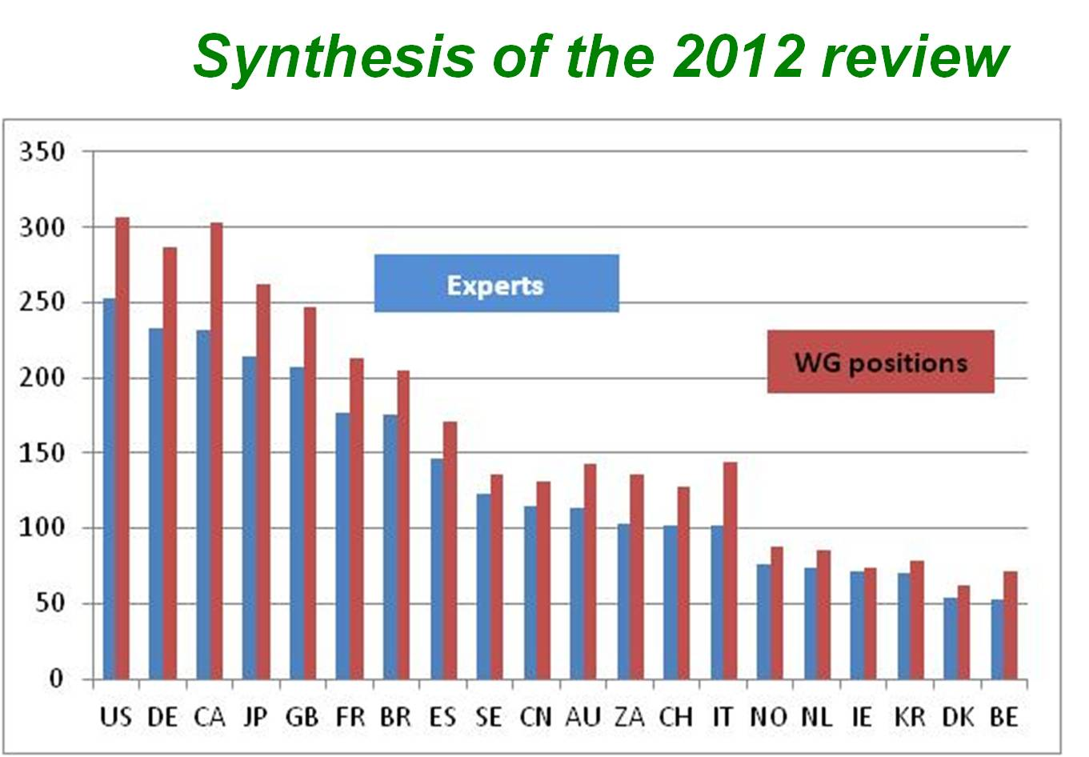

**Info. on USNC Registrants**

* August 2012 Paris 44th Session & Technical Exhibition attended by ~ 3200 Delegates
* Sam Mehta received the Distinguished Member Award in July 2012, and completed 8 years as US National Delegate for A2 Study Committee
* USNC Paris Registrants – 143
  + - 122 in 2010
    - 117 in 2008
    - 110 in 2006
    - 98 in 2004

**U.S. Representatives to CIGRÉ Study Committees & Appointment Dates**

* A1-Sam Salem (GE Energy) – 2006
* A2-Raj Ahuja (SPX Transformer Solutions Inc.) – 2012
* A3-Mietek Glinkowski (ABB Inc.) – 2008
* B1-David Lindsay (EPRI) – 2008
* B2-Dale A. Douglass (Power Delivery) – 2006
* B3-John Randolph (PG&E) – 2012
* B4-Hamid Elahi (GE Energy) – 2010
* B5-Mark Adamiak (GE Energy) – 2008
* C1-Richard Wakefield (DNV KEMA) – 2007
* C2-Anjan Bose (Washington State Univ.) – 2006
* C3-John Oglevie (Power Engineers) – 2006
* C4-Ian S. Grant (TVA) – 2006
* C5-Andrew L. Ott (PJM Interconnection) – 2006
* C6-Roger Dugan (EPRI) – 2008
* D1-Andrew Phillips (EPRI) – 2012
* D2-Thomas E. Kropp (Nexant) – 2006

**A2 – Raj Ahuja (SPX Transformer Solutions)**

**Scope** : Design, construction, manufacture and operation for all kinds of power transformers, including industrial , DC converters and phase-shift transformers and for all types of reactors and transformer components (bushing, tap-changer…)

**Today**, the two Strategic Directions for A2 activities are :

* **Services to Customers** ( Reliability, Life management, Economics, Tutorials, ...)
* **Technology Issues** (Safety, New technologies and New concepts, Electrical environment, Pre-standardisation work, ...)

**Chairman: Claude Rajotte (CA) Secretary: Patrick Picher (CA)**

**Present SC A2 Activities**

* 24 regular members
* 19 observer members
* 9 WG's and 3 JWG's
* 272 experts from 39 countries
* 5 AG’s
* Meeting at Paris was attended by 60 delegates (50 members and 10 guests)

**Present SC A2 Working Groups**

**WG A2-33 -Fire Safety** (A. Petersen/AU)

* + Avoidance of tank rupture
  + Precaution to fire victim
  + Precautions to fire origin

Technical Brochure target date Dec12

**WG A2-36 Guide for Transformer Procurement** (T. Breckenbridge / UK)

* Capability assessment of transformer manufacturers
* Evaluation of technical competence and experience
* Review and update of the existing CIGRE A2 documents on procurement
* Expected completion in 2012

**WG A2-37 Transformer Reliability Survey** (S. Tenbohlen/DE)

* Review all existing national surveys and study different practices ; identify best practices
* Compile and present the information available in these national survey reports
* Make recommendations to improve the situation
* Final brochure Expected to be ready in 2013

**WG A2-38 Transformer Thermal Modeling** (J. Lapworth/UK)

* Describe the state of the art techniques in transformer thermal modelling to evaluate winding hottest spot as well as hot spots on other metallic parts
* Examples of application of hottest spot direct measurement and best practices
* Recommendation for improvement of standards
* Interim report for Electra – Dec 2012

**JWG A2/C4.39 - Electrical Transient Interaction between transformers and the Power System** (A.Rocha/BR)

* Assess and discuss the different types of electrical transient interaction
* Discuss the general increase in transformer dielectric failures in the system
* 1st Draft @ 70% complete

**WG A2.40 - Copper sulphide long-term mitigation and risk assessment** (J. Lukic/RS)

* Method, tools and diagnostic
* Metal passivator stability and efficiency
* Efficiency of existing on-site oil treatment
* Interim report by Dec. 2012
* Final Report expected in 2014

**JWG A2/D1.41 - Oil conductivity under DC condition** (A. Küchler/DE)

* Started under recommendation of WG A2/B4.28
* Review techniques and standards for measurement of conductivity of liquids
* Suggestions for new standards

**WG A2.42 - Guide on transformer Transportation** (A. Mjelve/NO)

* Typical conditions/forces during transport
* Specifications and design review
* Requirements on transportation issues
* Final report Expected by Dec 2013

**WG A2.43 Transformer bushings reliability** (A. Mikulecky/HR)

* Bushing failure definition
* Failure mechanisms for OIP, RBP, RIP
* Bushings failure rate
* Predicted life time, maintenance, diagnostic
* First survey will be sent by Dec 2012

**WG A2.44 – Transformer Intelligent Condition Monitoring** (C. Dupont/BR)

* Conversion of data to relevant information
* Demonstration of benefits
* Hardware/software/data integration
* Draft expected by Mid 2013

**WG A2.45: Transformer Failure Investigation and post-mortem Analysis** (C. Kuen/AT)

* Important information to collect
* Availability and significance of design data
* Documentation during the dismounting
* Paper sampling: how, where, precautions

**JWG A2/D1.46: Field experience with transformer solid insulating ageing markers** (R. Mertens/BE)

- Field cases: correlation between chemical markers and DP

* Design information relevant to ageing markers models
* Consideration of operation and maintenance records
* Influence of oil sampling conditions (ex: temperature)

**Recent CIGRE BROCHURES**

* *Scope Ref Year*
* Moisture Equilibrium in Transformer Insulation 349 2008
* Copper Sulphide in Transformer Insulation 378 2009
* Thermal Performance 393 2009
* HVDC Tr. – Test, ageing, reliability in service 406 2010
* HVDC Tr. – Guidelines for design review 407 2010
* Experience in service with new insulating liquids 436 2010
* Guide on Transformer Maintenance 445 2011

**Expected in DEC 2012**

* **Guide for Preparation of Specifications for Power Transformers**
* **Guide for Conducting Design Reviews for Power Transformers**
* **Guide for Conducting Factory Capability Assessment for Power Transformers**

**Future activities**

**Possible future WG - under discussions**

* Shunt Reactor
* Transformer health index
* Spare transformer policy
* Efficient and eco-design transformers
* Experience with utilisation of transformers in FACTs

**2012 Grid of the Future Symposium. October 28-30, 2012. Kansas City, MO**

http://cigre-usnc.tamu.edu/ngn/grid/

**2013 SC A2 Colloquium**

**Sept. 9th – 13th in Zurich, Switzerland**

**Joint Colloquium with C4**

* Interaction between transformer and the Power System
* Experience with the use of Phase-Shifting transformers
* Network planning in the context of an ageing transformer fleet

**B3 – John Randolph (PG&E)**

Study Committee B3 Joint plans for 2012:

* + Expert Round Table #2: “On-Line Condition Monitoring”, again held jointly with IEEE/PES Substations Committee, on May 21 in Raleigh, USA
  + Plans now for Panel Session at IEEE/PES General Meeting in Vancouver, Canada in July 2013: “On-Line Condition Monitoring”, to include other Technical Committees within Power & Energy Society

**B3 Activities for 2012**

**AA1 Concepts and Developments:**

* **SC B3.12**: Obtaining value from substation condition monitoring
* **SC B3.13**: Reducing replacement time of high voltage equipment
* **SC B3/C1/C2.14**. Circuit configuration optimization
* **SC B3.26**: Guidelines for the design & construction of AC offshore wind farms

**AA2 Gas Insulated Substations:**

* + - **SC B3.25**: SF**6** analysis for AIS,GIS and MTS condition assessment
    - **SC JWG B3/B1.27**: Economical aspects of GIL and underground cables
    - **SC B3.29**: Field test technology on UHV substation construction and operation
    - **SC B3.30**: Guide to optimize the use of SF6 during routine testing of electrical equipment

**AA3 Air Insulated Substations:**

* + - **SC B3.21**: Turn key substations
    - **SC B3.23**: Guidelines for uprating and upgrading of substations
    - **SC B3.31**: Design for severe climate conditions
    - **SC B3.32**: Saving through optimized maintenance

**AA4 Substation Management:**

* + - **SC B3.06**: Substation management
    - **SC B3.10**: Primary/Secondary system interface, modeling for total asset performance
    - **SC B3.34** Expected impact of future grid concept

**D1 – Andrew Phillips (EPRI)  
 *MATERIALS AND EMERGING TEST TECHNIQUES***

**Advisory Groups:**

* AG D1.01 Liquids and liquid impregnated systems L.Lundgaard
* AG D1.02 High Voltage and High Current testing and diagnostic – M.Muhr
* AG D1.03 Insulating Gases – U.Schichler
* AG D1.04 Solid Materials – S.Gubanski

**WG’s :** Total of 26. 22 D1 Working Groups, plus 4 Joint Working Groups with other SCs

**D1 - Working Groups**

* WG D1.19 Solid insulation endurance stressed by repetitive transient voltages caused by power electronics J. Holboell
* WG D1.23 Diagnostics and accelerated life endurance testing of polymeric materials for HVDC application G.C. Montanari
* WG D1.25 Application guide for PD detection in GIS using UHF or acoustic methods U. Schichler
* WG D1.27 Material Properties for new and nonceramic insulation J. Seifert
* WG D1.28 Optimized Gas insulated systems by advanced dielectric coatings and functionally graded materials H. Hama
* WG D1.29 Partial discharges in transformers J. Fuhr
* WG D1.30 Oxidation stability of transformer insulating oils I. Hoehlein
* WG D1.31 Dielectric performance of insulating liquids for Transformers L. Lundgaard
* WG D1.34 Condition assessment for oil-impregnated insulation used in ac cables S. herukupalli
* WG D1.35 Performance of high-voltage and high-current measurement systems for high voltage testing Y. Li
* WG D1.36 Special requirements for dielectric testing of UHV equipment U. Riechert
* WG D1.37 Maintenance and evaluation of measuring procedures for conventional and unconventional partial discharge E. Gulski
* WG D1.38 Emerging test techniques common to High Temperature Superconducting power applications M. Noe
* WG D1.39 Methods for diagnostic/failure data collection and analysis P. Morshuis
* WG D1.40 Functional Nanomaterials for Electric Power Industry M. Fréchette
* WG D1.42 Radiation Ageing of Polymeric Insulating Material T. Okamoto
* WG D1.43 Rotating machine insulation voltage endurance under fast repetitive voltage transients A. Cavallini
* WG D1.44 Testing of naturally polluted insulators I. Gutman WG D1.45 Testing of insulator performance under heavy Rain A. Pigini
* WG D1.48 Properties of insulating materials under VLF voltages E. Ildstad
* WG D1.50 Atmospheric and altitude correction factors of air gaps and clean insulators J. Rickmann
* JWG A2/D1.41 HVDC transformer polarity reversal – Oil conductivity A. Küchler
* JWG A2/D1.46 Field experience with transformer solid insulating ageing markers R. Mertens
* JWG D1/A2.47 New frontiers of DGA interpretation for power transformers and their accessories M. Duval
* JWG D1/B1.49 Harmonized test for the measurement of residual inflammable gases in insulating materials by gas chromatography J.P. Mattmann