1.0 Chair’s Report – B. Chiu

1.1 IEEE Power & Energy Society Technical Council
The Technical Council of the IEEE Power Energy Society (PES) is presently composed of the Chairpersons of the PES Technical Committees, plus the Chairpersons of Standing Committees reporting to it. The Power Energy Society is Division VII of The Institute of Electrical and Electronics Engineers (IEEE). For operating functions it is responsible to the IEEE Technical Advisory Board and for technical activities to the IEEE Technical Activities Board. Please see http://www.ieee-pes.org/technical-committees/statement-of-purpose-and-scope-of-activities-for-the-pes-technical-council for further details on the Statement of Purpose and Scope of Activities for the PES Technical Council. The membership of the Technical Council is listed below.

TECHNICAL COUNCIL OFFICERS
Damir Novosel, Chair
Jeffrey H. Nelson, Vice Chair
S. S. (Mani) Venkata, Secretary
Rick Taylor, Past Chair
STANDING COMMITTEES
Awards Committee - John Randolph, Chair
Meetings & Marketing Committee - Jeffrey H. Nelson, Chair
Organization & Procedures Committee - Mani Venkata, Chair
Standards Coordination Committee - Bill Bartley, Chair
Technical Sessions Committee - Jeffrey H. Nelson, Chair
COORDINATING COMMITTEES
Emerging Technologies Coordinating Committee - Branislav Djokic, Chair
Intelligent Grid Coordinating Committee - Don Von Dollen, Chair
Marine Systems Coordinating Committee - Paul Bishop, Chair
Wind and Solar Power Coordinating Committee - Richard J. Piwko, Chair
TECHNICAL COMMITTEES
Electric Machinery Committee - Mike Sedlak, Chair
Energy Development and Power Generation Committee - Om Malik, Chair
Insulated Conductors Committee - John Smith, Chair
Nuclear Power Engineering Committee - S. K (Satish) Aggarwal, Chair
Power System Analysis, Computing, and Economics Committee - Sandoval Carneiro, Jr., Chair
Power System Communications Committee - Dan Nordell, Chair
Power System Dynamic Performance Committee - Nikos Hatziargyriou, Chair
Power System Instrumentation and Measurements Committee - R. Arseneau, Chair
Power System Operations Committee - William (Bill) Cassel Chair
Power System Planning and Implementation Committee - M. L. Chan, Chair
Power System Relaying Committee - Robert D. Pettigrew, Chair
Stationary Battery Committee - William (Bill) Cantor, Chair
Substations Committee - John D. Randolph, Chair
Surge Protective Devices Committee - Dr. A. J. (Tony) Surtees, Chair
Switchgear Committee - Ken Edwards, Chair
Transformers Committee - Bill Chiu, Chair
Transmission and Distribution Committee - S. J. Ranade Chair

1.2 Highlights of PES Technical Council Activities
The most recent Technical Council meeting took place on July 25, 2012, at the PES General Meeting in San Diego, CA. Highlights of several activities of Technical Council and its Committees are included below.
    - Conference Paper Review/Acceptance Criteria
Based on many of the feedbacks from the various technical committees within PES over the past several years, the Technical Council has identified an opportunity for improvement by providing consistent guideline for the review and acceptance of the PES sponsored conference papers. Over the course of the past year, there were additional efforts completed towards developing a general guideline. A taskforce was formed to address the paper review and acceptance criteria. Key members of this taskforce are representatives of the following technical committees:
- Power System Relaying Committee - Robert D. Pettigrew, Chair
- Transformers Committee - Bill Chiu, Chair
- Transmission and Distribution Committee - S. J. Ranade, Chair

The deliverable of this Taskforce is a set of guidelines for paper review and acceptance criteria. The taskforce completed its work and reported its recommendation at the Tech Council meeting during the PES GM in San Diego that took place in July 2012. The recommendations included high level review and acceptance guideline for both the authors and the reviewers of the paper. The Taskforce’s recommendations were accepted by the Technical Council and criteria will be proposed to the IEEE PES Governing Board for final approval. The presentation slides were included below for reference.

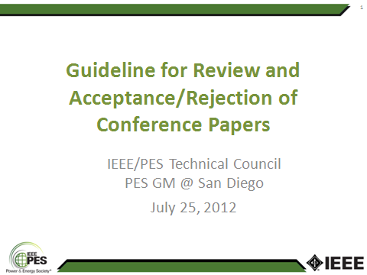
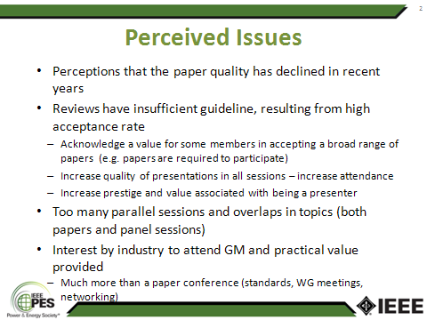
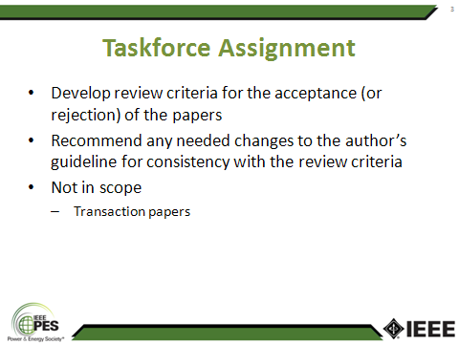
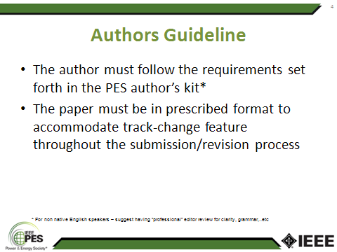
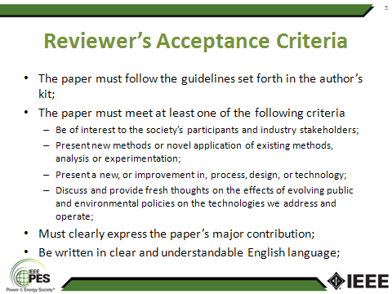
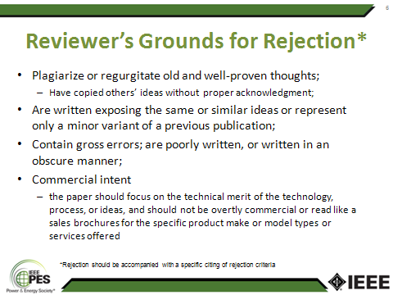

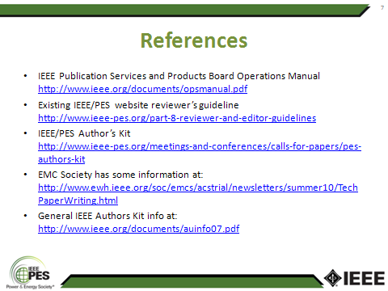

The Chair notes with appreciation that many key contributors within the Transformers Committee have authored papers and also took active roles in reviewing conference papers over the years. They also offer their experience and perspectives in this effort and many of their suggestions were also incorporated in the final recommendations.

    - Geomagnetic Disturbance (GMD) Taskforce
As a follow up to the discussion at the Transformers Committee meeting in Nashville back in March 2012, the concerns expressed by the members of the Transformers Committee GMD Taskforce members in regards to the IEEE Spectrum article published in February 2012 were elevated to the officers of the PES Technical Council and the representatives of the various technical committees. Many of the other PES technical committees also expressed similar concerns. Upon further dialogues over the course of several months leading up to the PES General Meeting at San Diego in July, the PES Technical Council expressed interested in having a coordinated response. The presentation slides that were the basis of the discussion at the July, 2012 Technical Council meeting are included below for reference:

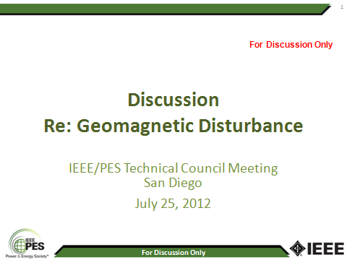
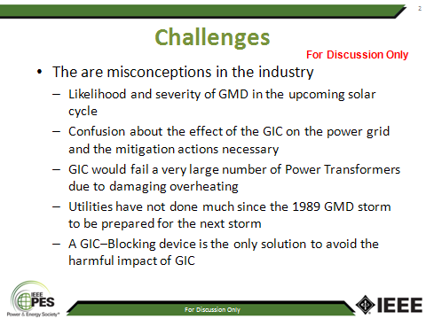
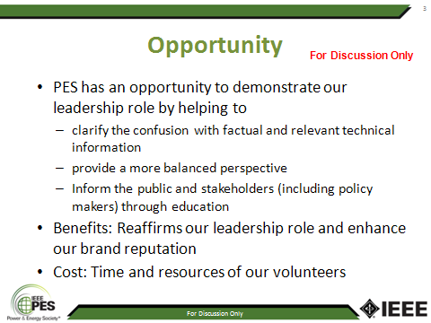
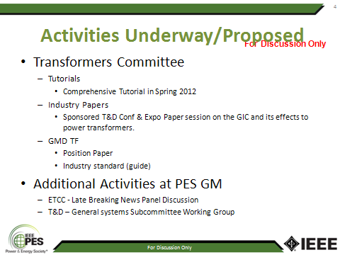
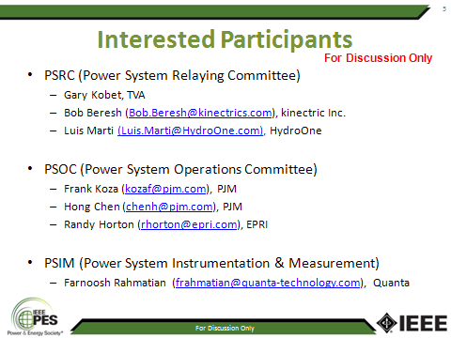
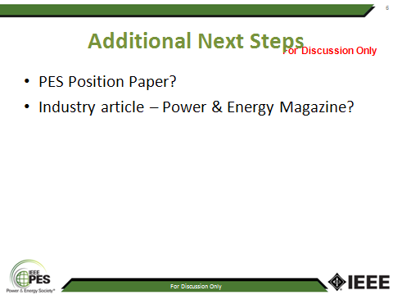
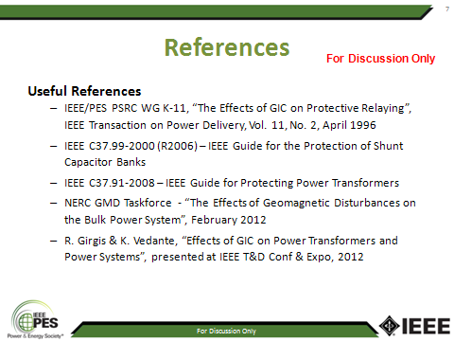

Following the discussion there was a motion made to form a Technical Council Taskforce to develop an industry white paper. The goal of this white paper is to provide additional technical information to demystify the many mis-information that has been circulating in various publications. The motion passed and subsequently the Transformers Committee Chair was appointed the Chair this Taskforce. The Technical Council also expressed its desire to have a joint white paper at the IEEE PES Technical Council level rather than independent efforts by the various technical committees.
  - Transformers Committee Activities
    - Subcommittee Chairperson & Technical Editor
Our current roster of the Subcommittee Chairs and Editor are:

- Bushings Subcommittee Peter Zhao
- Dielectric Test Subcommittee Loren Wagenaar
- Distribution Transformers Subcommittee Stephen Shull
- Dry-Type Transformers Subcommittee Charles Johnson
- HVDC Converter Transformers and Smoothing Reactors Subcommittee Michael Sharp
- Instrument Transformers Ross McTaggart
- Insulating Fluids Subcommittee Susan McNelly
- Insulation Life Subcommittee Bruce Forsyth
- Meetings Subcommittee Gregory Anderson
- Performance Characteristics Subcommittee Ed teNyenhuis
- Power Transformers Subcommittee Tom Lundquist
- Standards Subcommittee William Bartley
- Underground Transformers & Network Protectors Subcommittee Carl Niemann
- Technical Editor Sanjib Som

All of them have confirmed their commitment to serve the duration of the calendar year 2012. As we approach the end of 2012, the volunteer subcommittee leaders and editor will have the opportunity to reaffirm their desire to continue their service in the respective capacity in accordance with the established guideline in the Transformers Committee O&P Manual.

PES Technical Council was notified of the Subcommittee Chairs and Technical Editor appointments for the calendar year 2012 in accordance with the guideline set forth in our O&P Manual.

    - Association Management (AM) System
The AM system continues to serve important administrative functions in supporting the membership roster. This system is designed with self-administered features for updates of individual contact information. The system also serves to facilitate attendance record keeping and email distribution list for the various subgroups within the Transformers Committee.
All Subcommittees, Working Group (WG), and Taskforce (TF) Chairs are requested to use the AM system for assigning and tracking membership within their groups and for communication with their group members. All Committee members, active participants, and interested individuals are reminded also that you are responsible personally for maintaining the accuracy of your contact information, through the AM system, for Committee activities and communication. Keeping your contact information maintained in the AM system assures that the Chair of any Subcommittee, WG, or TF you are involved with will be able to contact you in a timely manner. Details on enrolling and maintaining your contact information in the AM system can be found on the Committee website.
    - Committee Membership
All are welcome to participate in the work of the Transformers Committee. Membership in the Committee provides recognition of your peers and indication to your co-workers and management of your active role in Committee work. If you are presently not a Main Committee Member, and you have been actively participating in our work for at least two full year – and can secure the acknowledgement and sponsorship of at least 3 activity Chairs (WGs, but must include at least one Subcommittee Chair) affirming that participation, the Committee will look forward to welcoming you as a member. Membership requirements and application forms can be found in the Organization and Procedures Manual posted on the Committee website.
As our organization is a 100% volunteer based organization, we are very much in need of all of your continued participation and sharing of your expertise towards our world-class standards development efforts. Many of our long-standing committee members have made tremendous contributions towards our standards development effort over the years and their contributions are greatly appreciated.

Respectfully submitted,

Bill Chiu
Chair, IEEE/PES Transformers Committee

