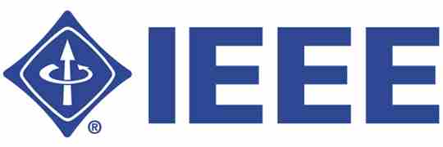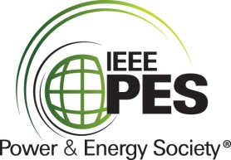IEEE/PES Transformers Committee

**Fall 2014 Meeting**

**Washington DC Metro Area, USA**

**Guide for the Application and Interpretation of Frequency Response Analysis for Oil Immersed Transformers C57.149**

**— Technical Presentation —**

**Thursday, October 23, 2014**

**Mark Lachman, Kirk Robbins, Charles Sweetser, and Peter Werelius**

**1. Abstract**

Frequency Response Analysis (FRA) is a valuable, non-intrusive diagnostic tool for verifying the mechanical integrity and other associated properties of power transformers. Our industry has been practicing FRA in the field for a decade without an official document or guide. The Working Group C57.149 successfully published the first FRA testing guide in March 2013. This presentation presents the general concepts, current practices, and analysis strategies associated with frequency response analysis testing, including the history and creation of the C57.149 FRA testing guide. Representatives from both the utility and OEM communities will discuss their FRA perspectives and experiences which will focus on FRA test application and analysis, helping to bring out the relevant importance of the FRA test.

Four topics will be covered:

* History of C57.149 from PAR to Publish (Charles Sweetser)
* FRA Theory and Application (Peter Werelius)
* FRA Measurement and Analysis (Mark Lachman )
* Utility Perspective and Experiences (Kirk Robbins)

**2. Learning Objectives**

This presentation plans to

* Provide history related to the creation of the C57.149 FRA testing guide.
* Provide FRA fundamentals as they relate to test application and analysis (when and why FRA diagnostics are applied).
* Investigate and focus on how FRA tests are performed: factory, commissioning, relocation, and post event.
* Review analysis strategies associated with incipient failure modes.
* Present utility and manufacturer’s perspectives and experiences.

**3. Learning Outcomes**

As a result of attending this session, members will gain an understanding of the following:

* Lessons learned from the C57.149 Working Group experiences.
* Fundamentals of frequency response analysis testing.
* Theory, application, and test procedures.
* Interpretation of the data and basic analysis strategies.
* Utility’s perspective regarding the recently published guide.

**4. Presenters’ Biographies**

**Mark Lachman, Ph.D., P.E.** has been with the power industry for over 30 years. His experience includes development of off-line and on-line diagnostics (Doble 1988–2001) as well as factory testing of power transformers (Delta Star, San Carlos, CA, 2005–2011). He returned to Doble in 2011 as Director of Diagnostic Analyses and is contributing to advancing interpretation of apparatus diagnostic data.

**Kirk Robbins** served in the US Navy submarine service from 1976–1990. Kirk worked as a research assistant at Salem Nuclear Generating Station from 1991–1992. He was employed by Exelon at the Dresden Nuclear Power Station from 1992–2001. In 2001, Kirk was transferred to the Corporate Office as a transformer subject matter expert. Currently, Kirk holds the position of Corporate Lead Engineer for the strategic Main Power Transformer Replacement project and Open Phase Detection project. He earned a BS in Physics from Lewis University in 1995 and holds a Senior Reactor Operator Certification.

**Charles Sweetser** received a BSEE in 1992 and a Master of Science Degree in Electrical Engineering in 1996 from the University of Maine. He joined OMICRON electronics Corp. USA, in 2009, where he presently holds the position of PRIM Engineering Services Manager for North America. Prior to joining OMICRON, he worked 13 years in the electrical apparatus diagnostic and consulting business. He has published several technical papers for IEEE and other industry forums. As a member of IEEE Power & Energy Society (PES) for 14 years, he actively participates in the IEEE Transformers Committee and is also a member of several other working groups and subcommittees. Additional interests include condition assessment of power apparatus and partial discharge.

**Peter Werelius** was born in Stockholm, Sweden and works as an application expert and Product Manager at Megger Sweden. He has a M.Sc. in Electrical Engineering (1991) and a Ph.D. in Electrical Engineering (2001), both from KTH (Royal Institute of Technology) in Stockholm, Sweden. He began his professional career starting up a spin-off company, WaBtech, in 1996, manufacturing FDS/DFR (Frequency Domain Spectroscopy/Dielectric Frequency Response) test equipment. From 1999, he continued work on the FDS/DFR application with Programma Electric and later with GE Energy Services. In 2005, he worked with others to found Pax Diagnostics which was acquired by Megger in October 2008. He has published a number of papers and articles, mainly related to FDS/DFR measurement techniques and application. He is member of IEEE and CIGRE and actively participates in working groups and task forces, especially those related to FDS/DFR and SFRA.