IEEE/PES
Transformers
Committee

Fall 2014
Meeting Minutes

Washington DC Metro Area, USA
October 19 - 23, 2014

Unapproved
(These minutes are on the agenda to be approved at the next meeting in Fall 2014)
Table of Contents
Monday Opening Session – October 20, 2014
- Agenda
- Attendance
- Meeting Schedule
- Approval of Agenda and Previous Minutes – Don Platts
- Chair’s Remarks & Report – Don Platts
- Vice Chair’s Report – Stephen Antosz
- Secretary’s Report – Susan McNelly
- Treasurer’s Report – Gregory Anderson
- Awards Report – Bill Chiu
- Administrative SC Meeting Report – Susan McNelly
- Standards Report – William Bartley
- Editor’s Report – Sanjib Som
- Unfinished (Old) Business
- New Business
- Monday Opening Session Adjournment
Thursday Closing Session – October 23, 2014
- Chair’s Remarks and Anouncements
- Liaison Reports
Standards Coordinating Committee No. 4 (Electrical Insulation) – Paulette Payne
Standards Coordinating Committee No. 18 (NFPA/NEC) – Ned Brush
IEC TC14 Technical Advisor to USNC – Phil Hopkinson
Cigre – Raj Ahuja
- Meetings Planning SC Minutes & Report – Gregory Anderson
- Reports from Technical Subcommittees (decisions made during the week)
- Report from Standards Subcommittee (issues from the week)
- New Business (Continued from Monday General Session)
- Thursday General Session Adjournment
Minutes of Technical Subcommittees
- Bushings SC – Peter Zhao
- Dielectric Tests SC – Michael Franchek
- Distribution Transformers SC – Steve Shull
- Dry Type Transformers SC – Charles Johnson
- HVDC Converter Transformers & Reactors – Mike Sharp
- Instrument Transformers SC – Ross McTaggart
- Insulating Fluids SC – David Wallach
- Insulation Life SC – Bruce Forsyth
- Meetings SC – Greg Anderson
- Performance Characteristics SC – Ed teNyenhuis
- Power Transformers SC – Joe Watson
- Standards SC – Bill Bartley
- Underground Trans & Network Protectors SC – Dan Mulkey

Monday Opening Session

Agenda
Opening Session
Monday, October 20; 8:00 am - 9:10 am
(rosters circulated and attendance recorded as eligibility for Committee membership)
- Welcome and Announcements Don Platts
- Approval of Agenda Don Platts
- Approval of Minutes from Spring 2014 Meeting Don Platts
- Chair’s Report Don Platts
- Vice Chair’s Report Stephen Antosz
- Secretary's Report Sue McNelly
- Treasurer's Report Greg Anderson
- Report from Administrative Subcommittee Meeting Don Platts
- Standards Report Bill Bartley
- Editor’s Report Sanjib Som
- Hot Topics for the Upcoming Week Subcommittee Chairs
- New Business & Wrap-up Don Platts
Closing Session
Thursday, October 23; 11:00 am - 12:00 pm
- Chair's Remarks and Announcements Don Platts
- Reports from Liaison Representatives (moved from Monday due to lack of time)
Stds Coord. Committee, SCC No. 4 (Electrical Insulation) Paulette Payne Powell
Standards Coord. Committee, SCC No. 18 (NFPA/NEC) Ned Brush
IEC TC-14 Technical Advisor to USNC Phil Hopkinson
CIGRE Raj Ahuja
- Meetings Planning Subcommittee Greg Anderson
- Reports from Technical Subcommittees (decisions made during the week)
Dielectric Tests Mike Franchek
Distribution Transformers Steve Shull
Dry Type Transformers Chuck Johnson
HVDC Converter Transformers & Reactors Mike Sharp
Instrument Transformers Ross McTaggart
Insulating Fluids David Wallach
Insulation Life Bruce Forsyth
Performance Characteristics Ed teNyenhuis
Power Transformers Joe Watson
Underground Transformers & Network Protectors Dan Mulkey
Bushings Peter Zhao
- Additional Report from Standards Subcommittee (issues from the week) Bill Bartley
- New Business (continued from Monday) and Wrap-up Don Platts

Attendance

Committee Member Attendance
Legend:
CM Committee Member
CM-LM Committee Member-IEEE Life Member
CM-EM Committee Member-Emeritus
Committee Member Attendance (Red designates CM added at present meeting)
Member Type |  | Name | Company | Mon | Thu
CM |  | Ahuja, Raj | Auriga Corporation | X
CM |  | Amos, Richard | Unifin International | X
CM |  | Anderson, Gregory | GW Anderson & Associates, Inc. | X | X
CM |  | Antosz, Stephen | Stephen Antosz & Associates, Inc | X
CM |  | Arteaga, Javier | ABB Inc. | X | X
CM |  | Ayers, Donald | Ayers Transformer Consulting | X | X
CM |  | Ballard, Robert | DuPont | X | X
CM |  | Balma, Peter | Peter M Balma Engr Consulting | X
CM |  | Bartley, William | Hartford Steam Boiler | X | X
CM |  | Beaster, Barry | H-J Enterprises, Inc. | X
CM |  | Beauchemin, Claude | TJH2b Analytical Services | X
CM |  | Betancourt, Enrique | Prolec GE | X | X
CM-LM |  | Binder, Wallace | WBBinder Consultant | X
CM |  | Blackburn, Gene | Gene Blackburn Engineering | X
CM |  | Blaydon, Daniel | Baltimore Gas & Electric | X | X
CM-LM |  | Boettger, William | Boettger Transformer Consulting LLC | X | X
CM |  | Boman, Paul | Hartford Steam Boiler | X
CM |  | Brender, David | Copper Development Assn. |  | X
CM |  | Bromley, Adam | Fort Collins Utilities | X | X
CM |  | Brush, Edwin | BBF & Associates | X
CM |  | Buckmaster, David | Transformer Forensics, LLC | X
CM |  | Bush, Carl | Pemco Corporation | X | X
CM |  | Callsen, Thomas | Weldy-Lamont Associates | X | X
CM |  | Castellanos, Juan | Prolec GE | X | X
CM |  | Cherry, Donald | ABB Inc. | X | X
CM |  | Chiu, Bill | Southern California Edison | X | X
CM |  | Chu, Donald | Consolidated Edison Co. of NY | X | X
CM |  | Claiborne, C. Clair | ABB Inc. | X | X
CM |  | Colopy, Craig | Eaton's Cooper Power System | X | X
CM |  | Damico, Frank | TAMINI Transformers USA | X
CM |  | Davis, Eric | Burns & McDonnell | X | X
CM-LM |  | Degeneff, Robert | Utility Systems Technologies, Inc. | X
CM |  | Del Rio, J. Arturo | Trench Limited | X | X
CM |  | Dix, Larry | Quality Switch, Inc. | X | X
CM |  | Ellis, Keith | Elect Connection, Inc (RHM International) | X | X
CM |  | Fairris, James | Nashville Electric Service | X
CM |  | Fallon, Donald | PSE&G | X
CM |  | Faulkenberry, Michael | Georgia Power Co. | X
CM |  | Foster, Derek | Magnetics Design, LLC | X
CM |  | Franchek, Michael | Weidmann Electrical Technology | X | X
CM |  | Garcia, Eduardo | Siemens | X | X
CM |  | Gardner, James | NRECA International | X | X
CM |  | Gaytan, Carlos | Prolec GE | X
CM |  | Ghafourian, Ali | ERMCO | X
CM-LM |  | Girgis, Ramsis | ABB Inc. | X
CM |  | Graham, James | Mott MacDonald, Inc. | X | X
CM |  | Graham, John | Siemens TDL | X | X
CM |  | Griesacker, Bill | Doble Engineering Co. | X
CM |  | Gromlovits, Mark | Federal Pacific
CM |  | Hachichi, Said | Hydro-Quebec | X | X
CM |  | Hardin, Michael | H-J Enterprises, Inc. | X
CM |  | Harley, John | FirstPower Group LLC | X | X
CM-LM |  | Harlow, James | Harlow Engineering Associates | X
CM |  | Hayes, Roger | ALSTOM Grid | X | X
CM |  | Heinzig, Peter | Weidmann Electrical Technology | X | X
CM |  | Hochanh, Thang | ALSTOM Grid | X | X
CM |  | Hoffman, Gary | Advanced Power Technologies | X
CM |  | Holdway, Timothy | Intermountain Electronics | X | X
CM |  | Holifield, Thomas | Howard Industries | X | X
CM-LM |  | Hopkinson, Philip | HVOLT Inc. | X
CM |  | Johnson, Charles | ABB Inc. | X
CM |  | Jordan, Stephen | TVA | X | X
CM |  | Kennedy, Gael | GR Kennedy & Associates LLC | X | X
CM |  | Kennedy, Sheldon | Niagara Transformer | X | X
CM |  | Khalin, Vladimir | KV Consulting | X
CM |  | King, Gary | Howard Industries | X
CM |  | Klaponski, Brian | Carte International Inc. | X
CM |  | Kraemer, Axel | Maschinenfabrik Reinhausen | X | X
CM |  | Kraetge, Alexander | HIGHVOLT | X | X
CM |  | Lackey, John | PowerNex Associates Inc. | X | X
CM |  | Lau, Michael | Weidmann Diagnostic Solutions | X
CM |  | Levin, Aleksandr | Weidmann Electrical Technology | X | X
CM |  | Lopez-Fernandez, Xose | Universidade de Vigo | X
CM |  | Marek, Richard | DuPont | X | X
CM |  | Matthews, Lee | Howard Industries | X
CM |  | McClure, Phillip | Weschler Instruments | X
CM |  | McNelly, Susan | Xcel Energy | X | X
CM |  | McShane, Charles Patrick | Cargill, Inc. | X
CM |  | McTaggart, Ross | Trench Limited | X | X
CM |  | Mehrotra, Vinay | SPX Transformer Solutions, Inc. | X | X
PCM-LM |  | Mehta, Shirish | Mehta Consultants
CM |  | Melanson, Joseph | J. Melanson, Inc. | X
CM |  | Melle, Thomas | HIGHVOLT |  | X
CM-LM |  | Miller, Kent | T&R Electric Supply Co. | X | X
CM |  | Miller, Michael | We Energies | X | X
CM |  | Millward, Paul | ITEC | X | X
CM |  | Molden, Arthur | AMEESCO | X
CM |  | Moleski, Hali | S.D. Myers Inc. | X
CM |  | Mukerji, Amitav | ABB Inc. | X | X
CM |  | Mulkey, Daniel | Pacific Gas & Electric | X | X
CM |  | Murphy, Jerry | Reedy Creek Energy Services | X | X
CM |  | Nicholas, Ray | Schaffner MTC Transformers | X
CM |  | Nicholas, Ron | ABB Inc. | X
CM |  | Papp, Klaus | Trench Austria GmbH | X | X
CM |  | Patel, Poorvi | ABB Inc. | X
CM |  | Penny, Brian | American Transmission Co. | X
CM |  | Perkins, Mark | ABB Inc. | X
CM |  | Pezzin, Justin | IFD Corporation | X
CM |  | Platts, Donald | Omicron | X | X
CM |  | Pointner, Klaus | Trench Austria GmbH | X | X
CM |  | Poulin, Bertrand | ABB Inc. | X | X
CM |  | Prevost, Thomas | OMICRON electronics Corp USA | X | X
CM | Progar, John |  | Jordan Transformer | X
CM |  | Puri, Jeewan | Transformer Solutions, Inc. | X
CM |  | Radbrandt, Ulf | ABB | X | X
CM |  | Rasor, Robert | S.D. Myers Inc. | X
CM |  | Rave, Martin | ComEd | X | X
CM |  | Recksiedler, Leslie | Manitoba Hydro | X
CM |  | Riffon, Pierre | Hydro-Quebec | X | X
CM |  | Roussell, Marnie | Entergy | X | X
CM |  | Sarkar, Subhas | Virginia Transformer Corp. | X
CM |  | Schweiger, Ewald | Siemens AG | X
CM |  | Sewell, Adam | Quality Switch, Inc. |  | X
CM |  | Sewell, Jeremy | Quality Switch, Inc. | X | X
CM-LM |  | Sharma, Devki | Entergy | X
CM |  | Sharp, Michael | Trench Limited | X | X
CM |  | Shekelton, James | H-J Enterprises, Inc. | X
CM |  | Shertukde, Hemchandra | University of Hartford | X | X
CM |  | Shull, Stephen | The Empire District Electric Co. | X | X
CM |  | Simmons, Charles | Duke Energy | X | X
CM |  | Sizemore, Thomas | ABB Inc. | X | X
CM |  | Skinger, Kenneth | CBI | X
CM |  | Smith, Edward | H-J Enterprises, Inc. | X | X
CM |  | Snyder, Steven | ABB Inc. | X | X
CM |  | Som, Sanjib | Siemens Industry, Inc. | X | X
CM |  | Spitzer, Thomas | City Transformer Service Co. | X
CM-LM |  | Stahara, Ronald | Stahara Consulting | X | X
CM |  | Stiegemeier, Craig | ABB Inc. | X | X
CM |  | Sweetser, Charles | OMICRON electronics Corp USA | X | X
CM |  | Swinderman, Craig | Mitsubishi Electric Power Products | X
CM |  | Tanaka, Troy | Burns & McDonnell | X
CM |  | Tarlapally, Susmitha | ABB Inc. | X
CM |  | teNyenhuis, Ed | ABB Inc. | X | X
CM |  | Termini, Giuseppe | PECO Energy | X | X
CM |  | Thompson, Jim | T&R Service Company | X
CM |  | Thompson, Robert | RST Consulting, P.C. | X | X
CM |  | Traut, Alan | Power Partners | X | X
CM |  | Trummer, Edgar | Transatlantic Transformer Consulting
CM |  | Tuli, Subhash | Electrical T&D Apparatus Consultant Inc.
CM |  | Verdolin, Rogerio | Verdolin Solutions Inc. | X | X
CM |  | Verner, Jane Ann | Pepco Holdings Inc. | X | X
CM |  | Vir, Dharam | SPX Transformer Solutions, Inc. | X | X
CM |  | Wallace, David | ABB Inc. | X | X
CM |  | Wallach, David | Duke Energy | X | X
CM |  | Watson, Joe | ZTZ Services | X | X
CM |  | Wicks, Roger | DuPont | X | X
CM-LM |  | Wilks, Alan | Consultant | X | X
CM |  | Wimmer, William | Dominion | X | X
CM |  | Woodcock, David | WICOR Americas | X
CM |  | Yang, Baitun | Pennsylvania Transformer | X
CM |  | Yu, Jennifer | Pacific Gas & Electric | X | X
CM |  | Yule, Kipp | Bechtel Power Corp | X | X
CM |  | Zhao, Peter | Hydro One | X | X
CM |  | Ziomek, Waldemar | CG Power Systems Canada Inc | X | X
 |  |  | Totals: | 147 | 91
 |  |  | % of Members Present: | 71% | 44%
In addition to the above totals,

Quorum achieved at Monday Opening Session
Quorum not achieved at Thursday Closing Session

General Attendance
Legend:
II Interested Individual
II-LM Interested Individual-IEEE Life Member
AP Active Participant
AP-LM Active Participant-IEEE Life Member
PCM-LM Past Committee Member-IEEE Life Member
General Attendance
Member Type | Name |  | Company |  | Mon | Thu
II | Ahmed, Omar |  | Transformer Protector Corp |  | X | X
AP | Allen, Jerry |  | Metglas Inc.
II | Almkvist, Marten |  | ABB Components |  | X | X
II | Alonso, Mario |  | Efacec Power Transformers
AP | Ansari, Tauhid Haque |  | ABB Inc. |  | X
II | Anthony, Stephen |  | Pepco Holdings Inc. |  | X
AP | Antweiler, James |  | Schneider Electric/Square D |  | X
II | Armstrong, Chris |  | Petro-Canada Lubricants Inc.
AP | Armstrong, James |  | Siemens Energy |  | X
AP | Atef, Kahveh |  | San Diego Gas & Electric |  |  | X
II | Averitt, Ralph |  | Reinhausen Mfg.
AP | Baranowski, Derek |  | Baron USA, Inc.
AP | Barnes, Abbey |  | Baron USA, Inc.
AP | Bartek, Allan |  | C-K Composites
II | Batey, Sheila |  | Alstom Grid UK Ltd |  | X | X
AP | Behrens, Tammy |  | SPX Transformer Solutions, Inc. |  | X
AP | Benach, Jeffrey |  | Weidmann Diagnostic Solutions |  | X
II | Bercea, Emil |  | ABB AG |  | X
II | Bergmann, Stefan |  | HIGHVOLT |  | X
AP | Berler, Zalya |  | ZTZ Services International, Inc
AP | Bernesjo, Mats |  | ABB Inc. |  | X
AP-LM | Bertolini, Edward |  | Richards Manufacturing Co.
II | Bittner, Carlos |  | Reinhausen Mfg. |  | X
II | Blake, Dennis |  | Pennsylvania Transformer
II | Blaszczyk, Piotr |  | The Specialty Switch Co LLC |  | X
II | Boege, Alan |  | Orto de Mexico |  | X
AP | Bolliger, Alain |  | HV Technologies |  | X
II | Borden, Michael |  | Mitsubishi Electric Power Products |  | X
II | Borowitz, James |  | Northeast Utilities |  | X
II | Bozich, Bradford |  | Smiths Power
AP | Brafa, John |  | ABB Inc. |  | X | X
II | Bray, Elizabeth |  | Southern Company Services |  | X
AP | Bressan, Natalia |  | Siemens Energy
AP | Britton, Jeffrey |  | Phenix Technologies, Inc. |  | X
AP | Brodeur, Samuel |  | ABB Inc. |  | X
II | Brown, Chris |  | Tempel |  | X
II | Brown, Darren |  | Howard Industries |  | X
II | Buchgeher, Erich |  | Siemens AG |  | X
AP | Burde, Jagdish |  | PDI |  | X
II | Burns, Curtis |  | Burns Power Consulting, LLC |  | X | X
AP | Cai, Jim |  | JSHP Transformer |  | X
II | Caldeira, Julio |  | M&I Materials Ltd |  | X
II | Cantrell, Richard |  | Doble Engineering Co.
II | Carpenter, Erin |  | Delta Star Inc.
AP | Caskey, John |  | NEMA
II | Chakraborty, Arup |  | ALSTOM Grid |  | X | X
II | Cham, Ebrima |  | Efacec Power Transformers
AP | Cheatham, Jonathan |  | General Electric |  | X
AP | Cheim, Luiz |  | ABB Inc. |  | X
II | Chen, Qi |  | JSHP Transformer |  | X
AP | Chhajer, Dinesh |  | Megger |  | X
II | Chiang, Solomon |  | The Gund Company |  | X
II | Chiodo, Vincent |  | HICO America
AP | Chisholm, John |  | IFD Corporation
II | Chon, Jihoon |  | Korea Testing Laboratory |  | X
II | Chow, Chih |  | Pepco Holdings Inc. |  | X | X
II | Christodoulou, Larry |  | Electric Power Systems |  |  | X
II | Chrysler, Rhett |  | ERMCO |  | X | X
II | Chuk, Shuk Yin |  | Pepco Holdings Inc.
II | Clonts, Jermaine |  | Power Partners |  | X
II | Collin, Jean-Francois |  | Nomos Systems
II | Coreno, Sergio |  | Siemens |  | X
AP | Costa, Florian |  | Corimpex USA, Inc.
II | Cox, Paul |  | GE Digital Energy |  | X
AP | Craven, Michael |  | Phoenix Engineering Services |  | X | X
AP | Cunningham, Kelcie |  | Delta Star Inc. |  | X
AP | Daniels, Timothy |  | Weidmann Electrical Technology
II | Dauzat, Thomas |  | General Electric
II | Dave, Nikita |  | Efacec Power Transformers
AP | Davydov, Valery |  | Mr. Valery Davydov |  | X | X
II | del Valle, Yamille |  | NEETRAC |  | X | X
II | Dennis, Scott |  | ABB Inc. |  | X
II | Denzer, Stephanie |  | General Electric |  | X
II | Dhawan, Anil |  | ComEd |  | X | X
AP | Diaby, Mohamed |  | Efacec Power Transformers
AP | Digby, Scott |  | Duke Energy |  | X | X
II | Dilling, Wayne |  | Mortenson Construction |  | X
AP | Dorpmanns, Luc |  | SMIT Transformatoren B.V. |  | X
AP | Dorris, Don |  | Nashville Electric Service |  | X | X
AP | Drees, Terry |  | Cindus Corp. |  | X
II | Drobnick, Jason |  | Jordan Transformer |  | X
II | Dunn, James |  | Unifin International
AP-LM | Duval, Michel |  | Hydro-Quebec IREQ
II | Ebbert, Alexander |  | HICO America
II | Elliott, Will |  | General Electric |  | X
II | Evans, Aaron |  | HICO America
AP | Fausch, Reto |  | Haefely-Hipotronics |  | X
II | Fedor, Ken |  | SMIT USA |  | X
AP | Field, Norman |  | Weidmann Diagnostic Solutions |  | X | X
II | Flores, Hugo |  | Efacec Power Transformers
II | Foata, Marc |  | Reinhausen Canada |  |  | X
AP | Forrest, George |  | Delta-X Research USA, Inc. |  | X
II | Friend, Fredric |  | American Electric Power |  | X | X
AP | Frimpong, George |  | ABB Inc. |  | X
II | Frotscher, Rainer |  | Maschinenfabrik Reinhausen
II | Gagnon, Jean-Francois |  | Siemens Transformers Canada
AP | Galbraith, Shawn |  | Nuclear Service Organization |  | X
II | Gara, Lorne |  | Orbis Engineering |  | X
II | Garcia, Benjamin |  | Southern California Edison |  | X
II | Geibel, David |  | ABB Inc. |  |  | X
II | Golarz, Jeffrey |  | LumaSense Technologies |  | X
II | Golner, Thomas |  | SPX Transformer Solutions, Inc. |  | X | X
II | Golon, David |  | Dynamic Ratings, Inc. |  | X
AP | Gomez, Rolando |  | Arteche
AP | Gonzalez de la Vega, Jorge |  | Orto de Mexico |  | X
AP | Gross, Detlev |  | Power Diagnostix |  | X | X
AP | Guerra, Jorge |  | Efacec Power Transformers
AP | Guilbault, Frank |  | Cogent Power Inc.
II | Guner, Ismail |  | Hydro-Quebec |  | X | X
AP | Hakim, Shamaun |  | CG Power Systems USA, Inc. |  | X
II | Hamilton, Kendrick |  | Power Partners |  | X
AP | Hammer, Mark |  | ALSTOM Grid
AP | Hanson, David |  | TJH2b Analytical Services |  | X | X
AP | Harden, Kenneth |  | Schneider Electric |  | X
II | Harder, Steven |  | Siemens Energy
II | Harrison, Ken |  | N. American Substation Services
II | Hartmann, Thomas |  | Delta Star Inc. |  | X | X
II | Hernandez, Ronald |  | Doble Engineering Co. |  | X
AP | Herron, John |  | HIGHVOLT - Reinhausen |  | X | X
AP | Herz, Josh |  | Qualitrol |  | X | X
II | Hicks, Roger |  | Pepco Holdings Inc.
II | Holleran, Joseph |  | Ameren |  | X | X
AP | Holmes, Jill |  | Bureau of Reclamation
AP | Holsomback, Steve |  | Southern Company Services |  | X
II | Humenick, Noelle |  | IEEE |  | X
II | Hurlet, Patrice |  | EDF |  | X | X
AP | Inkpen, Jesse |  | Qualitrol Corp. - Serveron |  | X
AP | Izquierdo, Jose |  | Siemens Servicios S.A de C.V |  | X | X
AP | Jacob, Nathan |  | Manitoba Hydro |  | X
AP | Jakob, Fredi |  | Consultant
AP | Jarman, Paul |  | National Grid |  | X | X
AP | Jaroszewski, Marion |  | Delta Star Inc. |  | X | X
AP-LM | Jauch, Erwin |  | Beckwith Electric Co. |  | X
II | Jensen, Brad |  | Burns & McDonnell |  | X | X
AP | John, John |  | Virginia Transformer Corp. |  | X | X
AP | Johnson, Derek |  | Reinhausen Mfg. |  | X
II | Johnson, Jean |  | NEMA
II | Johnson, Sidney |  | Rimkus Consulting Group, Inc. |  | X
AP | Johnson, Wayne |  | EPRI |  | X | X
II | Johnstone, Ted |  | Cogent Power Inc. |  | X
II | Joshi, Arvin |  | GE |  | X
II | Juchem, Kevin |  | ABB AG |  |  | X
II | Kaineder, Kurt |  | Siemens AG |  | X
II | Kaiserseder, Gerald |  | Starkstrom-Geraetebau GmbH |  | X | X
II | Kang, Jinho |  | Hyundai Heavy Industries |  | X
II | Kang, Sam |  | DuPont
II | Kharel, Rudra |  | Burns & McDonnell |  | X
AP | Kinner, Robert |  | FirstPower Group LLC |  | X
II | Kiparizoski, Zan |  | Howard Industries |  | X
II | Kirchenmayer, Egon |  | Siemens AG
AP | Kirchner, Lawrence |  | Siemens Energy |  | X
II | Kopf, Jon |  | Power Asset Recovery Corp.
AP | Kornowski, Marek |  | Polycast International |  | X | X
AP | Kranich, Neil |  | Jordan Transformer |  | X
II | Kremer, Daniel |  | Phenix Technologies, Inc. |  | X
II | Kulasek, Krzysztof |  | ABB Inc. |  | X
AP | Kurth, Bernhard |  | Reinhausen Mfg. |  | X
AP | Kyle, Randall |  | Southern Company |  | X
AP | Lachman, Mark |  | Doble Engineering Co. |  | X | X
II | Lamb, Michael |  | Dominion |  | X | X
II | Larochelle, David |  | NDB Technologies |  | X | X
II | Lawless, Andrew |  | Siemens Energy
II | Layman, Tim |  | HV Technologies Inc. |  |  | X
II | Leal, Gustavo |  | Dominion |  | X | X
II | Lee, So-young |  | Hyundai Heavy Industries |  | X | X
II | Leishman, Gary |  | American Electric Power |  | X | X
II | Lemos, Gilbert |  | Southern California Edison |  | X
AP | Livingston, Kerry |  | Great River Energy |  | X
II | Lobo, Gregorio |  | Mitsubishi Electric Power Products, Inc. |  | X
AP | Locarno, Mario |  | Doble Engineering Co. |  | X
II | Lugge, Andrew |  | Mitsubishi Electric Power Products |  | X
AP | Luksich, John |  | Cargill, Inc. |  | X
II | Luo, Shawn |  | Seattle City Light |  | X
II | Macalinden, Dan |  | BROCKHAUS MESSTECHNIK
II | Macias, Alejandro |  | CenterPoint Energy |  | X
II | Mango, Joseph |  | NextEra Energy Resources
II | Mani, Kumar |  | Duke Energy
II | Mao, Libin |  | Consolidated Edison Co. of NY
II | Marchini, Gregory |  | IEEE |  | X
II | Marquardt, Bryan |  | AK Steel
AP | Martin, Terence |  | Doble Engineering Co. |  | X
II | Martin, Zach |  | Delta Star Inc. |  | X
II | Martinez, Apollonia |  | Public Service Co. of New Mexico |  | X
AP | Mayer, Robert |  | San Diego Gas & Electric |  | X
AP | McBride, James |  | JMX Services, Inc. |  | X | X
II | McCloskey, Scott |  | Amran Inc.
II | McCullough, Douglas |  | Maxima / Hyundai |  | X
II | McHugh, Kathleen |  | SABIC Innovative Plastics |  | X
AP | McIver, James |  | Siemens Energy
II | McNeish, Kenneth |  | TXTS |  | X | X
II | Mehmel, Ronald |  | CG Power Systems Canada Inc |  | X
II | Meisner, David |  | American Electric Power |  | X | X
AP | Miller, Michael |  | Siemens Industry, Inc. |  | X
II | Minhaz, Ronnie |  | Transformer Consulting Services Inc. |  | X | X
II | Mitra, Sunit |  | Pepco Holdings Inc.
II | Montanha, Juliano |  | Siemens Ltda |  | X | X
II | Morales-Cruz, Emilio |  | Qualitrol |  | X
AP | Morgan, Charles |  | Northeast Utilities |  | X | X
II | Mulla, Robert |  | Pepco Holdings Inc
AP | Mullikin, Randolph |  | ABB Inc.
AP | Murray, David |  | Tennessee Valley Authority |  | X | X
AP | Mushill, Paul |  | Ameren |  | X
AP | Naderian, Ali |  | Kinectrics |  | X
II | Nambi, Shankar |  | Bechtel Power Corp |  | X
AP | Narawane, Aniruddha |  | ABB Inc. |  | X
II | Natale, Anthony |  | HICO America |  | X
AP | Navarro, Martin |  | Siemens Ltda |  | X | X
II | Nazarko, Jeffrey |  | Tempel |  | X
II | Neild, Kristopher |  | Megger |  | X
II | Nelson, Thomas |  | NIST
II | Newman, Steven |  | Delta Star Inc.
AP | Nims, Joe |  | Allen & Hoshall |  | X
AP | Nordman, Hasse |  | ABB Oy, Transformers |  | X | X
II | Nunes, Jr, Jayme |  | Nynas AB
II | Nunez, Arturo |  | Mistras Group, Inc.
AP | Oakes, Stephen |  | CG Power Systems USA, Inc. |  | X
AP | Ogajanov, Rudolf |  | ABB Inc.
AP | Olafsson, Gylfi |  | SPX Transformer Solutions, Inc. |  | X
II | Oliver, William |  | Hitachi HVB, Inc. |  | X
II | Ortiz, Jow |  | NextEra Energy
II | Osborn, Gary |  | TCI Sales
AP | Ostrander, David |  | Ameren |  | X | X
AP | Panetta, Sergio |  | I Gard Corporation
AP | Parkinson, Dwight |  | Cooper Power Systems by Eaton |  | X | X
AP | Patel, Dhiru |  | Hammond Power Solutions Inc. |  | X
AP | Patel, Sanjay |  | Smit Transformer Sales, Inc.
II | Patoine, Barbara |  | Weidmann Electrical Technology |  | X | X
AP | Payerle, George |  | Carte International Inc. |  | X
II | Pellon, Verena |  | Florida Power & Light Company |  | X
AP | Perjanik, Nicholas |  | Weidmann Diagnostic Solutions |  | X
AP | Perlichek, Robert |  | Public Service Co. of New Mexico |  | X
AP | Peterson, Alan |  | Utility Service Corporation
II | Pinon, Oscar |  | WEG-Voltran |  | X
II | Pitts, Chris |  | Howard Industries |  | X
II | Plante, Nicolas |  | IREQ |  | X | X
II | Pruente, John |  | SPX Transformer Solutions, Inc. |  | X
II | Ramnial, Madhvi |  | Powertech Labs Inc. |  |  | X
II | Rapp, Kevin |  | Cargill, Inc.
II | Rasco, Jimmy |  | Ergon, Inc
II | Rashid, Adnan |  | Measurement Canada/Industry Canada |  | X | X
AP | Ray, Jeffrey |  | JLR Consulting, Inc. |  | X | X
AP | Razuvayev, Sergiy |  | Delta Star Inc. |  | X
II | Reagan, Ashley |  | ELTEK International Labs |  | X
II | Reed, Scott |  | MVA Diagnostics, Inc.
AP | Reeves, Jerry |  | Efacec Power Transformers |  | X
II | Rezai, Hossein |  | The Transformer Consultant |  | X
II | Rijnsoever, Frank |  | SMIT Transformatoren B.V.
II | Rincon, Diego |  | Electroporcelana Gamma |  | X | X
AP | Rinks, Timothy |  | Reinhausen Mfg. |  | X
II | Riopel, Sebastien |  | Electro Composites (2008) ULC
II | Rivers, Mark |  | Doble Engineering Co. |  | X
II | Roach, John |  | Hartford Steam Boiler |  | X
AP | Roberts, Mark |  | N. American Substation Services
II | Rock, Patrick |  | ATC |  | X
II | Rodriguez, Leopoldo |  | Efacec Power Transformers
II | Roizman, Oleg |  | IntellPower Pty Ltd |  | X | X
II | Roman, Zoltan |  | ALSTOM Grid |  |  | X
II | Ronchi, Rodrigo |  | WEG-Voltran |  | X
II | Rottenbacher, Andre |  | Ritz Instrument Transformers |  | X | X
II | Russwurm, Dirk |  | DTM Instruments, LLC
II | Saldivar, Juan |  | Prolec GE |  | X
II | Sanders, Brian |  | ICMI, Inc. |  | X | X
AP | Sarkar, Amitabh |  | CG Power Systems USA, Inc. |  | X
AP | Sauls, Roderick |  | Southern Company Services |  | X
AP | Sauzay, Mathieu |  | JST Transformateurs |  |  | X
II | Scardazzi, Alaor |  | Siemens Ltda |  | X | X
II | Schiessl, Markus |  | Starkstrom-Geraetebau GmbH |  | X | X
AP | Schleismann, Eric |  | Southern Company |  | X | X
II | Schmitt, Philipp |  | Weidmann Electrical Technology |  | X | X
AP | Schrammel, Alfons |  | Siemens AG |  | X | X
II | Schubert, Juergen |  | Starkstrom Geraetebau GmbH |  | X
II | Sewell, Russell |  | Quality Switch, Inc. |  | X | X
II | Sexton, Aron |  | Kinectrics
II | Shannon, Michael |  | Rea Magnet Wire |  | X
II | Sharpless, Samuel |  | Rimkus Consulting Group |  | X | X
II | Shea, Kelly |  | San Joaquin Refining Company
II | Sheehan, David |  | HICO America |  | X
II | Shem-Tov, Mark |  | Von Roll Transformers |  | X | X
II | Sheridan, Peter |  | SGB-USA |  | X
II | Shertok, Yitzhak |  | Duke Energy |  | X
II | Shi, Lin |  | TBEA USA
II | Shirasaka, Yukiyasu |  | Hitachi Ltd. |  | X | X
II | Shor, Andre |  | Von Roll Transformers |  | X | X
AP | Siebert, Stefan |  | BROCKHAUS MESSTECHNIK
II | Simon, Preston |  | Electrical Technologies |  | X
II | Simonelli, Richard |  | SPX Transformer Solutions, Inc.
II | Slattery, Christopher |  | FirstEnergy Corp. |  | X | X
II | Smith, Shane |  | Delta Star Inc. |  | X | X
II | Snyder, Brian |  | Doble Engineering Co.
II | So, Eddy |  | National Research Council of Canada
II | Sohn, Yong Tae |  | Hyosung |  | X | X
II | Song, Kwang Jae |  | Korea Testing Laboratory |  | X
II | Sordo, Salvador |  | WEG Electric Corp. |  | X
AP | Spiewak, Erin |  | IEEE |  | X | X
AP | Stank, Markus |  | Maschinenfabrik Reinhausen
AP | Stankes, David |  | 3M IPT |  | X
AP | Steineman, Andrew |  | Delta Star Inc. |  | X | X
II | Steineman, Christopher |  | Meramec Electrical Products, Inc. |  | X
AP | Stem, Gregory |  | Cardinal Pumps & Exchangers
AP | Stranko, Jennifer |  | HPN Global
II | Stretch, Kerwin |  | SGB USA, Inc. |  | X | X
AP | Sullivan, Christopher |  | Westmark Parnters
II | Sullivan, Kevin |  | Duke Energy |  | X | X
II | Sullivan, Liz |  | ABB Inc. |  | X
AP | Sundin, David |  | DSI Ventures, Inc.
II | Susa, Dejan |  | Statnett SF |  | X
II | Tafoya, Mauricio |  | Siemens Energy
II | Taousakis, Anastasios |  | Pepco Holdings Inc.
AP | Tellez, Richard |  | Siemens S.A. |  |  | X
AP-LM | Tendulkar, Vijay |  | ONYX Power, Inc. |  | X | X
II | Thompson, Ryan |  | Burns & McDonnell |  | X
II | Tikvesa, Taib |  | KAEC
II | Toro, Diana |  | Gamma Insulators Corp |  | X | X
II | Tostrud, Mark |  | Dynamic Ratings, Inc. |  | X
II | Tozzi, Marco |  | Camlin Power |  | X
II | Trautmann, Frank |  | Siemens AG |  | X | X
AP | Trivitt, Donnie |  | Oklahoma Gas & Electric |  | X
II | Valentin, Reinaldo |  | Duke Energy |  | X
II | Van Horn, Jeremy |  | IFD Corporation |  | X
AP | Varghese, Ajith |  | SPX Transformer Solutions, Inc. |  | X | X
II | Varnell, Jason |  | SPX Transformer Solutions, Inc. |  | X
AP | Vedante, Kiran |  | ABB Inc. |  | X | X
AP | Veens, Jos |  | SMIT Transformatoren B.V. |  | X | X
II | Verdell, Joshua |  | ERMCO |  | X | X
II | Vijayan, Krishnamurthy |  | CG Power Systems Canada Inc |  | X | X
AP | vonGemmingen, Richard |  | Dominion |  | X | X
AP | Walia, Sukhdev |  | Brookfield Renewable Power |  | X
II | Wang, Evanne |  | DuPont |  | X
II | Wang, Jian |  | TBEA USA
AP | Weatherbee, Eric |  | PCORE Electric
AP | Weathington, Larry |  | N. American Substation Services
II | Weisensee, Matthew |  | PacifiCorp |  | X | X
AP | Werelius, Peter |  | Megger |  |  | X
II | White, Leon |  | Serveron
AP | Williams, Michael |  | ABB Inc. |  | X
AP | Williams, Randy |  | ABB Inc.
II | Wood, David |  | Central Moloney, Inc. |  | X
II | Woods, Deanna |  | Alliant Energy
II | Wright, Jeffrey |  | Mitsubishi Electric Power Products |  | X | X
AP | Yalla, Murty |  | Beckwith Electric Co.
II | Younes, Hassan |  | Kinectrics |  | X
AP | Young, Samuel |  | Reinhausen Mfg. |  | X
AP | Zhang, Jim |  | Arizona Public Service Co.
AP | Zhang, Shibao |  | PCORE Electric
AP | Zhu, Hanxin |  | BC Hydro
II | Zito, Anthony |  | Siemens Energy
II | Zouaghi, Abderrahmane |  | ABB Inc.
 |  |  |  | Total General Attendance: | 235 | 97
 |  |  |  |  | Mon | Thu
 |  |  |  | Total Committee Member Attendance: | 147 | 91
 |  |  |  | Total Attendance: | 382 | 188
In addition to the above totals, there were 174 of the total attendees that attended both the Monday and Thursday Sessions and 386 that attended either the Monday or the Thursday Session.

Meeting Schedule
The meeting schedule is provided at the end of this report.

Approval of Agenda and Previous Minutes – Don Platts
The Chair asked if there were any comments or corrections to the Agenda, hearing none, the Agenda was approved.
A motion to approve the minutes was received from the Phil Hopkinson and seconded by Kent Miller. The motion was unanimously approved.

Chair’s Remarks & Report – Don Platts
The Vice Chair’s Report was presented at the Monday General Session.
Highlights:
Don opened welcoming the attendees and expressed his and the committees deep sadness at the loss of our friend and committee member Rowland James. A short tribute will be presented at the Tuesday Awards Luncheon.
Don announced that Dan Mulkey has taken over the Underground Transformers and Network Protectors SC for Carl Niemen.
Don mentioned that there are some issues with appearance of possible coercion of members to vote in a specific way and possible corporate dominance in the progress of our work. Don asked everyone to be aware of these issues and present any unethical or the appearance of unethical practices. If you are aware of any issues, please bring them to the Executive Committee Officers attention.
Don mentioned that there are also concerns with dictating the design of equipment and the commercial content of the documents. The documents need to be consensus standards and should not be directed to one particular manufacturer’s product.

Chair’s Report – Presented at the Monday General Session

IEEE Power & Energy Society Technical Council
The Technical Council of the IEEE Power Energy Society (PES) is presently composed of the Chairpersons of the PES Technical Committees, plus the Chairpersons of Standing Committees reporting to it. The Power Energy Society is Division VII of The Institute of Electrical and Electronics Engineers (IEEE). For operating functions it is responsible to the IEEE Technical Advisory Board and for technical activities to the IEEE Technical Activities Board.
The PES Technical Committees report to the Technical Council on matters concerning membership, technical publications, recognition, scope and the coordination of the Power Energy Society generated standards. For standards relating to their technical scope, the Technical Committees work directly with the IEEE Standards Board and the Power Energy Society Standards Coordinating Committee.
Please see http://www.ieee-pes.org/statement-of-purpose-and-scope-of-activities-for-the-pes-technical-council
for further details on the Statement of Purpose and Scope of Activities for the PES Technical Council.

Technical Council Officers & Membership
The officers and members of the Technical Council are listed below for your reference. Each individual listed here is the chair of that respective committee. Where available, the affiliation of the technical committee chair is also shown in parentheses.
TECHNICAL COUNCIL OFFICERS
Jeffrey H. Nelson, Chair (TVA)
Ken Edwards, Vice Chair (BPA)
Miriam Sanders, Secretary (SEL University)
Damir Novosel, Past Chair (Quanta Technology)
STANDING COMMITTEES
Awards | John D. Randolph
Organization & Procedures | Miriam Sanders
Technical Sessions | Ken Edwards
Standards Coordination | Bill Bartley
Meetings & Marketing | Ken Edwards
COORDINATING COMMITTEES
Emerging Technologies | Branislav Djokic
Intelligent Grid | Steve Pullins
Marine Systems | Paul Bishop
Wind and Solar Power | R. J. Piwko
TECHNICAL COMMITTEES
Electric Machinery Committee | Michael Sedlak
Energy Development & Power Generation Committee | Randy Groves
Insulated Conductors Committee | Thomas C. Champion III
Nuclear Power Engineering Committee | George Ballassi
Power System Analysis, Computing & Economics Committee | Dagmar Niebur
Power System Communications Committee | Dan Nordell
Power System Dynamic Performance Committee | Thierry Van Cutsem
Power System Instrumentation & Measurements Committee | Rejean Arseneau
Power System Operations Committee | Antonio Conejo
Power System Planning & Implementation Committee | M. L. Chan
Power System Relaying Committee | Roger Hedding
Stationary Battery Committee | Lesley Varga
Substations Committee | Mike Dood
Surge Protective Devices Committee | Ron Hotchkiss
Switchgear Committee | Ted Olsen
Transformers Committee | Don Platts
Transmission & Distribution Committee | W. A. Chisholm
Power Engineering Education Committee | Anil Pahwa

Summary of IEEE Report to DOE QER on Priority Issues
This report was prepared by IEEE in response to a set of specific questions posed by U.S. DOE with a request for IEEE insights into these priority issues. The team endeavoured to keep the responses within the scope of the questions. There are many other grid-related issues that are not addressed here.

The past few years have brought about great strides in advancing knowledge on all fronts of interest to DOE. This pace of progress is expected to continue and the report should therefore be viewed as a snapshot reflecting the knowledge available today.

Responses discussed in this report are highlighted below.
- Effects of renewable intermittency on the electric power grid and the potential role of storage in addressing these effects
- Utility and other energy company business case issues related to microgrids and distributed generation (DG), including rooftop photovoltaics
- The technical implications for the grid (bulk and local distribution) of electric vehicle (EV) integration - and the timing you see as necessary to avoid having the grid status slow down any potential progress
- The implications and importance of aging infrastructure and the options for addressing these challenges, including asset management
- Recommendations for metrics for addressing Smart Grid issues, especially to help policy makers determine the importance and necessity of protocols
- Skilled workforce issues
- Report cards on the condition and performance of the electric grid
Download the Summary of IEEE Report to DOE QER on Priority Issues

PES Technical Council Activities
The Tech Council is undertaking a project to ensure that the activities of each of the technical committees fits within their scope, and that each has an updated O&P manual, and those that write standards also have a current P&P.
It appears that as some new technologies develop, they do not fit into the scope of the present committees, or that they may fit into several possible places due to scope overlaps, or gaps in the scopes. A program is underway to realign the technical committees with the industry today. There will likely be some changes in the standards documents assigned, and the scope of some of the technical committees. This project is the focus of a planning meeting scheduled for Nov. 2014.

Update on Geomagnetic Disturbance (GMD) Taskforce
The Technical Council Taskforce on GMD has made very little progress on the development of the position paper, since the last Chair’s report in October 2013. The task force was able to complete an initial release of an article entitled Geomagnetic Disturbance and Its Impacts on the Power Grid in the PES Power & Energy Magazine in the July, 2013 edition to coincide with the GMD Super Session planned at the PES General Meeting in July, 2013 at Vancouver Canada. This project continues to fall further behind schedule, primarily due to fundamental differences of opinion of some of the contributors. The IEEE PES Technical Council still maintains strong support for the project and has urged the task force to proceed with the completion, even if the report needs to be a Stage 1 report, subject to revision and additions as time passes and knowledge grows. The chair has a plan to try to move the participants toward completion of the project by later this year.

Transformers Committee Activities
Officers Progression for the 2014-2015 Period
In accordance with the rules set forth in the Transformers Committee Policies and Procedures Manual, the Committee Officers (the Chair, the Vice Chair, and the Secretary) are recommended by the incumbent Chair of the Committee with the concurrence of the immediate Past Chair and are approved by the Chair of the Technical Council and is expected to serve two years a two-year term, and follows the established progression cycle for the next two-year period. The table below shows the progression of officer's assignment for the next two years beginning January 2014.

Officer Role | 2014-2015 Term
Committee Chair | Donald W. Platts
Committee Vice-Chair | Stephen Antosz
Committee Secretary | Susan McNelly
Past Chair / Awards Chair | Bill Chiu
Committee Treasurer* | Greg W. Anderson
Standards Coordinator* | William (Bill) H. Bartley
* Treasurer and Standards Coordinator are excluded from the officer progression cycle.
Subcommittee Chairpersons & Technical Editor
In August, there was a change in the leadership for the Underground Transformers & Network Protectors Subcommittee. Dan Mulkey has agreed to take on the role of Chair, replacing Carl Niemann, who had served as the Chair since mid-year 2000. Our current roster of the Subcommittee Chairs and Editor are:
- Bushings Subcommittee Peter Zhao
- Dielectric Test Subcommittee Michael Franchek
- Distribution Transformers Subcommittee Stephen Shull
- Dry-Type Transformers Subcommittee Charles Johnson
- HVDC Converter Transformers & Smoothing Reactors Subcommittee Michael Sharp
- Instrument Transformers Ross McTaggart
- Insulating Fluids Subcommittee Susan McNelly
- Insulation Life Subcommittee Bruce Forsyth
- Meetings Subcommittee Gregory Anderson
- Performance Characteristics Subcommittee Ed teNyenhuis
- Power Transformers Subcommittee Joe Watson
- Standards Subcommittee William Bartley
- Underground Transformers & Network Protectors Subcommittee Dan Mulkey
- Technical Editor Sanjib Som

What You Need to Know About IEEE Standards and the Law [an excerpt]
IEEE standards should be relevant and respond to regulatory and market needs. They should not distort the global or domestic market, have adverse effects on competition, or stifle innovation and technological development. Efforts should be made to avoid duplication or overlap with other standards, especially international standards.

Wherever appropriate, IEEE standards-developing groups should specify standards based on performance or function rather than design or product specifications.
The full brochure can be found at:
https://standards.ieee.org/develop/policies/stdslaw.pdf

The Standards Board Operations Manual
The following text has been approved by The Standards Board and will be implemented into our Operations Manual in January 2015. The accompanying text may provide an opportunity to educate the committee members as a whole.

"5.4.3 Conduct of the standards balloting process
The ballot process may include communication among the Sponsor comment resolution group and Sponsor balloting group members regarding the substantive merits and possible resolution of comments. However, no comment resolution member, Sponsor balloting group member, or standards participant shall intimidate or coerce a specific vote from any Sponsor balloting group member."
IEEE-SA supports communication among participants and members as a part of the technical discourse or comment resolution, and advocating a personal view or opinion can be a part of the discourse. However, the WG or TF should be mindful not to give specific recommendations and proposed text with instructions to other members. This could be seen as a form of coercion for a specific vote, which violates Clause 5.4.3 of the IEEE-SA Standards Board Operations Manual, "Conduct of standards balloting process."

Within our committee we want to operate in a manner that does not give the appearance, or cause anyone to perceive, that our actions would result in collusion or coercion by any members or activity leaders.

IEEE Standards Association (SA) Requirements
IEEE SA’s Role
In the course of developing our standards, we as volunteers while having the best interest of advancing the technical understanding of our industry, are no doubt also influenced by those who sponsored our participation with other interests that potentially could influence our decisions. This is where a good understanding of the IEEE SA’s role and its relevant policy and procedures will help in clarifying some of the dos and don’ts in the process of developing our standards.
IEEE SA is a standards development organization that:
- Develops voluntary standards, recommended practices, and guides
- Uses an accredited process that promotes consensus building among those with material interest in any given technology, and is based on proven imperative principles of openness, consensus, balance, due process, and right of appeal
- Oversees the process by which consensus is reached
- Has standards that are adopted by regulatory agencies and international bodies around the world
- Promotes standards implementation, but does not define laws or regulatory requirements
- Defines technical requirements, not market mechanisms
- Reviews documents based on technical merit, and established scientific findings
IEEE SA does not:
- Test or verify the content of standards
- Assure health or safety
- Make guarantees
- Make warrantees
- Establish law or regulation
- Define essential patents, essential patent holders, or licensing terms
- Define commercial terms or market mechanisms
- Infer that an IEEE standard endorses products, services, or companies
Press Releases Policy Relating to IEEE SA Work & Products
Press releases about IEEE standards by outside entities without approval by IEEE:
- Cannot claim that the IEEE standard endorses a product, service, or company
- Cannot claim that the standard establishes requirements based on information in informative text (including informative annexes)
- Cannot include marketing text about IEEE or IEEE-SA that may infer endorsement by IEEE or IEEE-SA
- Must clearly indicate that all statements are that of the entity and does not necessarily represent a position or opinion of either IEEE or the IEEE Standards Association
IEEE SA Disclaimers
A statement, written or oral, that is not processed in accordance with the IEEE-SA Standards Board Operations Manual shall not be considered the official position of IEEE or any of its committees and shall not be considered to be, nor be relied upon as, a formal position of IEEE. At lectures, symposia, seminars, or educational courses, an individual presenting information on IEEE standards shall make it clear that his or her views should be considered the personal views of that individual rather than the formal position of IEEE.

IEEE Code of Ethics
The IEEE Code of Ethics serves as the guiding light to keep us focused on maintaining and evolving our culture that makes the Transformers Committee one of the best technical committees in the Power & Energy Society’s area. Below is the excerpt from the IEEE Policies, Section 7 – Professional Activities.
Affiliation
Given the core objectives of the standards development process to follow the concept of “openness” and “due process” in that it allows for equity and fair play we need to strive to have a balance of interests and not to be dominated by any single interest category. Moving forward, the disclosure of participants’ affiliation shall include not just who you are, but also who is your financial sponsor.

IEEE Membership – Senior Grade
IEEE membership has several categories, with the senior level being the highest grade which a member can apply. IEEE has developed a streamlined process for members to request elevation of their membership status. The process is simple and can be done entirely online. The Chair strongly encourages everyone that has been an active contributor to the industry for at least five years to apply for this elevation in membership status. The basic qualifications are:
- be engineers, scientists, educators, technical executives, or originators in IEEE-designated fields;
- have experience reflecting professional maturity;
- have been in professional practice for at least ten years;
- show significant performance over a period of at least five of their years in professional practice.
Benefits of becoming a senior member include:
- Recognition: The professional recognition of your peers for technical and professional excellence.
- Senior member plaque: Since January 1999, all newly elevated Senior members have received an engraved Senior Member plaque to be proudly displayed for colleagues, clients and employers. The plaque, an attractive fine wood with bronze engraving, is sent within six to eight weeks after elevation.
- US$25 coupon: IEEE will recognize all newly elevated Senior members with a coupon worth up to US$25. This coupon can be used to join one new IEEE society. The coupon expires on 31 December of the year in which it is received.
- Letter of commendation: A letter of commendation will be sent to your employer on the achievement of Senior member grade (upon the request of the newly elected Senior member).
- Announcements: Announcement of elevation can be made in section/society and/or local newsletters, newspapers and notices.
- Leadership Eligibility: Senior members are eligible to hold executive IEEE volunteer positions.
- Ability to refer other candidates: Senior members can serve as a reference for other applicants for senior membership.
- Review panel: Senior members are invited to be on the panel to review senior member applications.
- US$25 referral coupon: Newly elevated Senior members are encouraged to find the next innovators of tomorrow and invite them to join IEEE. Invite them to join and the new IEEE member will receive $25 off their first year of membership.
IEEE Membership – Fellow Grade
The IEEE membership grade of Fellow recognizes unusual distinction in the profession and shall be conferred only by invitation of the Board of Directors upon a person of outstanding and extraordinary qualifications and experience in IEEE-designated fields, and who has made important individual contributions to one or more of these fields. IEEE Fellow nominees are classified into the following four categories:
- Application Engineer/Practitioner
- Educator
- Research Engineer/Scientist
- Technical Leader
IEEE Fellow is a distinction reserved for select IEEE members whose extraordinary accomplishments in any of the IEEE fields of interest are deemed fitting of this prestigious grade elevation.
According to IEEE Bylaw I-305.5, the total number of Fellow recommendations in any one-year must not exceed one-tenth of one percent of the voting membership on record as of 31 December of the year preceding. At the time the nomination is submitted, a nominee must:
- have accomplishments that have contributed importantly to the advancement or application of engineering, science and technology, bringing the realization of significant value to society;
- hold IEEE Senior Member or IEEE Life Senior Member grade;
- have been a member in good standing in any grade for a period of five years or more preceding 1 January of the year of elevation.
For further details please refer to the website http://www.ieee.org/membership_services/membership/fellows/index.html
Transformers Committee Membership
All are welcome to participate in the work of the Transformers Committee. Membership in the Committee provides recognition of your peers and indication to your co-workers and management of your active role in Committee work. If you are presently not a Main Committee Member, and you have been actively participating in our work for at least two full year – and can secure the acknowledgement and sponsorship of at least 3 activity Chairs (WGs, but must include at least one Subcommittee Chair) affirming that participation, the Committee will look forward to welcoming you as a member. Membership requirements and application forms can be found in the Organization and Procedures Manual posted on the Committee website.
As our organization is a 100% volunteer based organization, we are very much in need of your continued participation and sharing of your expertise towards our world-class standards development efforts. Many of our long-standing committee members have made tremendous contributions towards our standards development effort over the years and their contributions are greatly appreciated.
Respectfully submitted,
Don Platts
Chair, IEEE/PES Transformers Committee

Vice Chair’s Report – Stephen Antosz

IEEE PES Calendar of Upcoming Events
Following are upcoming PES sponsored conferences and committee meetings. Please check the PES website at www.ieee-pes.org for further details, and additional events.
2015 IEEE PES Innovative Smart Grid Technologies Conference (ISGT)
February 17-20, 2015, Washington, DC
2015 IEEE/PES General Meeting
July 26-30, 2014, Denver, CO

Conference Papers Submitted in 2014

IEEE/PES T&D Conference and Expo Apr 14-17, 2014, Chicago IL
A total of 17 conference papers were submitted. After review, 5 papers were rejected and 8 papers were accepted and presented at the Poster Session. 4 papers were incomplete, as they were referred to revise and resubmit but there was no response from the author. In addition, one Transactions paper was accepted. The papers that were presented are:

ID | Title
14TD0004 | PROBABILISTIC TRANSFORMER FAULT TREE ANALYSIS USING BAYESIAN NETWORKS
14TD0109 | Development of Miniaturized AC Reactors with Lower-Losses Using Amorphous Wound Cores in 400-kVA UPS
14TD0295 | Combining dry type Resin Impregnated Fiberglass Paperless Transformer Bushings With Built-in Novel Insulation Monitoring Function
14TD0298 | Practical Aspects of Power Transformer Condition Monitoring
14TD0331 | Advanced Transformer Fleet Monitoring System
14TD0380 | A Process for Evaluating the Degree of Susceptibility of a fleet of Power Transformers to Effects of GIC
14TD0455 | Advanced Tap Changer Control of Parallel Transformers based on IEC 61850 GOOSE Service
14TD0532 | An Innovative Method for Cooling oil-immersed Transformers by Rayleigh-Benard Convection

IEEE/PES General Meeting July 27-31, 2014, Washington, DC
A total of 27 conference papers were submitted. After review, 15 papers were rejected and 10 papers were accepted and presented at the Poster Session. 2 papers were incomplete, as they were referred to revise and resubmit but there was no response from the author. In addition, one Transactions paper was accepted. The papers that were presented are:

ID | Title
14PESGM0192 | An Economic Evaluation Model of Transformers Considering Outage Consequence
14PESGM0245 | A Diffusion-Driven Model for Investigating Moisture Effects on Dielectric Response Measurement of Transformer Insulation
14PESGM0272 | Differential Partial Discharge Extraction Technique for Online Power Transformer Insulation Assessment
14PESGM0372 | Investigating the Sensitivity of Frequency Response Analysis on Transformer Winding Structure
14PESGM0631 | Analysis on the Effects of Energization Mode for Magnetically Controlled Shunt Reactor
14PESGM0782 | Detection of Minor Axial Winding Movement within Power Transformers Using Finite Element Modeling
14PESGM0871 | Application of FRA Polar Plot Technique to Diagnose Internal Faults in Power Transformers
14PESGM1039 | Application of Multifractal Spectrum to the Vibration Analyses of Power Transformer under DC Bias
14PESGM1539 | Performance Evaluation of On-Line Transformer Winding Short Circuit Fault Detection Based on Instantaneous Voltage and Current Measurements
14PESGM1597 | Research on Chaotic Dynamic Characteristics of On-load Tap Changers

On Oct 24, 2014 the paper submission web site to open to authors for 2015 General Meeting.
Stephen Antosz
Vice Chair
IEEE PES Transformers Committee
October 20, 2014

Secretary’s Report – Susan McNelly

Membership Review
Voting Committee Members – five new committee members were approved and added at the Spring 2014 Savannah, Georgia meeting as shown in the table below:

Name | Affiliation | Sponsor #1 | Sponsor #2 | Sponsor #3 | Membership Category
Alexsandr Levin | Weidmann | Hemchandra Shertukde  C57.159 & TF  (Since 2008) | Chuck Johnson  Dry-Type SC  (2yrs) | Richard Marek  PC57.96  (3yrs) | Producer
Michael Miller | WE Energies | Steve Shull  Distribution Transf. SC (3yrs) | Craig Colopy  C57.15  (2yrs) | Alan Traut  C57.120  (3yrs) | User
Diego M. Robalino | Megger | Wally Binder  WG C57.125 (2.5yrs) | Joe Watson  PTSC  (2.5yrs) | Greg Anderson  PTSC / WG C57.150  (1.5yrs) | Producer
William J. Solano | ABB | Steve Snyder  PCS / WG C57.12.00  (2yrs) | Mike Lau  WG C57.93  (1 yr) | William Bartley  Standards SC  (2yrs) | Producer
Susmitha Tarlapally | ABB, Inc. | Michael Franchek  Dielectric Test SC & WG C57.138  (1.5yrs) | Mark Perkins  WG C57.12.90  (1.5yr) | Steve Snyder  PSC / WG C57.12.00  (4yrs) | Producer
The Transformers Committee AMS database of people currently has three general categories of participation in our activities. These are: Interested Individual, Active Participant, and Committee Member. Anyone can join the AMS 123 system as the system is designed for self-registration. A new participant will automatically be assigned the role of Interested Individual when they first sign up. Based on the level of participation, the committee administrative staff will upgrade the participation status to “Active Participant” when appropriate. The Committee Member status however, can only be attained through a formal application with the sponsorship of a minimum of three WG or SC chairmanships. Details of the application requirements and approval process by the Administrative Subcommittee are outlined in our O&P manual.
The following table contains a count of the participants grouped by the three general categories.
Membership Status | Mar-12 | Oct-12 | Mar-13 | Oct-13 | Mar-14 | Oct-14
Interested Individual | 1132 | 1205 | 1277 | 1376 | 1381 | 1386
Interested Individual - IEEE Life Member | 6 | 7 | 8 | 16 | 12 | 10
Total Interested Individuals | 1138 | 1212 | 1285 | 1392 | 1393 | 1396
Active Participant | 232 | 231 | 173 | 178 | 192 | 201
Active Participant - IEEE Life Member | 6 | 6 | 5 | 5 | 5 | 6
Total Active Participants | 238 | 237 | 178 | 183 | 197 | 207
Committee Member | 182 | 182 | 186 | 170 | 166 | 170
Committee Member - Emeritus Member | 6 | 6 | 6 | 3 | 09 | 10
Committee Member - IEEE Life Member | 29 | 30 | 31 | 25 | 21 | 20
Total Committee Members | 217 | 218 | 223 | 198 | 196 | 200
Past Committee Member |  |  |  |  | 15 | 18
Past Committee Member - IEEE Life Member |  |  |  |  | 6 | 6
Total Past Committee Members |  |  |  |  | 21 | 24
TOTAL IN AMS DATABASE | 1593 | 1667 | 1686 | 1773 | 1810 | 1827
It is the responsibility of each individual to keep his/her profile updated, (except for the category).

New Member Applications
Eight new applications for Committee Membership have been received since the previous meeting in Savannah, Georgia.
Name | Affiliation | Sponsor #1 | Sponsor #2 | Sponsor #3 | Membership Category
Axel Kraemer  IEEE/PES/SA status confirmed | MR | Joe Watson  Power TR SC  (2 yrs+) | Raj Ahuja  WG PC57.157  (2 yrs) | Phil Hopkinson  WG PC57.131  (10+ yrs) | Producer
Thomas R. Melle  IEEE/PES/SA Status Confirmed | HighVolt (Prev. Siemens) | Wallace Binder  WG C57.125  (3 yrs) | Sheldon Kennedy  WG C57.32  (2 yrs) | Joe Watson  Power TR SC  (3 yrs) | Producer
Poorvi Patel  IEEE/PES/SA Status Confirmed | ABB Inc. | Ali Nadarian  WG PC57.161  (2 yrs) | Tom Prevost  WG Moisture in Inuslation  (---) | Ed teNyenhuis  Performance Char. SC  (2 yrs) | Producer
Leslie D Recksiedler  IEEE/PES/SA Status Confirmed | Manitoba Hydro International | Peter Zhao  Bushing SC  (7 yrs) | Michael Sharp  HVDC Converter & Reactor SC  (3 yrs) | Greg Anderson  WG C57.150  (5 yrs) | User
Adam M. Sewell  IEEE/PES/SA Status Confirmed | Quality Switch | Wallace Binder  WG C57.125  (3 yrs) | Phil Hopkinson  WG PC57.131  (3 yrs) | Joe Watson  Power TR SC  (3 yrs) | Producer
Charles E. Simmons  IEEE/PES/SA Status Confirmed | Duke Energy | Alan Traut  WG C57.12.20  (6+ yrs) | Stephen Shull  Distribution SC  (6+ yrs) | Ali Ghafourian WG C57.12.38  (6 yrs) | User
Kenneth R. Skinger  IEEE/PES/SA Status Confirmed | Chicago Bridge & Iron | Wallace Binder  WG C57.125  (2 yrs) | Michael Franchek  Dielectric Test SC  (3 yrs) | Ed teNyenhuis  Performance Char. SC  (2 yrs) | User
Troy Tanaka  IEEE/PES/SA Status Confirmed | Burns & McDonnell | Michael Franchek  Dielectric Test SC  (2.5 yrs) | Eric Davis  WG External Dielectric Clearances  (3 yrs) | Shibao Zhang  WG C57.19.01  (2 yrs) | User
The Committee welcomes and encourages active participants to become Members of the Committee. Requirements and application forms can be found in the Organization and Procedures (O&P) Manual, accessible on the Committee website. A link to the Membership Application form can be found on the TransformersCommittee.org homepage in the Committee Information Box. Subcommittee Chairs are encouraged to recommend new members and to communicate the process of attaining membership through active participation and contribution at the WG and SC level. WG and SC Chairs are reminded also that signing an application sponsoring a new member signifies their sponsorship that the applicant has met the requirement of membership and active participation for at least one year in the WG or SC they Chair. New member applications may be submitted to the Committee Secretary’s attention at any time. Applications will be collected for review and approval in batches at each Administrative Subcommittee meeting.

Committee, Subcommittees, and Working Group Rosters
In order to provide indemnification to working group and subcommittee members it is crucial that membership lists be maintained. The AM system has these functions built-in to ease these administration tasks. It is important that each subcommittee and working group chair keep the rosters updated so that this information can be provided to the IEEE SA.
A similar main committee roster has also been developed to track attendance for the Main Committee General Session meeting on Monday & Thursday. The data will be used to update participant’s membership profile.

IEEE/PES and IEEE/SA Membership Requirements
As a reminder, all members of the Transformers Committee must also be members in good standing of the Power & Energy Society (IEEE/PES) and the Standards Association (IEEE/SA). There are a number of Transformers Committee members who have lapsed and must renew their SA and/or PES affiliation. These memberships are renewed annually along with your IEEE Membership renewal, which typically occurs around October/November of each year.
WG Chairs must also be a member of the SC, IEEE, PES, and SA.
There are a number of Transformers Committee Members who are not PES or SA members. They will be sent a reminder to renew required memberships. If they do not comply then they will be dropped as Members. It is not fair to the other Members who adhere to this rule and pay the annual fees. Moreover, a person CANNOT participate in any ballot activity if they are not an SA member, and this is one of the basic responsibilities of an active member.

Committee Membership Maintenance
The following members were removed: Ravi Rahangdale, Paul Buchanan (retired), and Rowland James who passed away September 26.

Essential Patent Claims
The Transformers Committee asks each participant at the time of meeting registration if they are aware of an essential patent claim, and if so to provide details. An Essential Patent Claim is any Patent Claim the use of which was necessary to create a compliant implementation of the IEEE Standard when there was no commercially and technically feasible non-infringing alternative. In other words, if an IEEE Standard REQUIRES the use of a product or process that is already patented, then this could be an essential patent claim. If they did, they would be instructed to have the patent holder’s legal team file a Letter of Assurance (LOA) with the IEEE-SA Standards Board Patent Committee. There is a link to this information on the transformerscommittee.org website under Patent Disclosure Requirements.
For the Fall 2014, Washington DC Metro Area meeting, most people indicated No to the Patent question. There were 9 people who answered YES that they were aware of an essential patent claim. Of these, 6 provided no details and were therefore not considered any further. The remaining 3 were reviewed: 1 referred to US Patent 6613250 for the application of natural esters and 2 referred to Letters of Assurance (LOA) related to C57.139. The next steps that should be taken will be reviewed by IEEE.

Affiliation
According to the IEEE Standards Board Bylaws, there is a requirement that participants of an IEEE meeting must disclose their employer and affiliation. Consultants must state if they are sponsored, or not. One cannot simply announce that "My name is John Smith, and I'm a consultant." If a client is sponsoring an attendees presence, it must be disclosed. If the consultant does not have a sponsor, the proper introduction is something like.”My name is John Smith, I am a consultant, and I represent myself at this meeting.”

Meeting Minutes
The minutes of the Savannah, Georgia Transformers Committee Spring 2014 meeting were posted to the committee website in August of 2014.
Subcommittee Chairs are requested to submit their SC Minutes for the Washington DC Metro Area meeting by January 1, 2014.
The minutes should be submitted via e-mail to the Committee Secretary, Susan McNelly [sjmcnelly@ieee.org], who will also make sure that they are posted on the Committee website.
The submittal file should be saved as a Word document formatted Similar to this document. Attendance, indication of quorum, names of members making any motion, seconding any motion, and the result of any votes (affirmative and negative count) for each SC, WG, and TF meeting are to be included in all minutes.
Respectfully submitted,
Susan McNelly
Secretary
IEEE PES Transformers Committee
Revised October 17, 2014

Treasurer’s Report – Gregory Anderson
Greg mentioned some housekeeping items such as the IEEE WiFi access and other meeting specific issues.
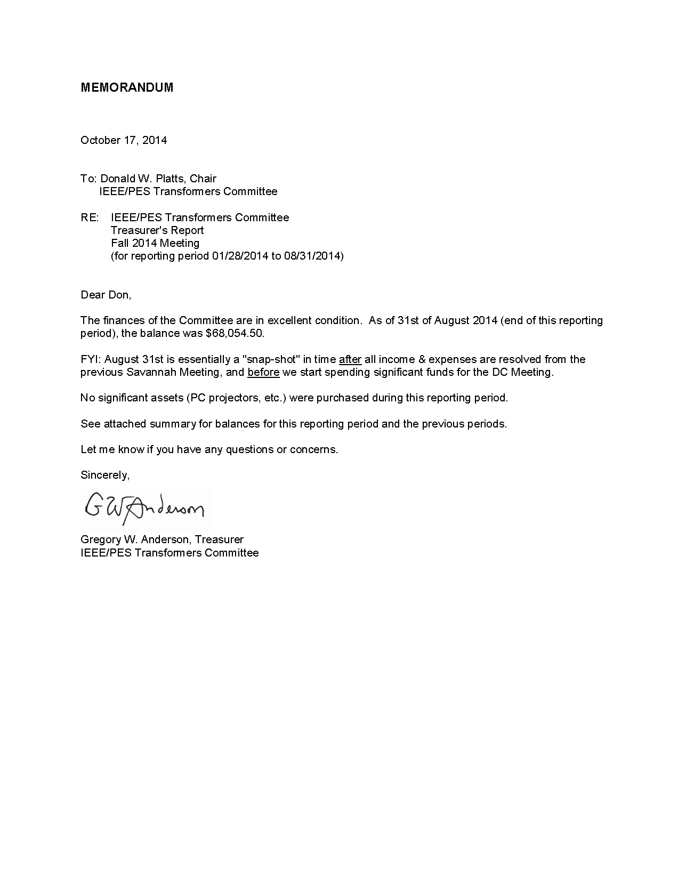
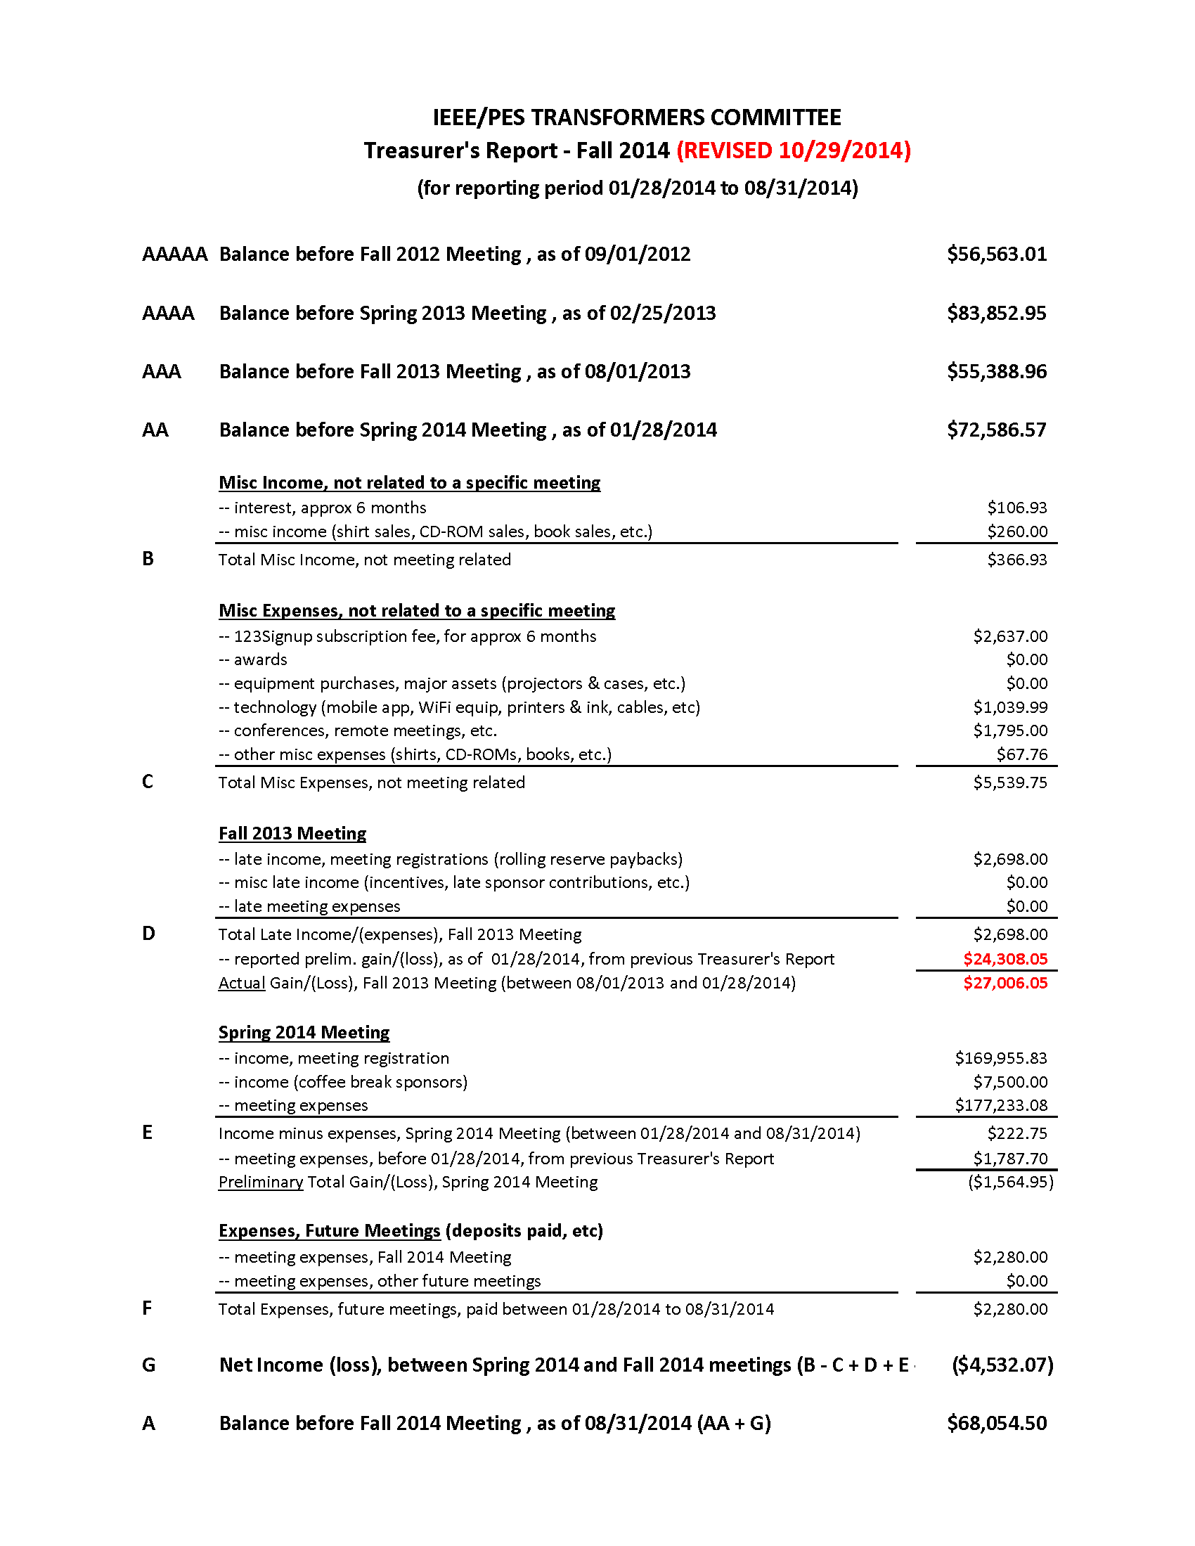Gregory W. Anderson,
Treasurer IEEE/PES Transformers Committee

Recognition and Awards Report – Bill Chiu
The Awards were presented at the Tuesday Awards Luncheon. No report was made at the Monday General Session.

Committee Membership Certificates
The Transformers Committee welcomes five new full committee members. Each of the following new members was presented with a membership certificate:

New Member | Affiliation
Thomas R. Melle | HighVolt
Poorvi Patel | ABB Inc.
Leslie D. Recksiedler | Manitoba Hydro
Adam M. Sewell | Quality Switch
Charles E. Simmons | Duke Energy
Kenneth R. Skinger | Chicago Bridge & Iron
Troy Tanaka | Burns & McDonnell

General Service Awards Certificate of Appreciation
Certificate of Appreciations were presented to the following list of recipients for their contributions to the Transformers committee:

Name of Award Recipients | Affiliation | Contributions
Jane Ann Verner | PEPCO | Meeting Host – Fall 2014
Potomac Electric Company | PEPCO | Host Company– Fall 2014
Carl G. Niemann |  | Subcommittee Chair  Underground Transformers & Network Protectors (2000 – 2014)
Brian F. Klaponski | Carte International Inc. | “Outstanding Contributor”  to the Transformers Committee

IEEE SA Standards Board Awards
In addition to the Committee Awards above, the IEEE SA SB presents its own Award to the WG Chair upon publication of a new or revised document, and offers the WG Chair the opportunity to nominate significant contributors to the project for an IEEE SA SB Certificate of Appreciation. All Working Group Chairs chose to have their awards sent direct to their residence or place of business. The award recipients were called forward for recognition during our Awards Luncheon on Tuesday.
IEEE SA Award Reccipients:
Revision of C57.134 - Guide for Determination of Hottest-Spot Temperature in Dry-Type Transformers
Paulette Payne Powell - Working Group Chair
Timothy L. Holdway - Significant Contributor
Charles W. Johnson - Significant Contributor
Richard P. Marek - Significant Contributor
Revision to C57.96 - Guide for Loading Dry-Type Distribution and Power Transformers
Richard P. Marek – Working Group Chair
Timothy L Holdway – Significant Contributor
Aleksandr A Levin – Significant Contributor
Dhiru S Patel – Significant Contributor
Sanjib K Som – Significant Contributor
Revision of IEEE 638 - Standard for Qualification of Class 1E Transformers for Nuclear Power Station
Craig Swinderman – Working Group Chair
Roger Wickes – ballot comment resolution
Richard Marek – dry type transformer aspects
Kent Brown – insight from user’s perspective
William Bartley – ballot process, PAR issues, etc.
Revision to C57.116 - Guide for Xfmrs Directly Connected to Generators
Gary Hoffman - WG Chair
Bill Griesacker - WG Vice Chair
Randall Kyle - WG Secretary
Peter Balma - Special Editor
Mark Baldwin, Joe Watson, Randall Kyle Task Force Chair

WG & TF Contributing Members
Wallace Binder | Roderick Sauls**
David Harris | Stephen Schroeder
Jose Izquierdo | Eduardo Tolcachir
John Lackey** | David Wallach**
Jeffrey Ray* | Kipp Yule**
* Technical Contributor
** Ballot Resolution Committee Members
Revision to C57.12.28 & C57.12.29 - Standard for Pad Mounted Equipment - Enclosure Integrity (& Coastal Environments)
Robert C. Olen & Daniel Mulkey - WG Co-Chairs
Revision to C57.12.38
Std. for Pad-Mounted Type, Self-Cooled, Single Phase, Dist Transformer, <250kVA
Ali Ghafourian – Working Group Chair
Michael D. Faulkenberry – WG Vice Chair
International Joint Working Group Chair Award
IEEE SA Award - IEC/IEEE 65700-19-03
Standard Requirements – Terminology and Test Code for Bushings for DC Applications
Leslie D. Recksiedler & John Graham – WG Chair
Pierre Riffon – WG Co-Chair
Reiner Krump – significant contributor
Ulf Radbrandt – significant contributor

IEEE PES Distinguished Service Award
The Transformers Committee recognized two very special individuals in the form of Power & Energy Society Distinguished Service Award at this meeting. This award is reserved for members of PES who has devoted a very significant portion of their career contributing to one of the technical committees within the PES umbrella.
Each Technical Committee is allotted a maximum of one recipient per year for outstanding distinguished individual service. This very special award and personal recognition acknowledges the efforts of those individuals with sustained performance, over many years and/or has contributed to the advancement of the committee technology. This award recognizes contributions in the following categories:
- Enhancing the process through continued service on its major action committees.
- Leadership in developing new aspects of what the technical committee can do to improve its procedural process.
- Interaction on behalf of technical committee to promote national and international growth of standards as a product of IEEE.
- Representing the technical committee at various levels within IEEE Societies/Committees and other standards-developing organizations (ASME, IEC, etc.), which encourages the implementation of the IEEE Standards and also the mission and goals of Power & Energy Society - To be the leading provider of scientific and engineering information on electric power and energy for the betterment of society, and the preferred professional development source for our members.
As in the criteria mentioned earlier, there is only a maximum of one award given each year in this category from each of the 14 technical committee. Because we did not take advantage of this category for the past couple of years, we negotiated with the PES Awards approval committee for us to use some of the past allotment. They were kind enough to have made a special dispensation to grant us two award recipient this year. So I do want to acknowledge my appreciation to the PES Awards Chair, Dr. Mariesa Crow for providing this generous variance. This recognition consists of an engraved brass plate mounted on a wooden plaque, although there is no honorarium attached to this award.
Our first recipient, Gregory W. Anderson, started attending our committee meetings in the mid-1990’s and has been a very active contributor event since. This individual really didn’t take much time to get himself indoctrinated with the committee. He jumped right in and hosted a meeting in the Spring of 1995 when we had our meeting in Kansas City. Over the years, he has continued to play a pivotal role for the success of the committee over the past couple of decades in carrying out his vision on what it takes to facilitate our meetings. He has led many of the innovations that we now take for granted. Many of you remembered what it was like to plan and host a meeting. The host had to physically mail out invitation letters and collect the registration fees from individual members, not to mention tracking individual attendees’ correspondence, on top of making all the local arrangements, from hotel lodging accommodations to food and beverages and everything else in between. During the past couple of decades, this individual has provided countless leadership in breaking the boundary of our traditional thinking on meeting arrangements. As an example of the many notable accomplishments, this individual spearheaded the transition to the Association Management System - AMS-123, which has profoundly changed the way we run our meetings, and greatly simplified some of the tedious task of managing the contact information of our attendees, tracking the meeting attendance, membership rosters, and streamlining the communications for each of the activities that are key to our successes.
Our next recipient, Donald J. Fallon, has been a long term contributor since the mid-1980’s. Don has tirelessly contributed to many of our documents despite some recent travel restriction and continued to participate through correspondences. An example of this is during the previous revision to one of our core document of C57.12.80 several years ago, Don tirelessly went through the more than 500 definitions and made sure we didn’t overlook or had conflicts between the terminologies. Don also held a continuous attendance record over a 25-year period where he had not miss a single meeting. Don had a series of impressive leadership role in the committee. He served as WG and TF chairs for many of the documents, been a Performance Characteristic Subcommittee Chair, and a former officer of the main committee. Although not able to actively attend our meetings for a few years, due to travel restrictions, I know I speak for many in that we are very glad that he is able to join us again at this meeting even though he is almost retired from his work. For me, not only did Don made his mark in a series of very significant leadership role for our committee, but Don was also a trusted advisor for me over the past 10 years or so in my progression from a standards coordinator and standards subcommittee chair through the officer’s ranks.
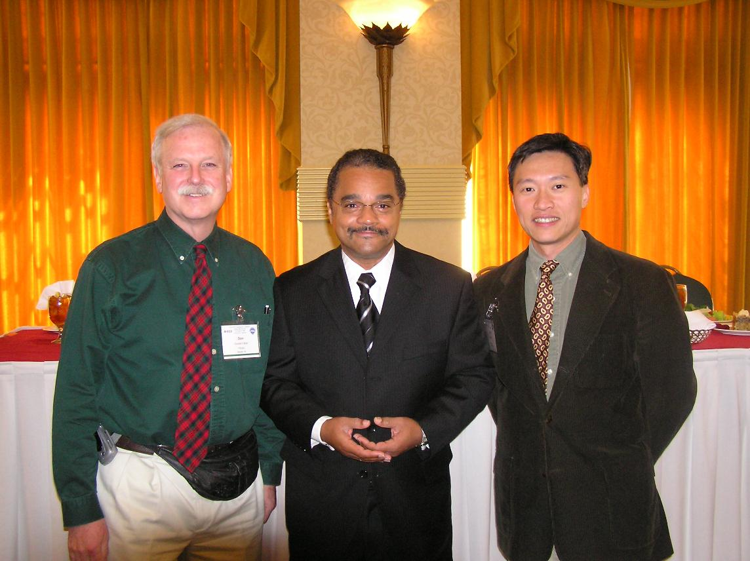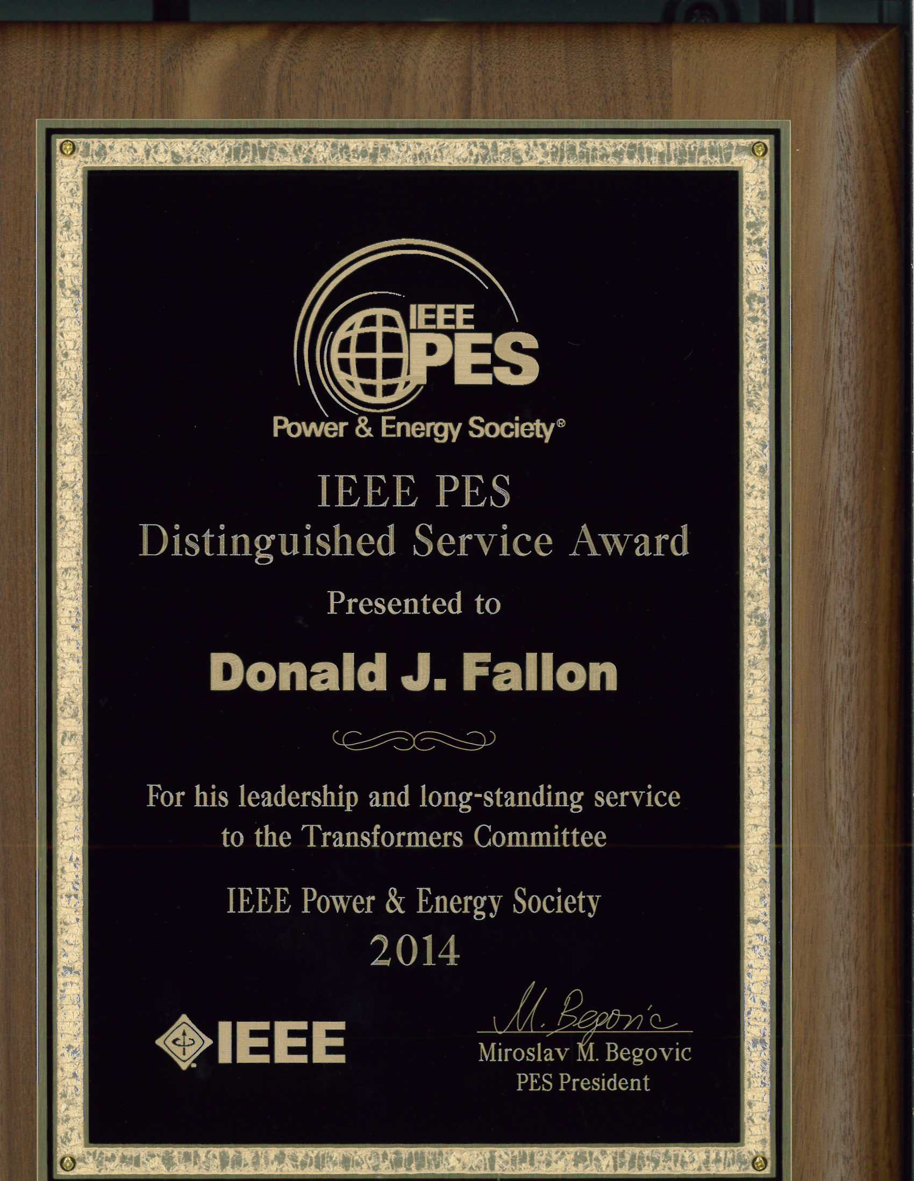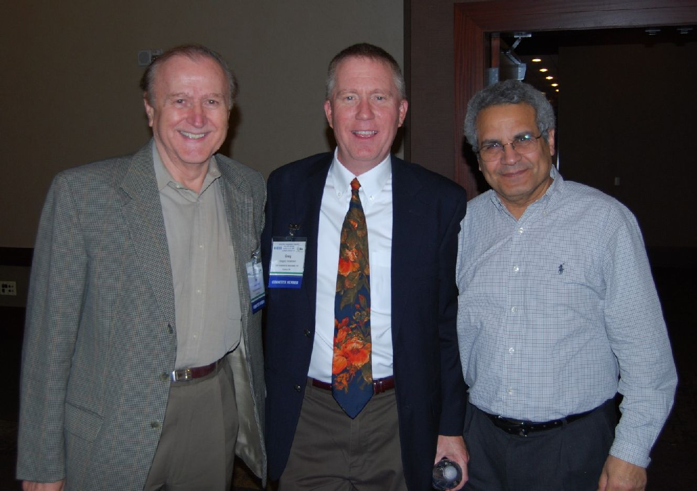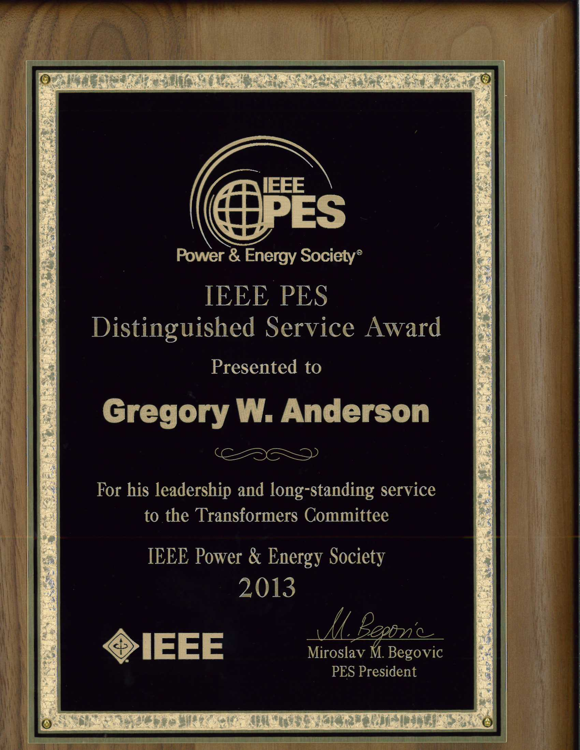
We will continue to present our PES Technical Committee Distinguished Service Award each year to one of our members who is recognized by his peers as having contributed significantly and consistently to Committee Standards activities. This personal recognition acknowledges the efforts of those individuals whose sustained performance, over many years, has contributed to the advancement of the committee technology. Please see the Awards Chair if you have suggestions for future recipients. We are always seeking nominations for this award.

Transformers Committee Meritorious Service Awards
There is also a process of additional recognition for Meritorious Service and Outstanding Contributions to the Committee. Suggested qualifications have been developed from a review of similar awards presented by other IEEE Technical Committees or Societies. General examples for qualification for the awards include the following:
- To recognize continuing exemplary service in notable technical contributions to multiple Committee projects/documents over a sustained period of time.
- To recognize an achievement of major value and significance to the Committee. The achievement can be a specific, concisely characterized accomplishment, as opposed to a collection of different efforts.
- As with the IEEE Education Society Meritorious Service Award – “to recognize pioneering contributions to the administrative efforts of the Society over a period of years, as evidenced by dedication, effort, and contributions.”
If you have any additional thoughts on qualifications for Meritorious Service Awards, and if you have potential nominees to suggest, please contact me. Award nominees will be reviewed by the Awards Chair and the SC Officers.

IEEE Standards Association (SA) Awards and Recognition
The IEEE SA sponsors additional awards besides the WG Chair Awards reviewed above. Discussion of these awards can be found on the IEEE SA Awards web pages (http://standards.ieee.org/sa/aw/). Note particularly the IEEE SA Standards Medallion. Excerpting from the website: “The Standards Medallion is awarded for major contributions to the development of standards. Examples of such contributions may include leadership in standardization of new technologies, assuring achievement of standards development goals, identifying opportunities to better serve the needs of standards users or other such contributions viewed as deserving of this award…” Please review, and if you have suggestions for nominations see our Committee Awards Chair.

Other IEEE PES Awards
The IEEE PES recognizes important technical, educational and service contributions through the conferral of numerous awards. The listing below highlights the various other awards that are available through the IEEE PES organization.
- IEEE PES Award for Excellence in Power Distribution Engineering
- IEEE PES IAS A.P. Seethapathy Rural Electrification Excellence Award
Nominations due by February 1st
- IEEE PES Charles Concordia Power Systems Engineering Award
Nominations due by January 31st
- IEEE PES Cyril Veinott Electromechanical Energy Conversion Award
Nominations due by February 1st
- IEEE PES Douglas M. Staszesky Distribution Automation Award
Nominations due by January 1st
- IEEE PES Lifetime Achievement Award
Nominations due by February 1st
- IEEE PES Leadership in Power Award
Nominations due by February 1st
- IEEE PES Meritorious Service Award
- IEEE PES Nari Hingorani Custom Power Award
Nominations due by January 31st
- IEEE PES Nari Hingorani FACTS Award
Nominations due by January 31st
- IEEE PES Outstanding Chapter Award
- IEEE PES Outstanding Power Engineering Educator Award
Nominations due by January 31st
- IEEE PES Outstanding Young Engineer Award
Nominations due by Februrary 1st
- IEEE PES Prabha S. Kundur Power System Dynamics and Control Award
Nominations due by January 31st - Call for Nominations
- IEEE PES Prize Paper Award
- IEEE Power & Energy Society Ramakumar Family Renewable Energy Excellence Award
- IEEE PES Robert P. Noberini Distinguished Contributions to Engineeering Professionalism Award Nominations due by February 1st
- IEEE PES G. Ray Ekenstam Memorial Scholarship
Nominations due by June 30th
- IEEE PES Scholarship Plus Initiative
Applications due by June 30th
- IEEE PES Roy Billinton Power System Reliability Award
Nominations due by February 1st
- IEEE PES Student Prize Paper Award in Honor of T. Burke Hayes
Nominations due by December 15th
- IEEE PES Uno Lamm High Voltage Direct Current Award
Nominations due by November 30th
- IEEE PES Wanda Reder Pioneer in Power Award
Nominations due by January 15th
- IEEE PES Working Group Recognition Awards
The PES Working Group Recognition Awards recognize “the most outstanding and timely publications” by a PES Working Group (or Committee or Subcommittee) from among the nominations. The PES Recognition Award is divided into two categories: 1) for technical reports; 2) standards and guides. Each Technical Council Committee may nominate one report from each category, published by IEEE, during the previous three year period.” This award consists of a plaque which will be presented to the Working Group Chair at the PES Summer Meeting Awards Luncheon. A framed certificate will be presented to each Working Group member at a designated meeting of the parent Technical Committee.
- IEEE PES CSEE Yu-Hsiu Ku Electrical Engineering Award

Respectfully submitted,
Bill Chiu
Chair, Awards Subcommittee

Administrative Subcommittee Meeting Report

Introductions
  - Introductions
The attendees were asked to introduce themselves. The chair asked each attendee to state his/her affiliation. If the attendee is a consultant, the attendee must state if he is representing a company other than his own consulting interest. Introductions were made by members and guests.
  - Attendance
Members Present:
Chair Donald Platts
Vice Chair Stephen Antosz
Secretary Susan McNelly
Treasurer Gregory Anderson
Standards Coordinator William Bartley
Awards/Past Chair Bill Chiu
Bushings Peter Zhao
Dielectric Tests Michael Franchek
Distribution Transformers Stephen Shull
Dry Type Transformers Charles Johnson
HVDC Converter Transformers & Reactors Michael Sharp
Instrument Transformers Ross McTaggart
Insulating Fluids David Wallach
Insulation Life Barry Beaster
Performance Characteristics Ed teNyenhuis
Power Transformers Joe Watson
Underground Transformers & Network Protectors Dan Mulkey
Guests Peter Balma, Erin Spiewak, Greg Marchini, and Noelle Humenick
  - Approval of Previous Meeting Minutes
The Chair asked for comments from the Spring 2014 Savannah Administrative Subcommittee meeting minutes. Hearing no comments or requests to change the draft minutes, the minutes were approved.
  - Approval of Agenda
The Chair reviewed the draft agenda with the attendees. There were no changes or additions.
Approved Agenda
- Introduction of Members and Guests (:05) All
- Approval of Spring 2014 Minutes from Savannah (:03) D. Platts
- Additions to and/or Approval of the Agenda (:02) D. Platts
- Chair’s Report (:05) D. Platts
- Vice Chair’s Report (:05) S. Antosz
- Secretary’s Report & New Committee Membership Approval (:10) S. McNelly
- Treasurer’s Report (:05) G. Anderson
- Recognition & Awards Report (:05) B. Chiu
- Standards Report (:30) B. Bartley
- IEEE Staff Update (:10) E. Spiewak
- Meeting Planning (:10) G. Anderson
  - Washington DC Metro Area Meeting Update
  - Future Meetings
Break & Time Check – 3:30 pm
- Old Business
  - WG Data – Confidentiality, Storage, Access, & Use (:10) S. McNelly/E. Spiewak
  - Meeting Improvement Initiative (:10) D. Platts/B. Bartley

- New Business
  - Committee P&P Refresher: Moving A Standard to Ballot, etc (:10) P. Balma
  - Committee O&P: Volunteers needed (:05) P. Balma
Time Check – 4:30 PM
- Subcommittee Reports – Roundtable (not intended to indicate order of reporting)
Bushings (:03) P. Zhao
Dielectric Test (:03) M. Franchek
Distribution Transformers (:03) S. Shull
Dry Type Transformers (:03) C. Johnson
HVDC (:03) M. Sharp
Instrument Transformers (:03) R. McTaggart
Insulating Fluids (:03) D. Wallach
Insulation Life (:03) B. Forsyth
Performance Characteristics (:03) E. teNyenhuis
Power Transformers (:03) J. Watson
Underground Transformers & Network Protector (:03) D. Mulkey
- Adjourn
  - Chair’s Report – Donald Platts
Refer to Section 5.0 for a complete “Chair’s Report.”
- Technical Council:
A summary of the DOE QER report was provided in the Chairs Report
- Technical Committee Structure
The scope of each technical committee will be reviewed to make sure that all documents assigned to the technical committees belongs in that committee and that new technologies have a place that they can fit into.
- Proposals to add lanquage to standards
What you need to know about IEEE Stds and the law excerpt is provided in the report. Wherever appropriate, IEEE standards-developing groups should specify standards based on performance or function rather than design or product specifications.
The full brochure can be found at:
https://standards.ieee.org/develop/policies/stdslaw.pdf
There will be a mention at the General Meeting regarding conduct of the standards balloting process. We need to make sure that we operate in a manner that does not give the perception of collusion in order to get members to vote in a certain way.
  - Vice Chair’s Report – Stephen Antosz
Refer to Section 6.0 for a complete “Vice Chair’s Report.”
Highlights:
IEEE/PES T&D Conference and Expo Apr 14-17, 2014: A total of 17 conference papers were submitted. After review, 5 papers were rejected and 8 papers were accepted and presented at the Poster Session
IEEE/PES General Meeting July 27-31, 2014: A total of 27 conference papers were submitted. After review, 15 papers were rejected and 10 papers were accepted and presented at the Poster Session
Most of the papers that were rejected were of very poor quality. Some of the papers had comments requesting revision and the documents were never resubmitted. Ed T indicated that the quality of the papers is improving. Most of the papers are submitted by students or professors.
  - Secretary’s Report – Susan McNelly
Refer to Section 7.0 for a complete “Secretary’s Report.”
Highlights:
The Secretary presented a list of membership requests for this meeting. Eight new requests for membership were received. The eight new committee members were approved with the stipulation that Poorvi Patel provide a 3rd reference meeting the minimum 2 year participation requirement. Poorvi responded that the Moisture TF/WG has been meeting for over 2 years, therefore, this application was also approved.
Patents - Dave Wallach indicated that the LOA for C57.139 is in place. He indicated that he did not know if this needed to be identified each time. Erin indicated that if the LOA is in place, it does not need to be disclosed in the patent notification.
  - Treasurer’s Report – Gregory Anderson
Refer to Section 8.0 for a complete “Treasurer’s Report.”
Highlights:
The Treasurer reported that at the end of August there was approximately $68,000 in the account.
  - Recognition & Award’s Report – Bill Chiu
Refer to Section 9.0 for a complete “Recognition & Award’s Report.”
Highlights:
The Recognition & Awards Chair presented
There will be a short tribute for Rowland James who passed away in September of this year. There will also be an Outstanding Service Award presented to Don Fallon and one other member that will be announced at the Tuesday Awards Luncheon.
IEEE/PES WG award – Bill indicated he would like to propose C57.152 (Field Testing Guide). He indicated that this group spearheaded the way using Web conferencing between meetings.
  - Standard’s Report – William Bartley
Refer to Section 11.0 for a complete “Standards’s Report.”
Highlights:
The Standard Coordinator presented.
There were 6 revisions to Standards and 1 Corrigenda approved
There is 1 ballot pending approval on the October Agenda – PC57.155
There were 8 PARs approved in the last 6 months.
There were 3 PAR modifcations approved in the last 6 months
There were 4 PAR extentions approved in the last 6 months; one with a 3 year extension, which is very unusual.
There are 12 PARs pending at present; 1 was approved by NESCOM but won’t come before the Standards Board until October 24.
Bill reiterated that Standards now have a ten year life cycle.
Ballot pools for C57.12.00 and C57.12.90 have been formed and will be released for Ballot shortly.
There are 5 PARs expiring at the end of 2014. They have all been taken care of.
Bill will be presenting “Moving a Standard to Ballot” at the Monday Standards Luncheon. Also, Greg Marchini will be presenting on the tools that are available.
  - IEEE Staff Update – Erin Spiewak
IEEE Staff Attendance at this meeting: Erin Spiewak (Technical Programs), Greg Marchini (Tools & Solutions), Lisa Weisser (NESCOM), Karen Evangelista (REVCOM), and Noelle Humenick (Strategy & Engagement).
IEEE-SA Public Review Policy
Status update and target dates were reviewed. There will be training at the ADMIN SC meeting at the Spring 2015 meeting and at the Standards Luncheon meeting. She asked for other training ideas, such as WebEx for WG Chairs.
  - Meeting Planning Report – Gregory Anderson
No written report provided.
Highlights:
The Meeting host is Jane Ann Verner and PEPCO.
The next meeting will be a hostless meeting in San Antonio, Texas.
A question was raised that if we are not going to have a host, do we want to consider allowing someone to sponsor the Sunday Reception. This will be taken under consideration.
  - Old Business

WG Data Confidentiality – E. Spiewak
Erin indicated that the agreement has been finalized by IEEE.
Steve Shull asked whether there will be a place that WGs can put documents that are needed for standards and guides so that they can be made available the next time a revision is needed, such as sketches, figures, etc. Erin will follow up on this and Sue indicated she would request a special Data folder be set up with a special password for storage of this type of materials.

Commercial or exclusion issues
Don indicated that we need to make sure that documents do not respresent only certain devices or suppliers products. An equal balance of content is needed and needs to remain uncommercial.

  - New Business

Committee P& P Refresher: Moving a Standard to Ballot – Peter Balma
Don asked each of the SC Chairs to give new WG Chairs a little direction on how to get started and where to go next, so that they have some guideance before calling Bill Bartley. Don also brought up the issue of Corporate dominance. Based on perception or actual dominance, corporate representation as an officer of a WG or TF needs to be limited to one.
Peter presented a refresher on Moving a Standard to Ballot.
In addition to the TC P&P and the WG P&Ps. There are three additional documents that need to be referred to: IEEE Standards Assoc Operations Manual, IEEE-SA Standards Board Bylaws, and IEEE-SA Standards Board Operations Manual.
A 2/3 majority vote of the working group to proceed is needed to move a document forward to ballot. After this, the WG Chair brings the project to the appropriate SC and makes a motion to proceed to Sponsor Balloting. The SC reviews this on a procedural basis, not a technical basis. The technical work belongs in the WG, but does not prevent the WG from surveying the SC on the content.
The WG may form subgroups (often called Task Forces). Membership in the subgroup must follow the same rules as the WG regarding meeting minutes and members. At the time of formation, the WG shall determine the scope and duties delegated to the subgroup.
O&P Manual – Developing a New Standards Project.
In this manual there is a scope for each SC. Each of the SC Chairs needs to review this scope and determine if it still covers everything which the SC is involved with.
Peter indicated that a process for how a new standards project is developed needs to be addressed in the O&P Manual.
A process for how a new standards project is developed, Standards Revision Project, and PAR submittal are also needed.
Bill Bartley, Chuck Johnson, Dan Mulkey, Joe Watson, Steve Antosz volunteered to help with this effort.
Don requested clarification on the 2/3 approval to proceed to ballot. Don indicated that it is being recommended that the wording be changed to 2/3 of the members, not 2/3 of the quorum. There was a long discussion on this and the difficulty in getting responses back will make this difficult to achieve. Steve Shull indicated that responses to these types of request is typically low.
Don indicated to the group, that Corresponding Member will no longer be an option. If Members are unable to attend, it will be up to the WG Chair to determine if a member is participating and even though cannot attend will be retained as a member. There was considerable discussion regarding how this will affect quorums and WG business.
Don indicated he would like to appoint a task force to look at the P&P documents and identify any changes needed. He asked for volunteers to lead this effort. Dan Mulkey, Chuck Johnson, Joe Watson, Peter Balma, and Don Platts volunteered to work on this. Steve Shull volunteered to lead the effort. The TF scope will address issues that need revision within the WG P&P, specifically Meeting notice, voting requirement, what to do with existing Corresponding Members that will be eliminated. The TF deadline is by the Spring 2015 meeting.
Don asked the SC Chairs to be aware of WGs straying from their intended scope of work and reign them back in.
A new TF is being formed to determine a process

Succession Planning
Don indicated it would be nice to have a list of people available for possible succession planning in the event a SC or WG Chair was to step down or pass away, such as in Rowland James’ situation.
  - Subcommittee Reports

Subcommittee | Report/Hot Topic
Bushings – P. Zhao | Scott Digby will be the WG Chair for GSU Bushing. C19.04
Dielectric Test – M. Franchek | John Crotty resigned as Chair of WG. Art Molden may take on this role  Revision of Table 4 and 5 and for revision of Class 1 & 2 definitions. These revisions will be in the next revision of C57.12.00 that will be sent for ballot shortly.
Distribution Transformers – S. Shull | C57.12.37 Will need a new chair as John Crotty has stepped down.  New joint WG between Distribution bushings and the Bushings SC. Expect to have WG start at next meeting.
Dry Type Transformers – C. Johnson | New WG C57.12.51 – General Requirements for 501 kVA and higher Ventilated Dry Type TRs - Sanjib Som will chair  Casey Ballard will be the new SC Secretary. He no longer works for ABB, so there will be no conflict in having multiple representation from one company.
HVDC – M. Sharp | Ulf Radbrandt will be the new WG chair for the joint Standard for Converter TRs
Instrument Transformers – R. McTaggart | C57.13 is close to being ready for moving toward ballot
Insulating Fluids – D. Wallach | C57.104 PAR extension was approved and hopefully can progress now that data confidentiality has been moved forward.
Insulation Life – B. Forsyth | A PAR for Amendment of IEEE 1538 has been filed.  The TF on WTIs needs closure
Performance Characteristics – E. teNyenhuis | New WG/TF Chairs:  Rick Marek WG C57.110 PAR Approved  Sanjib Som WG C57.21 PAR Approved  Adam Bromley TF C57.105  Vinay Mehrota TF C57.109  There are 14 WGs presently in progress.
Power Transformers – J. Watson | C57.140 will need a new Chair due to Rowland James passing. Paul Boman will become Chair and Brian Sparling will be VC. A straw ballot had been taken.
Standards SC – Bill Bartley | Bill indicated that if a new WG Chair has been assigned, he needs to be notified so that this information can be made in My Project.
Underground Transformers & Network Protector – D. Mulkey | George Payerle will be the new VC for the SC.
  - Adjournment

Standards Report – William Bartley
The Standards Report follows on the next page.

Editor’s Report
Between Spring 2014 meeting and this meeting a total of 73 new & resubmitted papers in the transformer area was under review of IEEE Transactions on Power Delivery for possible publication. For all of these papers the recommendations were as follows:
Accept: 22
Revise and Resubmit: 15
Reject: 15
Under review 21
The above numbers include reviews managed by all editors.
The papers which were accepted for publication are shown below:

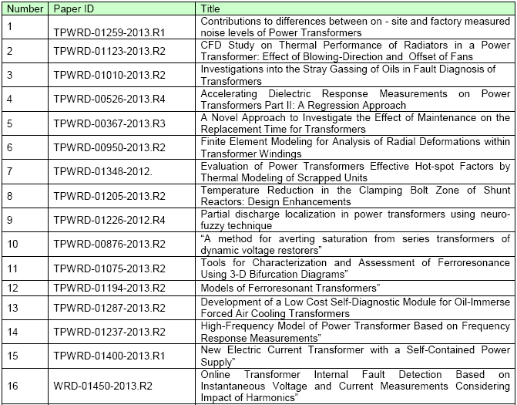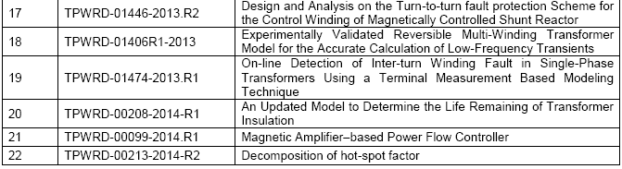
Two significant changes have taken place in favor of paper submitters.
Firstly, on first submission three reviewers are required compared to earlier practice of four.
Secondly, IEEE overall has changed its policy to allow for up to 40% commonality in comparison to earlier publication.
The first step has made the process faster while the second step allows authors to convert their ideas faster into papers.
I would like to thank all of the reviewers who volunteered for this effort and donated their time, and would like to encourage everyone associated with IEEE Transformers Committee activities to consider becoming a Reviewer. I would like to encourage those Reviewers that already have an account on IEEE Manuscript Central to keep their profile information updated and complete the areas for key words and areas of interest. We need more reviewers and I encourage any of you that have not signed up as reviewers to sign up per the instructions at the end of this document.
It is important for all interested individuals to follow the norm for writing papers as provided in IEEE; the link is http://www.ieee.org/publications_standards/publications/authors/authors_journals.html and the link to upload the paper is http://mchelp.manuscriptcentral.com/gethelpnow/training/author/.
Please inform me at sanjib.som@siemens.com as soon as you do sign up so that we are able to utilize your efforts.
- I would also like to take this opportunity to personally acknowledge the reviewers involved in the transformer committee who have been regularly and consistently reviewing papers. This is an important contribution since it maintains the high standards for our papers and it gives back to the industry their expert knowledge.
Special mention must also go out to the editors who have worked hard to make this possible; they are Dr Kulkarni, Dr. Francisco De Leon, and Dr. Wilsun Xu.
Respectfully Submitted,
Sanjib Som
Editor, IEEE Transactions on Power Delivery from Transformer Committee

Unfinished (Old) Business
No old business was discussed.

New Business
No new business was discussed.

Monday General Session Adjournment
The meeting adjourned at 9:10am.

Thursday General Session

Chair’s Remarks and Announcements
Don mentioned that IEEE sent out a notice yesterday regarding the C57 Collection CD is now available. The price is fairly high. A comment was made that the upcoming C57.12.00 and C57.12.90 updates are not in this and members were urged to wait if they were thinking of buying this compilation.

Liaison Reports

Standards Coordinating Committee, SCC No. 4 (Electrical Insulation) – Don Platts for Paulette Payne Powell

IEEE PES Transformers Committee

Liaison Report for General Session Meeting – October 20, 2014
Standards Coordinating Committee on Electrical Insulation – SCC 04

1. Scope:

• To formulate guiding principles for the evaluation of insulation materials and systems for electrical and electronic applications.

• To formulate principles for the identification of insulation materials and systems based on functional tests and/or experience.

• To coordinate the preparation of standards for functional test programs and diagnostic methods for the evaluation of insulation materials and systems.

2. Standards:

- IEEE 1-2000 (R2011) Recommended Practice – General Temperature Limits in the Rating of Electrical Equipment and for the Evaluation of Electrical Insulation

- IEEE 98-2002 (R2007) Standard for the Preparation of Test Procedures for the Thermal Evaluation of Solid Electrical Insulating Materials

- IEEE 99-2008 Recommended Practice for the Preparation of Test Procedures for the Thermal Evaluation of Insulation Systems for Electrical Equipment

3. Current Activities:

• PC 98 – The draft has been balloted; resolution of comments is in progress with the assistance of Roger Wicks. The WG Chair has resigned; the SCC 04 Chair has assumed the position. The goal is to complete this project before expiration of the PAR in December 2015.

• IEEE 99 – The SC will conduct a preliminary review for preparation of the PAR and to determine the extent of work required for the revision. An invitation is extended to anyone interested in chairing the Working Group

Anyone interested in joining the SC or WG activities even as a corresponding member should contact:

Paulette Payne Powell
Chairperson SCC 04
papayne@ieee.org

Respectfully submitted,
Paulette Payne Powell

Standards Coordinating Committee, SCC No. 18 (NFPA/NEC) – Don Platts for Ned Brush
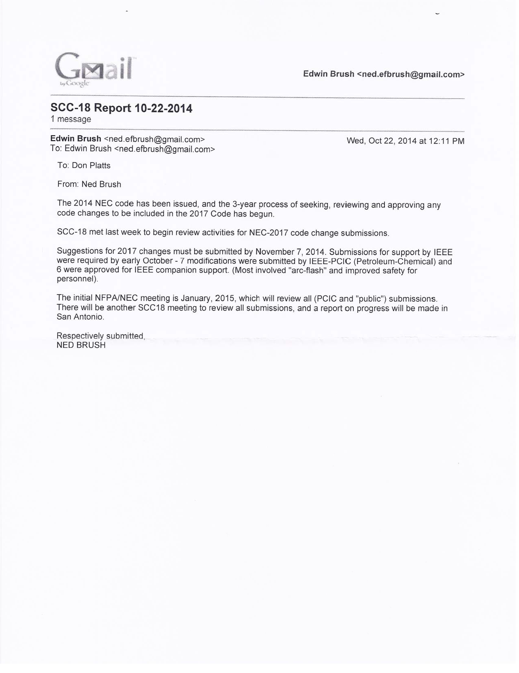

IEC TC14 Technical Advisor to USNC – Paul Jarman for Phil Hopkinson
No report submitted.

CIGRE – Paul Jarman for Raj Ahuja
Report follows on next page.

Meeting’s Planning SC Minutes & Report – Gregory Anderson
Greg thanked Jane Ann Verner for being this meetings host. He indicated that she has been very helpful in the arrangements and keeping the meeting on budget.
Greg provided some meeting logistics, indicating that St. Louis is still our largest meeting to date.
Future Meetings: Greg reminded everyone that all of this information is on the website. The next meeting (April 12-16, 2015) will be a hostless meeting in San Antonio, TX at the Hyatt Regency Riverwalk Hotel. The Fall 2015 meeting will be in Memphis, TN at the Peabody Hotel, November 1-5.
Greg gave a brief overview of the Committee Finances including existing funds and meeting expenses.
Greg thanked a group of people who helped with making the meeting run smoother (Abbey Allen, Jennifer Stranko, and Tammy Behrens). He indicated he is looking for people to help with projector set up and dispersment during the meetings.
He also invited people to contact Tom Prevost if they have ideas for Presentations for upcoming meetings.

Reports from Technical Subcommittees (decisions made during the week)
Reports from each Technical SC were provided. Their minutes are included in full in the attached Annexes.

Reports from Standards SubCommittee and Standards (Issues from the week)

New Business
No new business was raised.

Thursday General Session Adjournment
The meeting was adjourned at 12:00PM.

