Power Transformers Subcommittee

November 4, 2015

Memphis, TN USA

Meeting Time: 1:30 p.m.

Chair: Joe Watson   
Vice Chair: Bill Griesacker  
Secretary: Kipp Yule

# Meeting Attendance

The Power Transformer s Subcommittee met on Wednesday, November 4, 2015, at 1:30 PM. A call of members indicated that 80 of 123 members were in attendance, achieving a quorum at the meeting. Overall, there were 196 attendees with 80 members and 116 guests.

# Approval of previous meeting minutes, and meeting agenda

The Chair presented the Agenda, Attachment K.2, and it was approved.

The Chair requested a motion to approve the spring 2015 meeting minutes and the minutes were subsequently approved by unanimous vote.

# Chair’s Remarks

It is a requirement to record the name and affiliation of all people attending each WG, TF or SC meetings. While this can be done by entering the full list of attendees in the meeting minutes, the Administrative SC has agreed that this can best be accomplished by recording the attendance of each meeting in the AM system. All working groups are required to enter the individual’s attendance in the AM system. In the WG group minutes it is also required to note if the group plans to meet at the next TC meeting.

|  |
| --- |
|  |

# Working group reports

## Revision of C57.12.10 IEEE Standard Requirements for Liquid-Immersed Power Transformers – Gary Hoffman

See details of meeting minutes in Attachment K.4.1. A quorum was achieved. A task force was formed to conduct an editorial review of the document. There are three other task forces at this time addressing the revision of document sections 4, 5 and 6.

## Revision of C57.93 IEEE Guide for Installation and Maintenance of Liquid-Immersed Power Transformers – Mike Lau

See details of meeting minutes in Attachment K.4.2. Discussed the warning for confined space entry and working on transformers when under vacuum. Moved to replace with a general statement on safety issues with a comment to refer to company procedures and local requirements and codes. Plan to issue draft document by next meeting and will then move to send out draft for balloting. The PAR expires in 2016; the chairperson will consider requesting a 1-year PAR extension depending on progress.

## Revision of C57.125 Guide for Failure Investigation, Documentation, Analysis and Reporting for Power Transformers and Shunt Reactors – W. Binder

No meeting was held. Revisions to the guide were approved and the document is to be published.

## TF to Compare C57.131-2012 Standard for Load Tap Changers and IEC 60214-1 ED 2.0 for consideration of recommending adoption of IEC standard (Also WG 60214-2 Tap-Changer Application Guide) - Craig Colopy

See details of meeting minutes in Attachments K.4.3.1. and K.4.3.2. The general opinion from the TF is that prospects are very good to bring these two standards together as one. Annex E of C57.131 will be included in IEC 60214-2 as an Annex. A link under the Power Transformer SC has been created for access to a website for clause comparisons, agendas, minutes and supporting documentation.

## C57.140 Guide for the Evaluation and Reconditioning of Liquid-Immersed Power Transformers – Paul Bowman

See details of meeting minutes in Attachment K.4.4. A PAR extension was granted extending work to December 2017. Draft 5 of document is being prepared to send to the SC for review in the next six months and then will request approval to send document for sponsor ballot.

## Revision of C57.148 Guide for Control Cabinets for Power Transformers

A new working group will be formed at the next meeting to revise the guide.

## Revision of C57.150 Guide for the Transportation of Transformers and Reactors Rated 10,000 kVA or Larger

Will start up working group at next meeting for revision of the Guide.

## Development of PC 57.153 Guide for Paralleling Transformers - Tom Jauch

No meeting was held.

## Development of PC57.156 Guide for Transformer Tank Rupture Mitigation of Liquid-Immersed Power Transformers and Reactors - Peter Zhao

Working group did not meet. Document is in ballot review process. Successfully balloted the guide, addressed the responses and then sent out for second ballot.

## Development of PC57.157 Guide for Conducting Functional Life Tests for De-Energized Tap Changer Contacts - Phil Hopkinson

See details of meeting minutes in Attachment K.4.5. The guide was approved and will be published by December 2015. The working group will not meet at the next Transformers Committee meeting.

## Development of Standard Requirements for Phase Shifting Transformers - IEEE/IEC 60076-57-12 - Raj Ahuja

See the working group meeting minutes in Attachment K.4.6. One new comment came up regarding impulse testing. An editorial meeting was to be held on 11/5/15 to implement the changes that will be required. The FDIS document will go to IEC and will be circulated. The document and comments will be submitted to IEEE and REVCOM for approval.

# Old Business

C57.156 – Patrick McShane noted that promised changes were not made and an annex on fire prevention was removed. There were also wording changes on fire prevention.

# New Business

Phil Hopkinson – Distribution transformers can be made up to 10 MVA and can step up or down between primary and secondary voltages. Do we need a Class 1 power transformer classification? Renewable application transformers are Power, Class 1 transformers.

A motion was made to form a joint TF to clearly define the bounds between Power and Distribution transformers, which would include Power Transformers SC, Distribution Transformers SC and Standards SC.

It was further noted that C57.12.80 would need to be updated where definitions would be affected.

# Adjournment

The meeting adjourned as scheduled.

# Attachments –Working Group Meeting Minutes and Agenda

Attachment K.2 – F14 PTSC Agenda

Attachment K.4.1 – PC57.12.10 Standard Requirements

Attachment K.4.2 – PC57.93 Installation Guide

Attachment K.4.3.1 – TF IEC 60214-1 / IEEE C57.131 Tap Changer harmonization

Attachment K.4.3.2 – WG 60214-2 IEC Tap Changer Part 2 Application Guide

Attachment K.4.4 – PC57.140 Evaluation and Reconditioning Guide

Attachment K.4.5 – PC57.157 Functional Life DETC Guide

Attachment K.4.6 – IEEE / IEC 60076-57-12 Phase Shifting Transformers

**Attachment K.2**

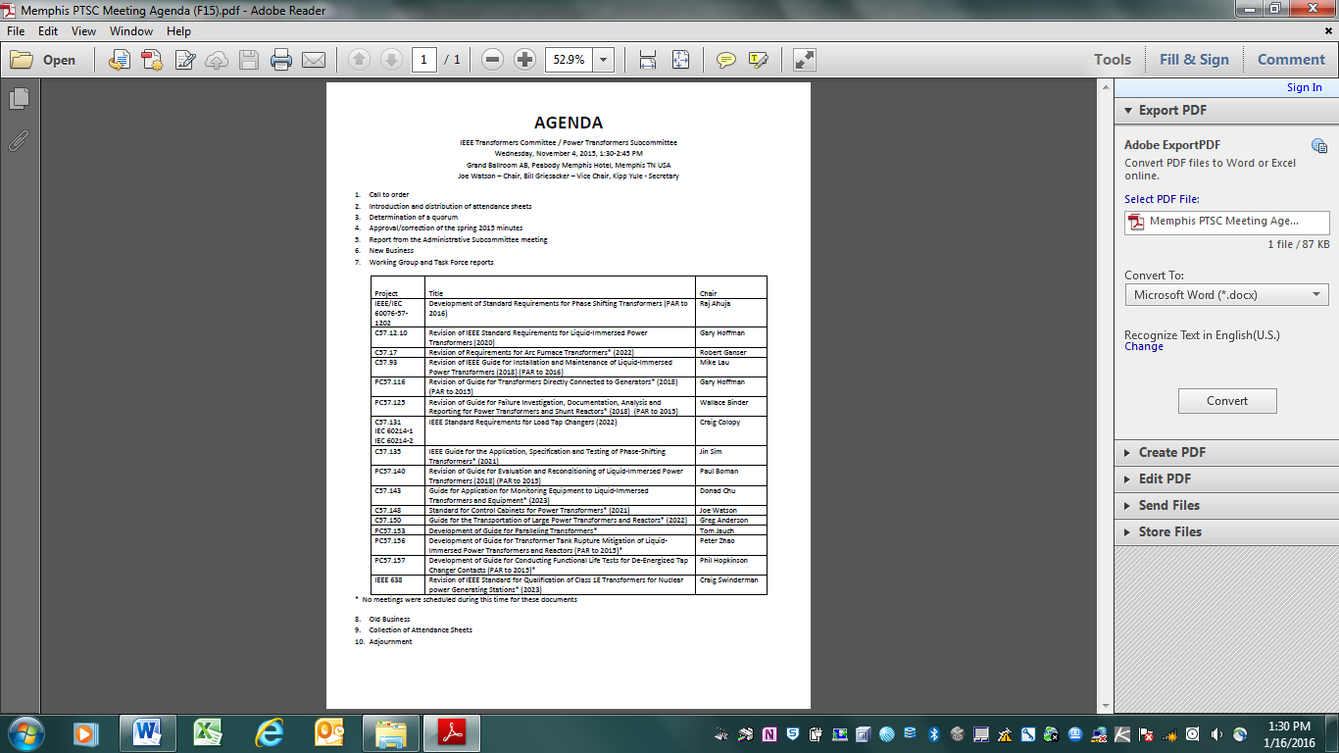

**Attachment K.4.1**

*PC57.12.10 - WG for the Revision of*

*IEEE Standard Requirements for Liquid-Immersed Power Transformers*

November 3, 2015

Peabody Memphis Hotel, Grand Ballroom B, 8:00 to 9:15 AM

Memphis, TN

***Unapproved Meeting Minutes***

WG Chair Gary Hoffman called the meeting to order at 8:00 a.m., Tuesday, November 3, 2015, with WG Vice-Chair Brian Penny and WG Secretary Scott Digby also present. Introductions were made. The Chair reviewed the WG membership requirement that individuals are required to be present at two (2) consecutive WG meetings in order to be eligible for membership.

|  |  |
| --- | --- |
| Total Attendance | 88 |
| Members in Attendance | 22 (out of 38 members, **quorum was achieved**) |
| Guests in Attendance | 66 |
| Guests Requesting Membership | 19 (1 meeting membership eligibility requirement of  attendance at 2 consecutive meetings) |

Guests Requesting Membership: Hamid Abdelkemel, Jerry Allen, Javier Arteaga, Arup Chakraborty, Matt Chu, Marcos Ferreira, Jeff Golarz, John Herron, Kurt Kaineder, Susan McNelly, Shankar Nambi, Dave Ostrander, Oscar Pinon, Rodrigo Ronchi, Hakan Sahin, Pugazhenthi Selvajaj, Fabian (Durand) Stacy, Dharam Vir, and Waldemar Ziomek. Kurt Kaineder was added as a member, having met the eligibility requirement of attendance at 2 consecutive meetings.

Additional guests that were eligible for membership, having met the eligibility requirement of attendance at 2 consecutive meetings, but did not request membership: Roy Ayers, Erin Skiewak, and Matthew Weisensee.

The agenda was reviewed and a **motion** to approve was made by Craig Stiegmeier and seconded by Rich vonGemmingen, which was approved by unanimous consent.

The minutes to the Spring-2015 meeting of this WG had been circulated to the WG membership and guests prior to the meeting and a **motion** to approve was made by Joe Watson and seconded by Brian Penny, which was approved by unanimous consent.

Clause 4 Task Force Chair, Brian Penny reported that the changes to this clause primarily involved editorial changes with some changes to references due to changes to such references, and briefly discussed the comments that had been received. Javier Arteaga suggested that the table of ratings might need to include reference other alternate fluids such as ester fluids, with the TF Chair stating that the TF would review the suggestion. The TF Chair stated that clause 4 would be updated based on the comments received.

Clause 5 Task Force Chair, Joe Watson presented for discussion several of the comments that had been received. One commenter objected to the DETC being listed as an optional feature in Table 4, though this was not a change from the previously approved standard. Sheldon Kennedy, who noted that he had been a member of the WG for the previous revision of this standard, remembered that it was intentional during the previous revision of this standard for the DETC to be optional but could not recall the rationale discussed at the time. Several attendees shared their opinion that they preferred the DETC remain an optional feature, while Steve Schroeder shared his believe based on his routine review of user specifications that there is an expectation among many users that non-LTC transformers include a DETC without their having to explicitly specify.

Motion was made by Wally Binder and seconded by Craig Stiegmeier for a DETC, with taps at ±2@2.5% steps, to be a standard requirement for non-LTC transformers and to be an optional requirement for LTC transformers. The motion passed with a vote of 11 in favor, 5 against, and 2 abstaining.

Discussion regarding this motion included comment by Jane Verner that the DETC can be an expensive feature and they her company had eliminated it from their specification, comment from Kumar Mani that power plants often have to change their GSU tap positions for various reasons, and comment from Eric Schleismann and one other attendee that they frequently adjust DETC positions to ensure that the LTC or that voltage regulators routinely run through neutral position.

It was noted that the list of Table 4 notes are intended to be normative and needed to be reviewed to confirm adherence with the IEEE Style Manual convention for table footnotes.

A suggestion was made by Paul Jarman to update the term LTC to OLTC. The clause 5 TF Chair said that the TF would consider this. It was additionally pointed out that this might require the inclusion of OLTC in the definitions of the document.

Sue McNelly stated concern that there is no standard for the location or numbering of tertiary bushings. The clause 5 TF Chair said that the TF would review. Sue McNelly also volunteered to join the clause 5 Task Force.

Clause 6 Task Force Chair, Mark Tostrud reviewed proposed changes to this clause.

One proposed change was for the removal of the drain valve sampling valve as a requirement. It was pointed out by Don Platts that an associated ASTM states to use that particular sampling valve and that removing it as a required feature in the standard would need coordination with that group.

It was noted that sections of the clause concerning control equipment enclosures were being removed since there is now a published Control Cabinet standard and that the TF will include reference to this standard within this clause.

The clause 6 TF has reviewed Annex A (informative) and has identified the material that is covered by new guide C57.153. The TF Chair noted that there is some material from Annex A that needs to be moved to the main body of standard C57.12.10 and that the will be working on doing so.

The WG Chair stated that there is still work to be done by the Task Forces so they would thus remain as active Task Forces and that another draft of the clauses will be forthcoming for circulation and review.

New Business:

1. The Chair made a request for volunteers to perform an Editorial Review of the document in advance of the next circulation of the draft clauses. Don Platts, Sue McNelly, Wally Binder, Ryan Musgrove, and Shankar Nambi, Ewald Schweiger volunteered to take on this task.
2. Don Platts suggested that a short paragraph be complied to track the DETC decision that was made during this meeting, possibly by the person who made the motion.

The WG Chair indicated that he will review the need for an electronic WG meeting between now and the next Transformer Committee meetings in Atlanta in the spring 2016, potentially in the February-2016 time frame, based on the status of the Task Forces. If such meeting were to be scheduled the WG members would receive notice at least 30-days prior.

The presentation slides from this meeting will be published to the website.

The motion to adjourn was made by Richard VonGemmingen and seconded by Don Platts. The motion passed and the meeting was adjourned at 9:15 a.m.

Respectfully Submitted

Scott Digby, WG Secretary

**Attachment K.4.2**

WG Revisions to Installation of Power Transformers C57.93

Monday, November 02, 2015 1:45 MM – 3:00 PM

Memphis, TN

**Minutes of the Working Group Meeting**

Chair Mike Lau called the WG meeting to order at 1:50 PM on November 02, 2015. 19 of 28 members were present, so a quorum was achieved. 91 guests also attended, for a total attendance of 110. Fifteen (15) guests requested membership.

The start of the meeting was delayed due to technical difficulties with the projector, so approval of the agenda and the spring 2015 minutes were bypassed.

Mike Lau reminded the working group that the PAR expires in 2016. A one-year PAR extension will be requested after the chair evaluates the progress of the guide revision.

Wally Binder raised an issue regarding the safety warnings concerning confined space entry. The meaning and intent of including lower explosive limits was discussed at great length. The need to include typical confined space entry procedures was also debated.

Joe Watson made a motion to remove the warnings for confined space, including references to LEL and all text discussing confined space procedures, and to add a generic statement that company procedures and requirements established by regulatory authorities should be followed. The motion was seconded by Alan Peterson. The motion passed unanimously.

A ballot resolution group was formed, comprised of Wally Binder, Patrick Rock, Ken Sullivan, Alwyn VanderWalt, Scott Reed, Stephanie Denzer, Alan Peterson, Rick Simonelli, and the working group officers.

Amotion to adjourn was made by Wally Binder, seconded by Derek Baranowski. The working group meeting adjourned at 3:00 PM.

Respectfully submitted

Mike Lau Saurabh Ghosh Jim Graham

WG Chair Vice Chair Secretary

November 02, 2015

**Attachment K4.3.1**

**Power Transformer Subcommittee**

**Task Force Report**

|  |  |
| --- | --- |
| **Document #:** | **TF Comparison of IEC 60214-1 and IEEE C57.131** |

|  |  |
| --- | --- |
| **Document Title:** | **Tap-Changers** |

|  |  |  |  |
| --- | --- | --- | --- |
| **Chair:** | **Craig A. Colopy** | **Vice-Chair** | **Axel Kraemer** |
| **Secretary** |  |  |  |

|  |  |  |  |
| --- | --- | --- | --- |
| **Current Draft Being Worked On:** | NA | **Dated:** | **NA** |

|  |  |  |  |
| --- | --- | --- | --- |
| **Meeting Date:** | **3 November 2015** | **Time:** | **13:45 to 15:00** |

|  |  |  |
| --- | --- | --- |
| Attendance: | Members | **12** |
| Guests | **39** |
| Guests Requesting Membership | **15** |
| **Total** | **66** |

**Meeting Minutes / Significant Issues / Comments:**

1. Meeting was called to order at 1:45 pm, November 3rd.
2. Chairman provided the WG a background regarding the work being done to harmonize the Tap-Changer Standards and Application Guide between IEEE and IEC. General opinion from TF is that prospects are very good to bring these two standards together as one. Clarification was made on the Harmonization process by Jodi Haasz. Adoption of IEC 60214-1 standard allows for an Annex to be included to clarify key differences between the two standards. This establishes a base for a joint revision by IEEE and IEC in the future when the stability of IEC 60214-1 is within 4 years. It was published in 2014 with a preliminary stability of 2019. Annex E of C57.131 will be included as an Annex in 60214-2, Application Guide.
3. Comparisons were presented for the following specific clauses:
   1. Clause 3 Definitions (Marten Almkvist)
   2. Clause 4 Service Conditions (Jeffrey Golarz)
   3. Clause 6 Requirements for motor-drive mechanisms for on-load tap-changers (Markus Stank)
   4. Clause 9 Nameplates (Jeremy Sewell)
4. The additional following comparisons will be completed and posted on the TF IEC 60214-1 and IEEE C57.131 website within the next 3-4 months before the Atlanta Spring 2016 meeting.
   1. Clauses 1 and 2, Overview and Normative References, respectively (Craig Colopy)
   2. Clause 5 Requirements for OLTC (Axel Kraemer and Marcos Ferreira)
   3. Clause 7 Requirements for de-energized tap changers (Dave Geibel and Jeremy Sewell)
   4. Clause 8 Requirements for motor-drive mechanisms for de-energized tap changers (Dave Geibel and Jeremy Sewell)
5. A link under the Power Transformer SC has been created for access to a website for clause comparisons, agendas, minutes and supporting documentation.
6. Next general summary meeting will take place in Atlanta, Spring 2016
7. Meeting closed at 3:00 pm, Nov 3rd

Submitted by: Craig A, Colopy

Date: 11/03/2015

**Attachment K.4.3.2**

**Power Transformer Subcommittee**

**Working Group Report**

|  |  |
| --- | --- |
| **Document #:** | **60214-2 (Joint Revision between IEC and IEEE)** |

|  |  |
| --- | --- |
| **Document Title:** | **OLTC Application Guide** |

|  |  |  |  |
| --- | --- | --- | --- |
| **Chair:** | **Craig A. Colopy** | **Vice-Chair** | **Axel Kraemer** |
| **Secretary** |  |  |  |

|  |  |  |  |
| --- | --- | --- | --- |
| **Current Draft Being Worked On:** | 4 WD IEC 60214-2 | **Dated:** |  |

|  |  |  |  |
| --- | --- | --- | --- |
| **Meeting Date:** | **3 November 2015** | **Time:** | **15:15 to 16:30** |

|  |  |  |
| --- | --- | --- |
| Attendance: | Members | **12** |
| Guests | **21** |
| Guests Requesting Membership | **6** |
| **Total** | **39** |

**Meeting Minutes / Significant Issues / Comments:**

1. Meeting was called to order at 3:15 pm, November 3rd .
2. Chairman provided the WG a background regarding the work being done to harmonize the Tap-Changer Standard and Application Guide between IEEE and IEC.
3. A Progress Report on the work was provided to the IEC TC14 general meeting in Boras, Sweden in October. For the time being 5 MT 60214-2 meetings have taken place, the last one being in Kista, Sweden in June. The group is working on the topics which were identified in the first meeting to be placed into the standard. The work is making very good process.
4. Next Work Sessions scheduled are the following:
   1. After the General IEEE transformer meeting in Memphis TN, this Friday and Saturday, November 5th and 6th, 2015 in the Louis XVI room.
   2. TBD, likely in Italy in the Spring 2016.
5. A link under the Power Transformer SC has been created for access to a website for document drafts, agendas, minutes and supporting documentation resulting from work being with a joint revision of the Tap-Changer Application guide, 60214-1.
6. Next general summary meeting will take place in Atlanta, Spring 2016
7. Meeting closed at 3:45 pm, Nov 3rd

Submitted by: Craig A, Colopy

Date: 11/03/2015

**Attachment K.4.4**

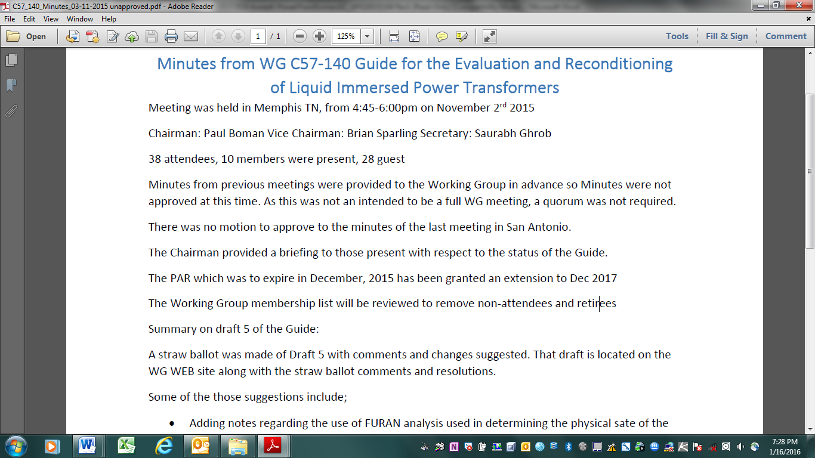

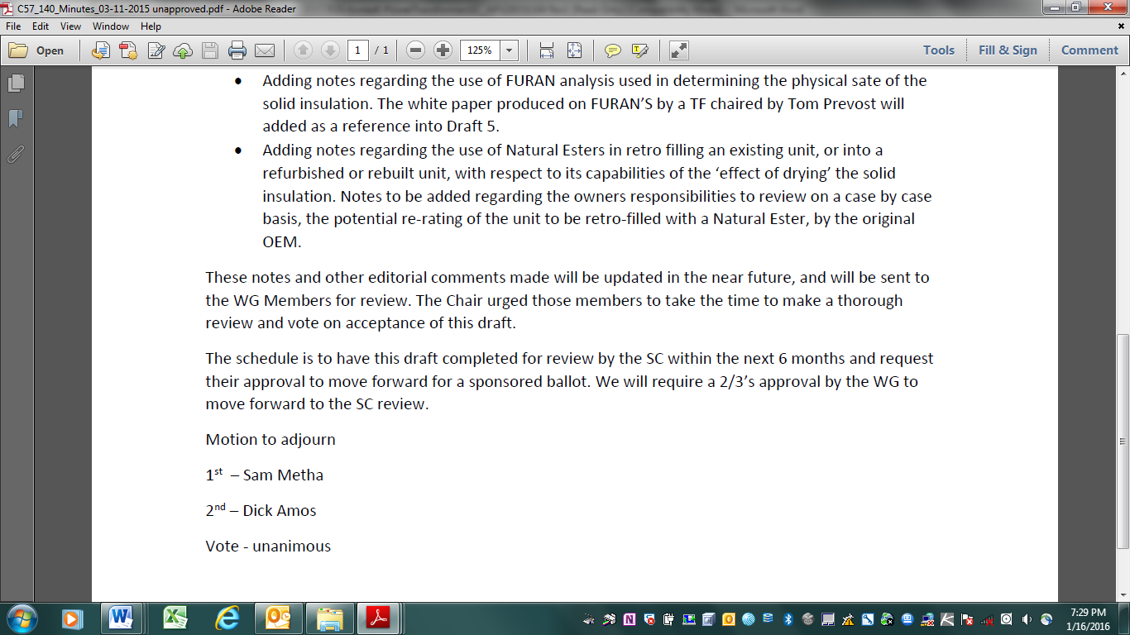

**Attachment K.4.5**

**IEEE/PES TRANSFORMERS COMMITTEE**

**WG FUNCTIONAL LIFE TESTS ON SWITCH CONTACTS PC57.157**

**MINUTES**

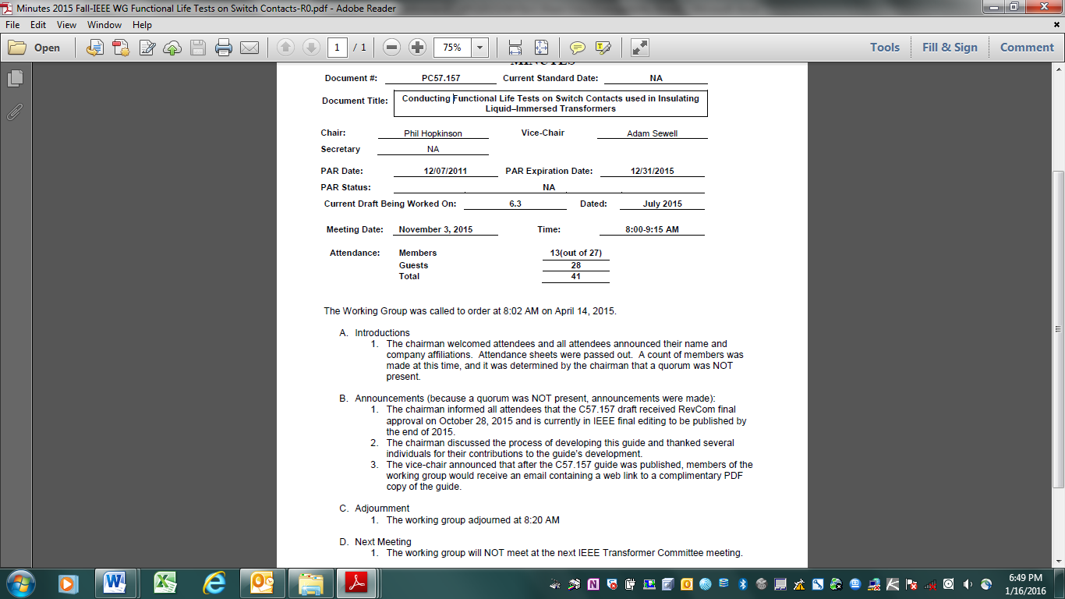

**Attachment K.4.6**

