Vancouver “Spectacular by Nature”  “You’re gorgeous, baby, you’re sophisticated, you live well… Vancouver is Manhattan with mountains. It’s a liquid city, a tomorrow city, equal parts India, China, England, France and the Pacific Northwest. It’s the cool North American sibling.” The New York Times  Majestic mountains, sparkling ocean, rainforests and beautiful foliage throughout all four seasons make Vancouver one of the most beautiful cities in the world. Canadians are known for our friendly nature, and Vancouver’s citizens take great pride in our welcoming, clean, safe streets – day or night, all year round.  Catering to any interest, enjoy world class shopping, gourmet meals, outstanding live entertainment, sporting events, theatre, outdoor adventure, and spectacular sights - it’s all waiting for you in Vancouver. Just as Vancouver welcomed the world in 2010 for the Olympic and Paralympic Winter Games, we’re ready to welcome you as well!  A vast multicultural population, endless activities, and excellent infrastructure, Vancouver is welcoming to all travelers.  A Gateway to Adventure  With quick and easy access to the year round destination of Whistler, the Canadian Rockies, Victoria, or Vancouver Island, and the endless year round water and land sports, whether you’re looking for extreme sports or family fun, you’ll find your personal adventure here. Vancouver also is the home port for Alaska cruises May through October.  Tourism Vancouver www.tourismvancouver.com  Tourism British Columbia www.hellobc.com  Sheraton Wall Centre Our downtown Vancouver hotel captures the charm, energy and innovative spirit of the West Coast. Standard room rate CAD$189, mention” IEEE Transformers” or register on the Committee’s website www.transformerscommittee.org (Next Meeting page) to book your room today!  1088 Burrard St, Vancouver, BC V6Z2R9 604.331.1000 / toll free 1.800. 663.9255 www.sheratonvancouver.com  [Company Name]  [Street Address]  [City, ST ZIP Code] |  |  |  | IEEE/PES  TRANSFORMERS COMMITTEE  FALL 2016 MEETING  OCTOBER 23-27, 2016  WELCOME TO VANCOUVER, BC

EARLY BIRD EVENTS  Saturday Oct 22nd Victoria Full Day Tour  Arrive Friday and tour the scenic Gulf Islands to Vancouver Island all day Saturday. Explore the capital city of Victoria, and the floral splendors of Butchart Gardens. Departs at 7:15am returns 7:30pm.  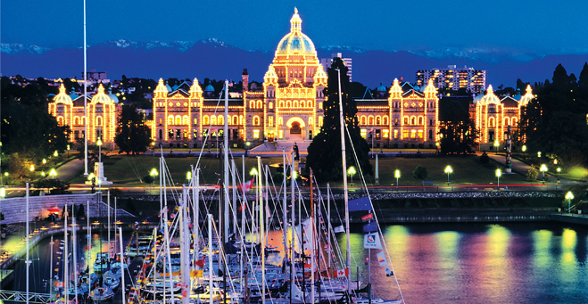  Saturday Oct 22nd An Evening of ……Laughter  Comedy Mix... An evening of hilarious entertainment featuring local and international comedians at the Comedy Mix, just a short walk from the Sheraton Wall Centre Hotel. Light snacks and cash bar.  TECHNICAL TOURS  Monday Evening Oct 24th Tour your host IFD Corporation. Join your colleagues for an intriguing evening of innovation, and savor a specially prepared west coast barbeque dinner at our Vancouver facility. www.ifdcorporation.com  Tuesday Evening Oct 25th TRIUMF is the heart of the Canadian accelerator-based experimental subatomic physics program. TRIUMF's cyclotron produces critical isotopes used for medical imaging. The techniques for producing these isotopes are also used by subatomic physicists to peer “inside” the atom. www.triumf.ca  Thursday Afternoon Oct 27th BC Hydro PowerTech Labs is a multidisciplinary testing, R&D facility with 19 different laboratories supporting large utilities, electric manufacturers, and OEM’s with specialized testing, qualification and non-standard testing for North American and international standards. www.powertechlabs.com |  |  |  | EVENING DINNER CRUISE SOCIAL  Wednesday Oct 26th  Join your colleagues on a magical dinner cruise aboard the SS Brittania as you navigate the active inner harbor waters of Port Metro Vancouver. Enjoy fabulous west coast cuisine and local craft beers, world famous Okanagan Valley wines, and the breathtaking views of Stanley Park, Coal Harbor & the north shore mountains.  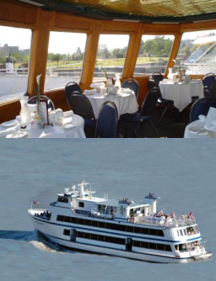  SPOUSE / COMPANION TOURS  Monday Oct 24th Sea to Sky Tour  Rated as one of the most scenic highways in the world, enjoy the spectacular views of Howe Sound, where ocean meets mountains. The adventure starts with a stop at Shannon Falls where the glacial waters drop over 1000 feet, then a ride on the Sea to Sky Gondola to the summit of Mount Habrich for lunch, and a visit to the village of Horseshoe Bay (six hour tour).  Tuesday Oct 25th Vancouver Highlights  A diverse sampling of a truly cosmopolitan city this adventure takes in the sights of the world famous Stanley Park, and fabulous views of Port Metro Vancouver. The tour includes the Museum of Anthropology, Queen Elizabeth Park & lunch at Seasons in the Park, exotic Chinatown and the quaint cobblestone streets of Gastown (six and a half hour tour)
 |  |  |  | 5

