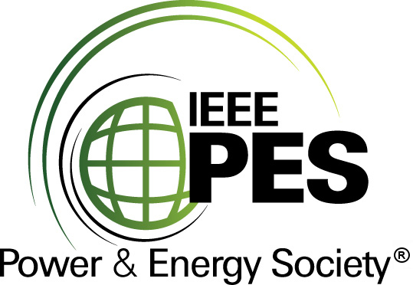
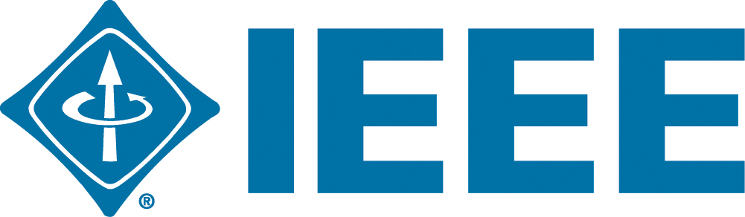

CERTIFICATE OF
EDUCATIONAL ACHIEVEMENT

This certificate is presented to

replace with your name

for attendance at the educational presentation:

"Tacit Knowledge Capture
and Brain-Drain at Electric Utilities - An IEEE Perspective"

sponsored by the IEEE/PES Transformers Committee

and has earned one (1) Professional Development Hours (PDH) unit.
Fall 2016 Committee Meeting; Thursday, October 27, 2016
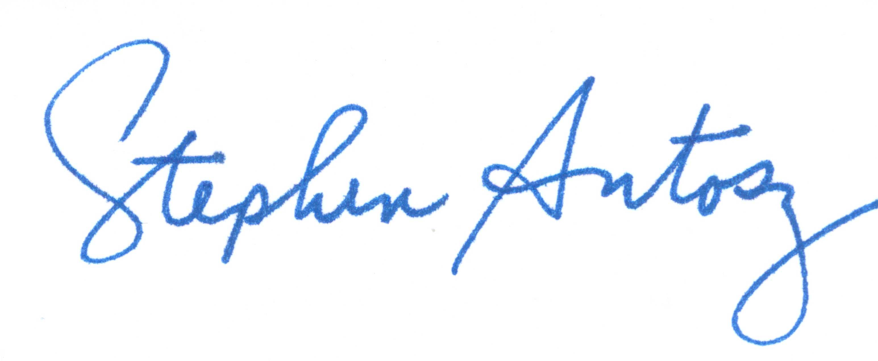

Stephen Antosz Instructors: Nick Perjanik and Alwyn VanderWalt

