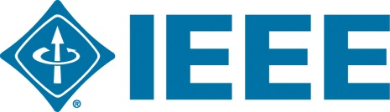
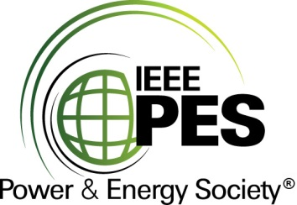

CERTIFICATE OF
EDUCATIONAL ACHIEVEMENT

This certificate is presented to

replace with your name

for attendance at the educational presentation:

"Appropriate Sound Pressure Levels for Power Transformer Specifications – How and Why"

sponsored by the IEEE/PES Transformers Committee

and has earned one (1) Professional Development Hour (PDH) unit.
Fall 2017 Committee Meeting; Thursday, November 2, 2017
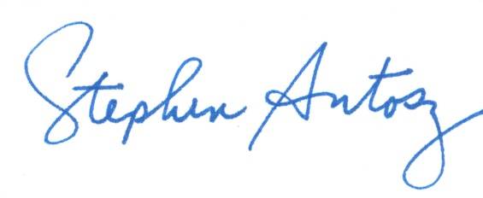

_________________________________ ___________________________________________________
Stephen Antosz Instructors: Ian Brewe and Ramsis Girgis
Committee Chair

