HVDC Converter Transformers and Smoothing Reactors Subcommittee
October 15, 2018, 3.15 pm
Jacksonville, Florida, USA
Chair: Michael Sharp
Vice Chair: Les Recksiedler
Secretary: Ulf Radbrandt

Introduction / Attendance
Introductions were made and the attendance list circulated.
There were 7 members and 14 guests present. One new request for membership was received.
The total membership of the SC is 16. We needed at least a total of 8 members to be present in order to have a quorum. This was not achieved.
The agenda for this meeting was preliminary approved. It will be circulated among SC members via email for a final approval.

Approval of the minutes of the March 26, 2018 meeting in Pittsburgh
The minutes from the Pittsburgh meeting were preliminary approved. It will be circulated among SC members via email for a final approval.

Brief report on the meeting of the Administrative SC by Mike Sharp
All consultants shall identify who are sponsoring their attendance at the meeting.
SC minutes must be submitted latest November 29.
Submission deadline for the last standards board meeting in 2019 is September 17.
The Policies and Procedures document for the Transformers Committee has been revised to include a section stipulating a maximum five year term for subcommittee leadership.
SC chairs must ensure that their web pages are kept updated.

Reminder that IEEE 1277 will expire in 2020.
The standard for smoothing reactors, IEEE 1277, will expire in 2020.

Brief report regarding the CIGRE general meeting in Paris 2018
Klaus Pointner provided a brief report regarding the CIGRE general meeting in Paris 2018 incl. SC B4. Main topics from that presentations were:
- The objective for CIGRE is not to write standards but to solve problems that are not mature for standards yet.
- CIGRE provides inputs that can be used for standards
- CIGRE aims to also go into Medium Voltage
- Main topics this year were
- super grids
- smart grids
- environment and sustainability
- thermal design of transformers
- 800kV VSC in China
- DC networks
- EU project PROMOTION for DC breakers
- At each meeting there is a large state of the art technical exhibition

Working Group Reports

WG IEEE P1277 - Dry-Type and Oil-Immersed Smoothing Reactors and Dry-Type Converter Reactors
Chair: Klaus Pointner (klaus.pointner@ieee.org)
Vice-Chair: -
Secretary: Ulf Radbrandt (temporary)
E.6.1.1 Introductions and Call for Patents
This WG meeting was conducted as part of the HVDC SC meeting.
The WG has different membership than the SC and different rosters. The WG roasters were distributed.
There were 8 members and 14 guests present. 1 new request for membership was received.
The total membership of the WG is 17. We needed at least a total of 9 members to be present in order to have a quorum. This was not achieved.
The agenda for this meeting was preliminary approved. It will be circulated among WG members via email for a final approval.
The minutes from the Pittsburgh meeting were preliminary approved. It will be circulated among WG members via email for a final approval.
E.6.1.2 Survey of Annexes.
The chair, Klaus Pointner did, prior to the meeting, a survey on what to do with the existing Annexes.
9 members (excl. the WG chair) responded.

Annex A - Application of HVDC smoothing reactors
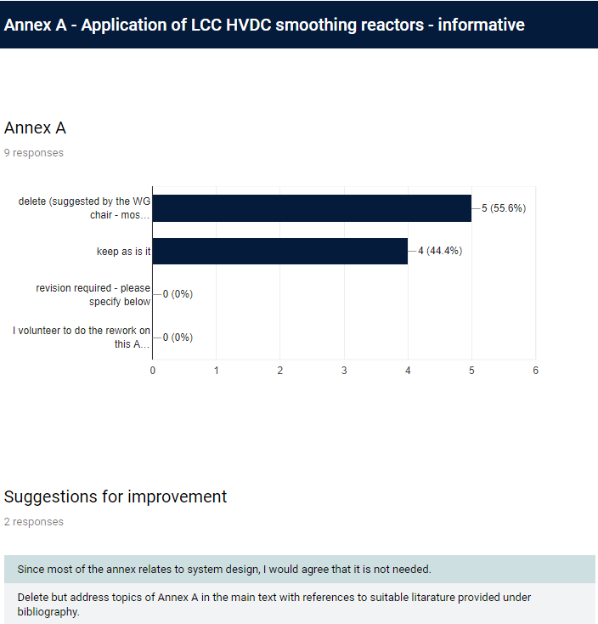
Preliminary decision: Delete since it mostly covers system design aspects. Klaus Pointner will check if there is something that we should keep and in that case copy it into the main text of the standard.

Annex B - Construction and installation of dry-type air-core smoothing reactors for HVDC application
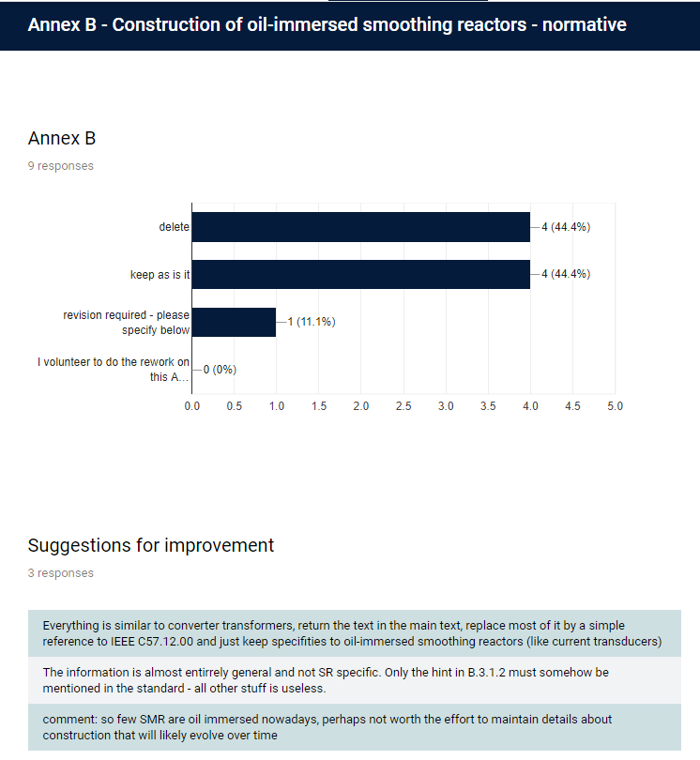

Preliminary decision: Keep. Volunteers are requested for review. Black spot issues should be addressed.

Annex C - Short-circuit capability
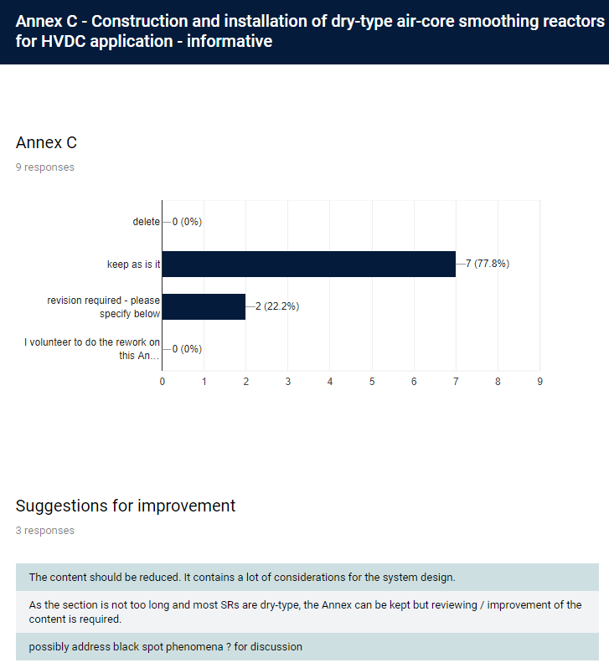
Preliminary decision: Keep but revised. Draft 5 is updated. WG members can review this Annex now.

Annex D - In-service overloading of HVDC smoothing reactors
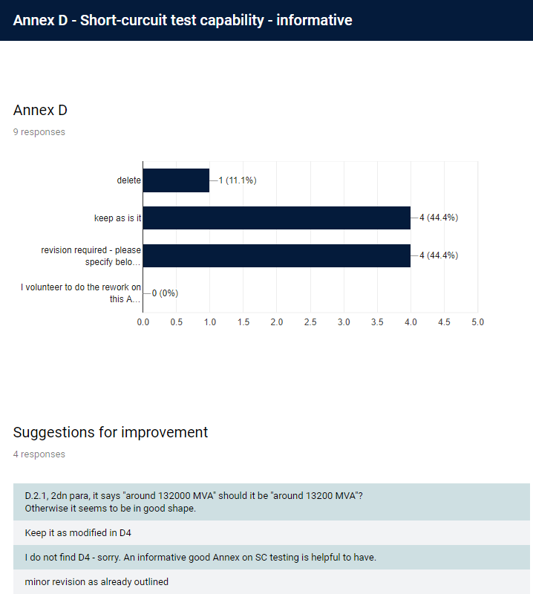
Preliminary decision: Keep but reduce the content. Overload is often a very important topic for an HVDC project. The examples are good to show end users typical kind of overloads.

Annex E - Smoothing reactors used in voltage source converters (VSC) HVDC schemes
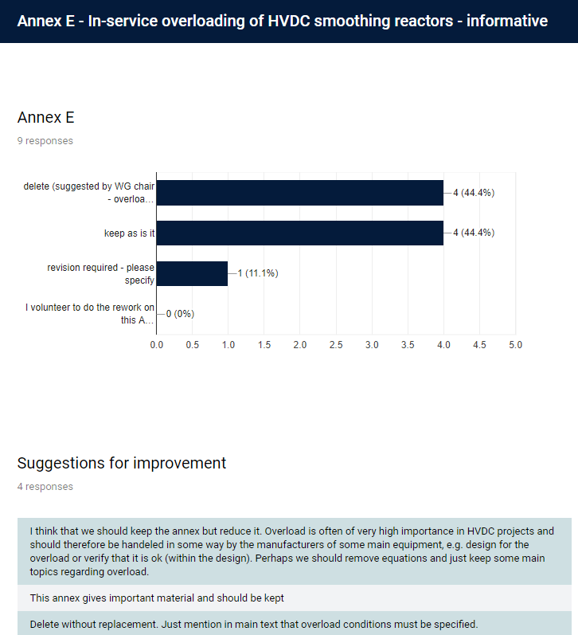
Preliminary decision: Delete. Smoothing reactors for VSC are handled in the same way as smoothing reactors for LCC.

Annex F - Smoothing reactors for 800 kV ultra high voltage direct current
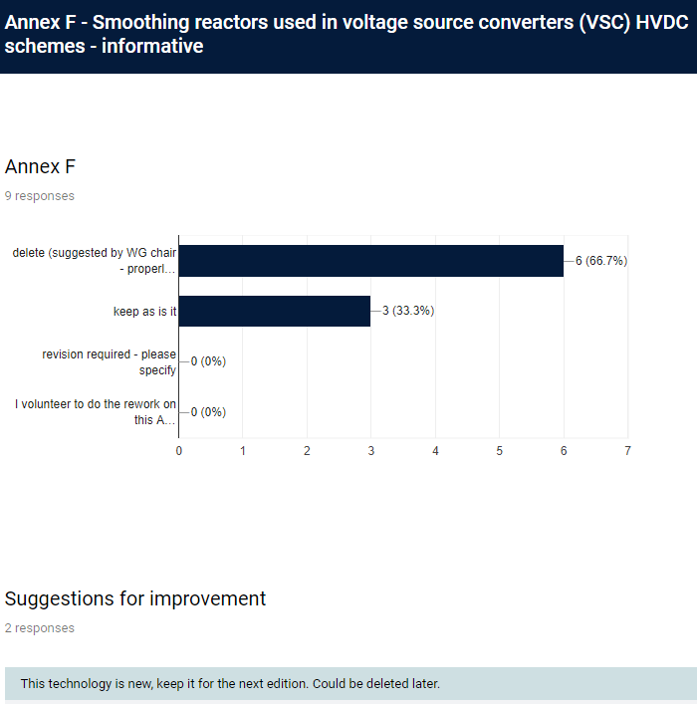
Preliminary decision: Delete. 800kV is now an established voltage level for HVDC and the reactors are specified and tested in the same way as for reactors for lower voltages. The main text will cover ultra high voltage direct current.
E6.1.3 Discussion of Input received from Pierre Riffon, Waldemar Ziomek and Klaus Papp
Dielectric correction factors due to unusual high ambient temperatures (above 40 °C) are available in IEEE Std 4. These corrections might be covered by insulation margins according to IEC 60071-5. That information is seldom transferred to the manufacturers though. Klaus Pointner will dig into this.
A note in clause 10.5 “Temperature rise of terminals” about possible higher allowed temperatures for terminals will be deleted.
Clause 11.1.3 “Switching impulse tests” 2nd paragraph should be modified with information about difficulties to get desired wave shape.
Clause 11.3 “DC polarity-reversal test with partial discharge measurements for oil-immersed smoothing reactors” should be updated with the extended test with longer times according to the new converter transformer standard.
In the case of converter reactors that carry significant DC and AC currents a consensus was reached that AC current should be used for heat run tests since it is more severe test condition, e.g. due to heating of structural parts due to eddy currents. The current distribution is different for DC current. The current sharing and the temperature rise for DC current should be calculated and included in a design report. The heat run test should as often as possible be performed indoor because small winds can lower the temperatures with several K.
Waldemar Ziomek has investigated the need for chopped impulse tests for the reactors in this standard. He concluded that the chopped test is not necessary in modern stations with modern surge arresters. Pierre Riffon pointed out that the test still can be valid if the surge arresters are not located very close to the reactor and there is an earth fault along a post insulator near the reactor. Chopped impulse is now an optional test and it can remain as that.
Klaus Pointner would like to have new comments on Draft 5. The intention is to have Draft 6 ready in December and have a survey of the main text among WG members. A final draft including updated Annexes should be ready for the 2019 spring meeting.
E.6.1.3 Other
Klaus Pointner will distribute draft 6 in two versions:
- One with track changes
- One clean because that is easier to read
E.4.2.4 New Business
- There was no new business
E.4.2.5. Adjournment
The WG meeting was adjourned and the SC chair, Mike Sharp, took over with the SC meeting.

Old Business
- There was no old business

New Business
- There was no new business

Adjournment
The meeting was adjourned at 4:20 pm.

