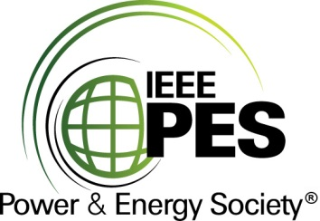

###### 

###### CERTIFICATE OF

**EDUCATIONAL ACHIEVEMENT**

# This certificate is presented to

## replace with your name

for attendance at the educational presentation:

**"** **HVDC Part 2: HVDC Equipment Aspects (LCC and VSC) "**

*sponsored by the IEEE/PES Transformers Committee*

**and has earned one (1) Professional Development Hours (PDH) unit.**

**Fall 2021 Virtual Committee Meeting; Thursday, November 18, 2021**

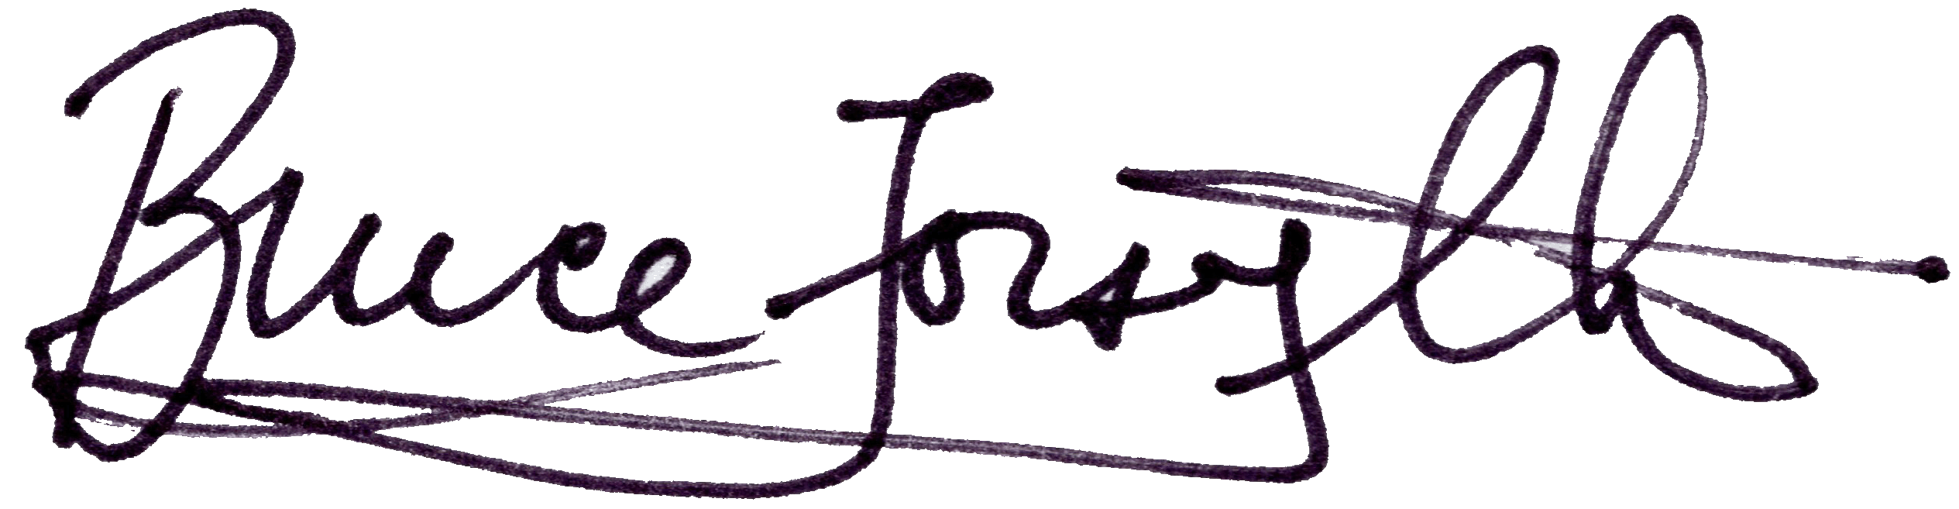

_________________________________ ___________________________________________________

Bruce Forsyth Instructors: Alexander Gaun, Klaus Pointner, Pierre Riffon,

Committee Chair and Waldemar Ziomek