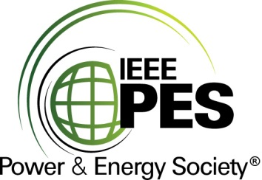

###### 

###### CERTIFICATE OF

**EDUCATIONAL ACHIEVEMENT**

# This certificate is presented to

## replace with your name

for attendance at the educational presentation:

**" IEEE 693 Power Transformer Amendment: Power Transformer Structural Dynamics Requirement for Seismic Qualification "**

*sponsored by the IEEE/PES Transformers Committee*

**and has earned one (1) Professional Development Hours (PDH) unit.**

**Fall 2021 Virtual Committee Meeting; Thursday, November 18, 2021**

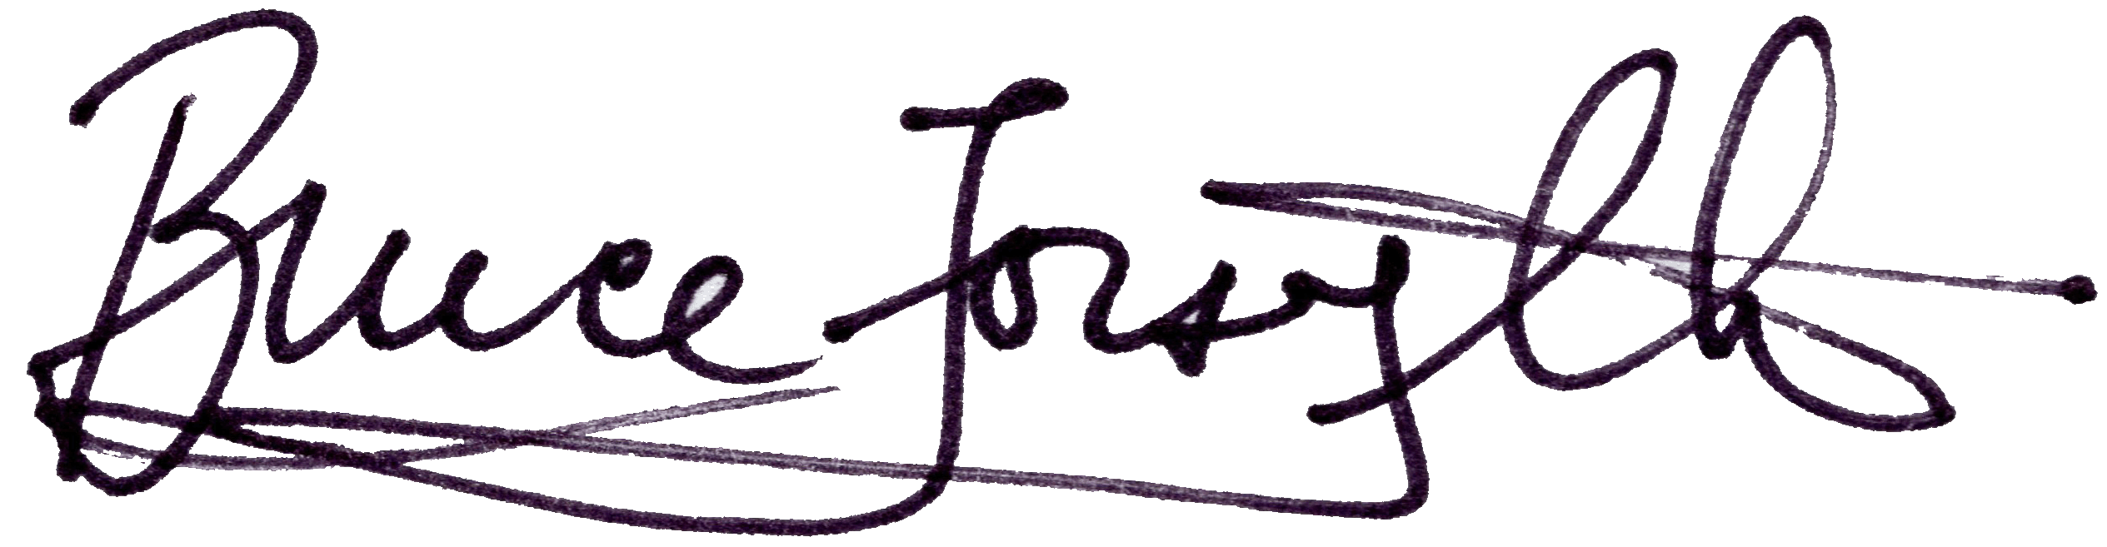

_________________________________ ___________________________________________________

Bruce Forsyth Instructors: Michael J. Riley and Jon Bender

Committee Chair