# Recognition & Awards Report – Susan McNelly

November 16, 2021, Virtual Meeting

This report is a for the Fall 2021 Virtual meeting. The Awards presentation will again be presented virtually live in lieu of the normal Awards Luncheon.

## In Memoriam

### Dr. C Clair Claiborne

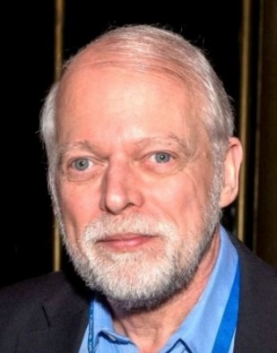Dr. C Clair Claiborne, age 69, of Apex, North Carolina passed away October 24, 2021. Clair is survived by his wife Patricia.

Clair initially wanted to be a chemist and began his career in 1973 as a chemotechnician with Sud-Chemie A.G. in Moosburg, Germany. After two years he decided to continue his studies in the field of materials. He received a BA in chemistry from the University of Kansas specializing in electrical transformers. He served as an engineer at James Manufacturing Inc., a research assistant at Northwestern University and a research chemist at Phillips Petroleum. In 1984, with a PhD in material science from Northwestern, he became a senior scientist at Westinghouse Electric Company between 1984 and 1991. Clair spent 26 years with ABB progressing through several positions during this time, before starting his own consulting company, Claiborne Consulting, LLC.

One of his biggest achievements, along with Dr. T.V. Oommen, was the invention of Biotemp, a biodegradable vegetable oil used to deliver high performance power transformer insulation. He was the author of two industry texts “Working with Metals” and “Working with Non-Metals” in 1981, as well as more than 75 articles in various peer-reviewed journals. He holds 10 US patents and 4 European patents

Clair was an ASTM Fellow. He was also an IEEE PES Transformer Committee member from 2009 to his passing. He was actively involved in the Insulating Fluids SC for many years, and was the Vice Chair of C57.147, Natural Ester Guide

He enjoyed Amateur Radio (KC3WJ), traveling, and had a great joy in is Audi cars.

Clair was an ASTM Fellow and was an IEEE PES Transformers Committee Member from 2009 to his passing. He was actively involved in the Insulating Fluids SC and its associated WGs for many years. He was the Vice Chair of C57.147, Natural Ester Guide.

## General Service Awards

Our sincere thanks and appreciation go out to the following for their service to the Transformers Committee.

### Transformers Committee Treasurer

### A Certificate of Appreciation was presented to Paul Boman for his service as Transformers Committee Treasurer from 2018 through 2021. Paul stepped up to fill this critical role with no advance notice. His contributions are greatly appreciated.

### Thank you to Paul for his 3 years of service in this role.

### Transformers Committee Chair

### A Certificate of Appreciation was presented to Bruce Forsyth for his service as Committee Chair from 2020 through 2021. In addition to his latest role, the Committee also recognizes his additional contributions as Secretary and Vice Chair as part of the Officer Progression.

### Bruce had a daunting task steering the Committee through cancelled meetings and a new virtual venue. We thank Bruce for his leadership in guiding us through these previously unchartered waters so successfully.

### Transformers Committee Awards & Recognition Chair

### A Certificate of Appreciation was presented to Susan McNelly by Bruce Forsyth for her service as Committee Awards & Recognition Chair from 2020 through 2021.

## New Members of The Transformers Committee

The Transformers Committee welcomes the following 4 new committee members. They were welcomed to the Committee at the Monday General Session and a membership certificate was mailed to them. Thank you and welcome to the Committee!

1. Gilles Bargone FISO Technologies Inc.
2. Colby Lovins Federal Pacific Transformer
3. Darrell Mangubat Siemens Power Operations Inc.
4. Joseph Tedesco Hitachi ABB Power Grids

## IEEE SA Standards Medallion Award

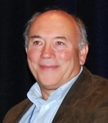We are happy to announce that Tom Prevost was granted the IEEE SA Standards Medallion Award in December of 2020 for ongoing leadership and contributions to the development of IEEE transformer standards and the standards development process. We were remiss in making this announcement at the Spring meeting, but wanted to congratulate Tom on this prestigious award. A recording of the IEEE SA awards program can be found at [https://www.youtube.com/watch?v=HvH7i3ZQjMg](https://nam04.safelinks.protection.outlook.com/?url=https%3A%2F%2Fwww.youtube.com%2Fwatch%3Fv%3DHvH7i3ZQjMg&data=04%7C01%7Csusan.j.mcnelly%40xcelenergy.com%7C1d31f28cff0f43ac3a9d08d9a4598644%7C24b2a5835c054b6ab4e94e12dc0025ad%7C1%7C0%7C637721526677546612%7CUnknown%7CTWFpbGZsb3d8eyJWIjoiMC4wLjAwMDAiLCJQIjoiV2luMzIiLCJBTiI6Ik1haWwiLCJXVCI6Mn0%3D%7C1000&sdata=06kv2lYqnp3E%2BRH7BPPo%2Ba%2FLx2tsKINqPbqGt4jBFmE%3D&reserved=0).

## Outstanding Service Awards

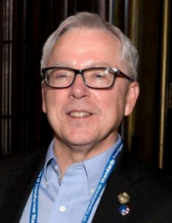For long-term commitment, dedication, and contributions to the Transformers Committee the following were awarded the Committee’s Outstanding Service Award.

Craig Colopy - Craig has been a Transformers Committee Member since April 18, 2002. He has been involved extensively for more than 2 decades in LTC, DETC, and Voltage Regulator standards and guides. Craig played a large part in the efforts to create a joint IEEE Standards with IEC Standards.

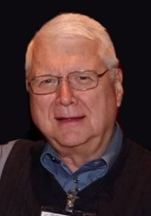Phil Hopkinson – Phil has been a longstanding very involved member of our Committee. He has led the way in creation of a new standard for wind turbine transformers, led C57.157 (DETC functional life testing), and continues to be a driving force behind the DOE transformer efficiency and loss efforts. Phil’s broad reach covers multiple SCs both as a leader and major contributor.

We are proud to present these awards to Craig and Phil!

## IEEE Standards Association Standards Board Working Group Awards

The IEEE SA SB presents Awards to the WG Chair upon publication of a new or revised document and offers the WG Chair the opportunity to nominate significant contributors to the project for an IEEE SA SB Certificate of Appreciation.

1. IEEE Std C57.104™-2019 (Published 6/2019)– IEEE Guide for the Interpretation of Gases Generated in Mineral Oil-Immersed Transformers  
   WG Chair: Claude Beauchemin  
   WG Vice Chairs: Don Platts & Norm Field  
   WG Secretary: Susan McNelly  
   Certificates of Appreciation: Paul Boman, Muhammad Ali Masood Cheema, Luiz Cheim, Donald Dorris, James Dukarm, Michel Duval, Marcos Ferreira, David Hanson, Mani Kumar, Richard Ladroga, Thomas Lundquist, Hali Moleski, Jerry Murphy, Arturo Nunez, Thomas Prevost, Robert Rasor, & David Wallach
2. IEEE Std C57.105™-2019 (published 3/2020)– IEEE Guide for Application of Transformer Connections in Three-Phase Electrical Systems  
   WG Chair: Rogerio Verdolin  
   WG Vice Chair: Ben Garcia  
   Certificates of Appreciation: David Jacobson, John John, Dan Mulkey, Samuel Sharpless, David Walker

## Other Awards

See the Awards Guidebook on our website <http://www.transformerscommittee.org/> for other award opportunities. The guidebook provides a reference for the awards that are available to the PES Technical Committees volunteers each year. The intent is to provide one reference point to assist the PES Technical Committees in recognizing the volunteers who donate their time and expertise to the betterment of the industry and society overall. This is meant to supplement, not replace the PES Awards web page: <https://www.ieee-pes.org/pes-communities/awards>.

Respectfully submitted,

Susan J. McNelly

Chair, Recognition & Awards Subcommittee

IEEE PES Transformers Committee

November 16, 2021