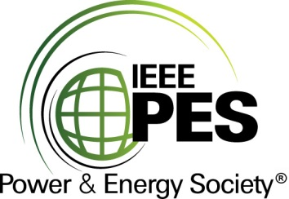

###### 

###### CERTIFICATE OF

**EDUCATIONAL ACHIEVEMENT**

# This certificate is presented to

## replace with your name

for attendance at the educational presentation:

**"** **Impact of GIC on Power Transformers and Power Systems –   
Case Studies "**

*sponsored by the IEEE/PES Transformers Committee*

**and has earned one (1) Professional Development Hour (PDH).**

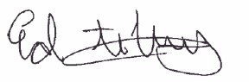**Fall 2022 Charlotte Committee Meeting; Thursday, October 20, 2022**

_________________________________ ___________________________________________________

Ed teNyenhuis Instructor: Ramsis Girgis, Thomas Hartmann, Gary Hoffman,

Committee Chair Mark Olson, Anastasia O’Malley, Chris Slattery