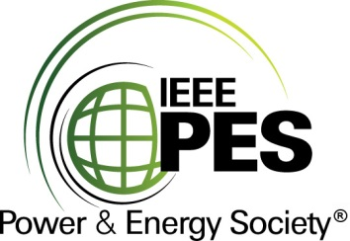

###### 

###### CERTIFICATE OF

**EDUCATIONAL ACHIEVEMENT**

# This certificate is presented to

## replace with your name

for attendance at the educational presentation:

**"Grid-Ready, Flexible Transformers to Enhance Resiliency and Operational Flexibility of Transmission Networks"**

*sponsored by the IEEE/PES Transformers Committee*

**and has earned one (1) Professional Development Hour (PDH).**

**Fall 2022 Charlotte Committee Meeting; Thursday, October 20, 2022**



_________________________________ ___________________________________________________

Ed teNyenhuis Instructor: Enrique Betancourt, Juan Castellanos,

Committee Chair Dr. Ibrahima Ndiaye