

###### 

###### CERTIFICATE OF

**EDUCATIONAL ACHIEVEMENT**

# This certificate is presented to

## replace with your name

for attendance at the educational presentation:

**“IEEE Guide for Dielectric Frequency Response Measurements on Bushings”**

*sponsored by the IEEE/PES Transformers Committee*

**and has earned one (1) Professional Development Hour (PDH).**

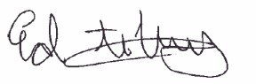**Fall 2023 Kansas City Transformers Committee Meeting; Thursday, October 26, 2023**

_________________________________ ___________________________________________________

Ed teNyenhuis Instructors: Poorvi Patel, Evgenii Ermakov, Ismail Guner   
Committee Chair and Peter Werelius