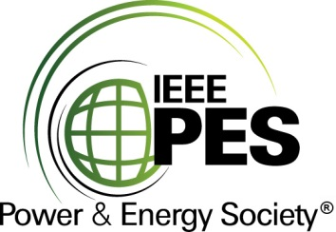

###### 

###### CERTIFICATE OF

**EDUCATIONAL ACHIEVEMENT**

# This certificate is presented to

## replace with your name

for attendance at the educational presentation:

**“IEEE Standard 1402: IEEE Guide for Physical Security of Electric Power Substations”**

*sponsored by the IEEE/PES Transformers Committee*

**and has earned one (1) Professional Development Hour (PDH).**

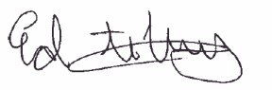**Fall 2023 Kansas City Transformers Committee Meeting; Thursday, October 26, 2023**

_________________________________ ___________________________________________________

Ed teNyenhuis Instructors: Connor Bowen, Isaac Cowger and Mark Smedvig  
Committee Chair