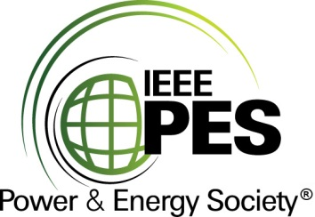

###### 

###### CERTIFICATE OF

**EDUCATIONAL ACHIEVEMENT**

# This certificate is presented to

## replace with your name

for attendance at the educational presentation:

**“Guide for the Condition Assessment of Liquid Immersed Transformers, Reactors and Their Components & Application of Probabilistic Bayesian Networks on Transformer Condition Assessment”**

*sponsored by the IEEE/PES Transformers Committee*

**and has earned one (1) Professional Development Hour (PDH).**

**Fall 2024 St. Louis Transformers Committee Meeting; Thursday, October 31, 2024**



_________________________________ ___________________________________________________

David Wallach Instructors: Brian Sparling, James Cross, Kumar Mani &   
Committee Chair Dr. Luiz Cheim, Alan Sbravati and Kumar Mani