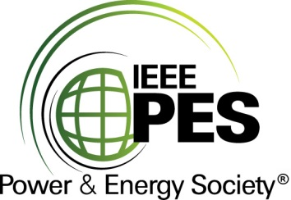

###### 

###### CERTIFICATE OF

**EDUCATIONAL ACHIEVEMENT**

# This certificate is presented to

## Replace with your name

for attendance at the educational presentation:

**“Pragmatic Approach to Seismic Protection of High Voltage Transformer Bushings”**

*sponsored by the IEEE/PES Transformers Committee*

**and has earned one (1) Professional Development Hour (PDH).**

**Fall 2024 St. Louis Transformers Committee Meeting; Thursday, October 31, 2024**

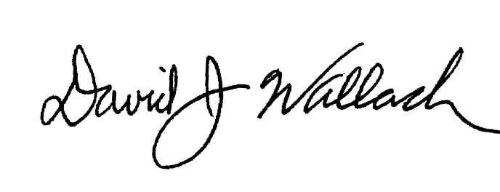

_________________________________ ___________________________________________________

David Wallach Instructors: Jon Bender and Bjorn Vaagensmith  
Committee Chair