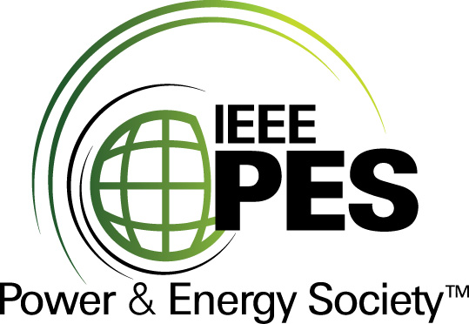
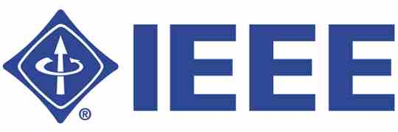

CERTIFICATE OF
EDUCATIONAL ACHIEVEMENT

This certificate is presented to

replace with your name

for attendance at the educational presentation:

“Geo-magnetically Induced Current: Effects on Power Transformers and the Power System; Monitoring, and Potential Mitigation”

sponsored by the IEEE/PES Transformers Committee

and has earned two (2) Professional Development Hours (PDH) units.
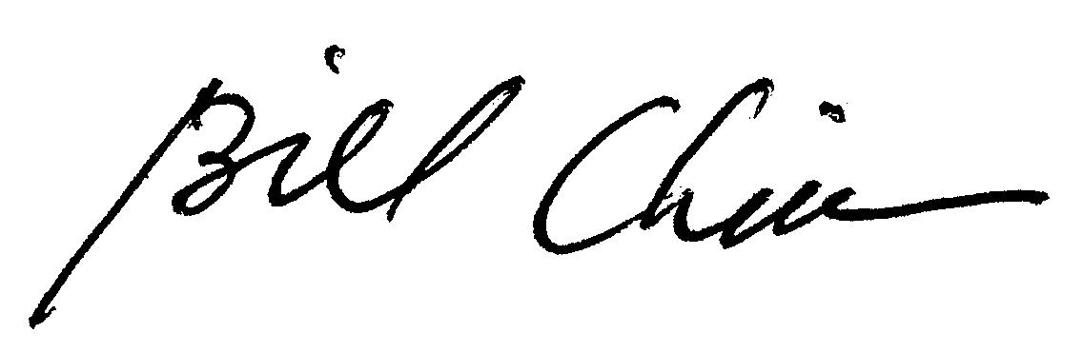
Spring 2012 Committee Meeting; Tuesday, March 15, 2012

Bill Chiu Instructors: E. Bernabeu, D. Fugate, R. Girgis, F. Koza
Chair, IEEE/PES Transformers Committee

