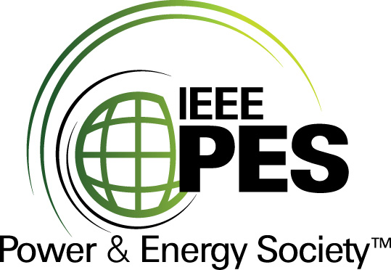


CERTIFICATE OF
EDUCATIONAL ACHIEVEMENT

This certificate is presented to

replace with your name

for attendance at the educational presentation:

"Guide for Diagnostic Testing
of Fluid-Filled Power Transformers"

sponsored by the IEEE/PES Transformers Committee

and has earned one (1) Professional Development Hours (PDH) unit.
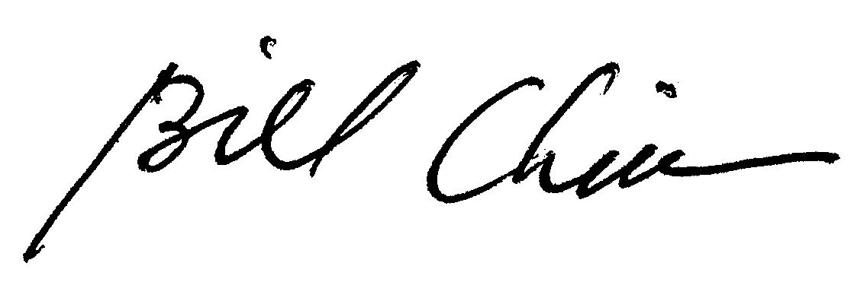
Spring 2012 Committee Meeting; Thursday, March 21, 2013

Bill Chiu Instructors: Wally Binder, Mario Locarno, Charles Sweetser
Chair, IEEE/PES Transformers Committee and Kipp Yule

