


CERTIFICATE OF
EDUCATIONAL ACHIEVEMENT

This certificate is presented to

replace with your name

for attendance at the educational presentation:

"Transformer Interaction with Switching of
Vacuum and SF6 Breakers"

sponsored by the IEEE/PES Transformers Committee

and has earned one (1) Professional Development Hours (PDH) unit.
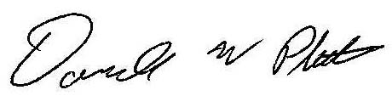
Spring 2014 Committee Meeting; Thursday, March 27, 2014

Donald Platts Instructors: B. Degeneff, A. Rocha, and others

