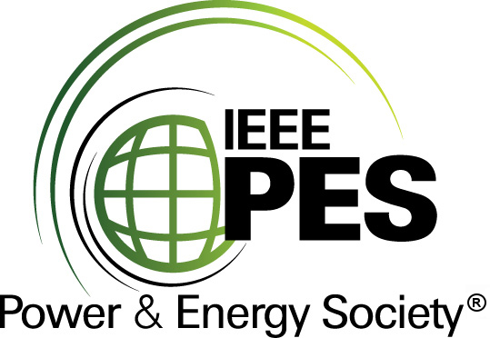


CERTIFICATE OF
EDUCATIONAL ACHIEVEMENT

This certificate is presented to

replace with your name

for attendance at the educational presentation:

"Guide for Application of Monitoring Equipment to
Liquid-Immersed Transformers and Components C57.143"

sponsored by the IEEE/PES Transformers Committee

and has earned one (1) Professional Development Hours (PDH) unit.
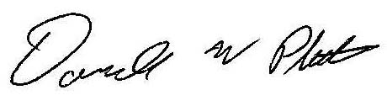
Spring 2014 Committee Meeting; Thursday, March 27, 2014

Donald Platts Instructors: J. Benach, C. Beauchemin, D. Chu,
T. Pink, and B. Sparling

