** Spouse/Companion Tour**

**Monday, March 24, 2014**

**— Historic Savannah Experience —**

**Victorian District**

**Bonaventure Cemetery**

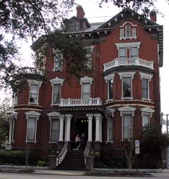The experience begins with a tour through historic Savannah, home to stately Southern architecture and distinctive park-like squares, including a stop at one of Savannah’s Historic House Museums for a look into the lives of some of the city’s wealthy cotton merchants. The tour continues with a visit to the Cathedral of St. John the Baptist which is often compared to some of the beautiful churches in Europe. <http://www.savannahcathedral.org/>

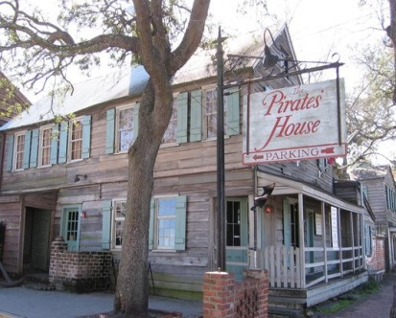

Lunch will be served at the Pirates House Restaurant. Located on one of the most historic spots in Georgia, this restaurant has been welcoming visitors to Savannah with a bounty of delicious food since 1753. Buffet style lunch includes Southern-fried chicken, BBQ pulled pork, baked tilapia, macaroni & cheese, mashed potatoes & gravy, salad with ranch or balsamic vinaigrette dressing, mixed vegetables, freshly baked biscuits, assorted desserts, iced tea and coffee.** <http://thepirateshouse.com/>

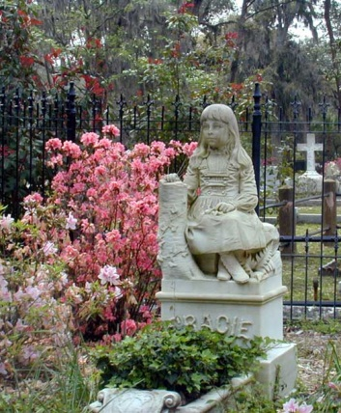The afternoon will include a drive through the Victorian District, Savannah’s first suburb onto Ardsley Park, home to large Savannah mansions. Then the bus stops at Bonaventure Cemetery. Formerly a 600 acre rural estate on the banks of the Intracoastal Waterway, it is now the resting place for Savannah’s famous son, singer/songwriter, Johnny Mercer. The cemetery became famous when it was featured in the 1994 novel *Midnight in the Garden of Good and Evil* by John Berendt and then the movie, directed by Clint Eastwood, based on the book.  
<http://www.bonaventurehistorical.org/>

**Itinerary**

9:15 am: Depart hotel for the Historic Savannah Experience via minibus*

11:30 am: Group arrives at the Pirate’s House for lunch

1:00 pm: Group departs the Pirate’s House and continues touring

2:15 pm: Group arrival at Bonaventure Cemetery

3:15 pm: Group departs Bonaventure Cemetery

3:30 pm: Return to hotel (approximate time)

*Please note that minibuses not equipped with restrooms will be the means of transportation due to the

uniqueness of Savannah streets; restroom stops ARE built into the day’s agenda.

**Please advise us of any special dietary needs when registering.



**Attendance will be limited… REGISTER EARLY!**