** Spouse/Companion Tour**

**Tuesday, March 25, 2014**

**Tybee Island & Paula Deen Tour**

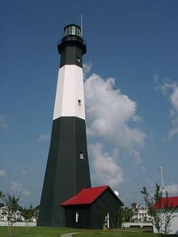

The day begins with a tour of Tybee Island. Ordered in 1732 by General James Oglethorpe, Governor of the 13th colony, the Tybee Island Light Station has been guiding mariners’ safe entrance into the Savannah River for over 270 years. The Tybee Island Light House is one of America's most intact, having all of its historic support buildings on its five-acre site. Rebuilt several times, the current light station displays its 1916 day mark with 178 stairs and a First Order Fresnel lens (nine feet tall). <http://www.tybeelighthouse.org/>

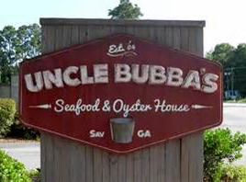Lunch will be served at Uncle Bubba’s (Paula Deen’s brother’s restaurant), where you’ll enjoy a buffet menu featuring a low country boil (shell-on shrimp, smoked sausage, new potatoes and corn-on-the-cob, prepared together and topped with Old Bay), grilled chicken, garden salad with choice of dressing, Savannah red rice, macaroni ’n cheese, green beans, dessert, iced tea and coffee.** <http://www.unclebubbas.com>

The afternoon begins as we take a peek into the life of a famous southern chef, Paula Deen. Visit a few of the shops that she frequented, and still showcases, on her way to establishing herself as one of America’s favorite celebrities and cooking icons. The tour will take guests to the Bethesda Boys Home where she and her husband, Mike, were married along with additional stops as we make our way back into the Historic District. Your Paula Deen tour will include a few surprises, which is sure to give your group an appetite for more of the “Good Ole South”.

**Itinerary**

9:15 am: Group departs for Tybee Island via minibus*

9:45 am: Group arrival at the Tybee Island Light House Complex

11:00 am: Group departs Tybee Island for Uncle Bubba’s

11:20 am: Group arrives at Uncle Bubba’s for lunch

12:30 pm: Group departs and begins the Paula Deen tour

3:30 pm: Group returns to hotel

*Please note that minibuses not equipped with restrooms will be the means of transportation due to the

uniqueness of Savannah streets; restroom stops ARE built into the day’s agenda.

**Please advise us of any special dietary needs when registering.

**  
 Attendance will be limited… REGISTER EARLY!**