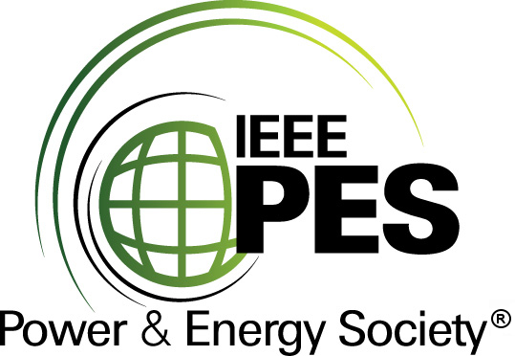


CERTIFICATE OF
EDUCATIONAL ACHIEVEMENT

This certificate is presented to

replace with your name

for attendance at the educational presentation:

"Transformer Core Grounding & Gassing,
Proposed Text for IEEE Standards"

sponsored by the IEEE/PES Transformers Committee

and has earned one (1) Professional Development Hours (PDH) unit.
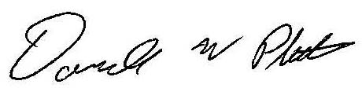
Spring 2015 Committee Meeting; Thursday, April 16, 2015

Donald Platts Instructors: D. Buckmaster, P. Hopkinson, and K. Whitehead

