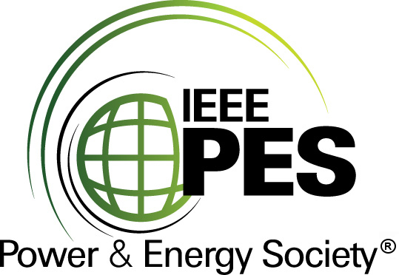


CERTIFICATE OF
EDUCATIONAL ACHIEVEMENT

This certificate is presented to

replace with your name

for attendance at the educational presentation:

"Transportation of Transformers, The Hot Buttons"

sponsored by the IEEE/PES Transformers Committee

and has earned one (1) Professional Development Hours (PDH) unit.
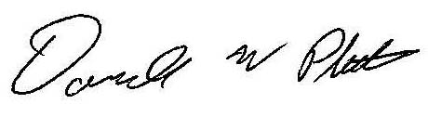
Spring 2015 Committee Meeting; Thursday, April 16, 2015

Donald Platts Instructors: D. Blaydon, P. Boman, A. Burns, K. Nunn,
Peter van den Berg, et al.

